Q1.)
#include <iostream>

struct Node {
int data;
Node* next;

// Constructor to initialize a node
Node(int val) : data(val), next(NULL) {}
};

class SinglyLinkedList {
private:
Node* head;

public:
SinglyLinkedList() : head(NULL) {}

// (a) Insertion at the beginning
void insertAtBeginning(int val) {
Node* newNode = new Node(val);
newNode->next = head;
head = newNode;
std::cout << val << " inserted at the beginning.\n";
}

// (b) Insertion at the end
void insertAtEnd(int val) {
Node* newNode = new Node(val);
if (head == NULL) {
head = newNode;
} else {
Node* temp = head;
while (temp->next != NULL) {
temp = temp->next;
}
temp->next = newNode;
}
std::cout << val << " inserted at the end.\n";
}

// (c) Insertion after a specific node value
void insertAfterNode(int targetVal, int newVal) {
Node* temp = head;
while (temp != NULL && temp->data != targetVal) {
temp = temp->next;
}

if (temp == NULL) {
std::cout << "Node with value " << targetVal << " not found.\n";
return;
}

Node* newNode = new Node(newVal);
newNode->next = temp->next;
temp->next = newNode;
std::cout << newVal << " inserted after " << targetVal << ".\n";
}

// (d) Deletion from the beginning
void deleteFromBeginning() {
if (head == NULL) {
std::cout << "List is empty. Cannot delete.\n";
return;
}
Node* temp = head;
head = head->next;
std::cout << temp->data << " deleted from the beginning.\n";
delete temp;
}

// (e) Deletion from the end
void deleteFromEnd() {
if (head == NULL) {
std::cout << "List is empty. Cannot delete.\n";
return;
}
if (head->next == NULL) { // Only one node
delete head;
head = NULL;
std::cout << "The only node has been deleted.\n";
return;
}
Node* second_last = head;
while (second_last->next->next != NULL) {
second_last = second_last->next;
}
Node* nodeToDelete = second_last->next;
std::cout << nodeToDelete->data << " deleted from the end.\n";
delete nodeToDelete;
second_last->next = NULL;
}

// (f) Deletion of a specific node
void deleteNode(int val) {
if (head == NULL) {
std::cout << "List is empty.\n";
return;
}

Node* temp = head;
// If head node itself holds the key to be deleted
if (temp != NULL && temp->data == val) {
head = temp->next;
delete temp;
std::cout << val << " deleted from the list.\n";
return;
}

Node* prev = NULL;
while (temp != NULL && temp->data != val) {
prev = temp;
temp = temp->next;
}

if (temp == NULL) {
std::cout << "Node with value " << val << " not found.\n";
return;
}

prev->next = temp->next;
delete temp;
std::cout << val << " deleted from the list.\n";
}

// (g) Search for a node and display its position
void searchNode(int val) {
if (head == NULL) {
std::cout << "List is empty.\n";
return;
}
Node* temp = head;
int position = 1;
while (temp != NULL) {
if (temp->data == val) {
std::cout << "Node " << val << " found at position " << position << ".\n";
return;
}
temp = temp->next;
position++;
}
std::cout << "Node with value " << val << " not found in the list.\n";
}

// (h) Display all the node values
void display() {
if (head == NULL) {
std::cout << "The list is empty.\n";
return;
}
Node* temp = head;
std::cout << "Linked List: HEAD -> ";
while (temp != NULL) {
std::cout << temp->data << " -> ";
temp = temp->next;
}
std::cout << "NULL\n";
}
};

int main() {
SinglyLinkedList list;
int choice, value, target;

while (true) {
std::cout << "\n--- Singly Linked List Menu ---\n";
std::cout << "1. Insert at Beginning\n";
std::cout << "2. Insert at End\n";
std::cout << "3. Insert After a Node\n";
std::cout << "4. Delete from Beginning\n";
std::cout << "5. Delete from End\n";
std::cout << "6. Delete a Specific Node\n";
std::cout << "7. Search for a Node\n";
std::cout << "8. Display List\n";
std::cout << "9. Exit\n";
std::cout << "Enter your choice: ";
std::cin >> choice;

switch (choice) {
case 1:
std::cout << "Enter value to insert: ";
std::cin >> value;
list.insertAtBeginning(value);
break;
case 2:
std::cout << "Enter value to insert: ";
std::cin >> value;
list.insertAtEnd(value);
break;
case 3:
std::cout << "Enter the value of the node to insert after: ";
std::cin >> target;
std::cout << "Enter the new value to insert: ";
std::cin >> value;
list.insertAfterNode(target, value);
break;
case 4:
list.deleteFromBeginning();
break;
case 5:
list.deleteFromEnd();
break;
case 6:
std::cout << "Enter value of the node to delete: ";
std::cin >> value;
list.deleteNode(value);
break;
case 7:
std::cout << "Enter value to search for: ";
std::cin >> value;
list.searchNode(value);
break;
case 8:
list.display();
break;
case 9:
return 0;
default:
std::cout << "Invalid choice. Please try again.\n";
}
}
return 0;
}

Output->

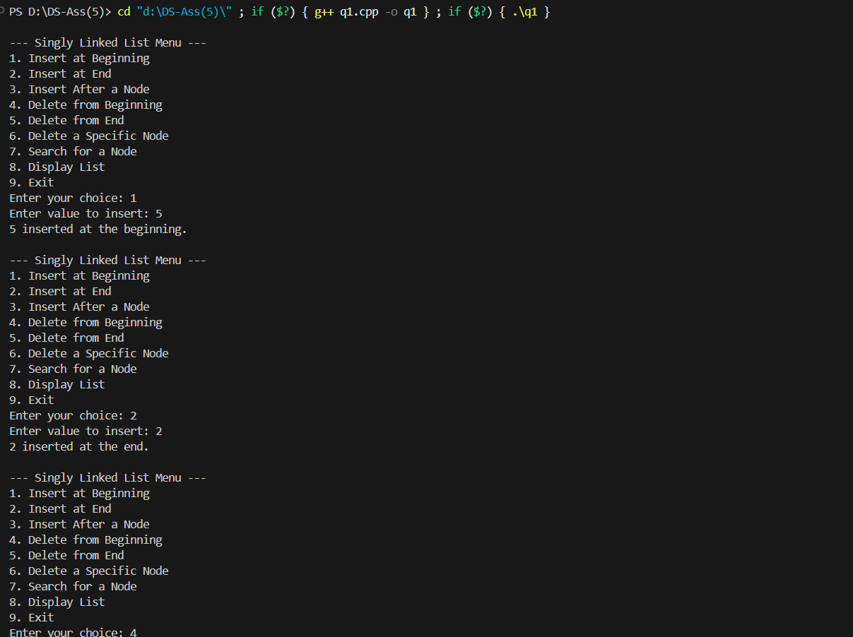

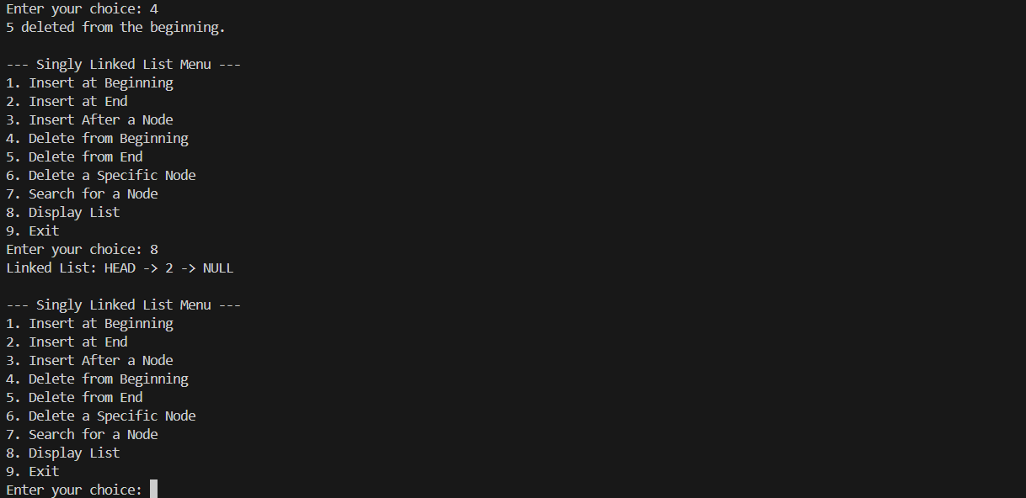

Q2.)
#include <iostream>

// Define the structure for a node
struct Node {
int data;
Node* next;
// Constructor now uses NULL for backward compatibility
Node(int val) : data(val), next(NULL) {}
};

// Helper function to print the list
void printList(Node* head) {
if (!head) {
std::cout << "List is empty.\n";
return;
}
Node* temp = head;
while (temp != NULL) {
std::cout << temp->data << " -> ";
temp = temp->next;
}
std::cout << "NULL\n";
}

// Function to count and delete all occurrences of a key
void countAndDeleteOccurrences(Node*& head, int key) {
int count = 0;
Node* temp = head;

// First, count the occurrences
while (temp != NULL) {
if (temp->data == key) {
count++;
}
temp = temp->next;
}

std::cout << "Count: " << count << std::endl;

// Now, delete the nodes
// Handle cases where the head node itself needs to be deleted
while (head != NULL && head->data == key) {
Node* nodeToDelete = head;
head = head->next;
delete nodeToDelete;
}

// Delete occurrences from the rest of the list
Node* current = head;
while (current != NULL && current->next != NULL) {
if (current->next->data == key) {
Node* nodeToDelete = current->next;
current->next = current->next->next;
delete nodeToDelete;
} else {
current = current->next;
}
}
}

int main() {
// Create the sample linked list: 1->2->1->2->1->3->1
Node* head = new Node(1);
head->next = new Node(2);
head->next->next = new Node(1);
head->next->next->next = new Node(2);
head->next->next->next->next = new Node(1);
head->next->next->next->next->next = new Node(3);
head->next->next->next->next->next->next = new Node(1);

int key = 1;

std::cout << "Original Linked List: ";
printList(head);

countAndDeleteOccurrences(head, key);

std::cout << "Updated Linked List: ";
printList(head);

return 0;
}

Output->
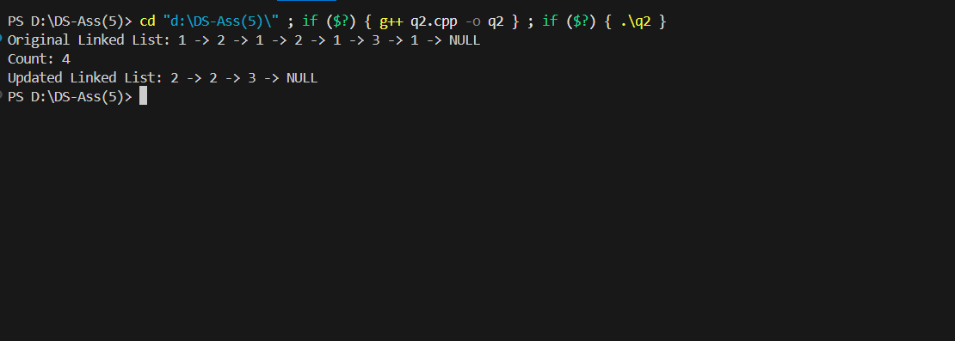

Q3.)
#include <iostream>

struct Node {
int data;
Node* next;
Node(int val) : data(val), next(NULL) {}
};

// Function to find the middle of the linked list
Node* findMiddle(Node* head) {
if (head == NULL) {
return NULL;
}

Node* slow = head;
Node* fast = head;

// Move fast pointer by two and slow pointer by one
// When fast pointer reaches the end, slow pointer will be at the middle
while (fast != NULL && fast->next != NULL) {
slow = slow->next;
fast = fast->next->next;
}

return slow;
}

int main() {
// Create the sample linked list: 1->2->3->4->5
Node* head = new Node(1);
head->next = new Node(2);
head->next->next = new Node(3);
head->next->next->next = new Node(4);
head->next->next->next->next = new Node(5);

Node* middleNode = findMiddle(head);

if (middleNode != NULL) {
std::cout << "The middle of the linked list is: " << middleNode->data << std::endl;
} else {
std::cout << "The list is empty." << std::endl;
}

return 0;
}

Output->

Q4.)

#include <iostream>

struct Node {
int data;
Node* next;
// Constructor now uses NULL for backward compatibility
Node(int val) : data(val), next(NULL) {}
};

// Helper function to print the list
void printList(Node* head) {
Node* temp = head;
while (temp != NULL) {
std::cout << temp->data << " -> ";
temp = temp->next;
}
std::cout << "NULL\n";
}

// Function to reverse the linked list
Node* reverseList(Node* head) {
Node* prev = NULL;
Node* current = head;
Node* next = NULL;

while (current != NULL) {
// Store the next node
next = current->next;
// Reverse the current node's pointer
current->next = prev;
// Move pointers one position ahead
prev = current;
current = next;
}
// The new head is the last node we processed (prev)
head = prev;
return head;
}

int main() {
// Create the sample linked list: 1->2->3->4
Node* head = new Node(1);
head->next = new Node(2);
head->next->next = new Node(3);
head->next->next->next = new Node(4);

std::cout << "Original List: ";
printList(head);

head = reverseList(head);

std::cout << "Reversed List: ";
printList(head);

return 0;
}

Output->
