Q1.)
#include <iostream>
using namespace std;
#define MAX_SIZE 5

class SimpleQueue {
private:
int arr[MAX_SIZE];
int front;
int rear;

public:
SimpleQueue() {
front = -1;
rear = -1;
}

bool isEmpty() {
return front == -1;
}

bool isFull() {
return rear == MAX_SIZE - 1;
}

void enqueue(int item) {
if (isFull()) {
cout << "Queue is full. Cannot enqueue.\n";
return;
}
if (isEmpty()) {
front = 0;
}
arr[++rear] = item;
cout << "Enqueued: " << item << "\n";
}

int dequeue() {
if (isEmpty()) {
cout << "Queue is empty. Cannot dequeue.\n";
return -1;
}
int item = arr[front];
if (front == rear) {
front = -1;
rear = -1;
} else {
front++;
}
cout << "Dequeued: " << item << "\n";
return item;
}

int peek() {
if (isEmpty()) {
cout << "Queue is empty.\n";
return -1;
}
return arr[front];
}

void display() {
if (isEmpty()) {
cout << "Queue is empty.\n";
return;
}
cout << "Queue elements: ";
for (int i = front; i <= rear; i++) {
cout << arr[i] << " ";
}
cout << "\n";
}
};

int main() {
SimpleQueue q;
int choice, item;

while (true) {
cout << "\n--- Simple Queue Menu ---\n";
cout << "1. Enqueue\n2. Dequeue\n3. Peek\n4. Display\n5. Exit\n";
cout << "Enter your choice: ";
cin >> choice;

switch (choice) {
case 1:
cout << "Enter item to enqueue: ";
cin >> item;
q.enqueue(item);
break;
case 2:
q.dequeue();
break;
case 3:
item = q.peek();
if (item != -1) {
cout << "Front element is: " << item << "\n";
}
break;
case 4:
q.display();
break;
case 5:
return 0;
default:
cout << "Invalid choice. Please try again.\n";
}
}
return 0;
}

Output->
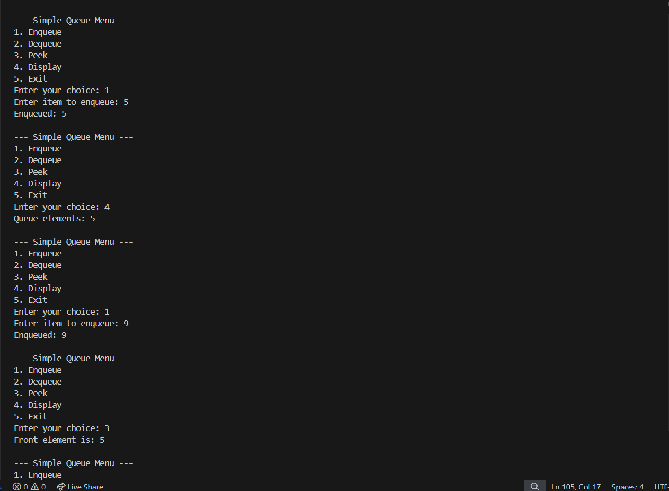

Q2.)
#include <iostream>
using namespace std;
#define MAX_SIZE 5

class CircularQueue {
private:
int arr[MAX_SIZE];
int front;
int rear;
int count;

public:
CircularQueue() {
front = -1;
rear = -1;
count = 0;
}

bool isEmpty() {
return count == 0;
}

bool isFull() {
return count == MAX_SIZE;
}

void enqueue(int item) {
if (isFull()) {
cout << "Circular Queue is full. Cannot enqueue.\n";
return;
}
if (isEmpty()) {
front = 0;
}
rear = (rear + 1) % MAX_SIZE;
arr[rear] = item;
count++;
cout << "Enqueued: " << item << "\n";
}

int dequeue() {
if (isEmpty()) {
cout << "Circular Queue is empty. Cannot dequeue.\n";
return -1;
}
int item = arr[front];
count--;
if (isEmpty()) {
front = -1;
rear = -1;
} else {
front = (front + 1) % MAX_SIZE;
}
cout << "Dequeued: " << item << "\n";
return item;
}

int peek() {
if (isEmpty()) {
cout << "Circular Queue is empty.\n";
return -1;
}
return arr[front];
}

void display() {
if (isEmpty()) {
cout << "Circular Queue is empty.\n";
return;
}
cout << "Queue elements: ";
int i = front;
for (int c = 0; c < count; c++) {
cout << arr[i] << " ";
i = (i + 1) % MAX_SIZE;
}
cout << "\n";
}
};

// --- Menu Driven Example ---
int main() {
CircularQueue cq;
cq.enqueue(10);
cq.enqueue(20);
cq.enqueue(30);
cq.display();
cq.dequeue();
cq.display();
cq.enqueue(40);
cq.enqueue(50);
cq.enqueue(60);
cq.display();
cq.enqueue(70);
return 0;
}

Output->

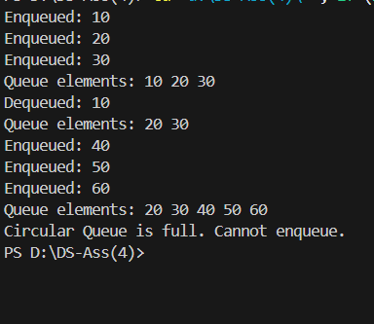

Q3.)
#include <iostream>
#include <queue>
#include <vector>

using namespace std;

// Function to perform the interleaving
void interleaveQueue(queue<int>& q) {
if (q.size() % 2 != 0) {
cout << "Error: Queue must have an even number of elements." << endl;
return;
}

queue<int> first_half;
int half_size = q.size() / 2;

for (int i = 0; i < half_size; ++i) {
first_half.push(q.front());
q.pop();
}

while (!first_half.empty()) {
q.push(first_half.front());
first_half.pop();
q.push(q.front());
q.pop();
}
}

// Helper function to print the contents of a queue
void printQueue(queue<int> q) {
while (!q.empty()) {
cout << q.front() << " ";
q.pop();
}
cout << endl;
}

int main() {
// Initialize the queue using a C-style array and a traditional for loop
int data[] = {4, 7, 11, 20, 5, 9};
int n = sizeof(data) / sizeof(data[0]);

queue<int> myQueue;
for (int i = 0; i < n; i++) {
myQueue.push(data[i]);
}

cout << "Original Queue: ";
printQueue(myQueue);

// Perform the interleaving operation
interleaveQueue(myQueue);

cout << "Interleaved Queue: ";
printQueue(myQueue);

return 0;
}

Output->

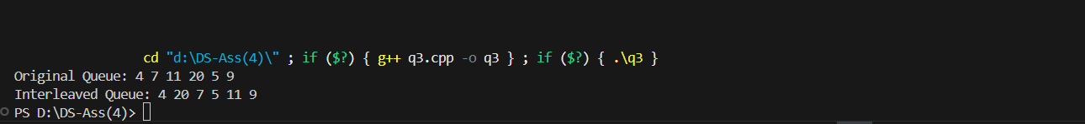

q4.)

#include <iostream>
#include <vector>
#include <queue>

using namespace std;

int countStudentsUnableToEat(vector<int>& students, vector<int>& sandwiches) {
queue<int> student_q;
for (size_t i = 0; i < students.size(); ++i) {
student_q.push(students[i]);
}

int sandwich_idx = 0;
int rotations_without_eating = 0;

while (!student_q.empty() && rotations_without_eating < student_q.size()) {
if (student_q.front() == sandwiches[sandwich_idx]) {
student_q.pop();
sandwich_idx++;
rotations_without_eating = 0;
} else {
student_q.push(student_q.front());
student_q.pop();
rotations_without_eating++;
}
}

return student_q.size();
}

int main() {

// Case 1
int students1_arr[] = {1, 1, 0, 0};
int sandwiches1_arr[] = {0, 1, 0, 1};
vector<int> students1(students1_arr, students1_arr + 4);
vector<int> sandwiches1(sandwiches1_arr, sandwiches1_arr + 4);

cout << "Students unable to eat (Case 1): "
<< countStudentsUnableToEat(students1, sandwiches1) << endl;

// Case 2
int students2_arr[] = {1, 1, 1, 0, 0, 1};
int sandwiches2_arr[] = {1, 0, 0, 0, 1, 1};
vector<int> students2(students2_arr, students2_arr + 6);
vector<int> sandwiches2(sandwiches2_arr, sandwiches2_arr + 6);

cout << "Students unable to eat (Case 2): "
<< countStudentsUnableToEat(students2, sandwiches2) << endl;

return 0;
}

Output->

