Question-1)

#include <iostream>
#include <vector>
#include <algorithm>

using namespace std;

void printVector(const vector<int>& arr) {
// Using a traditional for loop for C++98 compatibility
for (size_t i = 0; i < arr.size(); ++i) {
cout << arr[i] << " ";
}
cout << "\n";
}

void selectionSort(vector<int>& arr) {
int n = arr.size();
for (int i = 0; i < n; ++i) {
int min_idx = i;
for (int j = i + 1; j < n; ++j) {
if (arr[j] < arr[min_idx]) {
min_idx = j;
}
}
swap(arr[i], arr[min_idx]);
}
}

void insertionSort(vector<int>& arr) {
int n = arr.size();
for (int i = 0; i < n; ++i) {
int key = arr[i];
int j = i - 1;
while (j >= 0 && arr[j] > key) {
arr[j + 1] = arr[j];
j = j - 1;
}
arr[j + 1] = key;
}
}

void bubbleSort(vector<int>& arr) {
int n = arr.size();
for (int i = 0; i < n; ++i) {
bool swapped = false;
for (int j = 0; j < n - i - 1; ++j) {
if (arr[j] > arr[j + 1]) {
swap(arr[j], arr[j + 1]);
swapped = true;
}
}
if (swapped == false)
break;
}
}

void merge(vector<int>& arr, int l, int m, int r) {
int n1 = m - l + 1;
int n2 = r - m;

vector<int> L(n1);
vector<int> R(n2);

for (int i = 0; i < n1; i++)
L[i] = arr[l + i];
for (int j = 0; j < n2; j++)
R[j] = arr[m + 1 + j];

int i = 0;
int j = 0;
int k = l;

while (i < n1 && j < n2) {
if (L[i] <= R[j]) {
arr[k] = L[i];
i++;
} else {
arr[k] = R[j];
j++;
}
k++;
}

while (i < n1) {
arr[k] = L[i];
i++;
k++;
}

while (j < n2) {
arr[k] = R[j];
j++;
k++;
}
}

void mergeSort(vector<int>& arr, int l, int r) {
if (l >= r) {
return;
}
int m = l + (r - l) / 2;

mergeSort(arr, l, m);
mergeSort(arr, m + 1, r);

merge(arr, l, m, r);
}

void mergeSortWrapper(vector<int>& arr) {
mergeSort(arr, 0, arr.size() - 1);
}

int partition(vector<int>& arr, int low, int high) {
int pivot = arr[high];
int i = (low - 1);

for (int j = low; j <= high - 1; j++) {
if (arr[j] < pivot) {
i++;
swap(arr[i], arr[j]);
}
}
swap(arr[i + 1], arr[high]);
return (i + 1);
}

void quickSort(vector<int>& arr, int low, int high) {
if (low < high) {
int pi = partition(arr, low, high);

quickSort(arr, low, pi - 1);
quickSort(arr, pi + 1, high);
}
}

void quickSortWrapper(vector<int>& arr) {
quickSort(arr, 0, arr.size() - 1);
}

int main() {
// C++98 compatible initialization: define array, then construct vector
int data_array[] = {64, 25, 12, 22, 11, 78, 33};
int array_size = sizeof(data_array) / sizeof(data_array[0]);
vector<int> original_data(data_array, data_array + array_size);

vector<int> current_arr;

cout << "--- Sorting Algorithm Demonstrations ---\n\n";

current_arr = original_data;
cout << "1. Selection Sort:\n";
cout << "Original array: ";
printVector(current_arr);
selectionSort(current_arr);
cout << "Sorted array: ";
printVector(current_arr);
cout << "--------------------------------------\n";

current_arr = original_data;
cout << "2. Insertion Sort:\n";
cout << "Original array: ";
printVector(current_arr);
insertionSort(current_arr);
cout << "Sorted array: ";
printVector(current_arr);
cout << "--------------------------------------\n";

current_arr = original_data;
cout << "3. Bubble Sort:\n";
cout << "Original array: ";
printVector(current_arr);
bubbleSort(current_arr);
cout << "Sorted array: ";
printVector(current_arr);
cout << "--------------------------------------\n";

current_arr = original_data;
cout << "4. Merge Sort:\n";
cout << "Original array: ";
printVector(current_arr);
mergeSortWrapper(current_arr);
cout << "Sorted array: ";
printVector(current_arr);
cout << "--------------------------------------\n";

current_arr = original_data;
cout << "5. Quick Sort:\n";
cout << "Original array: ";
printVector(current_arr);
quickSortWrapper(current_arr);
cout << "Sorted array: ";
printVector(current_arr);
cout << "--------------------------------------\n";

return 0;
}

Output-)
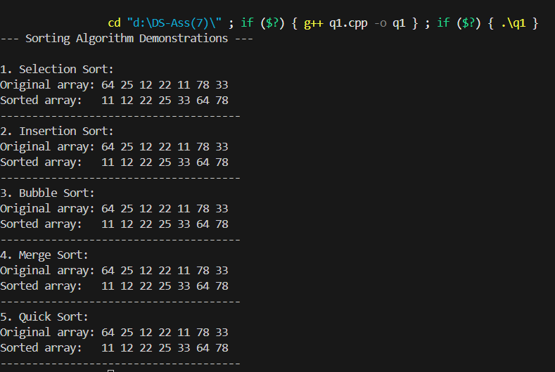

Question-2)
#include <iostream>
#include <vector>
#include <algorithm>

using namespace std;

void printVector(const vector<int>& arr) {
for (size_t i = 0; i < arr.size(); ++i) {
cout << arr[i] << " ";
}
cout << "\n";
}

void selectionSort(vector<int>& arr) {
int n = arr.size();
int left = 0;
int right = n - 1;

while (left < right) {
int min_idx = left;
int max_idx = left;

for (int i = left + 1; i <= right; ++i) {
if (arr[i] < arr[min_idx]) {
min_idx = i;
}
if (arr[i] > arr[max_idx]) {
max_idx = i;
}
}

swap(arr[left], arr[min_idx]);

if (max_idx == left) {
max_idx = min_idx;
}

swap(arr[right], arr[max_idx]);

left++;
right--;
}
}

int main() {
int data_array[] = {64, 25, 12, 22, 11, 78, 33};
int array_size = sizeof(data_array) / sizeof(data_array[0]);
vector<int> original_data(data_array, data_array + array_size);

vector<int> current_arr = original_data;

cout << "--- Bidirectional Selection Sort Demonstration ---\n\n";

cout << "Original array: ";
printVector(current_arr);

selectionSort(current_arr);

cout << "Sorted array: ";
printVector(current_arr);
cout << "--------------------------------------------------\n";

return 0;
}

Output->
