Q1.)
#include <iostream>
#include <vector>

using namespace std;

// Node structure for the Binary Tree
struct Node {
int data;
Node* left;
Node* right;
};

// Function to create a new Node (C++98 compatible)
Node* newNode(int data) {
Node* node = new Node;
node->data = data;
node->left = NULL;
node->right = NULL;
return node;
}

// 1. Pre-order Traversal (Root -> Left -> Right)
void printPreorder(Node* node) {
if (node == NULL)
return;

cout << node->data << " ";
printPreorder(node->left);
printPreorder(node->right);
}

// 2. In-order Traversal (Left -> Root -> Right)
void printInorder(Node* node) {
if (node == NULL)
return;

printInorder(node->left);
cout << node->data << " ";
printInorder(node->right);
}

// 3. Post-order Traversal (Left -> Right -> Root)
void printPostorder(Node* node) {
if (node == NULL)
return;

printPostorder(node->left);
printPostorder(node->right);
cout << node->data << " ";
}

int main() {
// Constructing a sample tree:
// 1
// / \
// 2 3
// / \
// 4 5
Node* root = newNode(1);
root->left = newNode(2);
root->right = newNode(3);
root->left->left = newNode(4);
root->left->right = newNode(5);

cout << "--- Binary Tree Traversals (Recursive) ---\n\n";

cout << "Pre-order traversal: ";
printPreorder(root);
cout << "\n";

cout << "In-order traversal: ";
printInorder(root);
cout << "\n";

cout << "Post-order traversal: ";
printPostorder(root);
cout << "\n";

// Clean up memory (optional, but good practice)
delete root->left->left;
delete root->left->right;
delete root->left;
delete root->right;
delete root;

return 0;
}

Output->
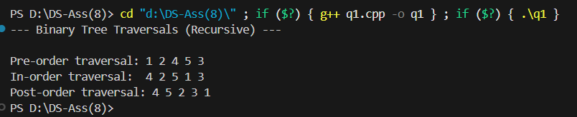

Q2.)
#include <iostream>
#include <vector>
#include <algorithm>
#include <cstdlib>

using namespace std;

struct Node {
int data;
Node* left;
Node* right;
};

Node* newNode(int data) {
Node* node = new Node;
node->data = data;
node->left = NULL;
node->right = NULL;
return node;
}

Node* insert(Node* node, int data) {
if (node == NULL)
return newNode(data);

if (data < node->data)
node->left = insert(node->left, data);
else if (data > node->data)
node->right = insert(node->right, data);

return node;
}

// 2(a) Search a given item (Recursive)
bool searchRecursive(Node* root, int data) {
if (root == NULL)
return false;
if (root->data == data)
return true;
if (data < root->data)
return searchRecursive(root->left, data);

return searchRecursive(root->right, data);
}

// 2(a) Search a given item (Non-Recursive)
bool searchIterative(Node* root, int data) {
Node* current = root;
while (current != NULL) {
if (current->data == data)
return true;
if (data < current->data)
current = current->left;
else
current = current->right;
}
return false;
}

// 2(c) Minimum element of the BST
Node* findMin(Node* node) {
Node* current = node;
while (current && current->left != NULL)
current = current->left;
return current;
}

// 2(b) Maximum element of the BST
Node* findMax(Node* node) {
Node* current = node;
while (current && current->right != NULL)
current = current->right;
return current;
}

// 2(d) In-order successor of a given node
Node* getSuccessor(Node* root, Node* target) {
// Case 1: If right subtree is not NULL, successor is the minimum in the right subtree
if (target->right != NULL) {
return findMin(target->right);
}

// Case 2: Successor is one of the ancestors
Node* successor = NULL;
Node* current = root;

while (current != NULL) {
if (target->data < current->data) {
successor = current; // Current node is a potential successor
current = current->left;
} else if (target->data > current->data) {
current = current->right;
} else {
break; // Found the target node
}
}
return successor;
}

// 2(e) In-order predecessor of a given node
Node* getPredecessor(Node* root, Node* target) {
// Case 1: If left subtree is not NULL, predecessor is the maximum in the left subtree
if (target->left != NULL) {
return findMax(target->left);
}

// Case 2: Predecessor is one of the ancestors
Node* predecessor = NULL;
Node* current = root;

while (current != NULL) {
if (target->data > current->data) {
predecessor = current; // Current node is a potential predecessor
current = current->right;
} else if (target->data < current->data) {
current = current->left;
} else {
break; // Found the target node
}
}
return predecessor;
}

void printInorder(Node* node) {
if (node == NULL) return;
printInorder(node->left);
cout << node->data << " ";
printInorder(node->right);
}

int main() {
Node* root = NULL;

// Build a BST
root = insert(root, 50);
insert(root, 30);
insert(root, 20);
Node* target_node_40 = insert(root, 40); // Node 40 for successor/predecessor tests
insert(root, 70);
Node* target_node_60 = insert(root, 60); // Node 60 for testing Case 1 successor
insert(root, 80);

cout << "--- BST Query Operations (2) ---\n\n";

cout << "BST (In-order traversal): ";
printInorder(root);
cout << "\n\n";

// Search (2a)
int search_val = 40;
cout << "Search (" << search_val << "): Recursive: " << (searchRecursive(root, search_val) ? "Found" : "Not Found");
cout << ", Iterative: " << (searchIterative(root, search_val) ? "Found" : "Not Found") << "\n";
search_val = 99;
cout << "Search (" << search_val << "): Recursive: " << (searchRecursive(root, search_val) ? "Found" : "Not Found");
cout << ", Iterative: " << (searchIterative(root, search_val) ? "Found" : "Not Found") << "\n\n";

// Min/Max elements (2b, 2c)
Node* minNode = findMin(root);
Node* maxNode = findMax(root);
cout << "Minimum element: " << (minNode ? minNode->data : -1) << "\n"; // Should be 20
cout << "Maximum element: " << (maxNode ? maxNode->data : -1) << "\n\n"; // Should be 80

// Successor/Predecessor (2d, 2e)
cout << "Target node for successor/predecessor is: " << target_node_40->data << "\n"; // 40
Node* successor = getSuccessor(root, target_node_40);
Node* predecessor = getPredecessor(root, target_node_40);
cout << "In-order successor: " << (successor ? successor->data : -1) << "\n"; // Should be 50
cout << "In-order predecessor: " << (predecessor ? predecessor->data : -1) << "\n\n"; // Should be 30

cout << "Target node for successor/predecessor is: " << target_node_60->data << "\n"; // 60
Node* successor2 = getSuccessor(root, target_node_60);
Node* predecessor2 = getPredecessor(root, target_node_60);
cout << "In-order successor: " << (successor2 ? successor2->data : -1) << "\n"; // Should be 70
cout << "In-order predecessor: " << (predecessor2 ? predecessor2->data : -1) << "\n\n"; // Should be 50

return 0;
}

Output->
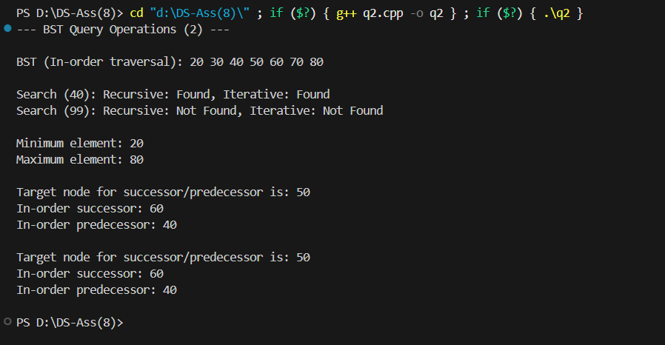

Q3.)
#include <iostream>
#include <vector>
#include <algorithm>
#include <cstdlib>

using namespace std;

struct Node {
int data;
Node* left;
Node* right;
};

Node* newNode(int data) {
Node* node = new Node;
node->data = data;
node->left = NULL;
node->right = NULL;
return node;
}

// Helper to find the minimum node (used by delete)
Node* findMin(Node* node) {
Node* current = node;
while (current && current->left != NULL)
current = current->left;
return current;
}

// 3(a) Insert an element
Node* insert(Node* node, int data) {
if (node == NULL)
return newNode(data);

if (data < node->data)
node->left = insert(node->left, data);
else if (data > node->data)
node->right = insert(node->right, data);

return node;
}

// 3(b) Delete an existing element
Node* deleteNode(Node* root, int data) {
if (root == NULL) return root;

if (data < root->data) {
root->left = deleteNode(root->left, data);
} else if (data > root->data) {
root->right = deleteNode(root->right, data);
} else {
// Case 1 & 2: Node with only one child or no child
if (root->left == NULL) {
Node* temp = root->right;
delete root;
return temp;
} else if (root->right == NULL) {
Node* temp = root->left;
delete root;
return temp;
}

// Case 3: Node with two children (replace with in-order successor)
Node* temp = findMin(root->right);
root->data = temp->data;
root->right = deleteNode(root->right, temp->data);
}
return root;
}

// 3(c) Maximum depth of BST
int maxDepth(Node* node) {
if (node == NULL)
return 0;

int leftDepth = maxDepth(node->left);
int rightDepth = maxDepth(node->right);

return (leftDepth > rightDepth ? leftDepth : rightDepth) + 1;
}

// 3(d) Minimum depth of BST
int minDepth(Node* node) {
if (node == NULL)
return 0;

if (node->left == NULL && node->right == NULL)
return 1;

if (node->left == NULL)
return minDepth(node->right) + 1;

if (node->right == NULL)
return minDepth(node->left) + 1;

int leftDepth = minDepth(node->left);
int rightDepth = minDepth(node->right);

return (leftDepth < rightDepth ? leftDepth : rightDepth) + 1;
}

void printInorder(Node* node) {
if (node == NULL) return;
printInorder(node->left);
cout << node->data << " ";
printInorder(node->right);
}

int main() {
Node* root = NULL;

cout << "--- BST Structure and Depth Operations (3) ---\n\n";

// Insert operations (3a)
root = insert(root, 50);
insert(root, 30);
insert(root, 70);
insert(root, 20);
insert(root, 40);
insert(root, 60);
insert(root, 80);

cout << "BST (In-order traversal after insertions): ";
printInorder(root);
cout << "\n\n";

// Depth (3c, 3d)
cout << "Maximum Depth: " << maxDepth(root) << "\n";
cout << "Minimum Depth: " << minDepth(root) << "\n\n";

// Delete operation (3b)
int delete_val = 70;
cout << "Deleting " << delete_val << "...\n";
root = deleteNode(root, delete_val);
cout << "BST (In-order after deletion): ";
printInorder(root);
cout << "\n";

// Recalculate depth after deletion
cout << "New Maximum Depth: " << maxDepth(root) << "\n";
cout << "New Minimum Depth: " << minDepth(root) << "\n";

return 0;
}

Output->
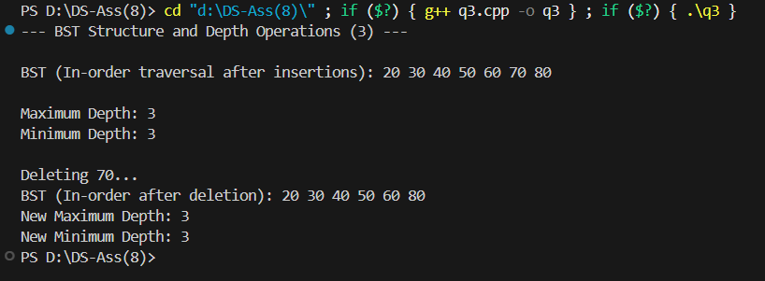

Q4.)
#include <iostream>
#include <vector>

using namespace std;

// Node structure
struct Node {
int data;
Node* left;
Node* right;
};

// Function to create a new Node (C++98 compatible)
Node* newNode(int data) {
Node* node = new Node;
node->data = data;
node->left = NULL;
node->right = NULL;
return node;
}

// Helper function to check if a tree is a BST within a given range [min, max]
bool isBSTUtil(Node* node, int min_val, int max_val) {
if (node == NULL)
return true;

// Check if the current node's value is outside the allowed range
if (node->data < min_val || node->data > max_val)
return false;

// Recursively check the left subtree, updating the max constraint to node->data - 1
// Recursively check the right subtree, updating the min constraint to node->data + 1
return isBSTUtil(node->left, min_val, node->data - 1) &&
isBSTUtil(node->right, node->data + 1, max_val);
}

// Main function to check if a binary tree is a BST
bool isBST(Node* node) {
// The range must be large enough to accommodate all possible int values.
// In C++98, INT_MIN and INT_MAX are available in <limits> or <climits>.
// Using a sufficiently large range here for simplicity.
return isBSTUtil(node, -999999, 999999);
}

int main() {
cout << "--- Determine If Binary Tree Is BST ---\n\n";

// Test Case 1: A valid BST
Node* root1 = newNode(4);
root1->left = newNode(2);
root1->right = newNode(5);
root1->left->left = newNode(1);
root1->left->right = newNode(3);

cout << "Test Case 1 (Valid BST):\n";
if (isBST(root1))
cout << "Result: The tree IS a BST.\n";
else
cout << "Result: The tree is NOT a BST.\n";

cout << "------------------------------------------\n";

// Test Case 2: An invalid BST (5 is in the left subtree of 4)
Node* root2 = newNode(3);
root2->left = newNode(2);
root2->right = newNode(5);
root2->left->right = newNode(4); // Invalid: 4 > 3, but is in the left subtree

cout << "Test Case 2 (Invalid BST):\n";
if (isBST(root2))
cout << "Result: The tree IS a BST.\n";
else
cout << "Result: The tree is NOT a BST.\n";

return 0;
}

Output->
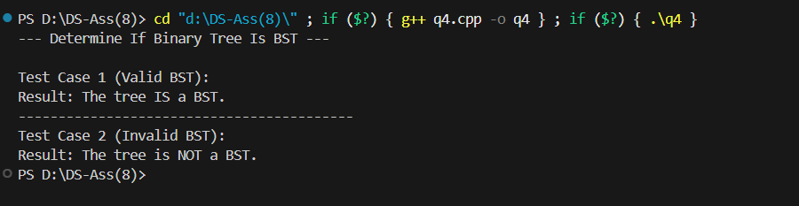

Q5.)
#include <iostream>
#include <vector>
#include <algorithm>

using namespace std;

void heapify(vector<int>& arr, int n, int i) {
int largest = i;
int l = 2 * i + 1;
int r = 2 * i + 2;

if (l < n && arr[l] > arr[largest])
largest = l;

if (r < n && arr[r] > arr[largest])
largest = r;

if (largest != i) {
swap(arr[i], arr[largest]);

heapify(arr, n, largest);
}
}

void heapSort(vector<int>& arr) {
int n = arr.size();

for (int i = n / 2 - 1; i >= 0; i--)
heapify(arr, n, i);

for (int i = n - 1; i >= 0; i--) {
swap(arr[0], arr[i]);

heapify(arr, i, 0);
}
}

void printVector(const vector<int>& arr) {
for (size_t i = 0; i < arr.size(); ++i) {
cout << arr[i] << " ";
}
cout << "\n";
}

int main() {
int data_array[] = {12, 11, 13, 5, 6, 7};
int array_size = sizeof(data_array) / sizeof(data_array[0]);
vector<int> arr(data_array, data_array + array_size);

cout << "--- Heapsort (Ascending Order) ---\n\n";

cout << "Original array: ";
printVector(arr);

heapSort(arr);

cout << "Sorted array: ";
printVector(arr);

return 0;
}

Output->
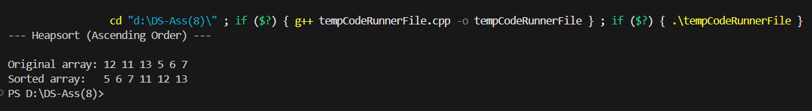

Q6.)
#include <iostream>
#include <vector>
#include <algorithm>
#include <stdexcept> // For runtime_error

using namespace std;

class PriorityQueue {
private:
vector<int> heap;

// Function to maintain the Max-Heap property
void heapifyDown(int i) {
int n = heap.size();
int largest = i;
int l = 2 * i + 1;
int r = 2 * i + 2;

if (l < n && heap[l] > heap[largest])
largest = l;

if (r < n && heap[r] > heap[largest])
largest = r;

if (largest != i) {
swap(heap[i], heap[largest]);
heapifyDown(largest);
}
}

// Helper to fix the heap property upwards after insertion
void heapifyUp(int i) {
while (i > 0 && heap[(i - 1) / 2] < heap[i]) {
swap(heap[i], heap[(i - 1) / 2]);
i = (i - 1) / 2;
}
}

public:
PriorityQueue() {
// Default constructor
}

// Insert an element into the Priority Queue
void insert(int value) {
heap.push_back(value);
heapifyUp(heap.size() - 1);
}

// Extract the maximum element
int extractMax() {
if (heap.empty()) {
throw runtime_error("Priority Queue is empty");
}

int max_val = heap[0];

// Move the last element to the root
heap[0] = heap.back();
heap.pop_back();

// Restore the Max-Heap property
heapifyDown(0);

return max_val;
}

// Get the maximum element without removing it
int getMax() {
if (heap.empty()) {
throw runtime_error("Priority Queue is empty");
}
return heap[0];
}

// Check if the priority queue is empty
bool isEmpty() {
return heap.empty();
}
};

int main() {
PriorityQueue pq;

cout << "--- Priority Queue using Max-Heap ---\n\n";

// Insert elements
pq.insert(10);
pq.insert(50);
pq.insert(20);
pq.insert(5);
pq.insert(100);

cout << "After inserting 10, 50, 20, 5, 100:\n";
try {
cout << "Max element (peek): " << pq.getMax() << "\n";
} catch (const std::runtime_error& e) {
cout << "Error: " << e.what() << "\n";
}

cout << "\nExtracting elements (Highest priority first):\n";
while (!pq.isEmpty()) {
try {
cout << "Extracted: " << pq.extractMax() << "\n";
} catch (const std::runtime_error& e) {
cout << "Error: " << e.what() << "\n";
}
}

return 0;
}

Output->

