Project Report
On
Computer Networking: Concepts (CSE3751)

Smart City Traffic Surveillance Network

Submitted by:

Name1 Regd. No : 23410
Name2 Regd. No : 23410
Name3 Regd. No : 23410
Name4 Regd. No : 23410
Name5 Regd. No : 23410
B. Tech. CSE 5th Semester (Section XYZ)

INSTITUTE OF TECHNICAL EDUCATION AND RESEARCH
(FACULTY OF ENGINEERING)
SIKSHA ‘O’ ANUSANDHAN (DEEMED TO BE UNIVERSITY), BHUBANESWAR, ODISHA

i

Declaration

We, the undersigned students of B. Tech. of CSE Department hereby declare that we own the full responsibility for the information, results etc. provided in this PROJECT titled “Smart City Traffic Surveillance Network” submitted to Siksha ‘O’ Anusandhan (Deemed to be University), Bhubaneswar for the partial fulfillment of the subject Computer Networking: Concepts (CSE 3751). We have taken care in all respect to honor the intellectual property right and have acknowledged the contribution of others for using them in academic purpose and further declare that in case of any violation of intellectual property right or copyright we, as the candidate(s), will be fully responsible for the same.

Name 1 Regd. No : 23410

Name 2 Regd. No : 23410

Name 3 Regd. No : 23410

Name 4 Regd. No : 23410

Name 5 Regd. No : 23410

Date:

Place: Bhubaneswar

Abstract
With the rapid growth of urbanization, effective traffic monitoring and control have become essential for smart city development. This project focuses on the design and implementation of a centralized Smart City Traffic Surveillance Network using Cisco Packet Tracer. The city is divided into four zones—East, West, North, and South—each equipped with IP-based traffic surveillance cameras connected through segregated local area networks. All surveillance data is transmitted to a Central Monitoring Centre (CMC), where traffic authorities can monitor, analyse, and store information. The network is designed using static routing to enable inter-zonal communication and centralized data flow. Dynamic Host Configuration Protocol (DHCP) is implemented for automatic IP address allocation, ensuring scalability and ease of management. Static Network Address Translation (NAT) is configured to allow secure communication between the CMC and vehicle owners through the public network for alerts and notifications. The proposed network ensures secure, scalable, and efficient traffic monitoring, demonstrating key networking concepts such as segmentation, routing, DHCP, and NAT in a realistic smart city scenario.

Contents

Serial  No. | Chapter No. | Title of the Chapter | Page No.
1. | 1 | Introduction | 1
2. | 2 | Problem Statement | 2
3. | 3 | Methodology | 3 - 4
4. | 4 | Results and interpretation | 5-7
5. | 5 | Conclusion | 8
6. |  | References | 9

- Introduction

With the rapid growth of urban population and increasing number of vehicles, managing traffic efficiently has become a major challenge for modern cities. Traditional traffic monitoring systems rely heavily on manual observation and lack real-time data analysis, which often leads to congestion, delayed responses to traffic violations, and inefficient traffic control. To overcome these challenges, smart city concepts make use of networking technologies, automation, and centralized monitoring systems to improve traffic surveillance and management.

This project presents the design and implementation of a Smart City Traffic Surveillance Network using Cisco Packet Tracer. The proposed system divides the city into four distinct traffic zones, namely East Zone, West Zone, North Zone, and South Zone. Each zone is equipped with IP-based traffic surveillance cameras connected through a local area network. These cameras continuously transmit traffic-related information to a Central Monitoring Centre (CMC), where traffic authorities can monitor live traffic conditions and store surveillance data for further analysis.

The network architecture is designed with proper segmentation to ensure organized and secure communication between different zones. Static routing is used to enable inter-zonal communication and controlled data flow through the central router. To simplify network management and improve scalability, Dynamic Host Configuration Protocol (DHCP) is implemented to automatically assign IP addresses to cameras and end devices across all zones.

Additionally, the project demonstrates communication between the CMC and vehicle owners through a public network using Static Network Address Translation (NAT). This allows traffic alerts, route modification messages, or penalty notifications to be accessed securely by vehicle owners using a public IP address. The entire network is tested and verified using simulation tools provided by Cisco Packet Tracer to ensure proper connectivity, routing, and data transmission.

Overall, this project provides a practical understanding of core computer networking concepts such as IP addressing, routing, DHCP, NAT, and network segmentation, while simulating a realistic smart city traffic surveillance scenario.
2. Problem Statement

I. Problem statement with identification of objects.
The objective of this project is to design and implement a centralized Smart City Traffic Surveillance Network using Cisco Packet Tracer. The network should enable traffic surveillance data from multiple city zones to be transmitted to a Central Monitoring Centre (CMC) and allow controlled communication with vehicle owners through a public network.
The implementation considers the following objects:
- Routers for inter-zone and external communication
- Switches for local area network connectivity
- IP-based cameras to represent traffic surveillance devices
- Central Monitoring Server for data monitoring and DHCP services
- Public router and vehicle owner PC to simulate external communication
- Networking services including static routing, DHCP, and static NAT

II. Highlighting the constraints (if any).
• The project is implemented as a simulation using Cisco Packet Tracer.
• IP cameras are used only for representation; real-time video streaming is not implemented.
• Security mechanisms such as firewalls and encryption are not included.
• Static routing is used instead of dynamic routing protocols for simplicity.
• Public network behavior is simulated using a router.

3. Methodology

I. Designing the Topology
The first step of the project involves designing a logical and scalable network topology that represents a smart city traffic surveillance system. The city is divided into four traffic zones: East Zone, West Zone, North Zone, and South Zone. Each zone contains IP-based traffic surveillance cameras connected to a local switch, which in turn connects to a zone-specific router. This design ensures proper network segmentation and prevents unnecessary traffic between zones.
All zone routers are connected to a central core switch, forming a backbone network that allows communication between different zones and the Central Monitoring Centre (CMC). The CMC consists of a monitoring server connected to the CMC router, which acts as the central point for data collection, monitoring, and control. To simulate real-world communication with vehicle owners, the CMC router is connected to a public router, representing an external or public network. This hierarchical topology improves manageability, scalability, and centralized control.

II. Configuring the devices.
After designing the topology, all networking devices are configured with appropriate IP addressing based on predefined subnets for each zone. Router interfaces are configured and enabled to allow data transmission between networks. Static routing is implemented on all routers to ensure controlled and predictable communication between zones and the CMC.
The Central Monitoring Server is configured to act as a DHCP server, enabling automatic IP address allocation for IP cameras and other end devices in all zones. DHCP relay (IP helper address) is configured on zone routers to forward DHCP requests from different subnets to the centralized DHCP server. Static Network Address Translation (NAT) is implemented on the CMC router to allow communication between the private CMC network and the public network, enabling vehicle owners to receive alerts or access information securely.

III. CLI instructions to attend the required objective.
Command Line Interface (CLI) is used extensively to configure routers and verify network operations. CLI commands are executed to assign IP addresses to router interfaces, enable and verify static routing, configure DHCP relay, and implement static NAT. Verification commands such as ping are used to test end-to-end connectivity, while show ip route confirms correct routing table entries. Commands like show ip interface brief are used to check interface status, and show ip nat translations is used to verify NAT functionality. These CLI-based configurations and verification steps ensure that all project objectives are met and that the network operates as intended.

4. Results & Interpretation
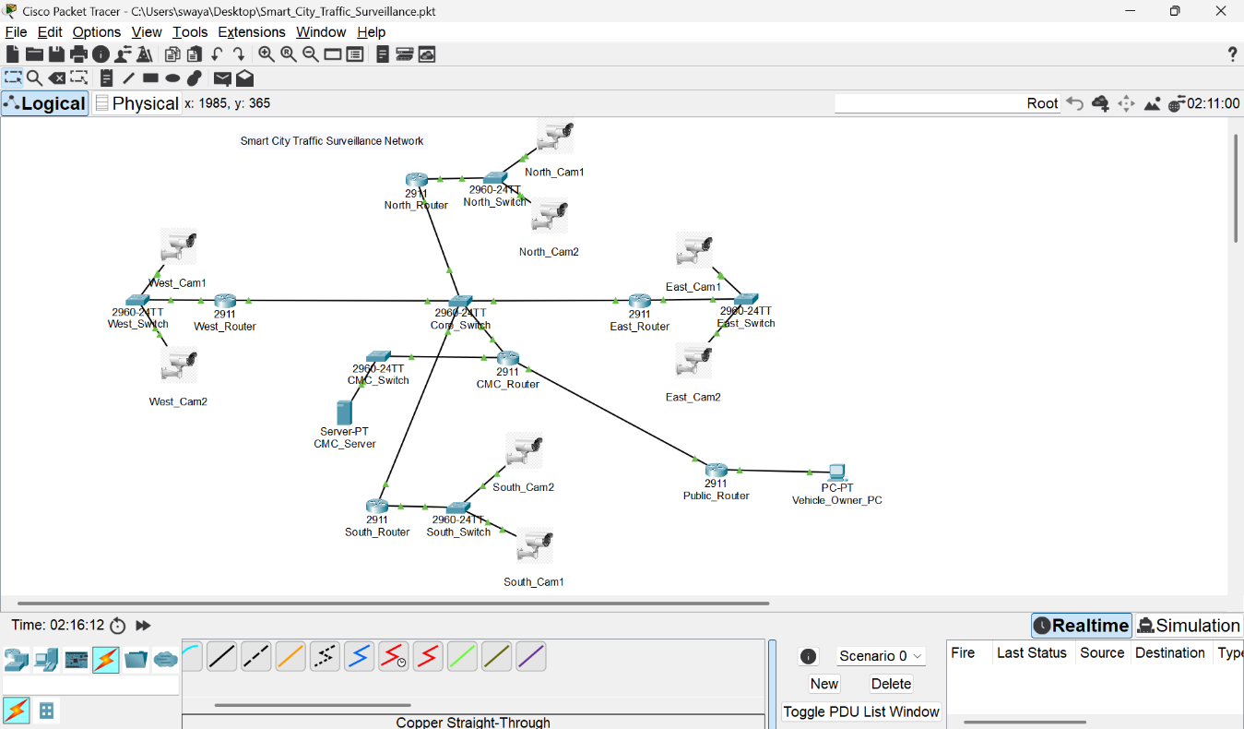
Screenshot–1: Final Network Topology
Figure 1 : shows the complete Smart City Traffic Surveillance Network topology designed in Cisco Packet Tracer. All city zones are connected to the Central Monitoring Centre through a core network, ensuring proper segmentation and centralized monitoring.
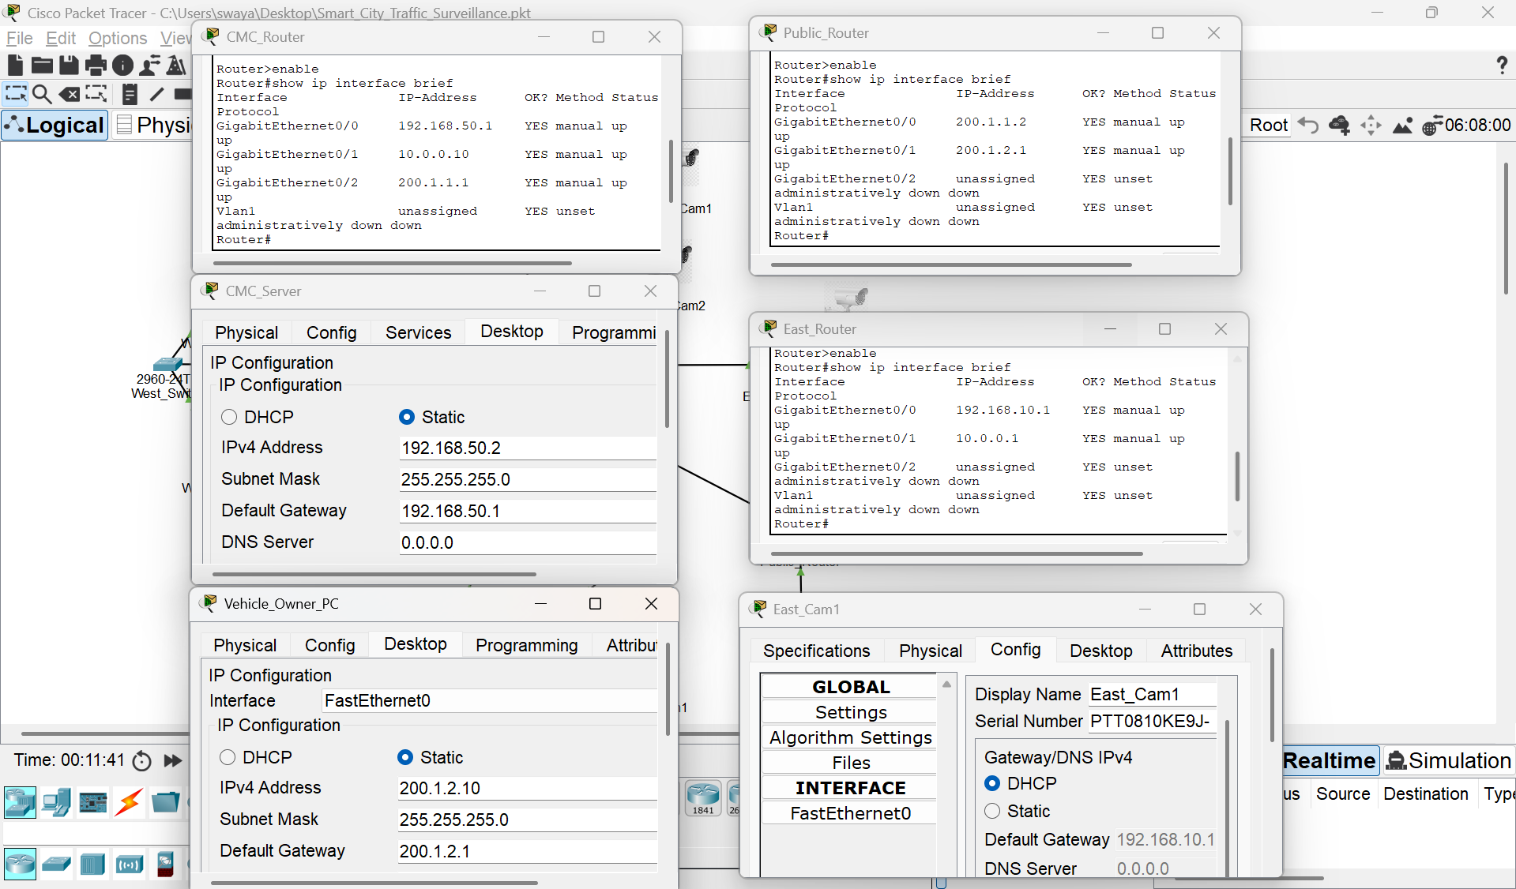
Screenshot–2: IP Address Configuration and Interface Status Verification
Figure 2 : shows the IP address configuration and interface status of key network devices including the CMC Router, Public Router, Zone Router, CMC Server, IP Camera, and Vehicle Owner PC. The screenshot confirms that all devices are correctly configured with appropriate IP addresses, subnet masks, and default gateways, and that active interfaces are in an operational (up) state.
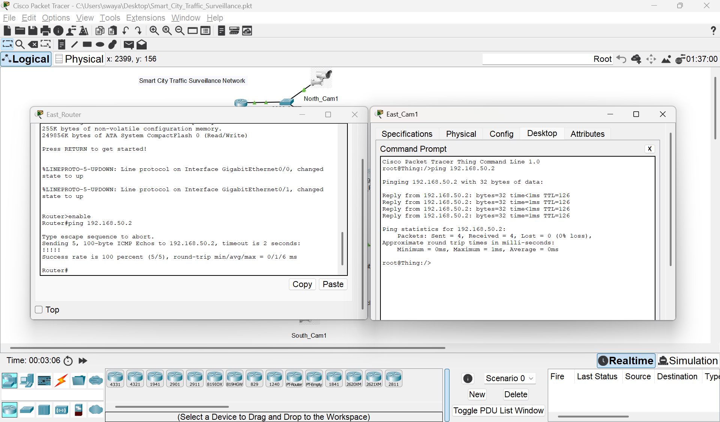
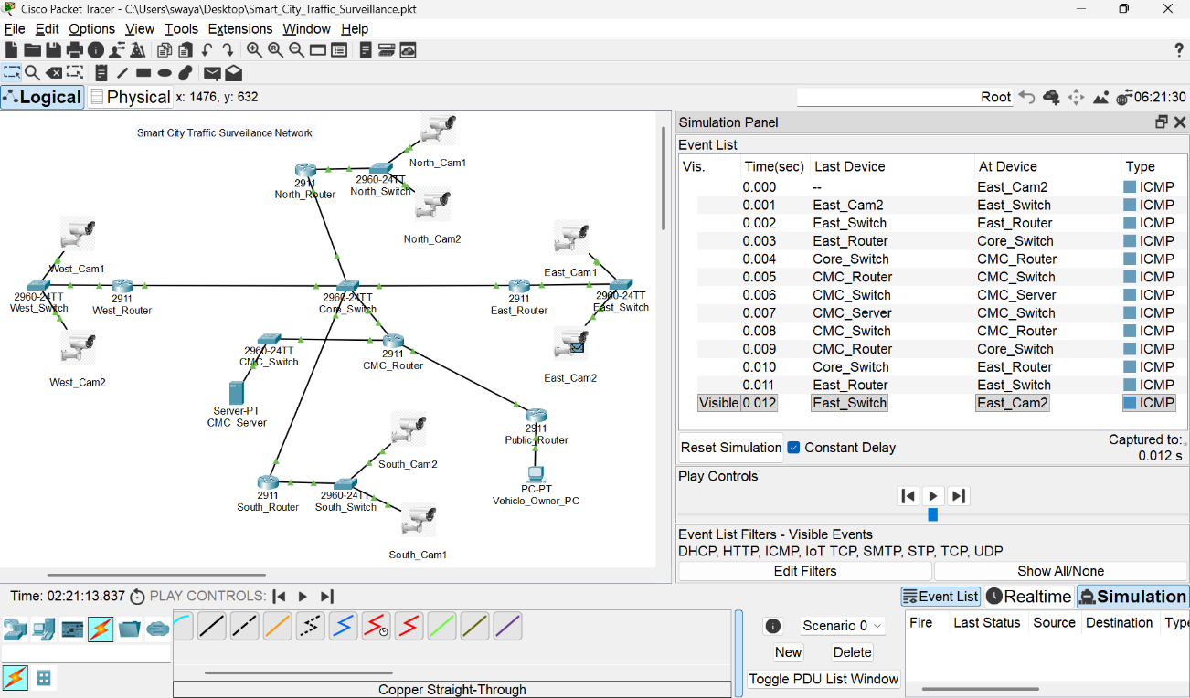
Screenshot–3: Packet Flow in Simulation Mode Screenshot–4: Ping Output (Zone → CMC)
Figure 4 : shows successful ICMP communication between a traffic surveillance device and the Central Monitoring Server, confirming inter-zone connectivity.
Figure 3 : illustrates the successful transmission of packets from an IP-based camera to the Central Monitoring Server, demonstrating proper routing and centralized data flow.
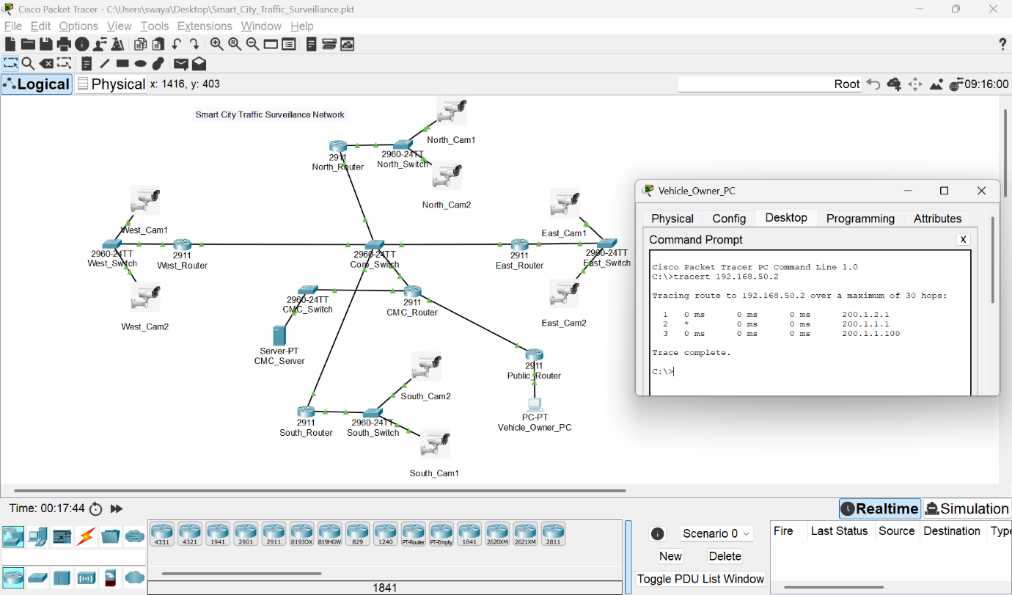
Screenshot–5: Traceroute Output Showing Packet Path
Figure 5 : shows the traceroute output indicating the path taken by packets from the vehicle owner network to the Central Monitoring Server through intermediate routing devices.
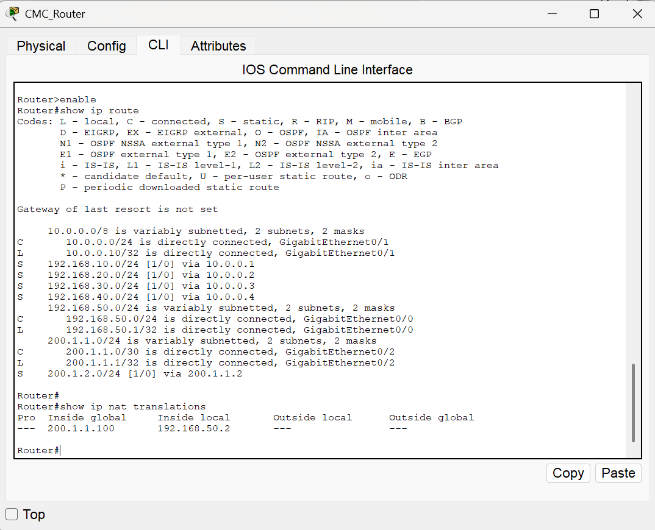
Screenshot–6: Routing Table and NAT Verification

Figure 6 : confirms the presence of static routing entries enabling communication between different city zones and the Central Monitoring Centre. The same screenshot also shows the static NAT translation that enables communication between the private CMC network and the public network.
5. Conclusion

This project successfully demonstrates the design and implementation of a Smart City Traffic Surveillance Network using Cisco Packet Tracer. The city was logically divided into multiple traffic zones, each equipped with IP-based surveillance devices, ensuring proper network segmentation and organized traffic monitoring. A Central Monitoring Centre (CMC) was implemented to collect and manage surveillance data from all zones, enabling centralized control and efficient traffic supervision.
Core networking concepts such as IP addressing, static routing, DHCP, and static Network Address Translation (NAT) were effectively implemented and verified. Static routing enabled reliable inter-zonal communication, while DHCP simplified network management by automating IP address allocation. Static NAT allowed secure communication between the private CMC network and the public network, simulating real-world access by vehicle owners.
The successful transmission of packets, verified through ping, traceroute, simulation mode, and CLI outputs, confirms that the network operates as intended. Overall, this project provides a practical understanding of essential computer networking concepts and demonstrates how they can be applied to a realistic smart city traffic surveillance scenario.

References

[1] G. D. Singh, CompTIA Network+ N10-008 Certification Guide, 2nd ed., Birmingham, U.K.: Packt Publishing, 2022.
[2] Cisco Networking Academy, Introduction to Networks, Cisco Systems, Inc., 2023. [Online]. Available: https://www.netacad.com
[3] Cisco Systems, Inc., Cisco Packet Tracer – Networking Simulation Tool, Cisco Networking Academy. [Online]. Available: https://www.netacad.com/courses/packet-tracer
[4] A. S. Tanenbaum and D. J. Wetherall, Computer Networks, 5th ed., Pearson Education, 2011.

