Computer Networking: Concepts Experiment 6

PART 1 — FIXED-LENGTH SUBNETTING
Given Network: 172.16.0.0/24
Required Subnets:
- Subnet A: 40 hosts
- Subnet B: 20 hosts
- Subnet C: 10 hosts
- Subnet D: 5 hosts

❗ Fixed-length subnetting means all subnets must be of equal size.

Step 1 — Determine Subnet Size
We need the largest host requirement → 40 hosts.
Formula:
Hosts = 2^h – 2 ≥ 40
2^6 – 2 = 62 → OK
So we need 6 host bits, leaving:
Prefix = 32 – 6 = /26
Subnet mask = 255.255.255.192
Each subnet size = 2⁶ = 64 addresses per subnet

Step 2 — Create Subnets of /26
Subnet | Network Address | First Host | Last Host | Broadcast
A | 172.16.0.0/26 | 172.16.0.1 | 172.16.0.62 | 172.16.0.63
B | 172.16.0.64/26 | 172.16.0.65 | 172.16.0.126 | 172.16.0.127
C | 172.16.0.128/26 | 172.16.0.129 | 172.16.0.190 | 172.16.0.191
D | 172.16.0.192/26 | 172.16.0.193 | 172.16.0.254 | 172.16.0.255

Step 3 — Packet Tracer Topology
Use:
- 1 Router
- 4 Switches
- Multiple PCs in each subnet
To add new interfaces (Extra Ports)

Drag the Router to the Workspace
- From Devices → Routers
- Choose Cisco 2911
- Drag onto the workspace.

Power OFF the Router
You cannot insert modules while powered on.
- Click the router
- Go to the Physical tab
- Find the Power button (left side → switch)
- Click it → It turns red (OFF)

Choose a Module to Add
Common modules for extra ports:
Module Name | Ports Added | Purpose
HWIC-2T | 2 Serial ports | WAN/Serial links
HWIC-4ESW | 4 FastEthernet switch ports | LAN expansion
HWIC-1GE-SFP | 1 GigE | High-speed port
NIM-ES2-4 | 4 Ethernet ports | Newer PT versions
For subnetting labs, the HWIC-4ESW is the easiest and most used.

Insert the Module
- In the router’s Physical tab, you’ll see empty HWIC slots.
- Drag the module (e.g., HWIC-4ESW) from the left panel
- Drop it into an empty slot.
You will see the module appear with new ports like:
Fa0/0
Fa0/1
Fa0/2
Fa0/3

Power ON the Router
- Click the same power switch
- It turns green (ON)

Go to CLI and Verify Ports
Open CLI → type:
show ip interface brief
You should now see the new interfaces.
Connect:

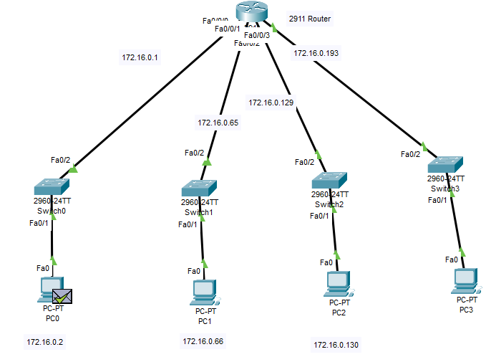

Step 4 — Router Configuration
Example for Router:
enable
configure terminal

interface g0/0
ip address 172.16.0.1 255.255.255.192
no shutdown

interface g0/1
ip address 172.16.0.65 255.255.255.192
no shutdown

interface g0/2
ip address 172.16.0.129 255.255.255.192
no shutdown

interface g0/3
ip address 172.16.0.193 255.255.255.192
no shutdown
Since a single router is used, routing is automatic (no static routes needed).

Step 5 — PC Configuration Example
PC in Subnet A:
IP: 172.16.0.10
Mask: 255.255.255.192
Gateway: 172.16.0.1
Repeat for all PCs.

Step 6 — Verification
Ping across subnets:
PC-A → PC-B
PC-A → PC-C
PC-A → PC-D
All pings should succeed.

PART 2 — VLSM

We use the same network 172.16.0.0/24, but assign subnet sizes based on host counts.
Host requirements:
- A → 40
- B → 20
- C → 10
- D → 5

Step 1 — Sort by host size
- A = 40 hosts → needs /26 (62 hosts)
- B = 20 hosts → /27 (30 hosts)
- C = 10 hosts → /28 (14 hosts)
- D = 5 hosts → /29 (6 hosts)

Step 2 — Allocate Subnets (largest first)

✔ Subnet A (40 hosts) → /26
172.16.0.0/26
Range: 172.16.0.1 – 172.16.0.62
Broadcast: 172.16.0.63

✔ Subnet B (20 hosts) → /27
Next available block starts at 172.16.0.64
172.16.0.64/27
Range: 172.16.0.65 – 172.16.0.94
Broadcast: 172.16.0.95

✔ Subnet C (10 hosts) → /28
Next block starts at 172.16.0.96
172.16.0.96/28
Range: 172.16.0.97 – 172.16.0.110
Broadcast: 172.16.0.111

✔ Subnet D (5 hosts) → /29
Next block starts at 172.16.0.112
172.16.0.112/29
Range: 172.16.0.113 – 172.16.0.118
Broadcast: 172.16.0.119

Step 3 — Router Interface Assignment
Do same as previous

Step 4 — Configure PCs
Example for Subnet C:
IP: 172.16.0.100
Mask: 255.255.255.240
Gateway: 172.16.0.97

Step 5 — Verify With Ping
All hosts must successfully ping across all networks.

