**HTML Assignments**

Name: Swayam Chandak

VIT-CSAI

Experiment 1- HTML web-page and form

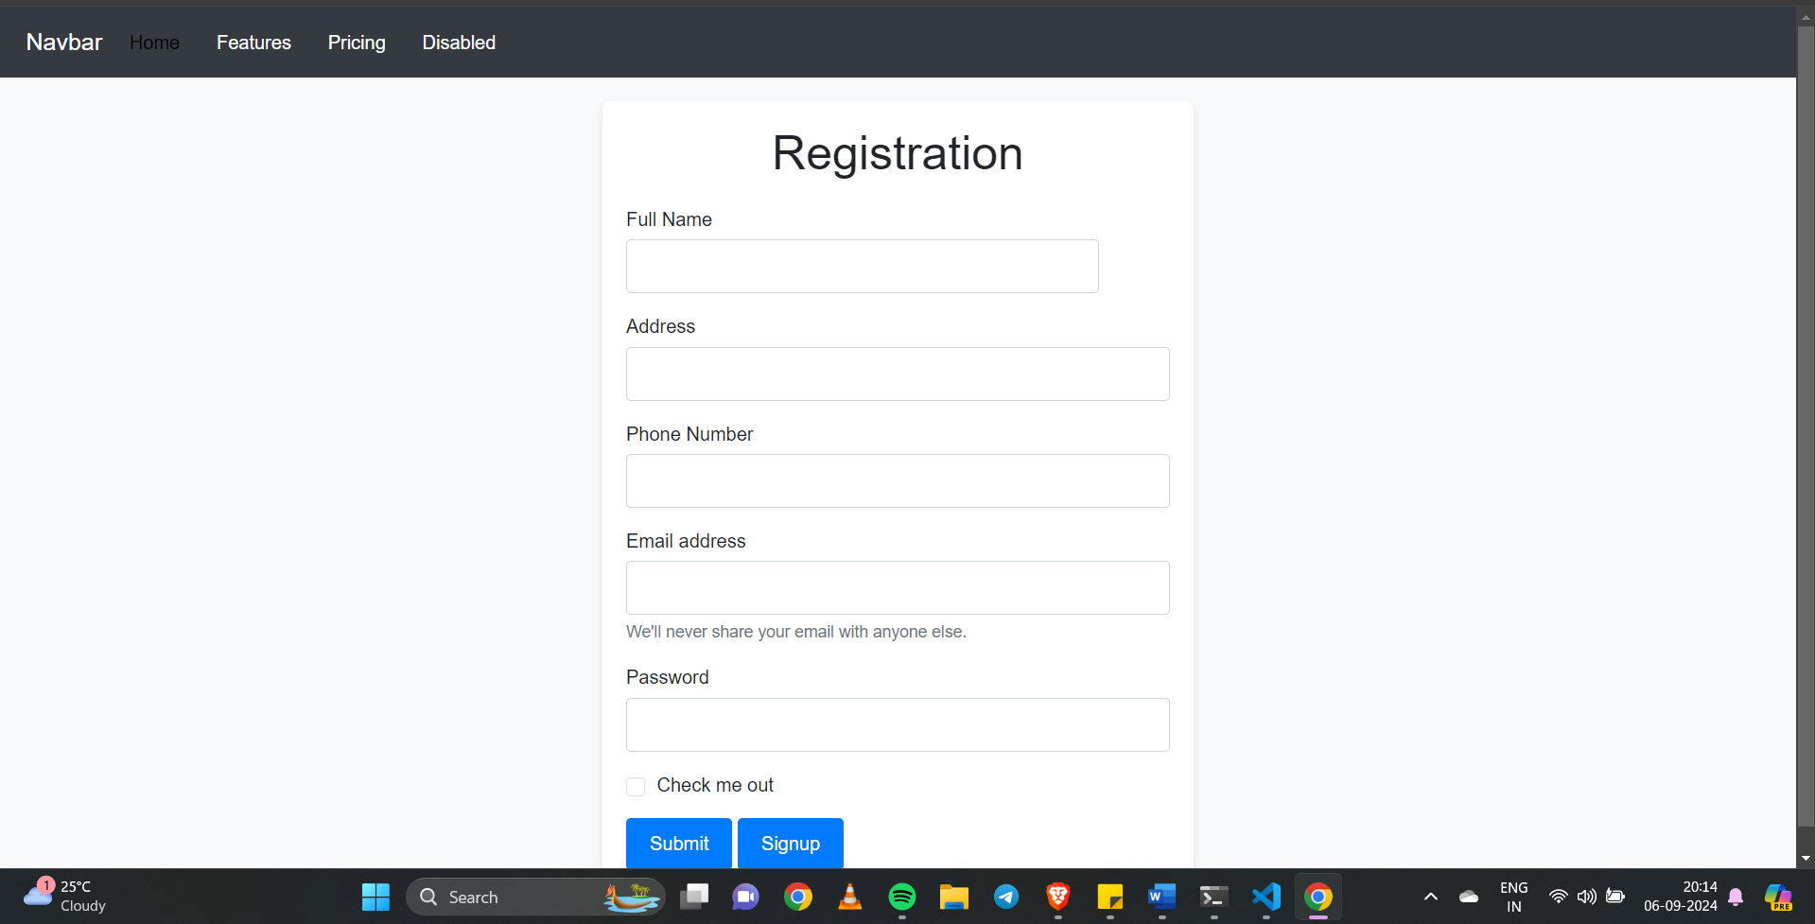

Exercise 2- A Multimedia and canvas web application

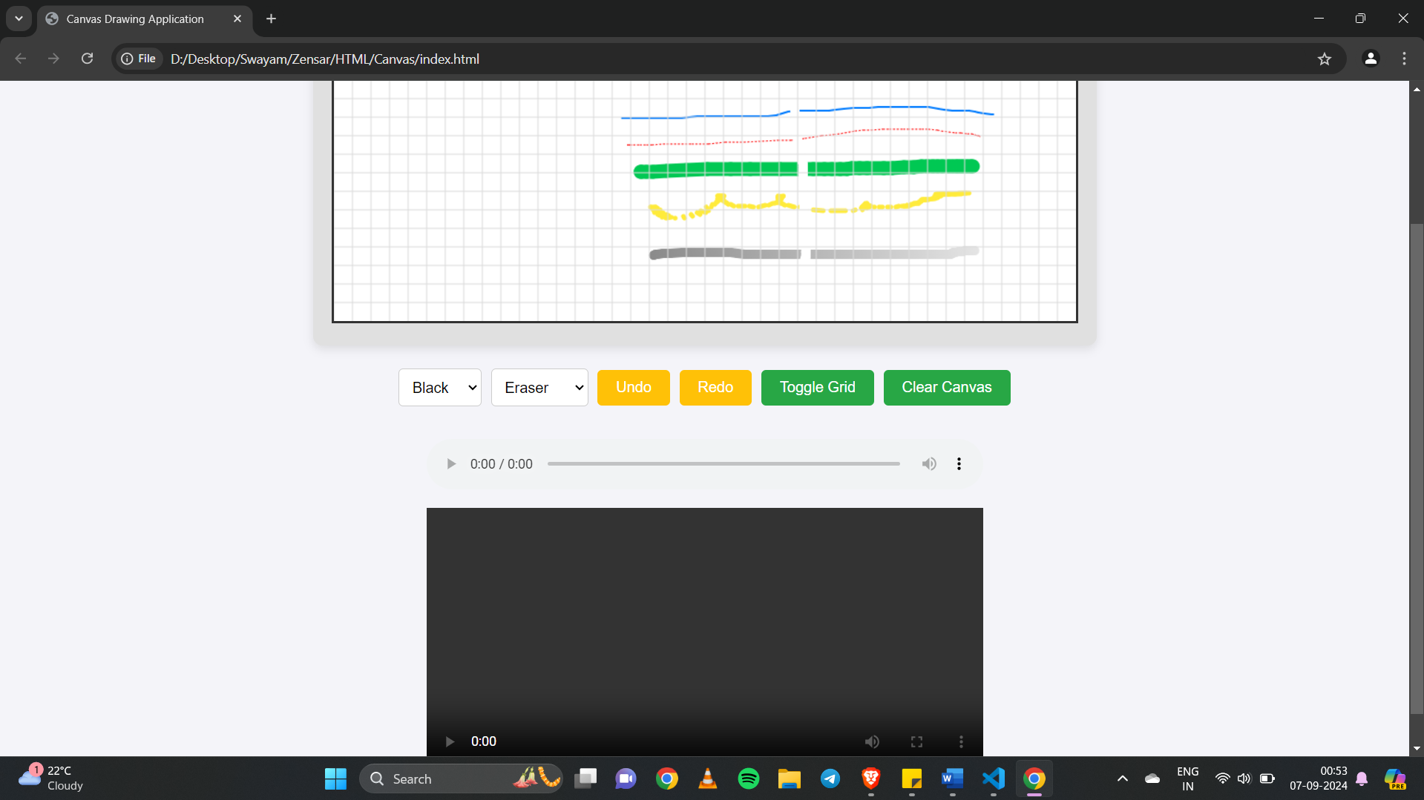

A multipurpose web canvas that has multiple functionalities.  
Different colours, as well as different pens are available as well.

There is an area to play a pre uploaded video below the canvas as well.

Exercise 3- Responsive Webpage

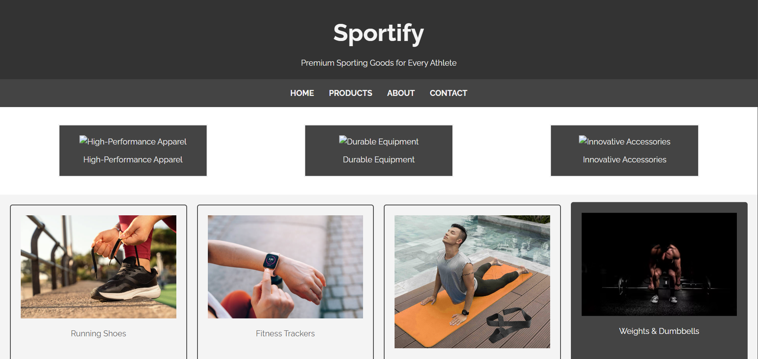

Exercise 4- TO-DO List

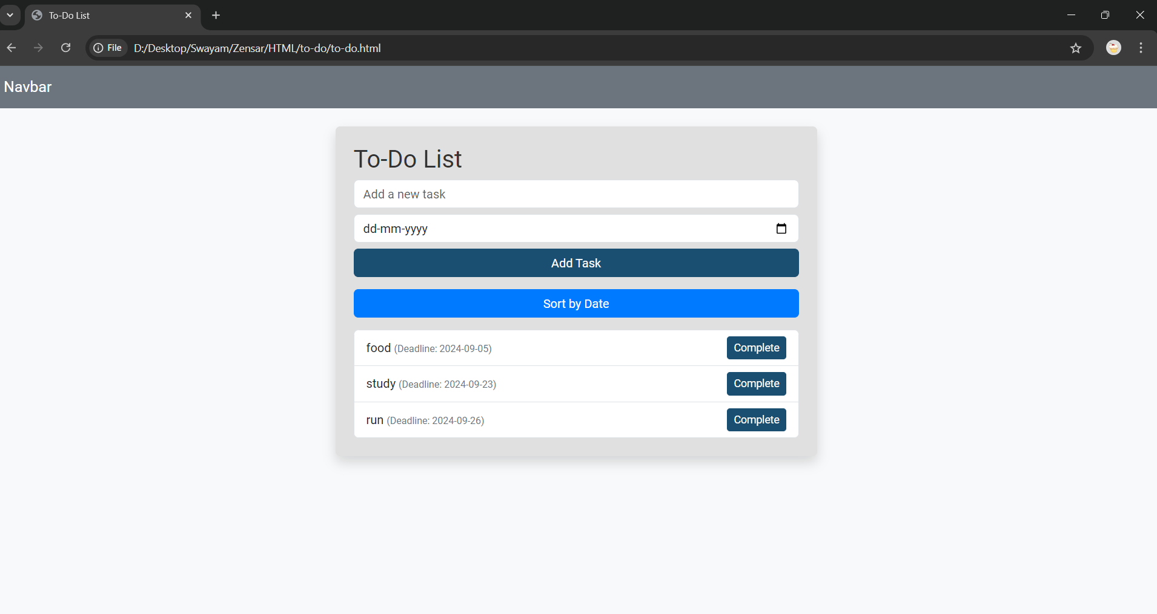

This responsive to-do list has the ability to sort tasks by date, putting the task with the earliest deadline first.   
Animation has been added to the task completion button while removing the task.

A local storage has been created for the to do list to save the progress offline as and when the changes are made in list. When the list is reopened, we can continue where we left off from.