EXPERIMENT 8
Explainable AI in Healthcare for Model Interpretation

1. Aim
To apply Explainable AI (XAI) techniques, specifically SHAP, on a cardiovascular disease prediction model (XGBoost) in order to interpret model predictions, identify influential features and build clinician trust in AI systems.

2. Objectives
- To train an XGBoost model on a cardiovascular disease dataset.
- To evaluate the model using accuracy, classification report and confusion matrix.
- To explain the model globally using the SHAP summary plot.
- To explain an individual patient's prediction using the SHAP force plot.

3. Software, Libraries and Dataset
Item | Details
Language / Platform | Python 3, Google Colab (GPU)
Libraries | pandas, NumPy, Matplotlib, Seaborn, XGBoost, scikit-learn, SHAP, kagglehub
Dataset | Cardiovascular Disease dataset – sulianova/cardiovascular-disease-dataset (Kaggle)
Size | 70,000 records, 13 attributes: id, age (days), gender, height, weight, ap_hi, ap_lo, cholesterol, gluc, smoke, alco, active, cardio
Target | cardio (0 = no cardiovascular disease, 1 = disease), classes are balanced

4. Theory
Explainable AI (XAI) is a set of techniques that make the working of AI models understandable to humans. In healthcare it is important because model predictions influence critical medical decisions; doctors must understand why a model made a prediction, so that they can trust it, check it against medical knowledge and meet regulatory and ethical requirements.
XGBoost is a gradient-boosted decision-tree algorithm that is very accurate but acts like a black box.
SHAP (SHapley Additive exPlanations) is based on Shapley values from cooperative game theory. It gives every feature a SHAP value for every prediction: a positive value pushes the prediction towards disease, a negative value pushes it away. The TreeExplainer in SHAP is a model-specific method designed for tree-based models such as XGBoost and Random Forest.
- Global explanation (summary plot): shows which features are important overall and how their values (high/low) affect the output.
- Local explanation (force plot): shows how each feature of one patient moves the prediction from the base value to the final output.

5. Procedure / Algorithm
- Download and load the cardiovascular disease dataset.
- Drop the id column, check missing values and split the data into 80% training and 20% testing sets.
- Plot the correlation heatmap and the distribution of the target.
- Train the XGBoost model (100 rounds) and compute accuracy and the classification report.
- Plot the confusion matrix.
- Create a SHAP TreeExplainer and plot the summary plot on a sample of test data.
- Plot the SHAP force plot for a single test patient.

6. Implementation (Code and Output)
Step 1: Download the dataset
Code:
import kagglehub
path = kagglehub.dataset_download("sulianova/cardiovascular-disease-dataset")
print("Path to dataset files:", path)
Output:

Step 2: Import the libraries
Code:
import pandas as pd
import numpy as np
import matplotlib.pyplot as plt
import seaborn as sns
from sklearn.model_selection import train_test_split
from sklearn.ensemble import RandomForestClassifier
from sklearn.metrics import classification_report, confusion_matrix, accuracy_score
import shap

Step 3: Load the dataset and display the first records
Code:
df = pd.read_csv("/root/.cache/kagglehub/datasets/sulianova/cardiovascular-disease-dataset/versions/1/cardio_train.csv", sep=';')
print("Shape of dataset:", df.shape)
df.head()
Output:
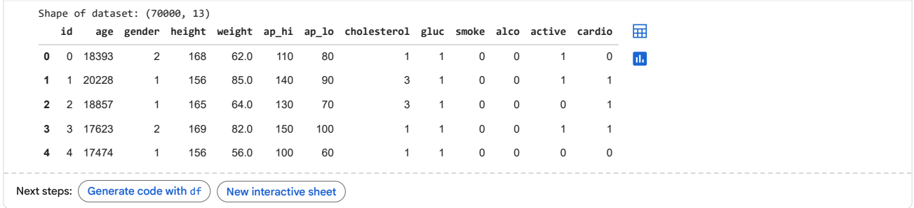

Step 4: Drop the id column, check missing values and split into training and testing sets
Code:
df = df.drop(columns=['id'], errors='ignore')
print("Missing values:\n", df.isnull().sum())
X = df.drop(columns=['cardio'])
y = df['cardio']

X_train, X_test, y_train, y_test = train_test_split(X, y, test_size=0.2, random_state=42)
Output:
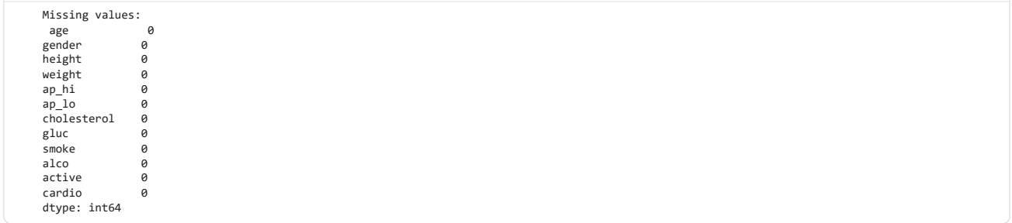

Step 5: Correlation heatmap and distribution of the target variable
Code:
plt.figure(figsize=(10,8))
sns.heatmap(df.corr(), cmap="coolwarm", annot=False)
plt.title("Feature Correlation Heatmap")
plt.show()
sns.countplot(x='cardio', data=df, palette='Set2')
plt.title("Distribution of Cardiovascular Disease (0 = No, 1 = Yes)")
plt.show()
Output:
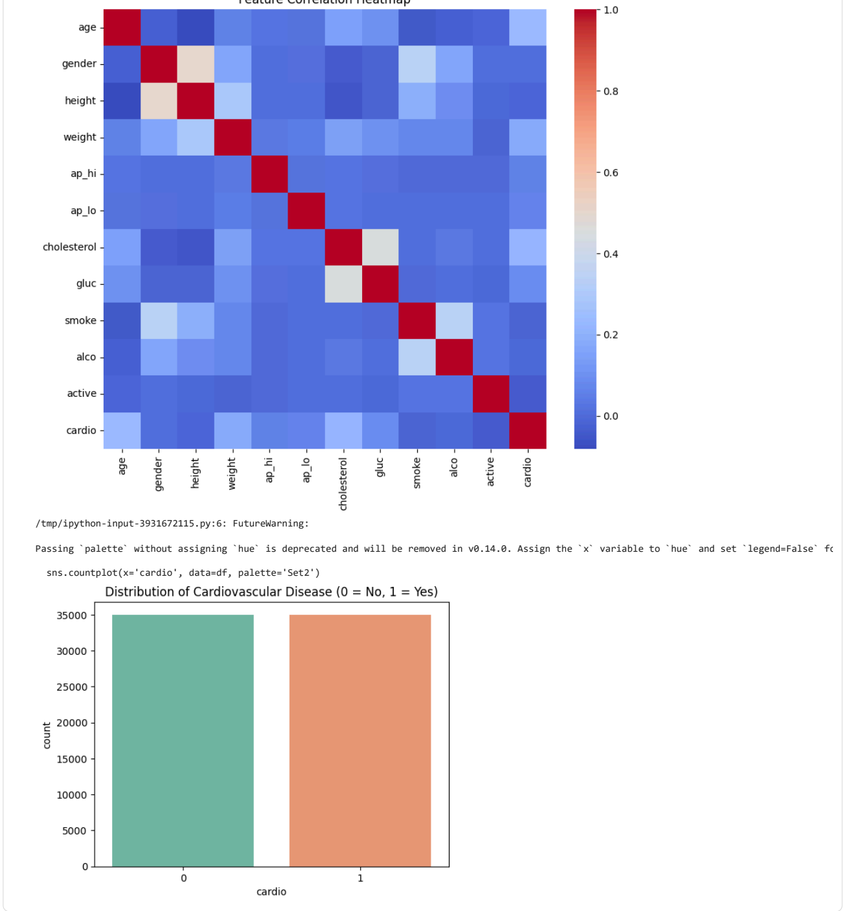

Step 6: Train the XGBoost model and evaluate it
Code:
import xgboost as xgb
from sklearn.metrics import accuracy_score, classification_report
dtrain = xgb.DMatrix(X_train, label=y_train)
dtest = xgb.DMatrix(X_test, label=y_test)

params = {
'tree_method': 'gpu_hist',
'predictor': 'gpu_predictor',
'objective': 'binary:logistic',
'seed': 42,
'verbosity': 1
}

num_round = 100
model = xgb.train(params, dtrain, num_round)
y_proba = model.predict(dtest)
y_pred = (y_proba >= 0.5).astype(int)
print("Accuracy:", accuracy_score(y_test, y_pred))
print("\nClassification Report:\n", classification_report(y_test, y_pred))
Output:
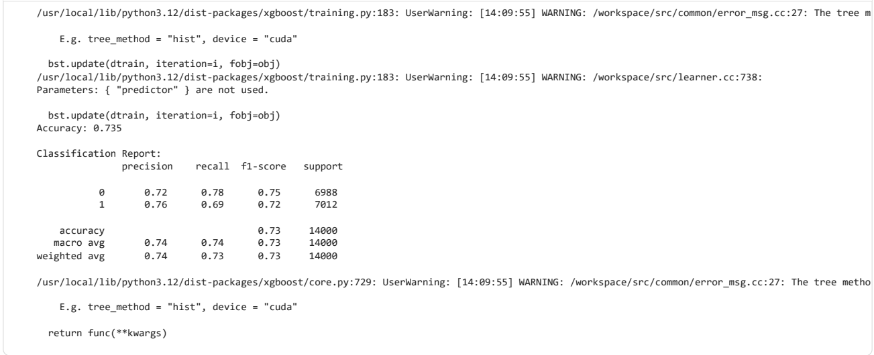

Step 7: Confusion matrix
Code:
cm = confusion_matrix(y_test, y_pred)
sns.heatmap(cm, annot=True, fmt='d', cmap='Blues')
plt.xlabel("Predicted")
plt.ylabel("Actual")
plt.title("Confusion Matrix")
plt.show()
Output:
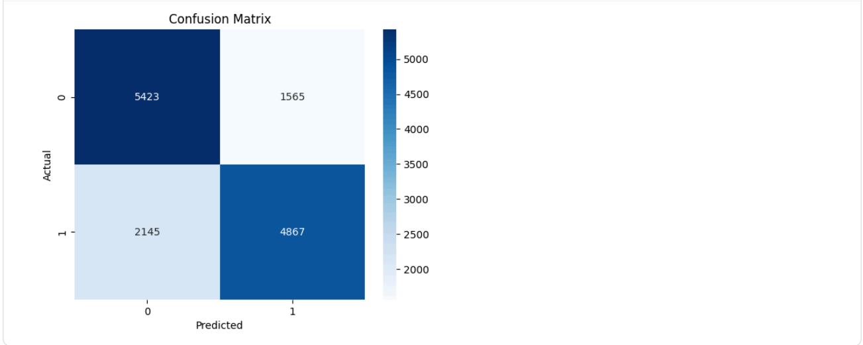

Step 8: SHAP summary plot (global explanation)
Code:
import numpy as np
import shap

explainer = shap.TreeExplainer(model)

sample_size = 10000 if len(X_test) > 10000 else len(X_test)
sample_indices = np.random.choice(X_test.index, size=sample_size, replace=False)
X_test_sample = X_test.loc[sample_indices]
dtest_sample = xgb.DMatrix(X_test_sample)
shap_values_sample = explainer.shap_values(dtest_sample)

shap.summary_plot(shap_values_sample, X_test_sample, feature_names=X_test.columns, max_display=10)
Output:
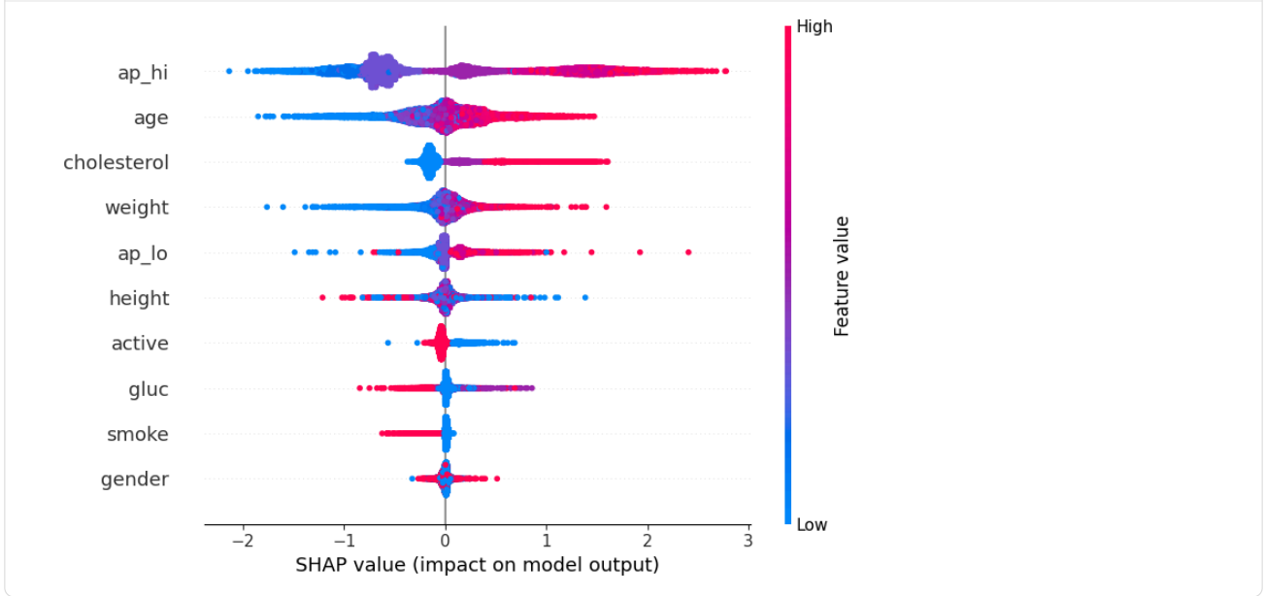

Step 9: SHAP force plot for a single patient (local explanation)
Code:
import xgboost as xgb
import shap
X_test_single = X_test.iloc[[i]]
dtest_single = xgb.DMatrix(X_test_single)

print("Predicted:", (model.predict(dtest_single) >= 0.5).astype(int))
print("True label:", y_test.iloc[i])
shap_values_single = explainer.shap_values(dtest_single)
shap.force_plot(explainer.expected_value, shap_values_single, X_test_single, matplotlib=True)
Output:
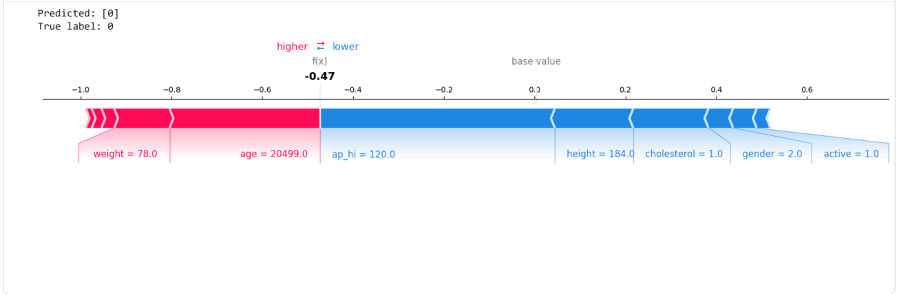

7. Observations and Result
- The dataset has 70,000 records and no missing values; the two classes are balanced (about 35,000 each). The target is most correlated with age, cholesterol, weight and blood pressure.
- The XGBoost model reached an accuracy of 73.5% on 14,000 test records: class 0 (no disease) precision 0.72, recall 0.78, F1 0.75; class 1 (disease) precision 0.76, recall 0.69, F1 0.72.
- Confusion matrix: 5,423 true negatives, 1,565 false positives, 2,145 false negatives and 4,867 true positives.
- The SHAP summary plot ranks systolic blood pressure (ap_hi) as the most influential feature, followed by age, cholesterol, weight, diastolic blood pressure (ap_lo), height, physical activity, glucose, smoking and gender. High blood pressure, age and cholesterol values increase the predicted risk, while high physical activity lowers it – this matches medical knowledge.
- The force plot of the selected patient shows a model output of −0.47, i.e. predicted class 0 (no disease), which equals the true label; weight and age push the output towards disease while blood pressure (120), height and cholesterol push it away.

8. Conclusion
Explainable AI ensures that healthcare models are not just accurate but also transparent, interpretable and trustworthy. Using SHAP on the XGBoost model, the most influential risk factors (blood pressure, age and cholesterol) were identified globally and the prediction for a single patient was explained, so that clinicians can use AI predictions for disease diagnosis and risk prediction with confidence.

