INTRODUCTION TO ECONOMICS · MONSOON 2026 · MEMBER 4 SECTION PACKET
The Foreign Exchange Rate
Real-world applications: what moves the rupee, why it matters, and what happens when a currency collapses
Sections | 7 What moves the rupee? · 8 Why exchange rates matter for India · D When currencies collapse: crises in South Asia
Main text | 7: 497 words · 8: 341 words · D: 520 words (total 1358)
Figures | M4-1 to M4-4 (PNG, 300 dpi, in figures/; editable source in source/)
Tables | M4-1 What moves the rupee · M4-2 Three currency crises compared
Boxes | How economists learn from facts · Real-life example · Worked example · When economists disagree
Handover | Key terms · Questions and answers · Box answer key · Further learning · References · Cross-references · Notes for the team
Builds on | Members 1–3; see Member4_Prerequisites_from_Members_1-3.md

7 What moves the rupee?
Main text: 497 words (budget about 450)
Newspapers report the rupee’s movements almost every day: ‘Rupee falls 30 paise against the dollar’. Behind each such headline sits the model from [see: How the exchange rate is determined: demand and supply]. Whenever the rupee moves, ask one question: did something change the demand for dollars, the supply of dollars, or both?
Figure M4-1 traces the rupee since 1991. The line climbs from about ₹18 per US dollar to about ₹95, a level first crossed in 2026 (Shivalkar, 2026). Long, quiet stretches are broken by sudden jumps, and each jump has a story behind it.
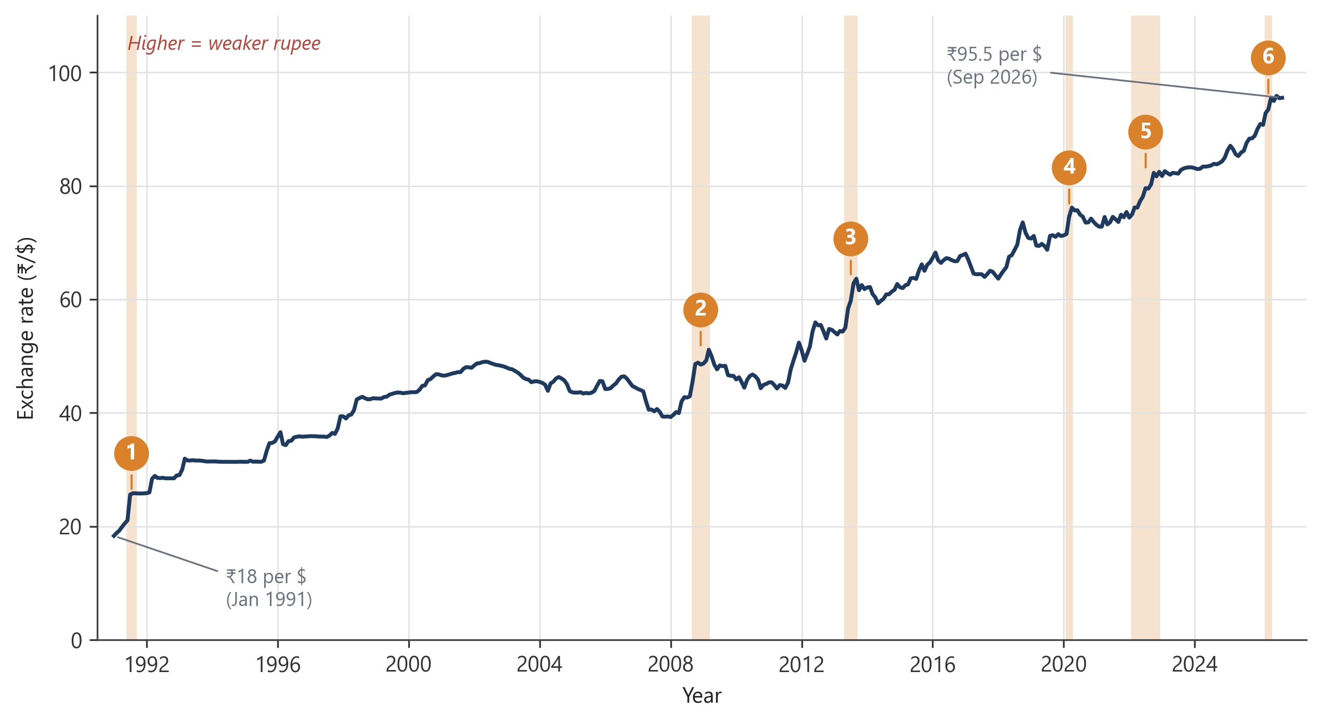
Figure M4-1 The rupee against the US dollar, January 1991 to September 2026
Each point is the average exchange rate for one month. A rise in the line means it takes more rupees to buy one dollar, so the rupee has weakened. The shaded bands, numbered 1 to 6, mark six sharp falls in the rupee. The box ‘Reading the rupee’s history’ asks you to identify them.
Source: Board of Governors of the Federal Reserve System (2026a), Indian rupees to U.S. dollar spot exchange rate [EXINUS], monthly averages, retrieved from FRED, Federal Reserve Bank of St. Louis, 1 November 2026.
The slow part of the climb is mainly about inflation. Prices in India have usually risen faster than in the United States, which slowly makes Indian goods dearer for foreign buyers and American goods cheaper for Indians [see: Nominal and real exchange rates, and purchasing power parity]. Fewer dollars come in through exports, more are needed for imports, and the rupee drifts down year after year.
The sudden jumps are usually about money crossing borders. When foreigners buy Indian shares, bonds or businesses, dollars flow in; when they sell, dollars flow out. These movements are called capital flows. Portfolio investors can sell and leave within a day, which is why they matter so much for short-run swings. | Capital flows  Money that moves between countries to buy or sell financial assets, such as shares and bonds, or real assets, such as factories.

What makes this money move? Very often, interest rates. Investors compare what they can earn on an American government bond with what they can earn on an Indian one. The gap between the two is the interest rate differential. When the US Federal Reserve raises its interest rate, the gap narrows. Foreign investors sell Indian assets and take their dollars home, and the supply of dollars shifts to the left (Figure M4-2b). This is why a decision taken in Washington is front-page news in Mumbai. | Interest rate differential  The difference between the interest rates paid in two countries. Funds tend to move towards the higher return, after allowing for risk.

Crude oil is the other big mover. India imports about 88 per cent of the crude oil it uses (Petroleum Planning & Analysis Cell [PPAC], 2025). When the world price of oil rises, refiners need more dollars to buy the same number of barrels, and the demand for dollars shifts to the right (Figure M4-2a). A widening current account deficit [see: The rupee’s account book: the balance of payments] has a similar effect.
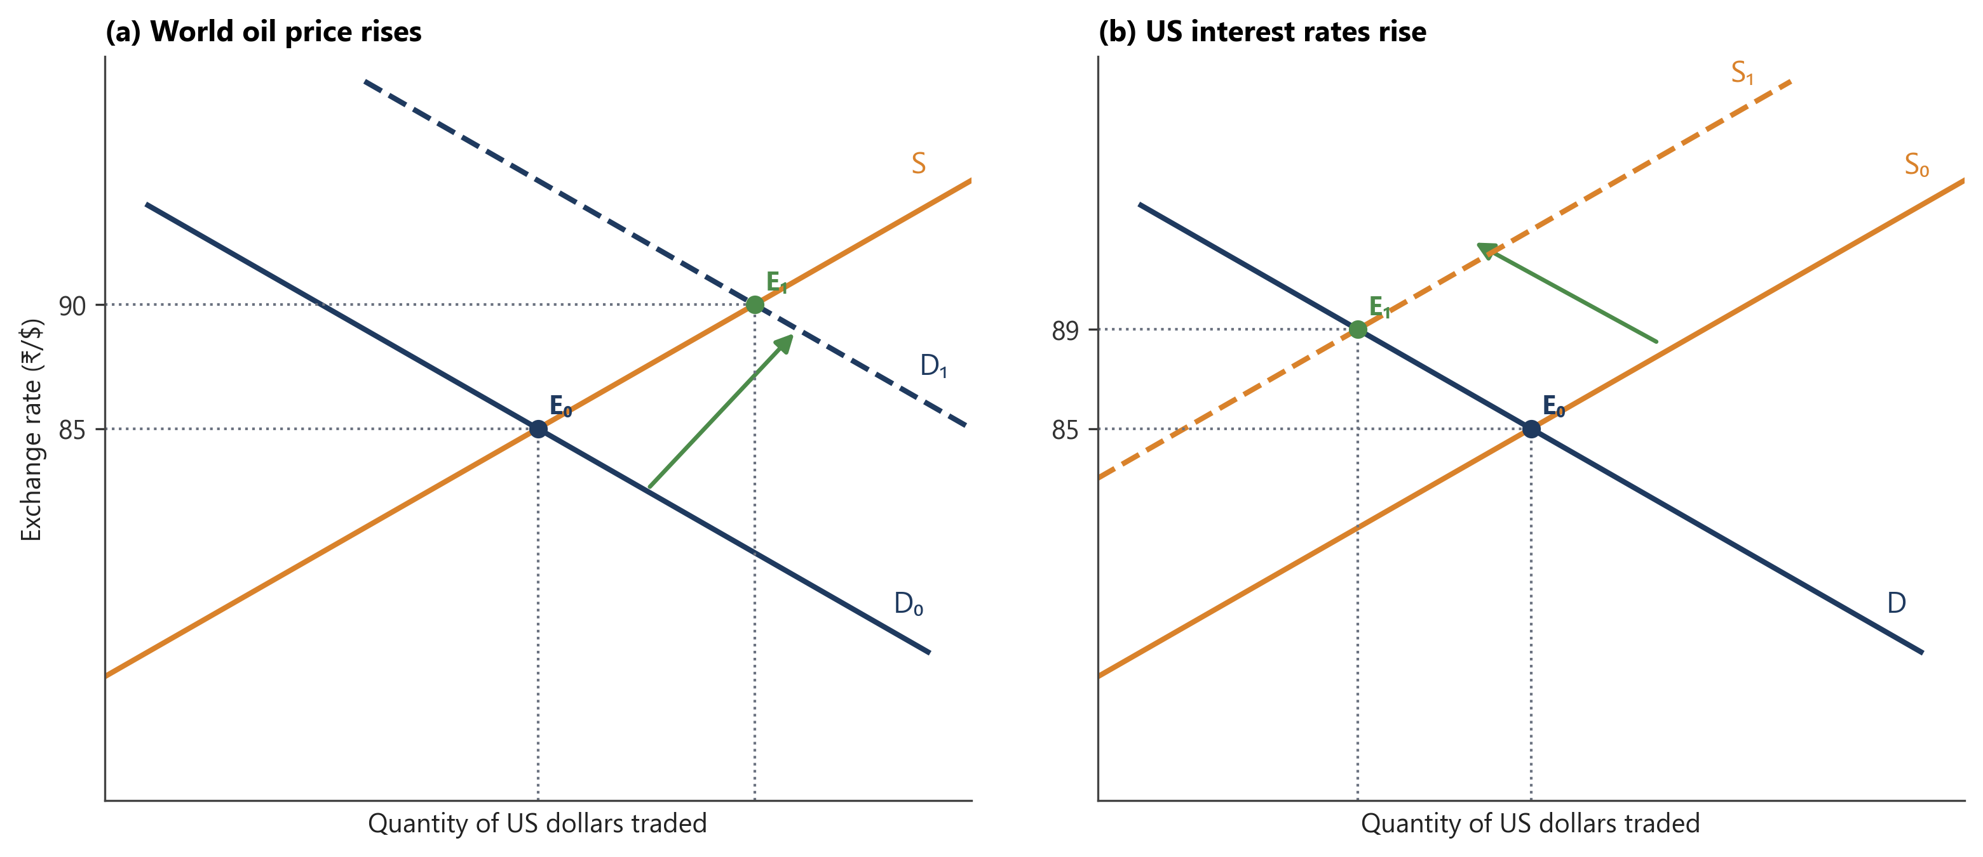
Figure M4-2 Two shocks in the market for US dollars (hypothetical numbers)
(a) A rise in the world price of oil. 1. The market starts at E₀, where demand D₀ meets supply S at ₹85 per dollar. 2. Oil now costs more, so refiners want more dollars at every exchange rate. Demand shifts right to D₁. 3. At ₹85 there is excess demand for dollars, and buyers bid the price up. 4. The new equilibrium is E₁ at ₹90: the rupee has depreciated and more dollars change hands.
(b) A rise in US interest rates. 1. Start again at E₀, ₹85 per dollar. 2. Foreign investors move funds to the United States, so fewer dollars are offered in India at every exchange rate. Supply shifts left to S₁. 3. The new equilibrium is E₁ at ₹89: the rupee has depreciated and fewer dollars change hands.
Source: Hypothetical figures drawn by the authors. To be redrawn in the common figure template [see: How the exchange rate is determined: demand and supply].
Markets also look ahead. If traders expect the rupee to fall, importers rush to buy dollars today and exporters hold on to the dollars they already have. Buying or selling a currency to profit from its expected future price is called speculation. It can turn a fear into a fact: the rupee falls partly because so many people acted on the belief that it would. | Speculation  Buying or selling an asset, such as a currency, in the hope of profiting from a change in its price.

Real episodes usually mix several of these forces. In the global financial crisis of 2008 and the COVID-19 panic of 2020, investors everywhere fled to the safety of the US dollar. India caused neither crisis, yet the rupee fell both times. Table M4-1 sums up the forces, and the box that follows asks you to read the rupee’s history for yourself.
Table M4-1 What moves the rupee: a summary
What happens | Effect in the market for dollars | ₹/$ rate | Rupee
Inflation in India runs ahead of US inflation | Demand rises and supply falls, slowly, over years | Rises | Depreciates
US interest rates rise | Supply shifts left as foreign investors take money home | Rises | Depreciates
Foreign investors pour money into India | Supply shifts right | Falls | Appreciates
World crude oil price rises | Demand shifts right | Rises | Depreciates
Current account deficit widens | Demand for dollars runs ahead of supply from trade | Rises | Depreciates
Traders expect the rupee to fall | Demand shifts right and supply shifts left | Rises | Depreciates
Global panic (‘flight to safety’) | Supply shifts left as money leaves emerging economies | Rises | Depreciates
Each change is assumed to happen on its own, with everything else held constant. The opposite change has the opposite effect.

HOW ECONOMISTS LEARN FROM FACTS
Reading the rupee’s history
Figure M4-1 marks six sharp jumps in the price of the dollar, numbered 1 to 6. Each matches one of the events below, which are listed in no particular order.
A. The US Federal Reserve raises interest rates at its fastest pace in four decades, while war in Ukraine pushes up oil prices.
B. India, with reserves for only a few weeks of imports, devalues the rupee.
C. Conflict in West Asia sends crude oil above $110 a barrel, and foreign investors sell Indian assets.
D. A giant American investment bank collapses and a global financial crisis spreads.
E. The US central bank hints that it will soon slow its support for the American economy, and investors pull money out of emerging markets.
F. A new virus shuts down economies around the world.
1. Match each number to an event. 2. For each, say whether the main change was in the demand for dollars, the supply of dollars, or both. 3. One event does not fit the demand and supply story. Which one, and why? (Hint: [see: Exchange rate systems: fixed, flexible and managed].)

8 Why exchange rates matter for India
Main text: 341 words (budget about 350)
You have already met the winners and losers from a change in the rupee [see: Appreciation and depreciation: who wins, who loses?]. Here we follow those effects through the wider economy. Whether you gain or lose depends on whether you earn dollars, spend them or owe them.
Start with those who earn dollars. When the rupee weakens, every dollar an exporter earns turns into more rupees. The exporter can keep the dollar price unchanged and enjoy a bigger income, or cut the price abroad to win more orders. Either way, Indian goods become easier to sell, and we say that their export competitiveness has improved. The gain is smaller than it looks for firms that import their own raw materials or machines, as the story of Selvi’s unit shows. | Export competitiveness  The ability of a country’s firms to sell goods and services abroad at prices that foreign buyers are willing to pay.

REAL-LIFE EXAMPLE
A weaker rupee in Selvi’s unit
Selvi’s unit in Tiruppur sells cotton T-shirts to a buyer in the United States, priced in dollars. Suppose she ships an order worth $20,000 (hypothetical). At ₹85 per dollar it brings in ₹17 lakh; at ₹90, the same order brings in ₹18 lakh. The extra ₹1 lakh can pay for overtime wages, or let her offer a small discount to win the next order.
This is not just a classroom story. In early 2025, the Tiruppur Exporters’ Association estimated that the rupee’s fall during 2024 accounted for about 5 per cent of the growth in the town’s garment exports (Business Standard, 2025).
But Selvi’s gain is not pure profit. Some of her dyes, accessories and machine parts are imported, and these now cost more. Her American buyer reads the same news, too, and may ask her to share the gain through a lower price.

Now consider those who spend dollars. India imports crude oil, gold, electronics, fertiliser and edible oil, almost all priced in dollars. A weaker rupee makes each of them dearer in rupees, even when the dollar price has not changed. Diesel runs the trucks that carry vegetables, grain and medicines, so costlier fuel spreads into the price of almost everything (Figure M4-3). A rise in prices that comes from dearer imports is called imported inflation. | Imported inflation  A rise in the general price level caused by higher rupee prices of imported goods, often because the rupee has depreciated.

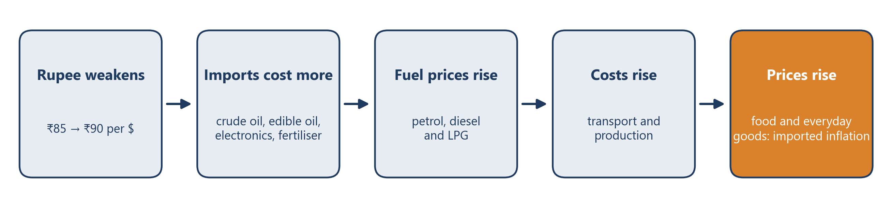
Figure M4-3 How a weaker rupee becomes imported inflation
Read the chain from left to right. Each step takes time, so the full effect on prices can take several months to appear. The exchange rates shown are hypothetical.
Source: Drawn by the authors.
WORKED EXAMPLE
The same barrel, a different price
Suppose a barrel of crude oil costs $80 on the world market (hypothetical figures).
• At ₹85 per US dollar, India pays 80 × 85 = ₹6,800 per barrel.
• At ₹90 per US dollar, India pays 80 × 90 = ₹7,200 per barrel.
The oil has not become any dearer in dollars, yet India pays ₹400 more for every barrel, a rise of about 5.9 per cent.
Now you try: the dollar price of oil rises to $90 while the rupee stays at ₹90 per dollar. What is the new rupee price of a barrel, and by what percentage has it risen compared with ₹6,800? (Answer: ₹8,100, a rise of about 19 per cent. When oil prices rise and the rupee weakens together, the two effects multiply.)

Then there are those who owe dollars. A company that borrowed in dollars, such as an airline paying for new aircraft, must now find more rupees to repay the same loan. A sharp fall in the rupee can turn a healthy balance sheet into a worrying one.
All of this matters to the Reserve Bank of India. When the RBI raises its policy interest rate (the repo rate), Indian assets pay more, foreign money tends to flow in and the rupee strengthens. Imports become cheaper and inflation cools, although exporters find life harder. This route from interest rates to spending and prices, working through the exchange rate, is called the exchange rate channel of monetary policy (Jayadev, 2021, Section 15.9). It is one reason the RBI keeps a close eye on the rupee whenever it sets interest rates. | Exchange rate channel  The way a change in the central bank’s policy interest rate affects spending and prices by moving the exchange rate, and through it exports and imports.

D When currencies collapse: crises in South Asia
Main text: 520 words (budget about 500)
Foreign exchange reserves work like a family’s savings for a bad year [see: The RBI and India’s foreign exchange reserves]. But what happens when the savings run out? A country that cannot find enough dollars to pay for its imports and repay its foreign loans can no longer protect its currency. The result is a currency crisis: a sudden, steep fall in the value of a currency, usually together with shortages and soaring prices. Two of India’s neighbours have lived through one recently. | Currency crisis  A sudden and large fall in the value of a country’s currency, usually because the country has run short of foreign exchange.

Sri Lanka, 2022. Sri Lanka’s troubles built up over several years. Large tax cuts in 2019 reduced the government’s income. The COVID-19 pandemic then emptied the tourist hotels that had earned much of the country’s foreign currency, while big repayments on foreign loans kept falling due. The central bank held the Sri Lankan rupee at about 200 per dollar and spent its reserves to do so. By the end of March 2022, gross reserves were down to about US$1.9 billion, and most of that could not easily be spent (Daily Mirror, 2022).
Once the currency was allowed to float in March 2022, it crashed, from about 202 rupees per dollar in February to about 356 by May (Figure M4-4). Fuel, cooking gas and medicines ran short, and people queued for hours outside petrol pumps. In April 2022 the government stopped paying its foreign debts, Sri Lanka’s first sovereign default. Inflation reached 69.8 per cent in September 2022 (Central Bank of Sri Lanka [CBSL], 2022). In March 2023 the IMF approved a loan of about US$3 billion (International Monetary Fund [IMF], 2023a), and prices slowly began to settle. | Sovereign default  When a government fails to make the payments on its debt that it has promised.

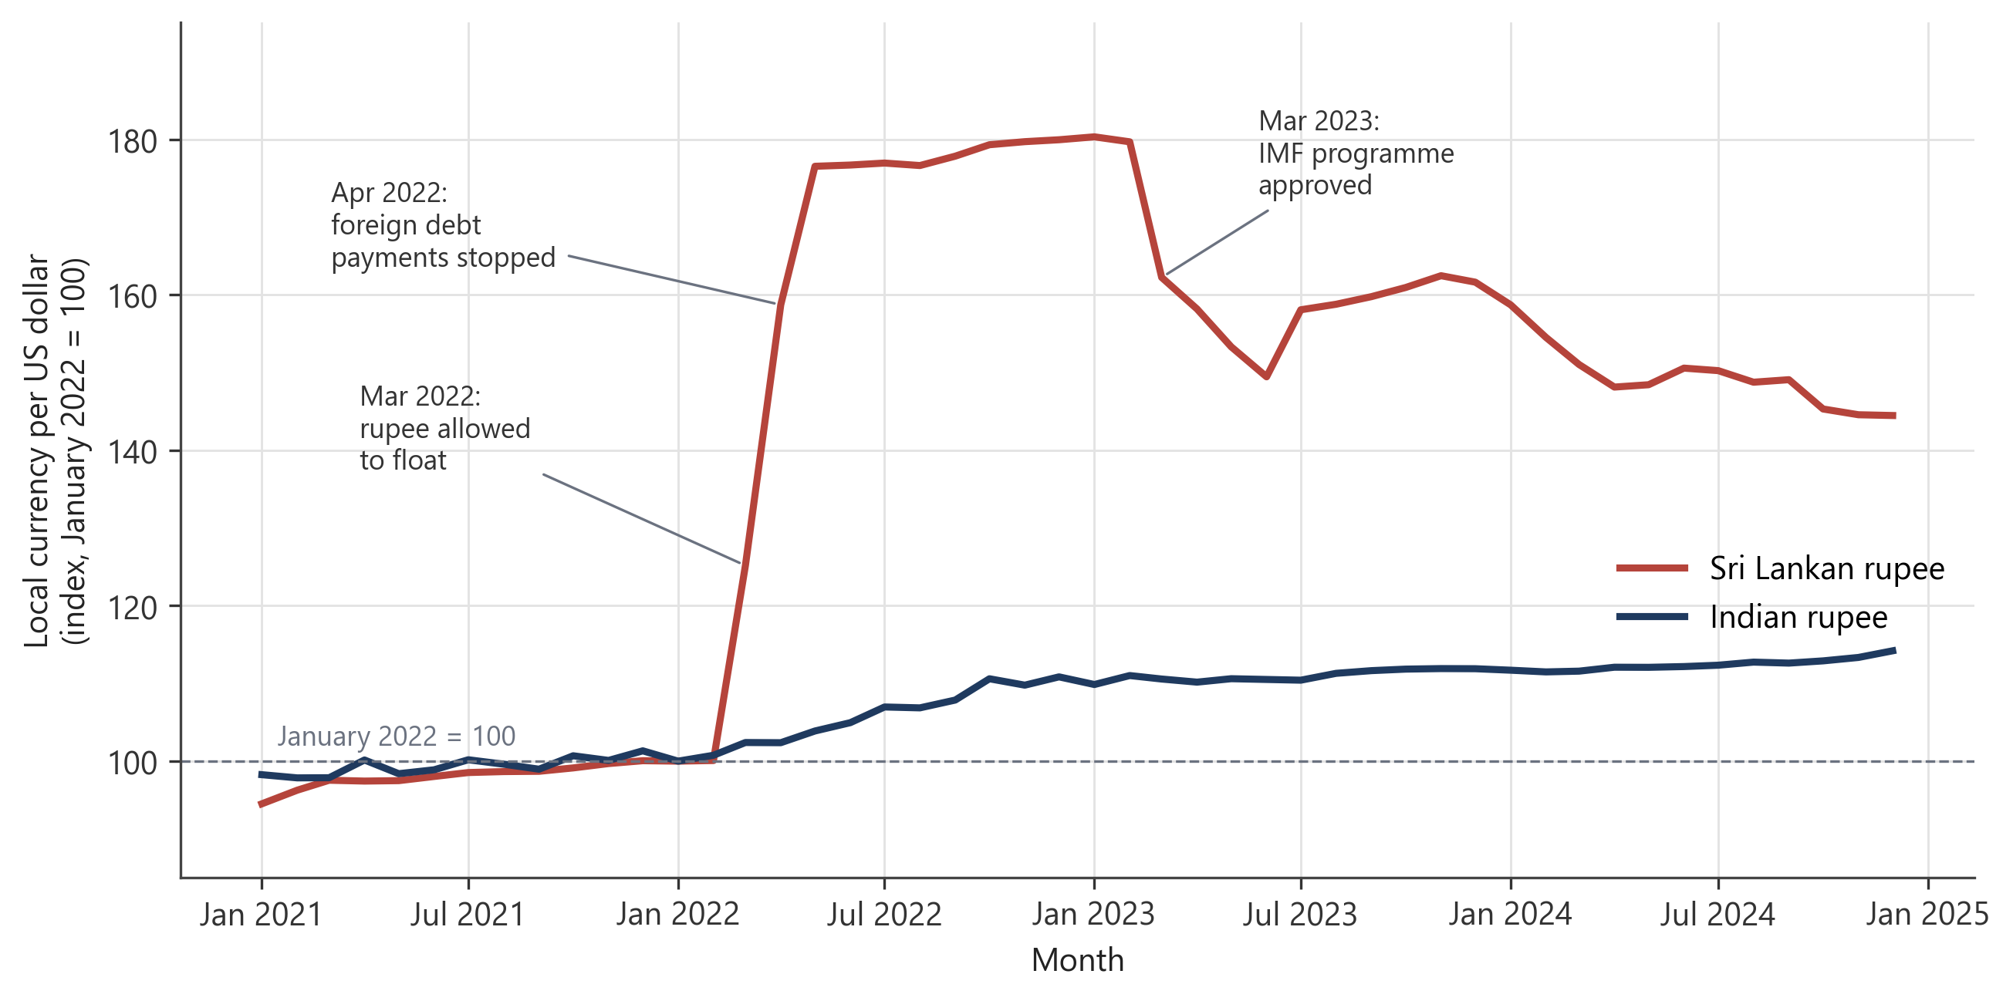
Figure M4-4 The Sri Lankan and Indian rupees against the US dollar, 2021 to 2024
Both lines show how many units of local currency it takes to buy one dollar, scaled so that January 2022 = 100. A rise means the currency has weakened. Once Sri Lanka stopped defending its rupee, it lost value within weeks. The Indian rupee also weakened over 2022, but gradually.
Source: Board of Governors of the Federal Reserve System (2026a, 2026b), series EXINUS and EXSLUS, monthly averages, retrieved from FRED, Federal Reserve Bank of St. Louis, 1 November 2026. Index calculated by the authors.
Pakistan, 2022–23. Pakistan came close to the same edge. High oil prices widened its current account deficit, floods in the summer of 2022 destroyed crops and homes, and talks with the IMF stalled. In early February 2023, the State Bank of Pakistan’s reserves fell to about US$2.9 billion, their lowest level in nine years and barely enough for a few weeks of imports (Business Recorder, 2023a). The government restricted imports and the Pakistani rupee slid, reaching a record low of about 307 per dollar in September 2023 (Xinhua, 2023). Inflation hit 38 per cent in May 2023 (Business Recorder, 2023b). A US$3 billion IMF programme, approved in July 2023, helped Pakistan avoid default (IMF, 2023b). | IMF programme  A loan from the International Monetary Fund to a country short of foreign currency, paid in instalments on condition that the country carries out agreed policy changes.

What about India? Both stories echo India’s own crisis of 1991 [see: Exchange rate systems: fixed, flexible and managed], when reserves covered only a few weeks of imports. India’s position today is much stronger. Its reserves stood at about US$700 billion in April 2026 (Reserve Bank of India [RBI], 2026). Under a managed float, the rupee adjusts a little every day, so pressure is released gradually instead of building up behind a fixed rate. And earnings from software services and remittances cover a large part of the gap in goods trade.
Table M4-2 Three currency crises compared
 | India, 1991 | Sri Lanka, 2022 | Pakistan, 2022–23
Main triggers | Oil price spike during the Gulf War; fall in remittances; large fiscal and current account deficits | Tax cuts; collapse of tourism during COVID-19; heavy foreign debt repayments; a sudden ban on chemical fertilisers that hurt harvests | High oil prices; large current account deficit; 2022 floods; political uncertainty; stalled IMF talks
Reserves at the worst point | Enough for only a few weeks of imports | About US$1.9 billion (March 2022) | About US$2.9 billion (February 2023)
What happened to the currency | Devalued in two steps in July 1991; about ₹21 per dollar in June to about ₹26 by August | Fell from about 202 to about 356 per dollar within three months of floating | Slid to a record low of about 307 per dollar (September 2023)
Peak inflation | About 14% (1991–92) | 69.8% (September 2022) | 38% (May 2023)
The way out | IMF loan, gold pledged abroad and wide-ranging economic reforms | Default on foreign debt (April 2022); IMF programme of about US$3 billion (March 2023); debt restructuring | IMF Stand-By Arrangement of US$3 billion (July 2023); curbs on imports
Source: Board of Governors of the Federal Reserve System (2026a); Business Recorder (2023a, 2023b); CBSL (2022); Daily Mirror (2022); IMF (2023a, 2023b); Xinhua (2023). India 1991 details follow [see: Exchange rate systems: fixed, flexible and managed].
The lesson from all three cases is that currencies rarely collapse because of a single bad event. Low reserves, heavy foreign-currency debt and a large current account deficit are like dry wood. A pandemic, an oil shock or a flood only supplies the spark.
WHEN ECONOMISTS DISAGREE
Is the IMF’s medicine too bitter?
IMF loans come with conditions. Under its 2023 programme, for example, Sri Lanka agreed to raise taxes and to price fuel and electricity so that they cover their costs.
Supporters argue that the conditions fix the problems that caused the crisis in the first place. They also reassure other lenders and investors, who return only when they trust the government’s plans. Without reform, they say, the loan would simply be spent and the crisis would return.
Critics reply that raising taxes and cutting spending in the middle of a crisis makes the slump deeper. The burden falls hardest on poor families, who spend most of their income on food and fuel. And conditions drawn up in Washington may not suit local circumstances.
What do you think? Should help in a crisis come with strings attached?

Handover: material for the shared end matter
Key terms for the glossary
Section | Term | Definition
7 | Capital flows | Money that moves between countries to buy or sell financial assets, such as shares and bonds, or real assets, such as factories.
7 | Interest rate differential | The difference between the interest rates paid in two countries. Funds tend to move towards the higher return, after allowing for risk.
7 | Speculation | Buying or selling an asset, such as a currency, in the hope of profiting from a change in its price.
8 | Export competitiveness | The ability of a country’s firms to sell goods and services abroad at prices that foreign buyers are willing to pay.
8 | Imported inflation | A rise in the general price level caused by higher rupee prices of imported goods, often because the rupee has depreciated.
8 | Exchange rate channel | The way a change in the central bank’s policy interest rate affects spending and prices by moving the exchange rate, and through it exports and imports.
D | Currency crisis | A sudden and large fall in the value of a country’s currency, usually because the country has run short of foreign exchange.
D | Sovereign default | When a government fails to make the payments on its debt that it has promised.
D | IMF programme | A loan from the International Monetary Fund to a country short of foreign currency, paid in instalments on condition that the country carries out agreed policy changes.
Review questions with answers
Multiple choice (Section 7)
The US Federal Reserve raises its interest rate sharply. Assuming nothing else changes, what is most likely to happen in the market for US dollars in India?
(a) The demand curve for dollars shifts left and the rupee appreciates.
(b) The supply curve of dollars shifts left and the rupee depreciates.
(c) The supply curve of dollars shifts right and the rupee appreciates.
(d) Nothing changes, because the RBI has not changed its own interest rate.
Answer: (b). The interest rate differential narrows, so foreign investors move funds out of India. Fewer dollars are offered at every exchange rate, and the ₹/$ rate rises.
Multiple choice (Section 8)
Which of the following is an example of imported inflation?
(a) Vegetable prices rise after a weak monsoon.
(b) Diesel prices rise after the rupee falls from ₹85 to ₹90 per US dollar.
(c) House rents rise in Bengaluru as more IT firms open offices.
(d) Wages rise after a new minimum wage law.
Answer: (b). Only (b) starts with imports becoming dearer in rupees. The others are caused by domestic supply or demand conditions.
Short answer with diagram (Section 7, 4 marks)
In 2022, two things happened at the same time: world crude oil prices rose, and the US Federal Reserve raised interest rates. (i) Draw a diagram of the market for US dollars in India showing both changes. (ii) Explain why we can be sure what happened to the value of the rupee, but not to the quantity of dollars traded.
Answer: (i) Demand for dollars shifts right (refiners need more dollars for oil); supply of dollars shifts left (foreign investors take funds to the United States). (ii) Both shifts push the ₹/$ rate up, so the rupee clearly depreciates. But the demand shift raises the quantity of dollars traded while the supply shift lowers it, so the net effect on quantity depends on which shift is larger.
Extra multiple choice (Section D, optional)
Which combination of conditions left Sri Lanka most exposed to a currency crisis in 2022?
(a) High reserves, little foreign debt and a booming tourism sector.
(b) Low reserves, heavy foreign debt repayments and a collapse in tourism earnings.
(c) A flexible exchange rate and fast-growing exports.
(d) Rising remittances and falling world oil prices.
Answer: (b). Low reserves, heavy foreign-currency debt and a sudden loss of foreign earnings are the ‘dry wood’ described in the section.
Answer key: ‘Reading the rupee’s history’ box
Band | Event | What shifted
1 | B (1991) | Does not fit: the rate was set by an official devaluation, not by the market [see: Exchange rate systems: fixed, flexible and managed].
2 | D (2008) | Supply of dollars shifted left as investors fled to the safety of the dollar.
3 | E (2013, the ‘taper tantrum’) | Supply shifted left as foreign money left; India’s large current account deficit kept demand for dollars high.
4 | F (2020) | Supply shifted left: a global flight to safety.
5 | A (2022) | Both: supply shifted left (US rate rises) and demand shifted right (dearer oil).
6 | C (2026) | Both: demand shifted right (oil above $110) and supply shifted left (foreign investors sold Indian assets) (Shivalkar, 2026).
Further learning
Khan Academy. (n.d.). Open economy: International trade and finance [Video lessons, AP Macroeconomics]. See ‘Exchange rate primer’ and ‘Causes of shifts in currency supply and demand curves’. https://www.khanacademy.org/economics-finance-domain/ap-macroeconomics/ap-open-economy-international-trade-and-finance
Jayadev, A. (2021). Section 15.9, ‘The exchange rate channel of monetary policy’. In The economy: A South Asian perspective. CORE Econ. https://books.core-econ.org/the-economy-south-asia/book/text/15.html
References (APA 7th edition)
Board of Governors of the Federal Reserve System (US). (2026a). Indian rupees to U.S. dollar spot exchange rate [EXINUS] [Data set]. FRED, Federal Reserve Bank of St. Louis. Retrieved November 1, 2026, from https://fred.stlouisfed.org/series/EXINUS
Board of Governors of the Federal Reserve System (US). (2026b). Sri Lankan rupees to U.S. dollar spot exchange rate [EXSLUS] [Data set]. FRED, Federal Reserve Bank of St. Louis. Retrieved November 1, 2026, from https://fred.stlouisfed.org/series/EXSLUS
Business Recorder. (2023a, February 9). Highly critical: SBP-held foreign exchange reserves fall $170mn, now stand at mere $2.92bn. https://www.brecorder.com/news/40225346
Business Recorder. (2023b, June 1). Pakistan’s headline inflation hits new record at 38% in May 2023. https://www.brecorder.com/news/40245453
Business Standard. (2025, January 6). Textile hub Tiruppur threads a recovery on sliding rupee as exports surge. https://www.business-standard.com/industry/news/textile-hub-tiruppur-threads-a-recovery-on-sliding-rupee-as-exports-surge-125010600927_1.html
Central Bank of Sri Lanka. (2022, September 30). CCPI based headline inflation recorded at 69.8% on year-on-year basis in September 2022 [Press release]. https://www.cbsl.gov.lk
Daily Mirror. (2022, April 9). Sri Lanka’s foreign reserves down by US $372mn to US $1.93bn by end-March. https://www.dailymirror.lk/business-news/Sri-Lankas-foreign-reserves-down-by-US-372mn-to-US-1-93bn-by-end-March/273-234865
International Monetary Fund. (2023a, March 20). IMF Executive Board approves US$3 billion under the new Extended Fund Facility (EFF) arrangement for Sri Lanka (Press Release No. 23/79). https://www.imf.org/en/News/Articles/2023/03/20/pr2379-imf-executive-board-approves-under-the-new-eff-arrangement-for-sri-lanka
International Monetary Fund. (2023b, July 12). IMF Executive Board approves US$3 billion Stand-By Arrangement for Pakistan (Press Release No. 23/261). https://www.imf.org/en/News/Articles/2023/07/12/pr23261-pakistan-imf-exec-board-approves-us3bil-sba
Jayadev, A. (2021). The economy: A South Asian perspective (Version 1.0.1). CORE Econ. https://books.core-econ.org/the-economy-south-asia/
Petroleum Planning & Analysis Cell. (2025). Snapshot of India’s oil & gas data. Ministry of Petroleum and Natural Gas, Government of India. https://ppac.gov.in
Reserve Bank of India. (2026, April 17). Weekly statistical supplement [Foreign exchange reserves, week ended April 10, 2026]. https://www.rbi.org.in
Shivalkar, A. (2026, April 30). Rupee slips past 95 per dollar to record low on April 30, 2026. Angel One. https://www.angelone.in/news/economy/rupee-slips-past-95-per-dollar-to-record-low-on-april-30-2026
Xinhua. (2023, September 6). Pakistani rupee picks up crash mode against USD, touching record low. The Star. https://www.thestar.com.my/news/world/2023/09/06/pakistani-rupee-picks-up-crash-mode-against-usd-touching-record-low
Cross-references made in these sections
Used in | Section referred to | Owner
7 | How the exchange rate is determined: demand and supply | Member 2, Section 3
7 | Nominal and real exchange rates, and purchasing power parity | Member 3, Section 6
7 | The rupee’s account book: the balance of payments | Member 1, Section A
7 (box) | Exchange rate systems: fixed, flexible and managed | Member 3, Section 5
8 | Appreciation and depreciation: who wins, who loses? | Member 2, Section 4
D | The RBI and India’s foreign exchange reserves | Member 3, Section C
D | Exchange rate systems: fixed, flexible and managed | Member 3, Section 5
Notes for the team
• Member 2: Figure M4-2 uses placeholder colours (navy demand, orange supply, green shift arrows). Please share the common template and I will redraw it; the source script is source/build_figures.py, and colours change in one place (PALETTE).
• Member 3: the India 1991 column of Table M4-2 must match your case study box. Please confirm the reserve level, the size of the devaluation and the 1991–92 inflation figure (about 14% used here).
• Member 1: nine glossary terms are listed above with one-line definitions. ‘Current account deficit’ is used in Sections 7 and D but not defined, since Section A owns it.
• Optional photograph for Section D: a fuel queue in Colombo, 2022. Use a Creative Commons image (for example from Wikimedia Commons) with full credit, or skip it.
• The word count at the top of each section covers main text only (paragraphs). Boxes, captions and tables are excluded, as the plan assumes.

