**STRUCTURE DIAGRAM:**

**HIGH LEVEL DESIGN:**

**USE CASE DIAGRAM:**

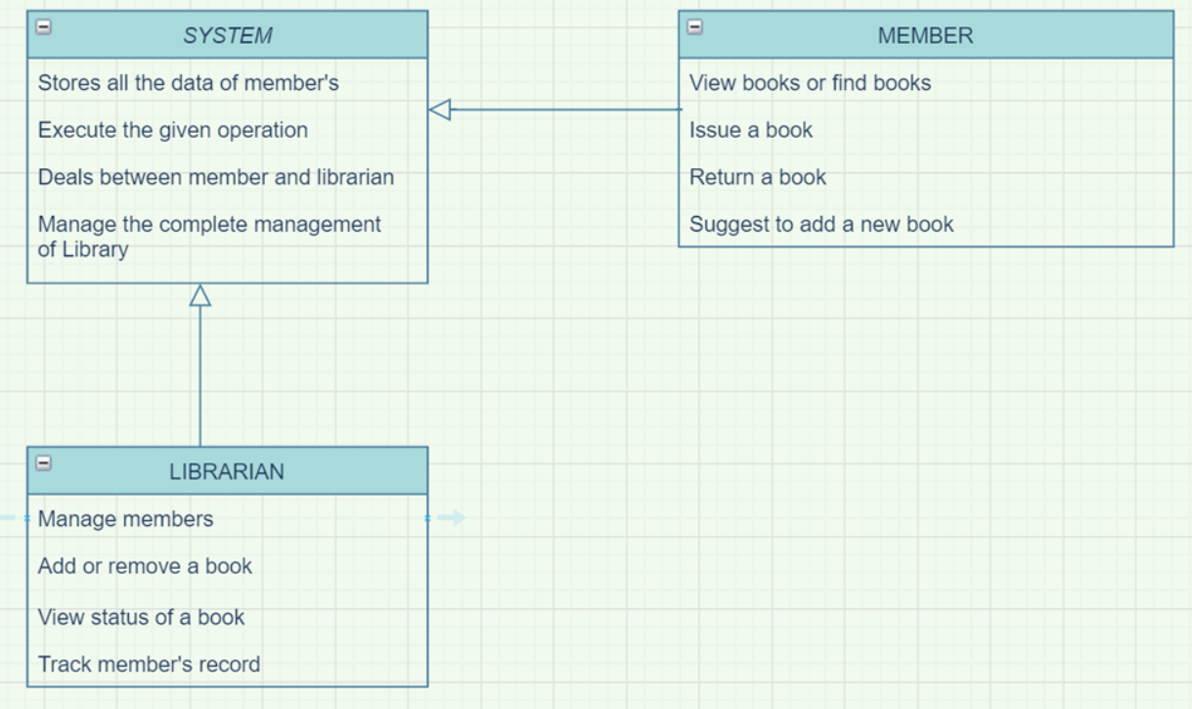

**BEHAVIOUR DIAGRAMS:**

**LOW LEVEL DESIGN:**

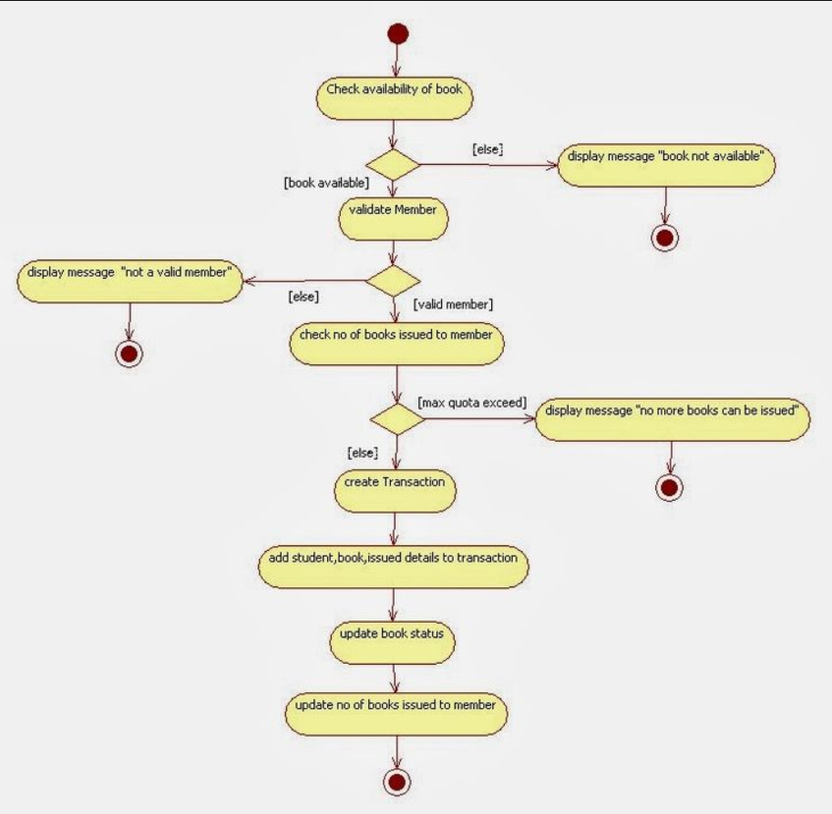

**SEQUENCE DIAGRAM:**

