Name: Najay Green Web Programming Tuesday @11am
ID: 2402084
Storyboard Individual Assessment #2
Colour Palette
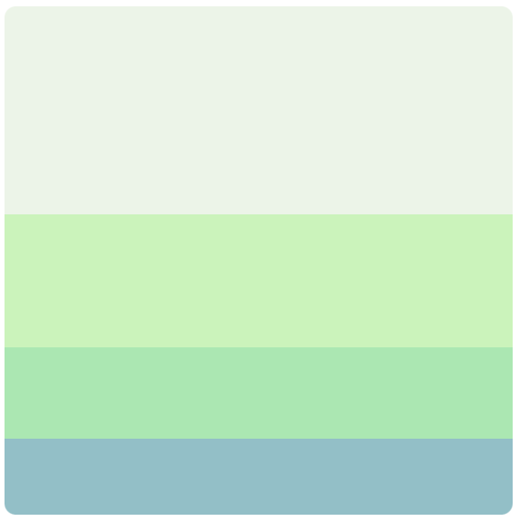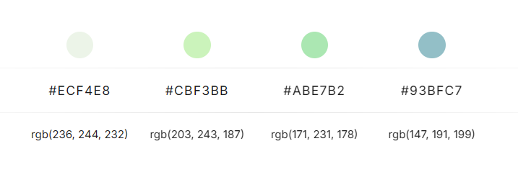
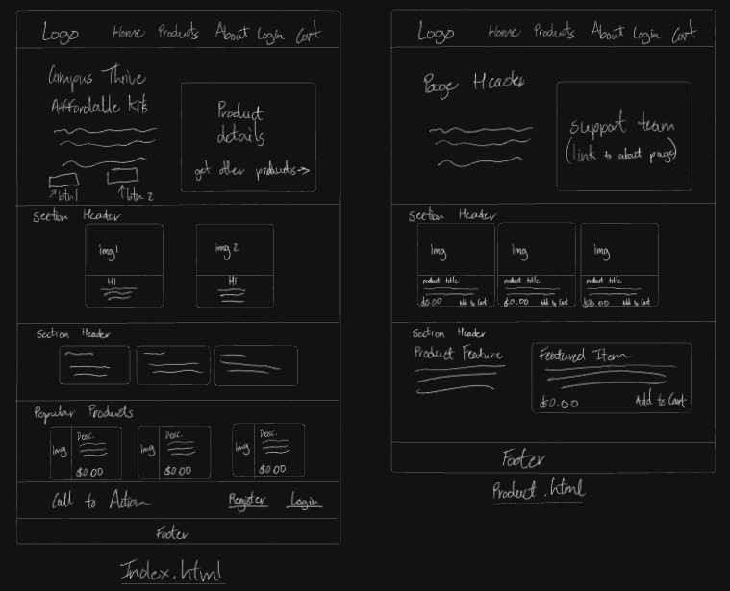
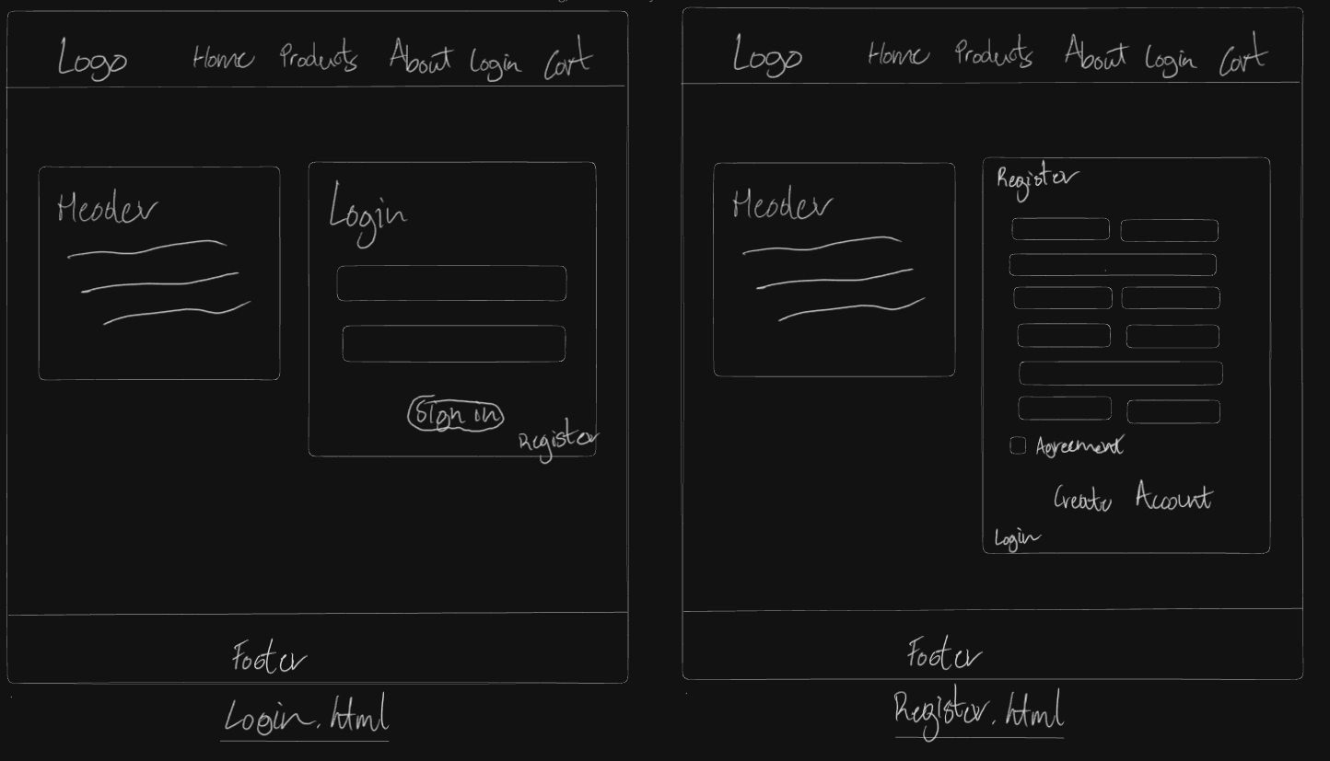
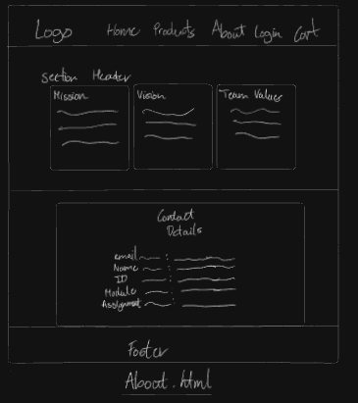
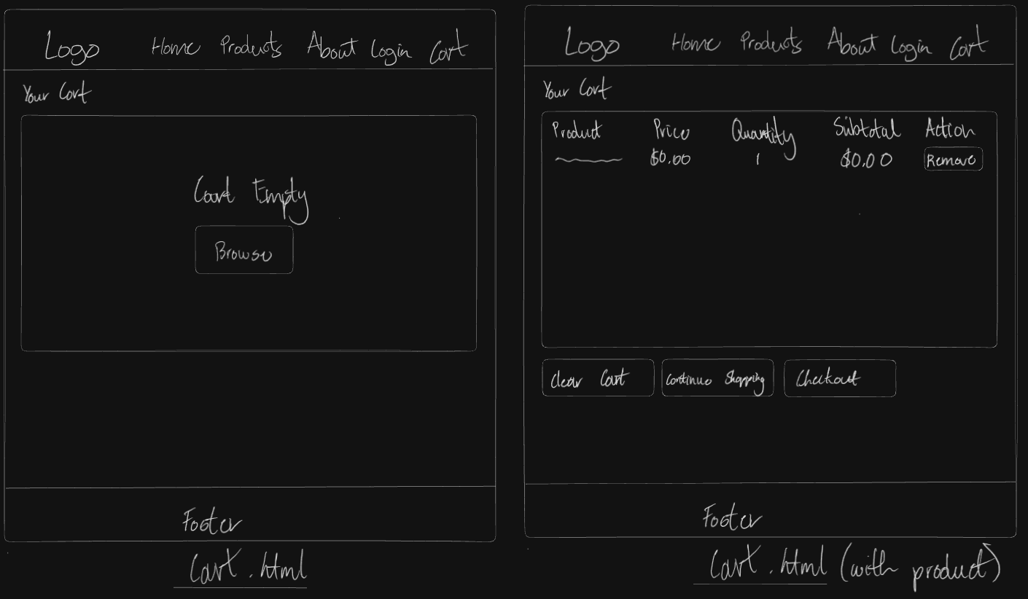
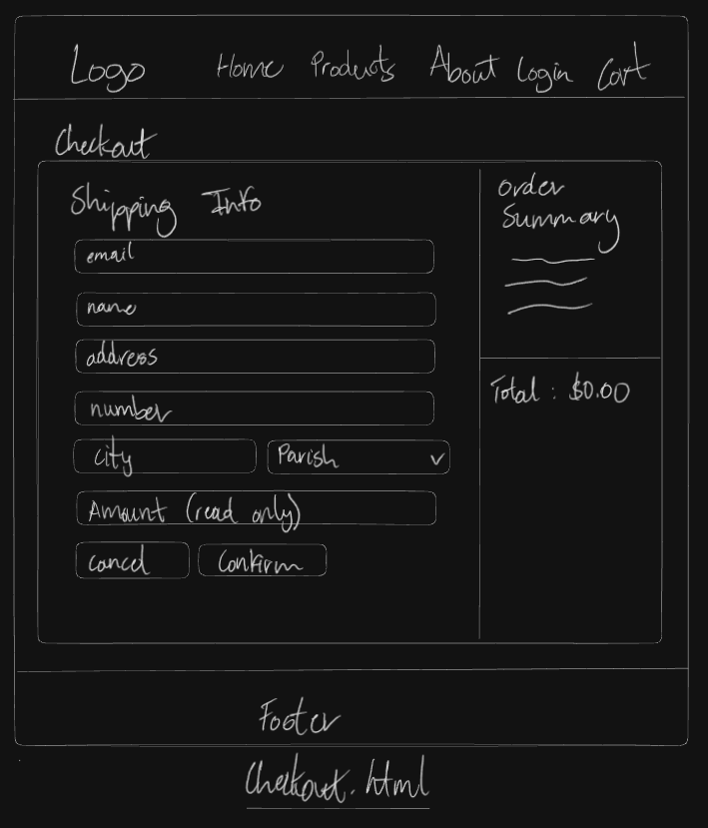

Logo

Font Family
Primary Font: Quicksand (Google Fonts)
Font Weights: 300-700
Import: @import url('https://fonts.googleapis.com/css2?family=Quicksand:wght@300..700&display=swap');
Font Sizes
Root/Base: 16px
Hero Heading (h1): 2.5rem (40px)
Hero Brand Title: 2rem (32px)
Section Headings (h2): Default browser size
Price Tags: 1.25rem (20px)
Spec List Strong: 1.4rem (22.4px)
Brand Title: 1.1rem (17.6px)
Body Text: 1rem (16px - inherited)
Brand Subtitle: 0.85rem (13.6px)
Form Labels: 0.85rem (13.6px)
Eyebrow Text: 0.75rem (12px)
Cart Badge: 0.75rem (12px)
Tiny Text: 0.8rem (12.8px)

Font Weights
Brand Title: 700 (Bold)
Buttons: 600 (Semi-bold)
Navigation Links: 500 (Medium)
Link Arrows: 600 (Semi-bold)
Price Tags: 700 (Bold)
Form Labels: 600 (Semi-bold)
Product Thumbs: 600 (Semi-bold)
Body Text: 400 (Normal - default)
Line Height:
Body: 1.6
Letter Spacing:
Eyebrow Text: 0.2em
Product Thumbs: 0.08em
Product Label: 0.1em
Spacing System
CSS Variables:
--space-xs: 0.5rem (8px)
--space-sm: 0.85rem (13.6px)
--space-md: 1.5rem (24px)
--space-lg: 2.25rem (36px)
--space-xl: 3.5rem (56px)

Border Radius CSS Variables
--radius-md: 0.75rem (12px) - Cards, forms
--radius-lg: 1.5rem (24px) - Large containers
Buttons: 999px (fully rounded/pill-shaped)
Cart Badge: 999px (fully rounded)
Navigation Links: 0.5rem (8px)
Form Inputs: 0.65rem (10.4px)
Product Thumb Span: 999px (fully rounded)
Shadows CSS Variables:
--shadow-sm: 0 3px 8px rgba(17, 24, 39, 0.12) - Small elevation
--shadow-md: 0 12px 30px rgba(17, 24, 39, 0.18) - Medium elevation
Container & Layout
Main Container:
Max Width: 1200px
Width: min(1200px, 90vw)
Padding: 0 1.5rem (0 24px)
Margin: 0 auto (centered)
Grid Gaps:
Card Grid: 1.25rem (20px)
Products Grid: 1.5rem (24px)
Gallery Grid: 2.25rem (36px)

Business Description
Campus Thrive is a student-focused e-commerce business that provides affordable essentials for college life, all in one convenient online space. The store is designed specifically with university and college students in mind, offering budget-friendly items like backpacks, notebooks, stationery, study accessories, personal care items, and small tech gadgets that support everyday campus life. Instead of students having to visit multiple physical stores or pay high prices in bookstores, Smart Budget Store helps them save time and money by curating practical, low-cost products that still maintain good quality.
Mission Statement
Deliver transparent, accessible, and student-friendly supply bundles at consistent prices, so you can shift budget planning from quarterly chaos to simple repeatable orders.
Vision Statement
Become the reference platform for Jamaican university supply logistics, supporting faculties with inventory insights and students with predictable costs.
Color Palette Justification
The Campus Thrive website uses a soft green-based colour palette to reinforce its identity as an affordable, welcoming, student-focused e-commerce platform. Light green backgrounds (rgb(236, 244, 232) and rgb(203, 243, 187)) create a sense of calm, cleanliness, and approachability, which helps students feel at ease while browsing.
Shades of green are strongly associated with savings, value, and smart decision-making, aligning naturally with the brand’s promise of budget-friendly products. The slightly stronger green (rgb(171, 231, 178)) adds energy and renewal, encouraging users to engage with calls-to-action without overwhelming them.
The teal-green shade (rgb(147, 191, 199)) provides contrast, stability, and trust, balancing the lighter tones and giving the site a professional feel. This ensures visual clarity, accessibility, and a positive shopping experience overall.

Primary Target Audience
- University and college students in Jamaica/Caribbean who are between the ages of 18-25
- Have moderate to high digital literacy and comfortable with online shopping
- In need of Affordable academic supplies, technology accessories, dorm essentials, and study materials
APA References
Pinterest. (n.d.). Pinterest. Retrieved November 17, 2025, from https://www.pinterest.com/
W3Schools. (n.d.). W3Schools online web tutorials. Retrieved November 17, 2025, from https://www.w3schools.com/
InspireUI. (n.d.). Color palette #ECF4E8 CBF3BB ABE7B2 93BFC7. ColorHunt. Retrieved November 17, 2025, from
https://colorhunt.co/palette/ecf4e8cbf3bbabe7b293bfc7
UX Trends. (2023, May 10). Color psychology for UI designers [Video]. YouTube. https://www.youtube.com/watch?v=8J0nbuunDXc
Google. (n.d.). Quicksand – Google Fonts. Retrieved November 17, 2025, from
https://fonts.google.com/specimen/Quicksand

