Harshpreet Singh

8872633

PortFOLIO-2

Task1: Creating the Initiator Machine

The new initiator machine is created using the predefined template from vsphere using the windows 19 server to install the iSCSI shared drive in the initiator machine.

This is a client-side component on a machine that accesses storage, initiates communication with the target, and sends commands for storage management. (Configuring iSCSI Storage Server On Windows Server 2019, n.d.)

Task2: Creating the Target Machine

A server or storage device provides storage resources by housing physical disks and exposing them as block storage via the iSCSI protocol.

Task3: Creating the ISCSI target server.

Adding the role in the target server as iSCSI connections connect client machines to a dedicated storage server, allowing clients to access the target's storage space like a local hard drive. This creates a centralized storage system, simplifies management, maximizes utilization, is scalable, facilitates disaster recovery, and frees up client machines for core processing tasks, making it an efficient storage solution for distributed computing needs. (Harmouch, 2023)

Task 4: Connection setup with target server

iSCSI connections will enable remote block storage access, allowing a network initiator to use a dedicated server's storage space like a local hard drive created in the initiator server.

* Initiator is now connected to target server.

Task5:

* Disk partition on initiator server.

New partition is created which will further used as the shared volume between both of the servers using command line.

Commands used :

**Diskpart**

**San**

**Online all**

**Attributes disk**

**Select disk 1**

**Attributes dusk clear read only**

**Online disk**

* Creating the new volume in initiator server

Previously created partition will now crated as the new disk Volume with the specific name in the machine and will be used as the shared drive between both servers.

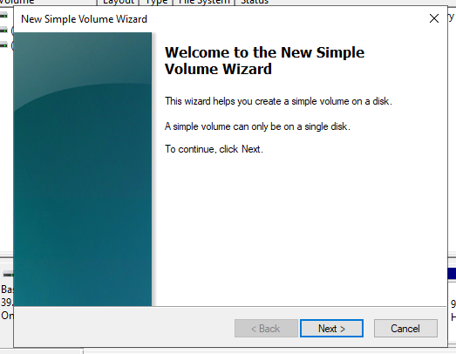

* Drive created.

* Shared drive is successfully created. And can be seen in the Target server .

# References

*Configuring iSCSI Storage Server On Windows Server 2019*. (n.d.). Retrieved from YUTUBE.COM: https://www.youtube.com/watch?v=XktfIpQHC2M

Harmouch, D. A. (2023, 11 14). *What is iSCSI*. Retrieved from starwindsoftware.com: https://www.starwindsoftware.com/blog/what-is-iscsi#:~:text=Simplified%20Management%3A%20Centralized%20storage%20systems,streamlined%20operations%20and%20reduced%20downtime.

**THANK YOU**