SYST8111 Lab 5

Deploy and Configure Virtual Machines

# Overview

This exercise consists of five tasks that will result in uploading an ISO image to be used for creating VMs, creating virtual machines, installing VMware Tools, and copying some files to the VM that are required for later lab exercises. There are demonstration videos for all tasks to be completed.

Note that we will be using Linux based VMs for our lab exercises since the resource requirements are much less than Windows.

# Preparation

Create a Remote Desktop session to your course Infrastructure VM. Note – DO NOT use a console window from vCenter.

# Task 1: Upload an OS Distribution ISO to ESXi

In this task, you create a folder on your datastore and upload an ISO image that can be used to install a guest OS on a VM. This task is to be completed on your ESXi-01 host.

1. In Firefox, download a copy of CentOS 7 Minimal ISO. I recommend the University of Waterloo mirror since it will provide the best performance. ( https://www.centos.org/download/ ) Select x86_64, then find the link of the CSClub link from the University of Waterloo.
2. Open a session to your ESXi-01 host using root as the User name and Vclass123$ as the Password.
3. Select Storage in the Navigator pane.
4. Select a datastore in the middle pane. I suggest lun_01
5. Click Datastore browser.
6. In the Datastore browser dialog, click Create directory.
7. Enter ISOs as the Directory name and click Create directory.
8. Click the ISOs folder that was just created.
9. Click Upload.
10. In the File Upload dialog, navigate to and select the CentOS ISO downloaded earlier and click Open.
11. In the Datastore browser dialog, click Close.

# Task 2: Create a Virtual Machine

You create a virtual machine based on specific requirements, such as a particular operating system or hardware configuration. You have already created virtual machines in a vSphere environment so completing the wizard should be familiar to you. This task is to be completed on your ESXi-01 host. Open a new session on your ESXi-01 host if you closed the session from the previous task.

1. In the Navigator pane, select Virtual Machines.
2. In the right pane, click Create/Register VMto open the New virtual machine wizard.
3. On the Select creation type page, verify that Create a new virtual machineis selected and click Next.
4. On the Select a name and guest OS page, configure settings for your virtual machine.
   1. Name your virtual machine <student_id>-websrv01.
   2. From the Compatibilitydrop-down menu, select ESXi 7.0 virtual machine.
   3. From the Guest OS familydrop-down menu, select Linux.
   4. From the Guest OS versiondrop-down menu, select CentOS 7 (64-bit)and click Next.

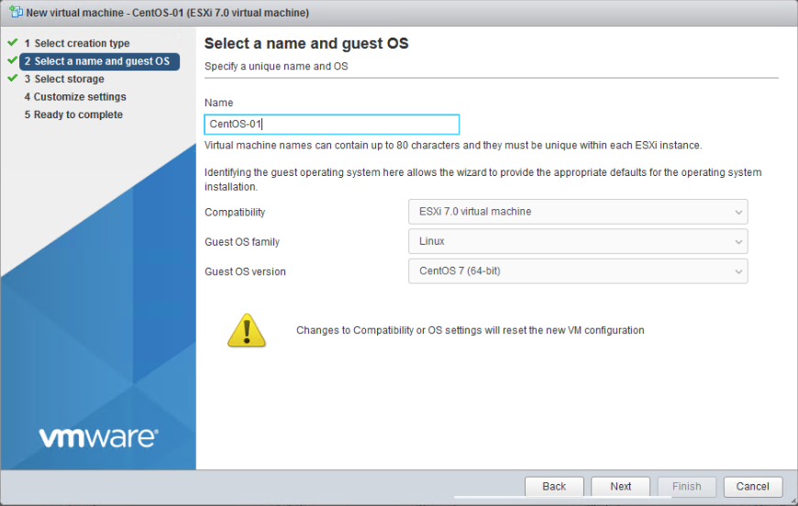

‘

1. On the Select storage page, select an appropriate datastore and click Next.
2. On the Customize settings page, configure settings.
   1. From the CPUdrop-down menu, select 2.
   2. Enter 4096MBin the Memorytext box and enter 100GBin the Hard Disk 1text box.
   3. Expand the Hard disk 1 object and select Thin provisioned, then collapse the Hard disk 1 object.
   4. Find CD/DVD Drive 1 and select Datastore ISO filefrom the drop-down menu.
   5. In the Datastore browser window, select the datastore the ISOs folder is located in.
   6. Select the ISOs folder, then select the CentOS 7 image uploaded in the previous task.
   7. Click Select.
   8. Click the arrow next to CD/DVD Drive 1.
   9. Verify that the Connect at power oncheck box is selected and click Next.
3. On the Ready to Complete page, review the information and click Finish.
4. In the Navigator pane, verify that the virtual machine number count is 1.
5. In the Navigator pane, select Virtual Machinesand verify that your newly created virtual machine appears in the right pane.
6. Click on the <student_id>-websrv01virtual machine name in the right pane.

**Note:** be sure to click the name of the VM, not just the row. The center pane will update to display information about the selected virtual machine.

1. Examine the General Information pane, the Hardware Configuration pane, and the Resource Consumption pane to review the current settings.
2. In the Hardware Configuration pane, expand Hard disk 1and record information.

* Backing __________
* Capacity __________
* Thin provisioned __________

1. Click Power on and open a web console in a new tab for your VM. You have installed CentOS Linux before so detailed instructions will not be included. Configure the VM as follows:
   1. Enable the network.
   2. Configure IPv4 on the network to use host address .104 on your subnet with your normal default gateway and DNS server: 10.173.?.100.
   3. Configure the hostname as <student_id>-websrv01.
   4. Configure the root password as Vclass123$.
2. Wait for the installation to complete and reboot the VM
3. Edit the VM settings and select Host Device from the CD/DVD drive drop down and click Save. THIS IS REALLY IMPORTANT!

# Task 3 – Install VMware Tools

In this task, you will install VMware Tools on your new VM. This task is to be completed on your ESXi-01 host. Open a new session on your ESXi-01 host if you closed the session from the previous task.

Unlike Windows, there are two ways to install VMware Tools on Linux. A package named open-vm-tools is included in Linux update repositories. This is the easiest method to install VMware Tools and the one that we will use. There is also a VMware Tools ISO included with vSphere. That is much more challenging to install since there are quite a few more steps. The advantage of using the VMware Tools ISO included with vSphere is security patches are updated a little more quickly.

1. Authenticate to the root account on your new Linux VM.
2. Enter the command yum install –y open-vm-tools.
3. We also need perl for some future labs. While we’re here, let’s install that as well. Enter the command: yum install –y perl.
4. Log out of the Linux VM.

# Task 4 – Copy a file to your VM

In this task, you will copy a file that is required for future labs to your new Linux VM. This work will be completed on your Infrastructure VM.

1. Open a browser tab and log in to eConestoga.
2. Navigate to Creating/Configuring Virtual Machines module.
3. Download the cpubusy.pl file to your Infrastructure VM desktop.
4. Launch WinSCP.
5. Select SCP from the File protocol drop down.
6. Enter the IP address of your Linux VM as the Host name, root as the User name and Vclass123$ as the Password and click Login.
7. Click Yes to accept the self-signed certificate.
8. Above the left pane, select Desktop from the drop down (currently on Drive C:).
9. Select the cpubusy.pl file, drag it to the right pane and click OK to copy the file.
10. Let’s make a change to that file now to save some headaches later on. Right-click the cpubusy.pl file in the right pane and select Properties. Select the X check box beside Owner in the Permissions area and click OK.
11. Click Session->Disconnect in the WinSCP application.
12. In the Login dialog click Close.
13. In the program vSphere infrastructure client, edit your Infrastructure VM settings.
14. Select Client Device from the CD/DVD drive drop down and click OK.

# Task 5: Create Additional Virtual Machines

In this task, you create two more virtual machines. This task is to be completed on your ESXi-01 host. Open a new session on your ESXi-01 host if you closed the session from the previous task.

1. Repeat tasks 2 through 4 to create a second VM with VM name <student_id>-dbsrv01 and IP host address .105.
2. Repeat tasks 2 through 4 to create a third VM with VM name CentOS-ForTemplate.
   1. Enable the network, assign a static IP configuration using the student network spreadsheet.
   2. Do not upload the cpubusy.pl script.

That is a wrap for this lab. If you are finished with labs, close your Remote Desktop session to your Infrastructure VM. You do not need to shut down your VMs although you can if you wish.

# References

The content of this lab document is based heavily on the VMware Install, Configure, Manage lab text.