ICU SMART PATIENT MONITORING SYSTEM (SIMULATION)
Subject: Wireless Sensor Network Design (CEC365)
Submitted by
Sweatha S

1. Abstract
This design presents a software-based ICU patient monitoring system developed using Visual Studio Code and Python. The system simulates real-time monitoring of patient vital parameters such as heart rate and oxygen saturation (SpO₂), along with patient video analysis.
The system continuously analyzes both video and simulated sensor data. If any abnormal condition such as high heart rate, low SpO₂, or lack of movement is detected, an alert is generated and displayed on a web application for doctors or patient attenders.
This project provides a low-cost, scalable ICU monitoring solution using software simulation without physical hardware.

2. Introduction
In modern healthcare systems, continuous monitoring of ICU patients is critical. Traditional systems rely heavily on hardware sensors and manual observation.
This project aims to:
- Replace physical sensors with simulation
- Provide remote monitoring through a web service
- Automatically detect abnormal conditions
- Alert medical staff instantly

3. Objective
- To simulate ICU patient monitoring using software
- To analyze patient video and vital parameters
- To detect abnormal conditions automatically
- To send alerts to doctor/attender via web interface

4. System Architecture
Patient Video (MP4 File) + Patient Data (Simulated) → Analysis Engine (Python) → Flask Server → Web Dashboard → Doctor / Attender

5. Methodology

5.1 Patient Data Simulation
- Heart Rate: 60–120 bpm
- SpO₂: 90–100%
- Generated using Python's random function

5.2 Video Analysis
- Video file used instead of a real camera
- Motion detection technique applied
- Detects: No movement → Critical condition

5.3 Condition Detection
Parameter | Condition | Status
HR > 100 | High HR | Alert
SpO₂ < 92 | Low Oxygen | Critical
No movement | Motion failure | Emergency

5.4 Backend Development
Developed using Flask. Handles:
- Data processing
- Video streaming
- API communication

5.5 Web Dashboard
Displays:
- Patient video
- Vital parameters
- Alert status

6. Implementation
Tools used:
- Visual Studio Code
- Python
- OpenCV
- Flask
Working:
The system uses a pre-recorded patient video and simulated vital parameters such as heart rate and SpO₂. The video is analyzed using OpenCV to detect patient movement, while the vital data is generated using Python. These values are compared with predefined threshold limits to identify abnormal conditions. If any critical condition such as high heart rate, low SpO₂, or no movement is detected, an alert is generated. The Flask server sends this information to a web dashboard, where doctors or attenders can monitor the patient in real time.

7. Results
Output 1: Emergency Alert (Low SpO₂)
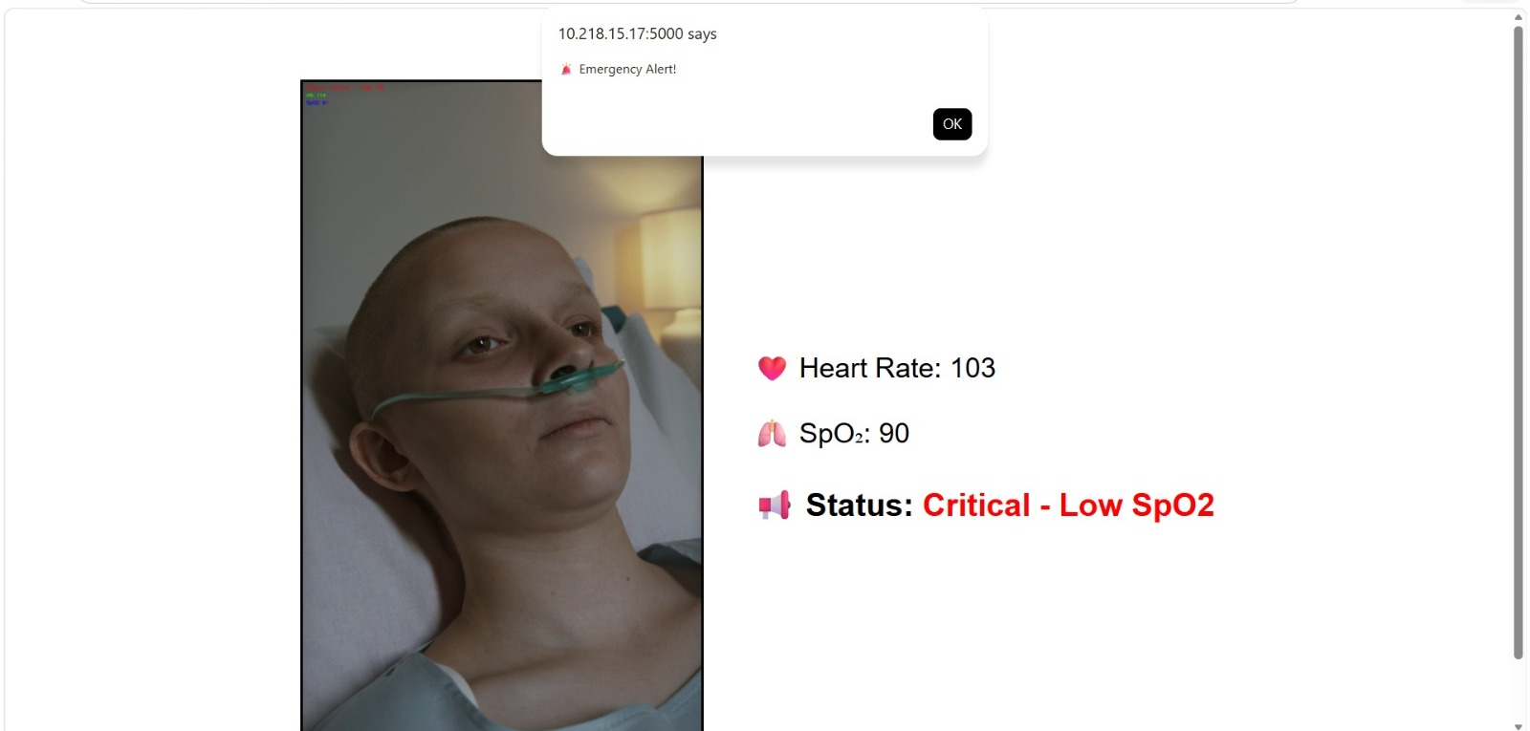
Output 2: No Movement Detection
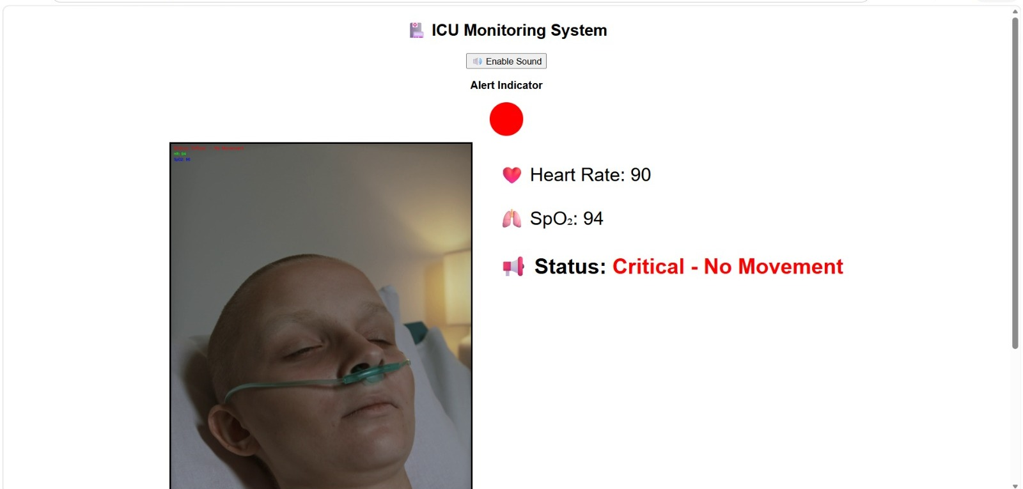

8. Advantages
- Low cost (no hardware required)
- Real-time monitoring
- Automatic alert system
- Remote accessibility
- Easy to implement

9. Limitations
- Uses simulated vital data rather than readings from real medical sensors
- Currently supports monitoring a single patient at a time
- No persistent database — alerts and readings are not stored for later review
- Motion detection relies on a fixed camera angle and pre-recorded video

10. Future Enhancement
- Integration with real IoT sensors
- AI-based health prediction
- Mobile application development
- Cloud database storage
- Multi-patient monitoring

11. Applications
- ICU patient monitoring
- Remote healthcare systems
- Telemedicine
- Smart hospitals

12. Conclusion
The system successfully demonstrates a smart ICU monitoring system using simulation. By combining video analysis and patient data monitoring, the system detects abnormal conditions and alerts doctors in real time.
This system can be extended into a real-world healthcare solution with IoT and AI integration.

