Predictive Modeling and Risk Scoring for Bank Customer Churn
A Research Paper Prepared for the European Central Bank — Unified Mentor Data Analyst Internship

1. Abstract
Customer churn erodes retail banking revenue, weakens cross-sell potential, and raises acquisition costs to replace lost relationships. This study builds a predictive churn intelligence system using 10,000 customer records from a European retail bank operating in France, Germany, and Spain. Four classification models were developed and compared — Logistic Regression, Decision Tree, Random Forest, and Gradient Boosting — with the goal of assigning each customer a churn probability score before they leave, rather than explaining churn only after it occurs. The Gradient Boosting model achieved the strongest overall discrimination (ROC-AUC 0.871), while Random Forest offered the best balance of precision and recall (F1 0.639). Age, number of products held, and geography emerged as the dominant churn drivers. The paper closes with retention recommendations and a description of an accompanying Streamlit dashboard that operationalizes the model for business users.

2. Background and Problem Statement
Traditional churn analysis is retrospective: it explains why a customer left after the fact. Modern retail banking requires the opposite — early identification of customers who are likely to leave, so that retention teams can act before the relationship ends. Despite holding rich customer-level data, banks frequently lack accurate churn prediction models, quantitative risk scores, and explainable insight into what drives attrition. As a result, retention efforts tend to be reactive, broad-based rather than targeted, and costly relative to their impact.
This project addresses that gap directly. The primary objectives are to predict churn with high accuracy, generate a churn probability score for every customer, and identify the key drivers behind those predictions. Secondary objectives are to control false positives, keep the model interpretable, and support scenario-based what-if analysis for retention planning.

3. Dataset Description
The dataset contains 10,000 customer records with no missing values, covering demographic attributes (age, gender, geography), account attributes (credit score, tenure, balance, number of products, credit card ownership, activity status, estimated salary), and the binary target Exited (1 = churned, 2037 customers, 20.4% of the base; 0 = retained, 7963 customers).
Non-informative identifier fields (CustomerId, Surname) were dropped prior to modeling, as they carry no predictive signal and risk overfitting to arbitrary IDs.

4. Exploratory Data Analysis
Churn is unevenly distributed across geography, product holding, and engagement. Customers in Germany churn at 32.4%, roughly double the rate seen in France (16.2%) and Spain (16.7%), despite Germany holding a similar customer share to France. Inactive members churn at 26.9% versus 14.3% for active members — activity status nearly doubles risk on its own.
The most striking pattern is in product holding. Churn rises sharply once a customer holds three or more products: 27.7% churn at one product, dropping to 7.6% at two products (the safest zone), then spiking to 82.7% at three products and 100% at four products (though this top tier is a small group, 60 customers). This non-monotonic, U-shaped relationship suggests that a third or fourth product is frequently a symptom of dissatisfaction or a forced cross-sell that backfires, not a sign of deeper loyalty.
Age also separates the two groups clearly: churned customers have a median age of 45 versus 36 for retained customers, pointing to a mid-life or pre-retirement segment as higher risk.
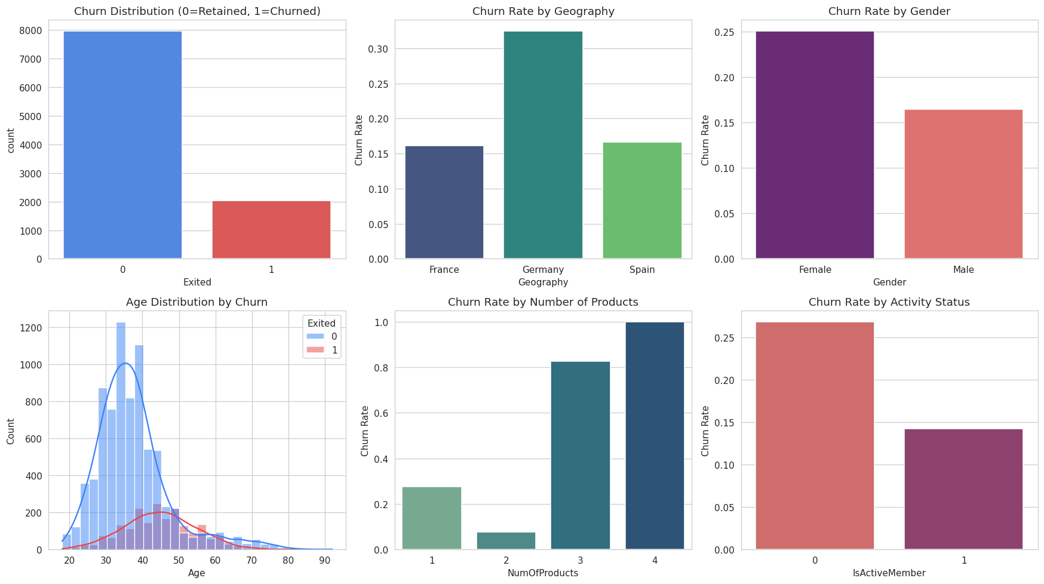
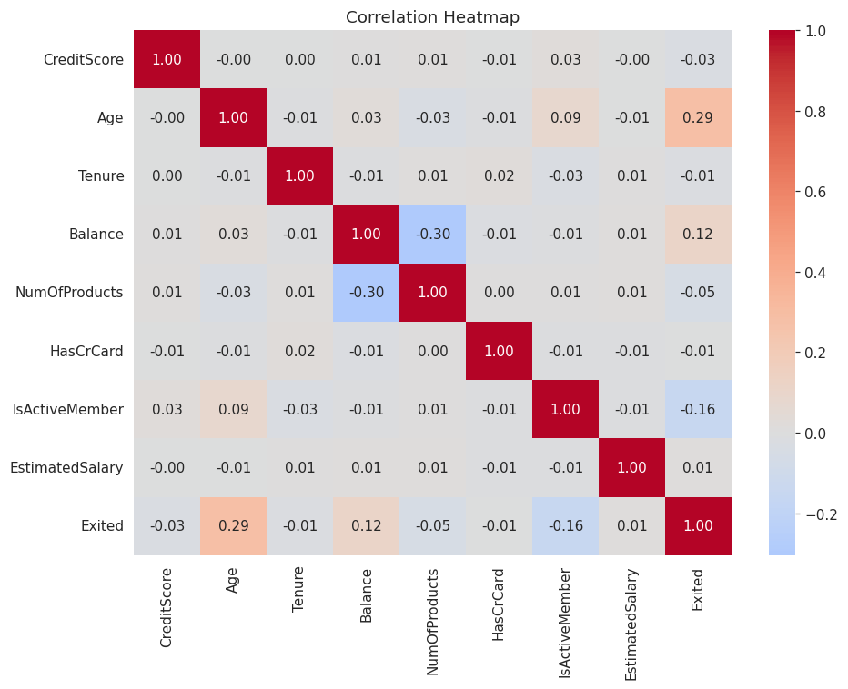

5. Feature Engineering
Beyond the raw fields, six derived features were constructed to capture relationships the brief specifically calls out:
- Balance-to-Salary Ratio — account balance relative to income, a proxy for financial capacity and product fit.
- Product Density — balance concentration per product held.
- Engagement-Product Interaction — activity status multiplied by product count, capturing whether product holding is 'engaged' or 'passive'.
- Age-Tenure Interaction — joint effect of customer age and relationship length.
- Zero-Balance Flag — indicator for dormant or empty accounts.
- Senior Flag — indicator for customers aged 60 or above.
Categorical fields (Geography, Gender) were one-hot encoded, and numeric features were standardized for the linear model. A stratified 80/20 train-test split preserved the 20.4% churn ratio in both partitions, and 5-fold stratified cross-validation was used to validate model stability.

6. Model Development and Evaluation
Four models were trained: Logistic Regression as an interpretability benchmark, a Decision Tree, a Random Forest, and Gradient Boosting as the advanced ensemble method (in place of XGBoost, which the brief lists as optional and which required a package unavailable in this environment; scikit-learn's Gradient Boosting implementation serves the same role).
Model | Accuracy | Precision | Recall | F1-Score | ROC-AUC
Logistic Regression | 0.724 | 0.402 | 0.727 | 0.518 | 0.792
Decision Tree | 0.757 | 0.443 | 0.769 | 0.562 | 0.826
Random Forest | 0.846 | 0.611 | 0.668 | 0.639 | 0.867
Gradient Boosting | 0.868 | 0.785 | 0.484 | 0.599 | 0.871

Gradient Boosting produced the strongest overall discrimination (ROC-AUC 0.871, cross-validated mean 0.865 ± 0.009), and its precision (0.785) means retention campaigns built on its flags waste little effort on false alarms. However, its recall of 0.484 means it misses over half of customers who actually churn — a meaningful business cost when the goal is proactive intervention. Random Forest trades some precision for materially better recall (0.668) and the best F1-score (0.639) of the four models, making it the more balanced choice if the bank prioritizes catching at-risk customers over minimizing outreach volume.
Because this trade-off is a business decision and not a purely statistical one, the deployed dashboard uses Gradient Boosting as its default scoring model but exposes an adjustable probability threshold, letting stakeholders shift the balance toward recall (catch more churners, accept more false alarms) or precision (fewer, higher-confidence alerts) depending on retention campaign capacity.
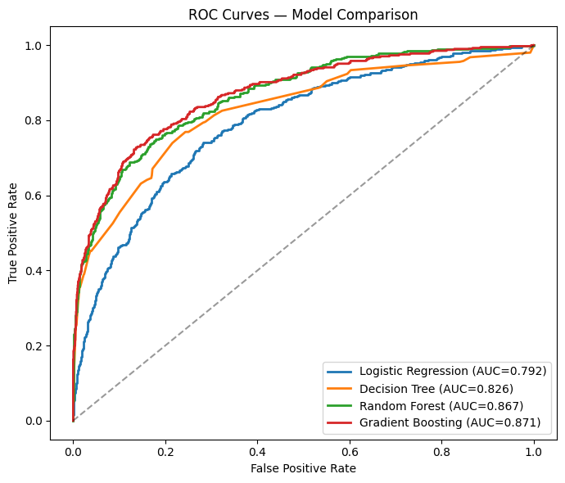
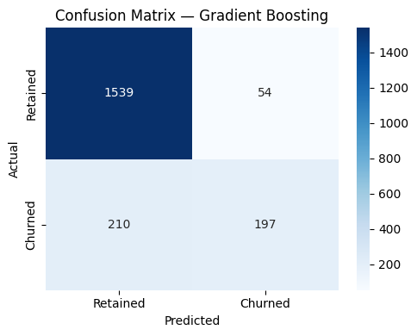

7. Model Explainability
SHAP was unavailable in this environment; explainability was instead derived from scikit-learn's permutation importance (which measures the drop in ROC-AUC when a feature's values are randomly shuffled) and partial dependence plots, which show comparable interpretive value for tree-based models.
Age and NumOfProducts are by a wide margin the two strongest predictors, followed by Geography (Germany), activity status, and balance. This confirms the EDA finding: churn risk is concentrated in older customers holding either too few or, more strikingly, three-plus products, and is elevated for customers in Germany regardless of other factors.
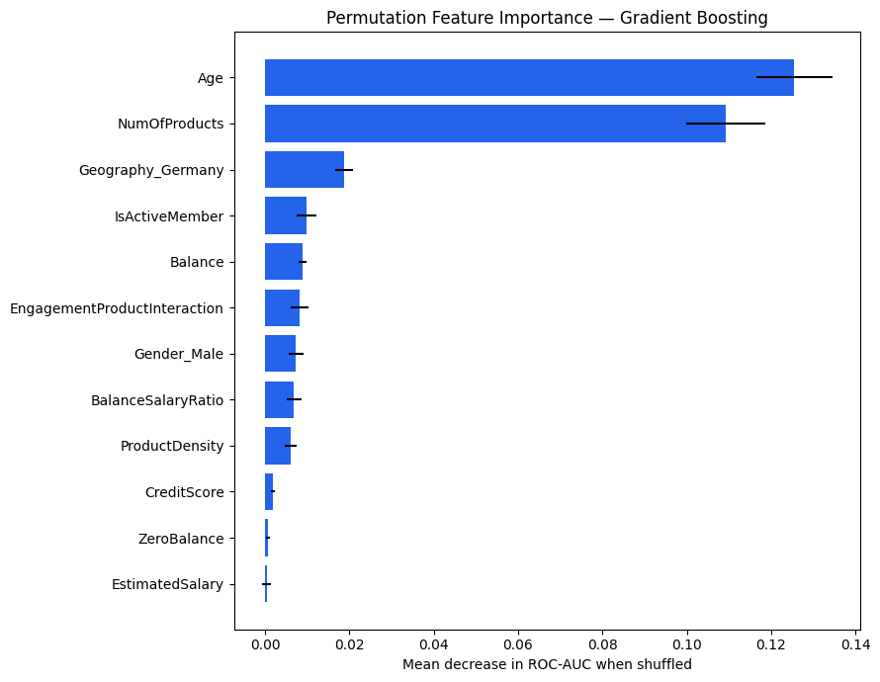
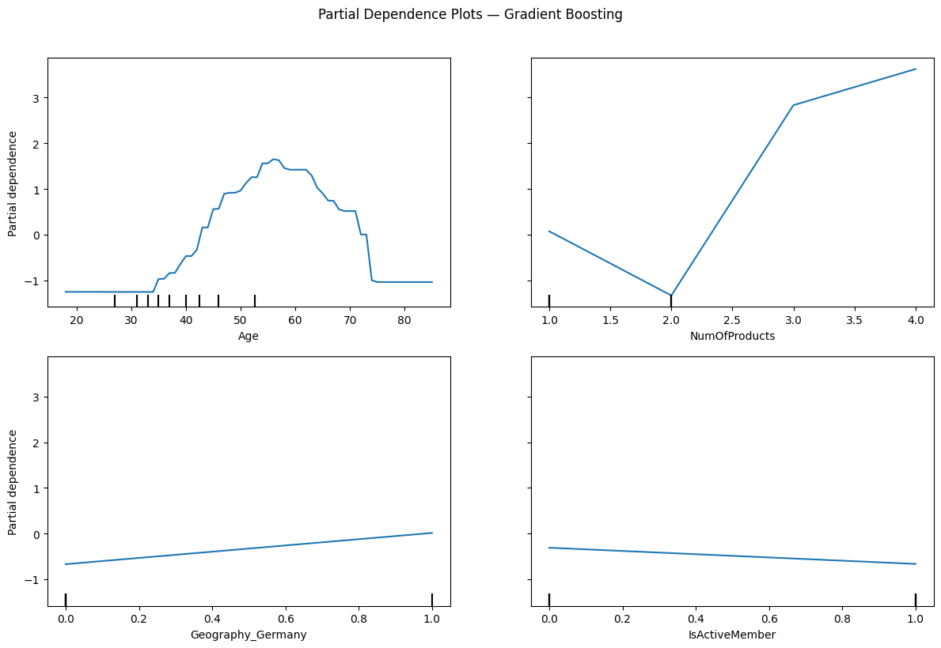

8. Business Recommendations
- Investigate the 3-4 product segment immediately — an 83-100% churn rate suggests these customers are being over-sold or mis-sold products, or are escalating complaints before leaving. This is a high-value, low-volume group (326 customers) worth a manual review.
- Prioritize re-engagement campaigns for inactive members, who churn at nearly double the rate of active members — a comparatively low-cost lever (e.g., app nudges, statement check-ins).
- Review the German market specifically — its churn rate (32.4%) is double France and Spain, warranting a local investigation into competitive pressure, pricing, or service quality.
- Target retention offers at customers aged 45+, who show meaningfully higher churn than the under-40 base.
- Use the adjustable-threshold dashboard to size retention campaigns to available capacity — a lower threshold surfaces more at-risk customers for high-capacity campaigns; a higher threshold concentrates effort on the most confident predictions.

9. Conclusion
This project reframes churn analysis from a retrospective, demographic exercise into a forward-looking, engagement-and-product-driven risk scoring system. The clearest actionable insight is that product over-concentration, not just product scarcity, drives attrition — a finding that a purely demographic lens would have missed. Combined with the accompanying Streamlit dashboard, this system gives retention teams a probability score, an explanation, and a simulation tool to act before customers leave rather than after.

