Storyboard

102103092 (Pahuljot Singh) ||102103180 (Sanmaandeep Singh Gill)

**Bouncing Ball Project**

 

Frame-1 Frame-2

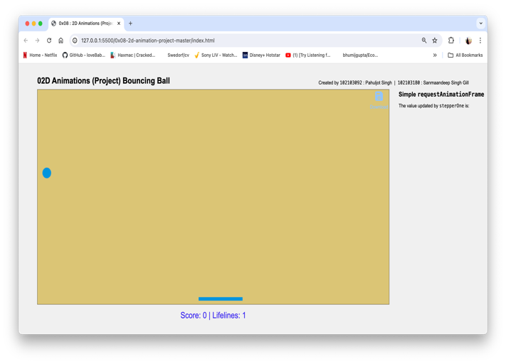 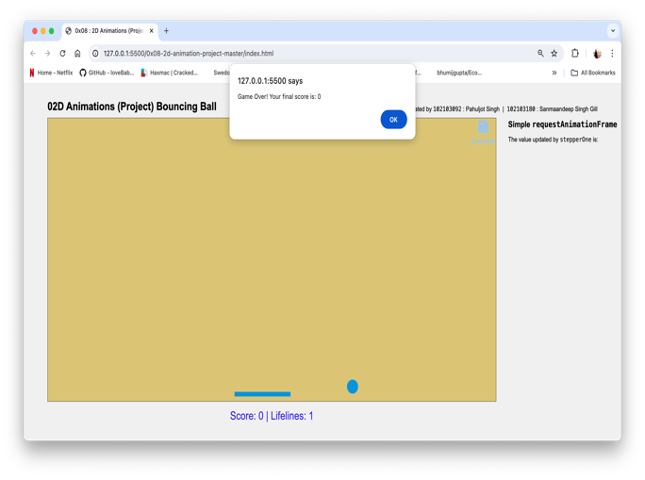

Frame-3 Frame-4