KAIBURR

Task 1. Java REST API example.

# 1.1] ● GET servers.

-> Should return all the servers if no parameters are passed

[Initially there are no servers on the database]

-> Code: curl http://localhost:8080/servers

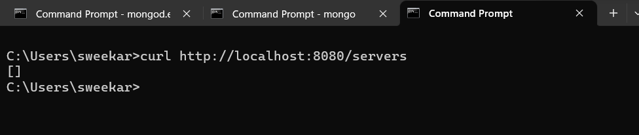

-> after entering some values

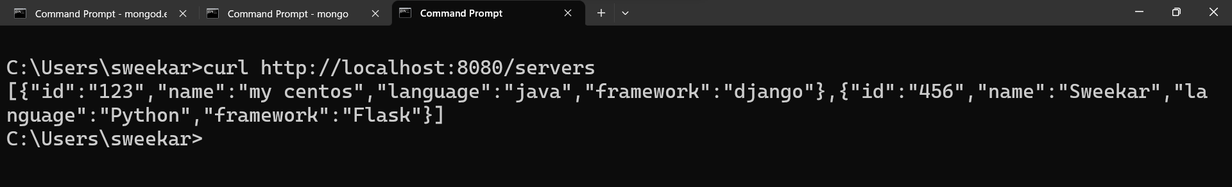

*[When server id is passed as a parameter - return a single server or 404 if there’s no such a server.]*

-> Code: [By id]

curl <http://localhost:8080/servers?id=123>

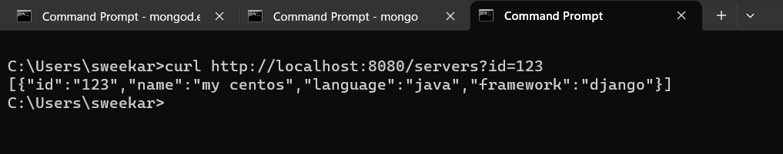

curl [http://localhost:8080/servers?id=456](http://localhost:8080/servers?id=4563)

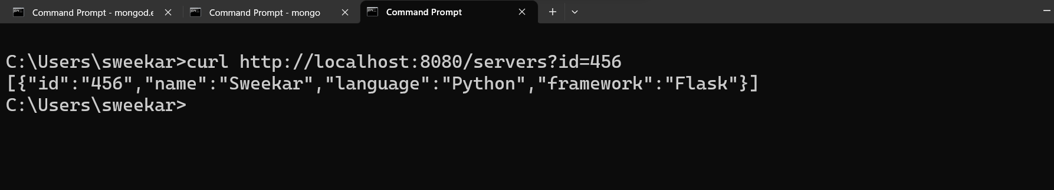

-> Code : curl http://localhost:8080/servers?id=789

when: [Id not in Database]

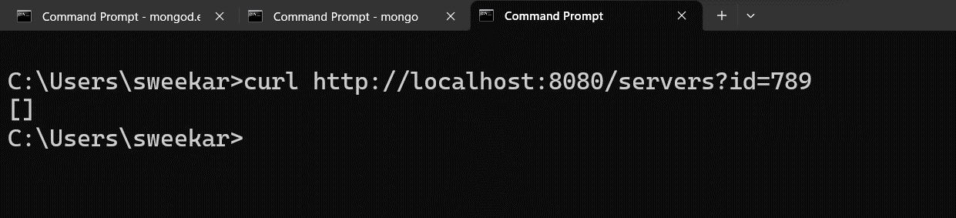

# 1.2] ● PUT a server.

-> Code:  
curl -X PUT -H "Content-Type: application/json" -d "{\"id\": \"123\", \"name\": \"my centos\", \"language\": \"java\", \"framework\": \"django\"}" <http://localhost:8080/servers>



# 1.3] ● DELETE a server.

-> Code: [The parameter is a server ID.]

curl -X DELETE http://localhost:8080/servers/123

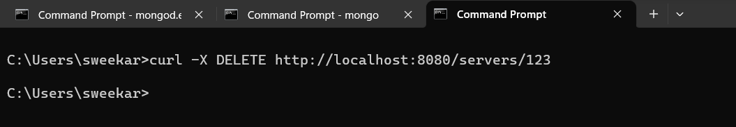

# 1.4] ● GET (find) servers by name.

-> Code: curl [http://localhost:8080/servers?name=my centos](http://localhost:8080/servers?name=my%20centos)

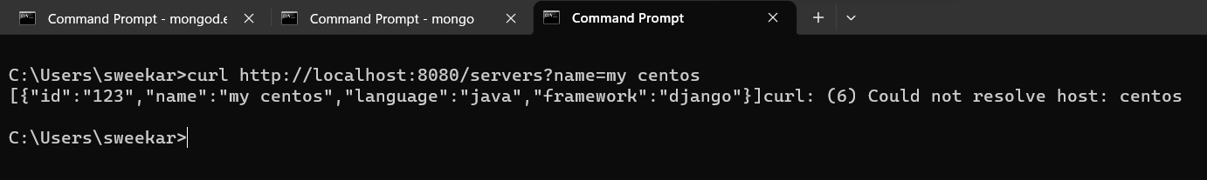

-> Code: curl <http://localhost:8080/servers?name=Sweekar>

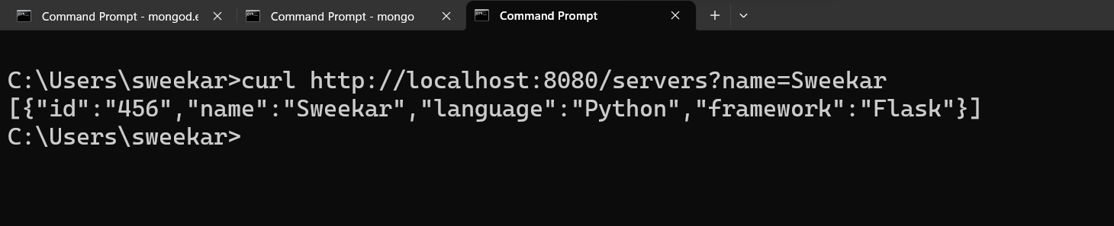

-> code: [with wrong name]

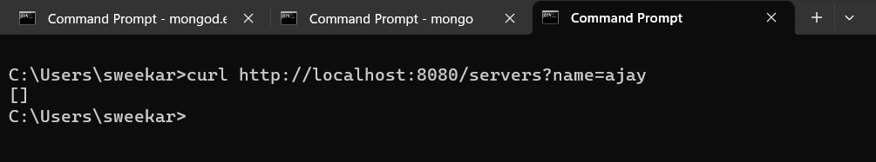

# -> All these values are stored in the mongodb database:

