**Face Recognition on Raspberry Pi – Project Setup Guide**

# 1. Overview

This document provides step-by-step instructions to set up and run a face recognition system on a Raspberry Pi using a camera module, ONNX-based InsightFace model, and Python. The project captures an image using the Pi camera, processes it with a pre-trained deep learning model, and identifies known faces based on previously trained embeddings.

# 2. Hardware Requirements

1. **Raspberry Pi 4 Model B 2019 Quad Core 64 Bit WiFi Bluetooth (4GB)**

https://www.amazon.com/Raspberry-Model-2019-Quad-Bluetooth/dp/B07TC2BK1X?th=1

1. **Raspberry Pi 4 Case with Fan Cooling Pi 4B Case with 5V 3A Power Supply**

https://www.amazon.com/dp/B07TTN1M7G?ref=ppx_yo2ov_dt_b_fed_asin_title

1. **Micro HDMI to HDMI Adapter (for connecting to a display monitor)**

https://www.amazon.com/dp/B0DGG7NTSS?ref=ppx_yo2ov_dt_b_fed_asin_title&th=1

1. **SanDisk Ultra 32GB UHS-I/Class 10 Micro SD**

https://www.amazon.com/SanDisk-Ultra-UHS-I-Memory-Adapter/dp/B00M55C0NS?th=1

1. **Picamera2 (for Raspberry Pi camera)**

https://www.amazon.com/Raspberry-Pi-Camera-Module-Megapixel/dp/B01ER2SKFS?ref_=ast_sto_dp

All these components are readily available on Amazon. Following is what I purchased, but you can get it from many online sources:

1. RaspberryPi 4Gb board

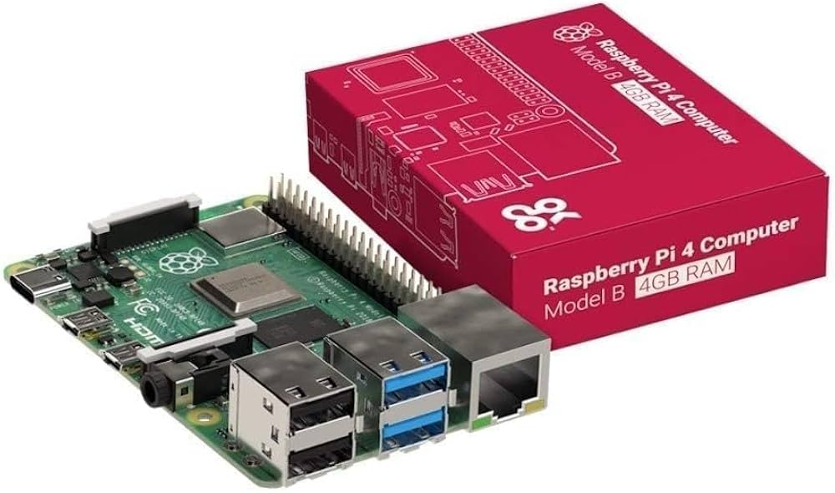

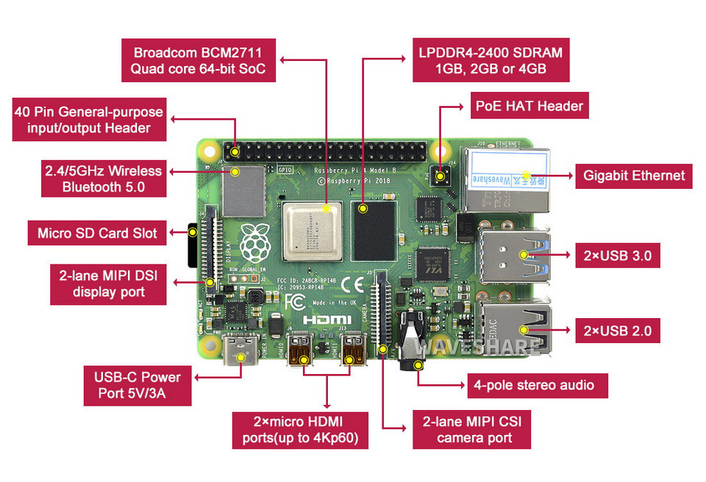

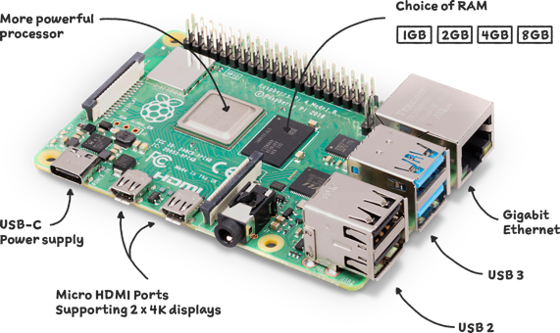

1. Case with Fan

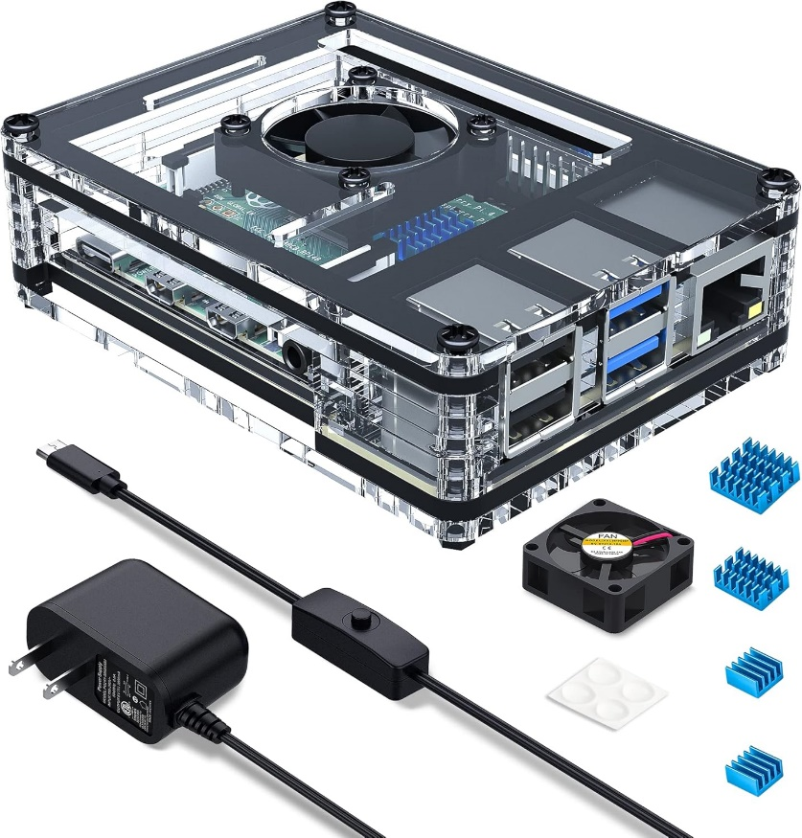

1. Micro HDMI to HDMI adapter

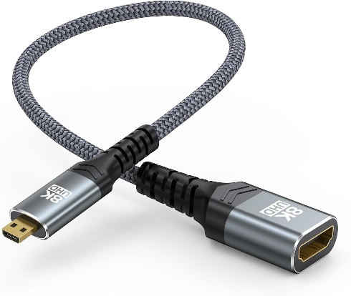

1. MicroSD Card



1. Raspberry Pi Camera Module 2

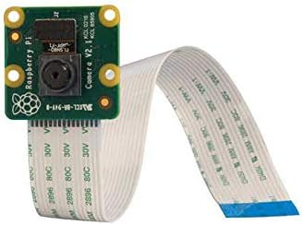

# 3. Software Requirements

- Raspberry Pi OS (download available: [Raspberry Pi OS – Raspberry Pi](https://www.raspberrypi.com/software/))

- Python 3.9 or later

- ONNX Runtime, NumPy, and OpenCV libraries

- InsightFace model

- Download buffalo_l file available from:<https://github.com/deepinsight/insightface>

- Will be specifically using the w600k_r50.onnx file

# 4. Software Setup

a. Update and install required system packages:

sudo apt update

sudo apt install python3-picamera2 libcamera-apps

b. Set up a Python virtual environment (optional but recommended):

python3 -m venv deepface_env  
source deepface_env/bin/activate

c. Install Python dependencies:

pip install numpy opencv-python onnxruntime

# 5. Download the InsightFace Model

Download the ONNX model file (e.g., w600k_r50.onnx) from the official InsightFace GitHub repository:  
https://github.com/deepinsight/insightface  
Place the model in a folder such as buffalo_l/ and update your code to match the path.

# 6. Recommended Folder Structure

face_recognition_pi/  
├── train.py  
├── recognizer.py  
├── capture_and_show.py  
├── buffalo_l/  
│ └── w600k_r50.onnx  
├── embeddings/  
├── Dataset/  
├── capturedimage/  
└── test_images/

# 7. Running the Program

- First, run train.py to extract embeddings from Dataset/

- Then, run recognizer.py to capture an image, recognize the face, and print the result

# 8. Notes

- Ensure lighting is good for face detection.

- Use consistent face angles for training and testing.

- The camera takes a short time to warm up; allow for a brief delay before capture.