Atmospheric Analysis of WASP-39 b Using JWST Transmission Spectra

Figure 0: Artist's Concept of WASP-39b, taken from NASA

Abstract
The James Webb Space Telescope (JWST) has opened a new era in exoplanetary science, allowing a precise detection of atmospheric molecules for various exoplanets. This study leverages JWST's NIRSpec PRISM transmission spectrum of WASP-39 b to decode the chemical and molecular composition of its atmosphere. Clear absorption features reveal the presence of water vapor (H₂O) and carbon monoxide (CO), while methane (CH₄) remained undetected. The possible existence of alkali metals and carbon dioxide (CO₂) is also observed. Signal-to-noise analysis across key molecular bands supports a high-temperature, water-rich atmosphere with limited cloud or haze interference.

Introduction
WASP-39 b is a hot Jupiter-class exoplanet orbiting a G-type star roughly 698 light-years from Earth. Discovered in 2011 via the transit method, it has a low density, with a mass of 0.28 Jupiter masses and a radius of 1.33 Jupiter radii. With an orbital period of just 4.1 days and equilibrium temperature near 1100 K, WASP-39 b provides an ideal resource for testing its atmospheric spectroscopy, especially for the water and carbon-based molecules. In June of 2022, it became one of the first exoplanets observed with the James Webb Space Telescope (JWST), allowing researchers to study its transmission spectrum in unprecedented detail.

Background
The identification of exoplanets holds profound importance for humanity, fundamentally reshaping our understanding of our place in the universe and offering tantalizing prospects for the future. The discovery of planets orbiting stars beyond our Sun directly addresses the long-standing question of whether our solar system and Earth are unique. Each new exoplanet detection provides crucial statistical data, allowing us to estimate the prevalence of planetary systems throughout the galaxy and to better understand the diverse conditions under which planets can form and evolve. This knowledge informs our search for potentially habitable worlds and the conditions necessary for life to arise elsewhere.
In addition to this foundational understanding, the study of exoplanet atmospheres offers a pathway to detect biosignatures—chemical imbalances or molecules indicative of life. While the detection of life beyond Earth remains a distant goal, ongoing advancements in telescope technology and analytical techniques are bringing this possibility closer to realization. The implications of such a discovery would be revolutionary, altering our understanding of biology, philosophy, and our cosmic destiny. Beyond the purely scientific, the search for and eventual understanding of other planetary systems can inspire future generations, drive technological innovation, and foster a broader perspective on the interconnectedness of the universe.
Given this context, analyzing the hot gas giant WASP-39 b presents an excellent starting point for in-depth exoplanet atmospheric studies for several compelling reasons. As a “hot Jupiter”—a planet with a size similar to Jupiter but orbiting its star much closer—WASP-39 b exhibits a significantly inflated atmosphere. This inflated nature, coupled with its relatively high temperature, results in a larger atmospheric scale height. A greater scale height translates to a larger atmospheric volume available for observation, making it easier to detect and characterize the presence of various molecules through transmission spectroscopy as the planet transits its star.
Moreover, WASP-39 b has been the subject of previous observations by space telescopes like Hubble and Spitzer, providing a valuable foundation of existing data across a range of wavelengths. This prior knowledge allows for more focused and efficient follow-up observations with newer, more powerful instruments like the James Webb Space Telescope (JWST). The combination of its favorable atmospheric properties and existing multi-wavelength data makes WASP-39 b an ideal laboratory for refining our techniques in atmospheric analysis and for probing the chemical composition and physical processes occurring in exoplanet atmospheres. Studying this well-characterized world will pave the way for more detailed investigations of potentially habitable exoplanets.
When an exoplanet like WASP-39 b passes in front of its star, some of the starlight filters through the planet’s atmosphere, causing tiny dips in the star’s observed brightness at certain wavelengths—a measurement known as transit depth. Scientists use this information to create a transmission spectrum, showing how much light was absorbed at each wavelength. Different molecules absorb light differently, so by analyzing these patterns, researchers can determine the chemicals present in the atmosphere and how they might behave under the planet’s temperature and pressure conditions.

Methods
JWST NIRSpec PRISM transmission spectrum data for WASP-39 b was obtained from the NASA Exoplanet Archive, hosted by Caltech/IPAC. The dataset was accessed in CSV format from the archive’s “Exoplanet Atmospheres” section and includes wavelength values (µm), transit depths, and uncertainty estimates across the 0–5 µm range.
Data analysis was performed using Python (version 3.11), with libraries including Pandas, NumPy, SciPy, and Matplotlib. The transmission spectrum was plotted with wavelength on the x-axis and transit depth on the y-axis; it also included error bars and overlaid known molecular absorption bands for water (H₂O), carbon dioxide (CO₂), methane (CH₄), carbon monoxide (CO), and alkali metals (Na/K).
Band strengths were analyzed by calculating the mean transit depth within each molecular range and comparing it to a nearby continuum. Signal-to-noise ratios (SNRs) were computed to assess detection confidence. A linear regression was performed across 0.8–2.0 µm to estimate the overall slope of that spectrum’s section.

Results
Data of Molecular Band on a Wavelength with the Transit Depth
The results of the implemented Python program display the following charts (wavelength vs transit depth and the same one with a signal-to-noise ratio), along with a final Molecule Detection Summary, based on the JWST dataset and the input range in µm:
Figure 1
Transmission Spectrum of WASP-39 b with Overlaid Molecular Bands:
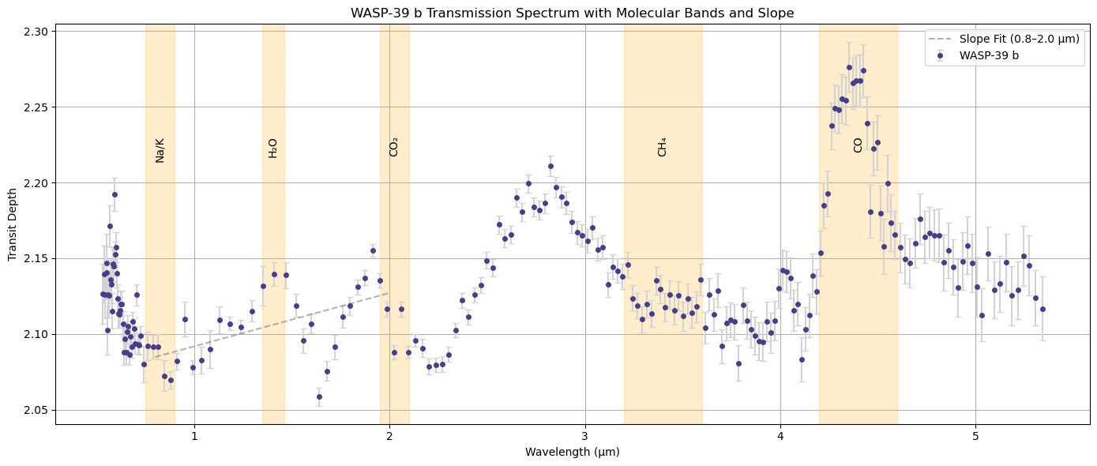This figure shows the wavelength-dependent transit depth of WASP-39 b's atmosphere. Absorption features correspond to expected molecular bands for H₂O, CO₂, CH₄, CO, and Na/K.
Figure 2
Signal-to-Noise Ratio (SNR) Across Molecular Bands:
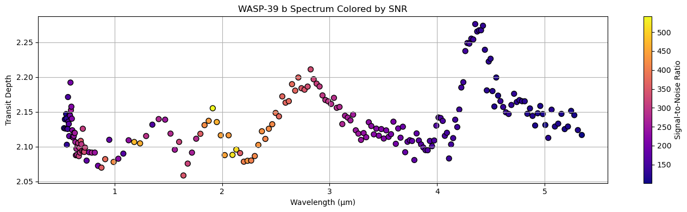Each colored segment represents a molecular band. SNR values above 3 indicate strong detections. H₂O and CO show strong signals, while CH₄ and Na/K bands are weak or negative.
Molecular Band Summary
Table 1
Molecular Detection Summary from JWST Transmission Spectrum
Molecule | Range (µm) | Mean Depth | Δ Depth vs. Continuity | SNR
H₂O | 1.35-1.46 | 2.1356 | 0.0257 | 2.44
CO₂ | 1.95-2.10 | 2.1088 | -0.0252 | -5.54
CO | 4.20-4.60 | 2.2214 | 0.1096 | 6.53
CH₄ | 3.20-3.60 | 2.1225 | -0.0249 | -2.66
Na/K | 0.75-0.90 | 2.0834 | -0.0225 | -2.70
Slope Analysis
The slope of the transmission spectrum between 0.8–2.0 µm was calculated as:
$$3.53×{10}^{-2} per µm$$
This positive slope indicates increasing transit depth with wavelength—an expected characteristic for a relatively clear atmosphere with molecular absorption values.

Discussion
Interpretation of Molecular Features
H₂O (1.35–1.46 µm): The spectrum shows a rise in this region. This suggests strong evidence for water vapor in the upper atmosphere, however, one must be aware that this band only contains three data points with a 250-300 SNR, so it may not be completely reliable.
CO₂ (1.95–2.1 µm): Surprisingly, the signal dips, having a negative slope and a negative SNR. This suggests no significant CO₂ detection in this region of the spectrum, possibly due to overlapping opacities or vertical mixing occurring in the atmosphere of the planet.
CO (4.2–4.6 µm): A sharp increase is present, indicating a strong CO signal. This aligns with predictions from thermochemical models for hot Jupiters, where CO becomes dominant over CH₄ at high temperatures.
CH₄ (3.2–3.6 µm): The spectrum in the methane region is relatively flat, with no significant rise and having a negative SNR, suggesting CH₄ is not abundant—contrary to cooler gas giants.
Na/K (0.75–0.9 µm): There is a slight bump around 0.8 µm, but it lacks a strong signal and has a low SNR. These alkali metals may exist in deeper layers or be obscured by possible clouds.
Chemistry and Temperature Effects
The absence of methane and low sodium/potassium signals may be explained by:
Photodissociation: High-energy ultraviolet radiation from the host star can break down CH₄ into CO or complex hydrocarbons, through an equation like this:
CH₄ + CO₂ → 2CO + 2H₂
Thermal Chemistry: At high temperatures (~1100 K), carbon monoxide (CO) becomes thermodynamically favored over methane (CH₄), as seen in equilibrium models, like:
CH₄ + H₂O → CO + 3H₂
This reaction shifts towards the right (creating CO and H₂) at higher temperatures, as predicted by Le Chatelier’s Principle. Since WASP-39 b is a hot Jupiter-type planet with an equilibrium temperature above 1000 K, CO becomes the dominant carbon molecule, replacing CH₄.
Vertical Mixing: Intense atmospheric motion can transport CO-rich air from deeper layers upward, preventing methane buildup.

Implications
Implications for Planetary Formation
The strong detection of CO and H₂O, and the absence of CH₄, implies that WASP-39 b’s atmosphere is shaped more by internal heat and vertical mixing. This explains WASP-39 b’s constantly unstable atmosphere where the molecules CO and H₂O don't react to form other compounds at a rate predicted by their chemical potential (having different concentrations). The low visibility of alkali metals like sodium and potassium hints at their possible existence in deeper atmospheric layers.
Implications for Exoplanet Climatology
The positive spectral slope and the molecular features imply a relatively clear atmosphere, with little haze, allowing for a higher possibility of observing the atmospheric layers. Furthermore, the patterns of heat redistribution within the atmosphere and the absence of high levels of methane support current models of hot Jupiters. This aids in the refinement of climate dynamics predictions for similar gas giants exposed to intense stellar irradiation like WASP 39b.
Broader Scientific Impact
WASP-39 b’s well-characterized atmosphere and strong molecular signals make it a valuable reference planet for validating testing methods of analyzing atmospheres. The analytical methods used here can also be adapted to study other exoplanets, particularly those in habitable zones, improving the ability to assess potential atmospheric chemical compositions of different chemically diverse and potentially life-hosting exoplanets.

Conclusion
Based on the JWST dataset, the transmission spectrum of WASP-39 b reveals a chemically diverse and thermally dynamic atmosphere. Water vapor and carbon monoxide are confidently detected, while carbon dioxide, methane, and the alkali elements like Na and K are weak or undetectable. An overall positive spectral slope suggests minimal cloud interference and a relatively clear atmosphere, supporting the clearer observation of molecular bands. The influence of temperature and photochemistry on molecular composition can help support CO’s existence in comparison to CH₄. These findings contribute to the growing understanding of the molecular makeup of hot Jupiter-type atmospheres and the mechanisms that sculpt them.

References
NASA. (2025, April 19). WASP-39 b. NASA Science. https://science.nasa.gov/exoplanet-catalog/wasp-39-b/
WebbTelescope.org. (2022, November 22). Webb reveals an exoplanet atmosphere as never seen before. https://webbtelescope.org/contents/news-releases/2022/news-2022-060
NASA Exoplanet Archive. (2025, April 19). Exoplanet atmospheres dataset. Caltech/IPAC. https://exoplanetarchive.ipac.caltech.edu/cgi-bin/atmospheres/nph-firefly?atmospheres. https://doi.org/10.26133/NEA36
ScitechDaily. (2022, December 17). Webb space telescope reveals a uniquely inflated and asymmetric exoplanet. https://scitechdaily.com/webb-space-telescope-reveals-a-uniquely-inflated-and-asymmetric-exoplanet/
WebbTelescope.org. (2025, April 19). Webb’s impact on exoplanet research. https://webbtelescope.org/contents/articles/webbs-impact-on-exoplanet-research
WebbTelescope.org. (2025, April 19). How will Webb study exoplanets? https://webbtelescope.org/contents/articles/how-will-webb-study-exoplanets
NASA. (2022, November 22). NASA’s Webb reveals an exoplanet atmosphere as never seen before. https://www.nasa.gov/universe/nasas-webb-reveals-an-exoplanet-atmosphere-as-never-seen-before/
Jet Propulsion Laboratory. (2022, November 26). NASA finds a large amount of water in an exoplanet’s atmosphere. https://www.jpl.nasa.gov/news/nasa-finds-a-large-amount-of-water-in-an-exoplanets-atmosphere/

