**Megadeus**

April 10, 2013

|  |
| --- |
|  |
| E-Learning Resource Locator |
|  |
|  |

**E-Learning Resource Locator**

**Software Requirement Specification**

**Version <1.0>**



**VELAMMAL ENGINEERING COLLEGE**

**Chennai-600066**

**TEAM MEMBERS VAIDHYANATHAN.A BARATH.R PRASHANTH.V PRADEEP.A.J PROJECT GUIDE Mr. Ahamed Ali Assistant Professor**

**Department of Information Technology**

Table of Contents

1.0 Introduction 5

1.1 Purpose 5

1.2 Scope 5

1.2.1Additional features 6

1.3 Users 6

1.4 Definitions 7

1.5 Tools Used 8

1.6 References 13

1.7 Technologies to be used 13

1.8 Overview 13

1.8.1 Existing system and their disadvantages 13

1.8.2 Proposed System 13

1.8.3 Advantage 14

2.0 Overall Description 15

2.1 Product Perspective: 15

2.2 Software Interface 15

2.3Hardware interface 16

2.4 Product function: 16

2.5 Communication Interface: 17

2.6 User Characteristics: 17

2.7 Constraints: 17

2.8 Architecture: 17

2.9 User case model survey: 18

2.10 Class diagram 19

2.11 Sequence Diagrams 20

2.11.1 E-R DIAGRAM 20

2.12 Assumptions and Dependencies 21

3.0 Specific Requirements 21

3.1 Use case reports 21

3.2 Supplementary Requirements 23

SOFTWARE REQUIREMENT

SPECIFICATION

**E-Learning Resource Locator**

# 1.0 Introduction

## 1.1 Purpose

E-Learning Resource Locator is a website that provides interaction between students and professors of various universities in one place. .

## 1.2 Scope

• Study materials can be downloaded from this site, and also a wide range of topics-related documents are also available

• Providing user account to every student, professor and publication.

• Upon verification, the user can do the allowed actions, based on the user account they have activated.

• E-books can be published by renowned publications.

• Users can discuss and share knowledge in forum.

• Topper and Professor can upload study resources.

• Mentor suggest a book in public.

• All user can like/dislike articles.

• Mentor reads reports and remove documents if necessary.

### 1.2.1Additional features

• Advanced Search facility is available to search for documents using various criteria.

• Specimen copies of books are given by publications to professors.

## 1.3 Users

    • Student , who is promotable to Topper.

    • Professors of Esteemed Institutions & Colleges.

    • Mentors, who help the students in the online learning process.

    • Book publications, which upload e-books.

## 1.4 Definitions

**JSP: Java Server Page** – Server side programming tool

**AJAX**: **Asynchronous java script and XML** - Used to change page content without reload. It can also be used to create dynamic web pages.

**DB2**: **Database Management System 2 -** It provides the flexible and efficient database platform

**UML**: **Unified Modeling Language** - It is a standard language for writing software blue print.

**HTML: Hypertext Markup Language** –It’s a markup language used to design static web pages.

**HTTP**: **Hyper Text Transfer Protocol** – It’s a service protocol.

**HTTPS:** Secure Hypertext Transfer Protocol is a HTTP over SSL (secure socket layer).

**WASCE**: **Web Sphere Application Server community edition -** It is an application server that runs and support J2EE and web service application.

**RAD: Rational Application Developer -** It is a development tool that helps to design web pages and also helps to design the diagrams like ER, Database schema diagrams and to generate DDL.

## 1.5 Tools Used

**J2EE**

Java Platform, Enterprise Edition provides an API and runtime environment for developing and running enterprise software, including network and web services, and other large-scale, multi-tiered, scalable, reliable, and secure network applications. The platform incorporates a design based largely on modular components running on an application server. The platform emphasizes Convention over configuration and annotations for configuration.

**JSP**

Java Server Pages (JSP) is a technology that helps software developers create dynamically generated web pages. JSP may be viewed as a high-level abstraction of Java servlets.1At runtime, JSP's are translated into servlets; each JSP's servlet is cached and re-used until the original JSP is modified. JSP allows Java code and certain pre-defined actions to interleave with static web markup content, with a resulting page being compiled and executed on the server to deliver a document. The compiled pages and any dependent Java libraries, use Java bytecode rather than native software format. Similar to any other Java program, they must be executed within Java virtual machine (JVM) that integrates with the server's host operating system to provide an abstract platform-neutral environment. JSPs are usually used to deliver HTML and XML documents, but with the use of OutputStream, they can deliver any other types of data as well.The Web container creates JSP implicit objects like pageContext, servletContext, session, request & response.

**HTML**

HyperText Markup Language is the main markup language for creating web pages and other information that can be displayed in a web browser. HTML is written in the form of HTML elements consisting of tags enclosed in angle brackets, within the web page content. The purpose of a web browser is to read HTML documents and compose them into visible or audible web pages. The browser does not display the HTML tags, but uses the tags to interpret the content of the page. It provides a means to create structured documents by denoting structural semantics for text such as headings, paragraphs, lists, links, quotes and other items. It can embed scripts written in languages such as JavaScript which affect the behavior of HTML web pages. Web browsers can also refer to Cascading Style Sheets (CSS) to define the appearance and layout of text and other material. The W3C is the maintainer of both the HTML and the CSS standards.

**CSS**

Cascading Style Sheets is a style sheet language used for describing the presentation semantics (the look and formatting) of a document written in a markup language. Its most common application is to style web pages written in HTML and XHTML. CSS is designed primarily to enable the separation of document content (written in HTML or a similar markup language) from document presentation, including elements such as the layout, colors, and fonts. This separation can improve content accessibility, provide more flexibility and control in the specification of presentation characteristics, enable multiple pages to share formatting, and reduce complexity and repetition in the structural content (such as by allowing for tableless web design).

**Javascript**

JavaScript is an interpreted computer programming language. It was originally implemented as part of web browsers so that client-side scripts could interact with the user, control the browser, communicate asynchronously, and alter the document content that was displayed. JavaScript is dynamic, weakly typed, and has first-class functions.

**AJAX**

Asynchronous JavaScript and XML is a group of interrelated web development techniques used on the client-side to create asynchronous web applications. With Ajax, web applications can send data to, and retrieve data from, a server asynchronously (in the background) without interfering with the display and behavior of the existing page. Data can be retrieved using the XMLHttpRequest object. Ajax is not a single technology, but a group of technologies. HTML and CSS can be used in combination to mark up and style information. JavaScript and the XMLHttpRequest object provide a method for exchanging data asynchronously between browser and server to avoid full page reloads.

**RAD**

Rational Application Developer for WebSphere Software is a commercial Eclipse-based integrated development environment , made for visually designing, constructing, testing, and deploying Web services, portals, and Java Enterprise Edition (JEE) applications. Rational Application Developer includes tools to improve code quality. To manage source code, a development team can configure Rational Application Developer to work with a source code repository system. The workbench includes tools for deploying an application to a local or remote server. It contains test environments for WebSphere Application Server. Using these tools, a software developer can test their application locally before publishing it to a production server.

**WASCE**

WebSphere Application Server Community Edition is a free, certified Java EE 6 application server for building and managing Java applications. It is IBM's supported distribution of Apache Geronimo that uses Tomcat for servlet container and Axis 2 for web services.

**DB2**

DB2 is a relational model database server developed by IBM. It provides graphical interface tools for developing and deploying database applications easily. SQL is used to perform operations on the database systems

**ECLIPSE**

Eclipse is an open source community which develops open platforms and products. The Eclipse Platform is designed for building integrated development environments (IDEs). It can be used to create diverse end-to-end computing solutions for multiple execution environments.

## 1.6 References

• IEEE SRS format

• Wikipedia[-www.wikipedia.com](http://www.wikipedia.com)

• IBM Red Books

• IBM TGMC Sample SRS

• IBM [–www.ibm.com](http://www.ibm.com)

## 1.7 Technologies to be used

• DB2: Rational Database Management System.

• RAD: Rational Application Developer (Development tool).

• WASCE: Web Sphere Application Community Edition (Web server).

• Rational Software Modeler.

## 1.8 Overview

### 1.8.1 Existing system and their disadvantages

• By today’s position, we have to fill a lot of applications with same information.

• And there is lot of the wastage of time and paper.

• Tracking system became much complex.

### 1.8.2 Proposed System

Modified and advanced way of collecting Data Base for easy access.

### 1.8.3 Advantage

Reduced filling of application and easy access of a particular

person’s information.

# 2.0 Overall Description

## 2.1 Product Perspective:

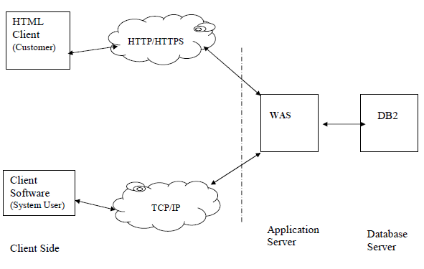

## 2.2 Software Interface

**Client:** Web browser(any).

**Web Server:** WASCE

**Data Base Server:** DB2

**Development end:** RAD(JSP, HTML), DB2, Web Sphere(web server).

## 2.3Hardware interface

**Minimum system requirements**:

|  |  |  |  |
| --- | --- | --- | --- |
| ***Client Side*** | | | |
| ***Internet Explorer6.0***  ***&above, Mozilla***  ***Firefox, Chrome*** | ***Processor***  *Pentium III*  *at 800*  *MHz* | ***RAM***  *128MB* | ***Disk Space***  *1GB* |
| ***Server Side*** | | | |
| ***Web sphere application server***  ***v6.1*** | *Pentium IV*  *at 1.3 GHz* | *512MB* | *2GB* |
| ***DB2 V9.1*** | *Pentium IV*  *at 1.3 GHz* | *512MB* | *1GB(Excluding data size)* |

## 2.4 Product function:

To provide a safe and virus-free website for sharing of study materials

Students can create an account, and can get access to all uploaded documents can be accessed.

Best students are promotable to Topper, who can also share valuable study materials.

Publications can upload electronic copies of their books, so as to help the students to select which books to study.

Mentors are available to help out the students in case if one needs to acquire a specific document about a specified subject.

There is a separate division for Forums where various discussions take place.

## 2.5 Communication Interface:

• Client on Internet will be using HTTP/HTTPS protocol.

• Client on Intranet will be using TCP/IP protocol.

## 2.6 User Characteristics:

Every user should be comfortable of working with computer and net browsing. He must have basic knowledge of English too.

## 2.7 Constraints:

• GUI is only in English.

• Login and password is used for identification of customer and there is no facility for guest.

• Limited to HTTP/HTTPS.

## 2.8 Architecture:

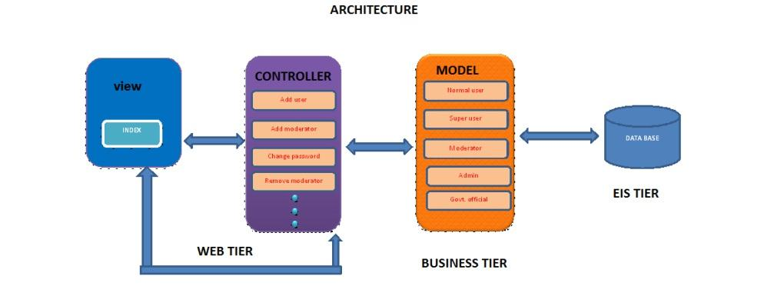

## 2.9 User case model survey:

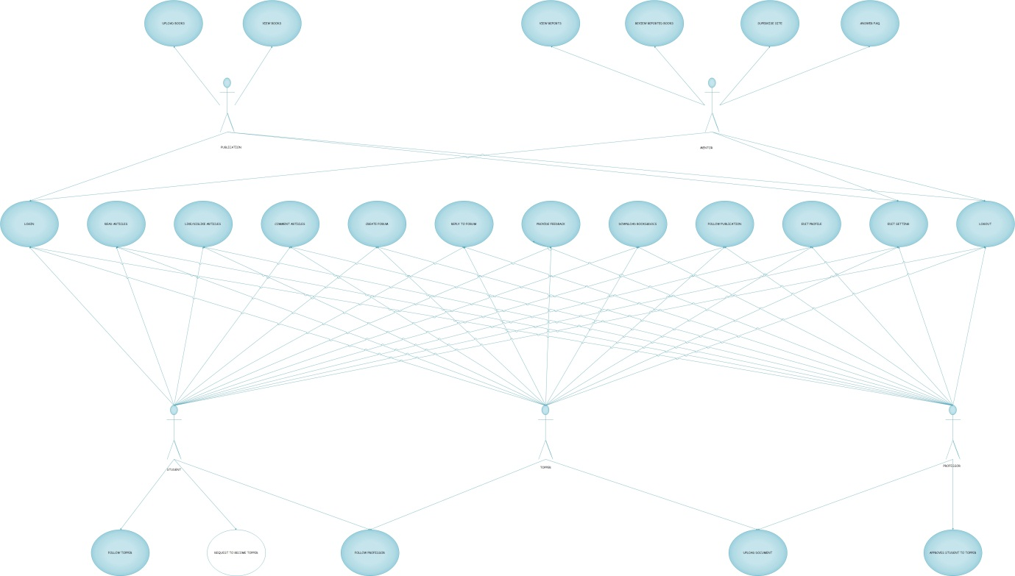

## 2.10 Class diagram

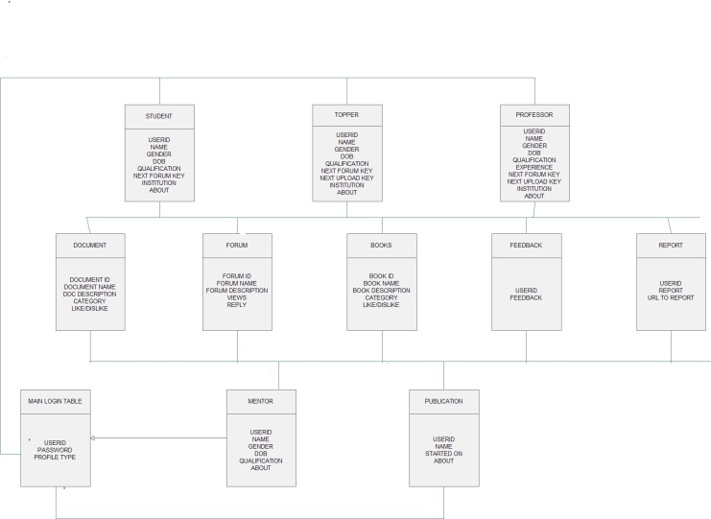

## 2.11 Sequence Diagrams

### 2.11.1 E-R DIAGRAM

## 2.12 Assumptions and Dependencies

• The end user should have a basic knowledge of English and computer

usage.

• Administrator is created in the system already.

• Roles and tasks are predefined.

# 3.0 Specific Requirements

## 3.1 Use case reports

**Login:**

Every user should log in order to access his/her account.

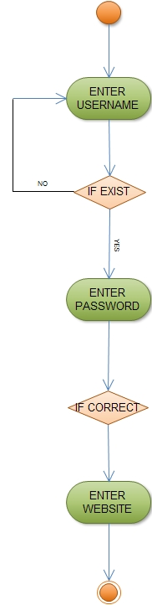

**Edit profile:**

He can able to view profile of his account and his profile info to any person he want.

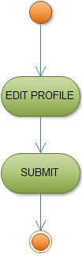

**Give feedback:**

He can give feed back to the admin about the system functionality.

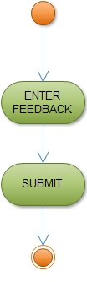

**Logout**

Finally he has to log out in order to avoid unauthorized usage.

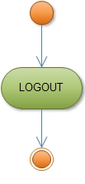

## 3.2 Supplementary Requirements

• **24 x 7 Availability -** If the base is now the entire world, staying open 24 hours a day becomes critical. Because system can be an automated Process, so it can stay open for 24 hours a day. So UPS support must be on server site for at least 8 hours in case of power failure. System will remain inaccessible to users at 2:00 to 4:00 am for backup and maintenance purpose.

• **Integration with existing enterprise systems –** Any existing Web site that relies on the manual duplication of data from another system is one that can be improved. Most of the business data in the world today exists in enterprise servers that can be connected to the Web servers to make this process far more effective.

• **Provide good performance and the ability to scale the server –** The Web application Server should provide good performance and the ability to

manage performance with techniques, such as support for caching, clustering, and load balancing.

• **Providing session management capability -** Web application developers should not spend valuable time worrying about how to maintain sessions within the application. The Web Application Server should provide these services.

**4. Concerns / Queries / Doubts if any:** When connecting to the database, the DB2Driver was not found. And installing the drivers didn’t help solve the problem.