用MATLAB画出全市结点、服务平台、出入口、路线后

用[D,R]=floyd(a);

S=D(:,PA)

[min_S,index]=min(S,[],2)

no=[1: length(NA)]

No=no'

data=[No,index,min_S]

xlswrite('data2', data)%%导出到excel

创建距离矩阵并导出有用数据到excel处理如表（部分）

|  |  |  |  |  |
| --- | --- | --- | --- | --- |
| 结点 | 最近平台 | 最近距离 | 发案率 | 平台总发案率 |
| 1 | 1 | 0 | 1.7 | 10.3 |
| 67 | 1 | 16.19417 | 0.8 |  |
| 68 | 1 | 12.07107 | 0.9 |  |
| 69 | 1 | 5 | 1.1 |  |
| 71 | 1 | 11.40312 | 1.1 |  |
| 73 | 1 | 10.29611 | 0.9 |  |
| 74 | 1 | 6.264982 | 1.1 |  |
| 75 | 1 | 9.300538 | 0.8 |  |
| 76 | 1 | 12.83607 | 1.1 |  |
| 78 | 1 | 6.403124 | 0.8 |  |
| 2 | 2 | 0 | 2.1 | 9.7 |
| 39 | 2 | 36.82186 | 1.4 |  |
| 40 | 2 | 19.14419 | 1.7 |  |
| 43 | 2 | 8 | 1.7 |  |
| 44 | 2 | 9.486833 | 1.1 |  |
| 70 | 2 | 8.602325 | 0.9 |  |
| 72 | 2 | 16.06226 | 0.8 |  |
| 3 | 3 | 0 | 2.2 | 5.6 |
| 54 | 3 | 22.70886 | 0.9 |  |
| 55 | 3 | 12.65899 | 1 |  |
| 65 | 3 | 15.23975 | 0.7 |  |
| 66 | 3 | 18.40203 | 0.8 |  |

按最近距离升序，得出表中最近距离大于50的结点数据如表

|  |  |  |  |
| --- | --- | --- | --- |
| 391 | 63 | 50.22116 | 0.9 |
| 524 | 73 | 50.64336 | 0.4 |
| 263 | 29 | 51.22334 | 0.9 |
| 200 | 40 | 52.01092 | 1.2 |
| 523 | 72 | 52.39522 | 0.6 |
| 287 | 41 | 53.31321 | 0.7 |
| 301 | 43 | 53.58276 | 1.2 |
| 316 | 43 | 54.07045 | 0.8 |
| 317 | 44 | 54.75164 | 0.6 |
| 199 | 38 | 55.0909 | 1.1 |
| 515 | 73 | 55.69654 | 0.6 |
| 513 | 73 | 55.73494 | 0.7 |
| 29 | 15 | 57.00525 | 1.4 |
| 208 | 41 | 57.10246 | 0.8 |
| 578 | 74 | 57.57529 | 0.6 |
| 253 | 34 | 58.25945 | 0.7 |
| 206 | 41 | 59.60544 | 0.8 |
| 388 | 28 | 61 | 0.8 |
| 575 | 74 | 61.63573 | 0.6 |
| 420 | 62 | 62.97488 | 1.6 |
| 202 | 40 | 64.60903 | 0.5 |
| 239 | 36 | 65.68564 | 1.4 |
| 574 | 75 | 65.83202 | 0.6 |
| 510 | 78 | 66.06822 | 1.1 |
| 264 | 29 | 66.22334 | 0.5 |
| 207 | 41 | 68.60544 | 0.7 |
| 541 | 79 | 70.41784 | 0.1 |
| 331 | 63 | 71.50951 | 0.6 |
| 371 | 46 | 73.61269 | 1.5 |
| 418 | 62 | 74.18817 | 1.1 |
| 332 | 69 | 76.1981 | 0.2 |
| 370 | 46 | 78.08483 | 1.2 |
| 389 | 28 | 79.86796 | 0.2 |
| 362 | 49 | 81.06913 | 0.1 |
| 419 | 62 | 81.18817 | 1.4 |
| 390 | 63 | 85.73172 | 1.6 |
| 329 | 63 | 91.60926 | 0.4 |
| 330 | 63 | 98.99167 | 0.1 |
| 387 | 28 | 126.8027 | 1.1 |

将该表中结点导入到matlab中并标出所在位置如图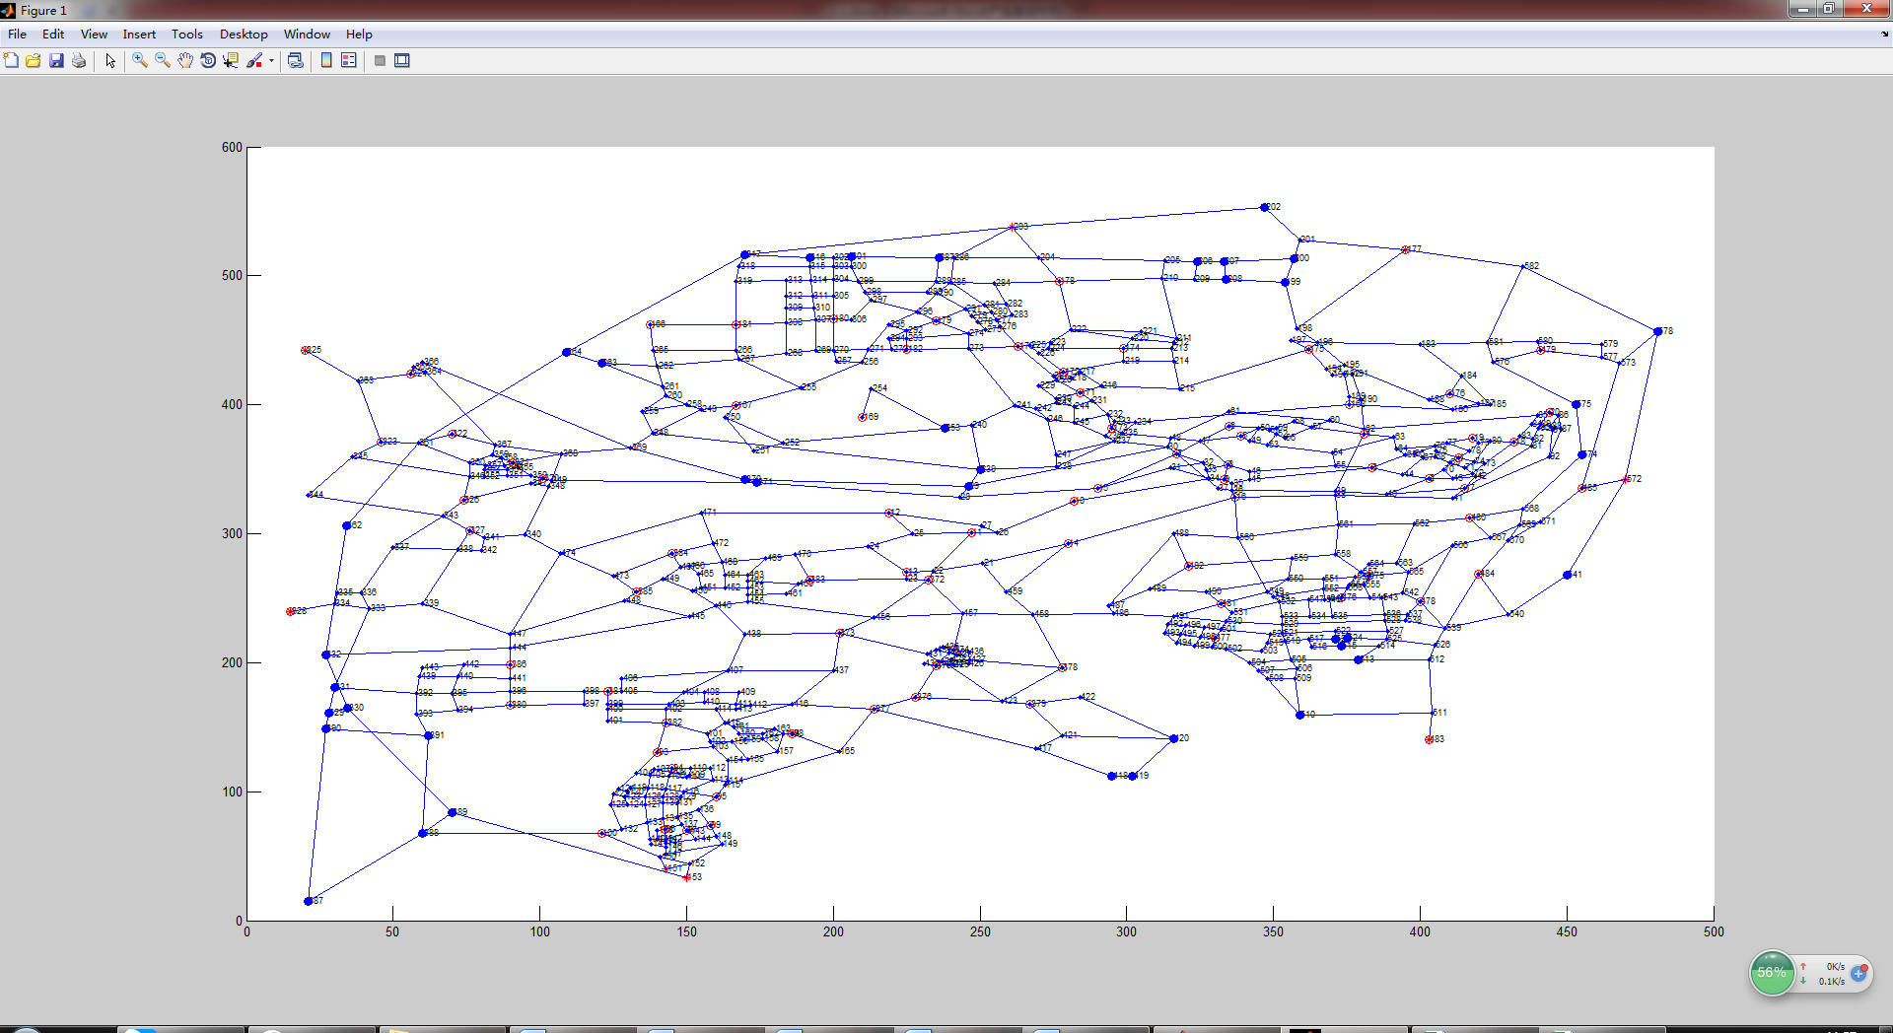

根据改图选定应该增加服务平台的结点有

505;263;200;301;578;388;239;574;370;419;390

验证

将结点增加到PA矩阵中重复运算，得出结果如