北京师范大学2021 ～ 2022学年第二学期期末考试试卷
课程名称： 高等计算物理 任课教师姓名：马天星，丁阳，徐辛亮
卷面总分： 100 分 考试时长： 120 分钟 考试类别：闭卷 □ 开卷 ☑ 其他 □
院（系）： 专 业： 年级：
姓 名： 学 号：

题号 | 第一题 | 第二题 | 第三题 | 第四题 | 第五题
得分
阅卷教师（签字）：

1．（20 points）A ball with a diameter D=20cm and a weight 0.2kg is thrown by a student from a height of 1.8m. The initial speed of the ball is 40m/s. The drag force from the air can be described by the following equation:
F_{d}(v) = kD²v², where k=0.02 kg m⁻³
- Find the ground distance travelled when the initial angle is 25,35, and 45 degrees to the oriental direction.
- Find the optimal initial angle that can result in the greatest ground distance.

2．（20 points）Compute the Fourier series approximation of the function 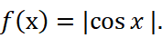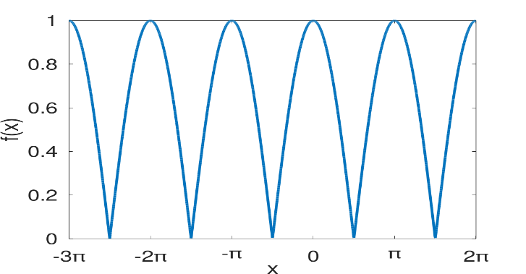
That is to find the coefficients , ，in 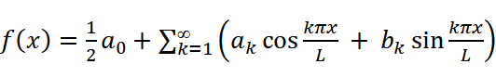 where L=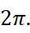
（1）Find at least one zero term in or .
（2）Find the , for k ≤ 2 using one of the following method:

- Numerical integration
- Fitting and optimization
- Fast Fourier Transform

3. （20 points）Velocity Verlet method:
We have a 1D harmonic oscillator with mass 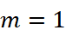 and spring constant 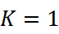. The initial condition is 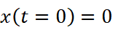 and 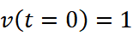.
- Simulate the motion of the system and obtain the location and velocity of the oscillator after one time step 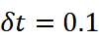, i.e. get 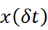 and 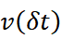 based on the velocity Verlet method
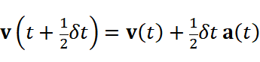
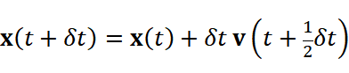
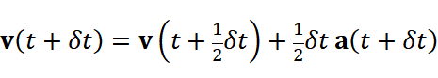

- Consider the time reversal problem: Use the location and velocity obtained in question (1) as the new initial condition, simulate the motion of the system and obtain the location and velocity of the oscillater one time step before, i.e. get 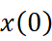 and 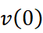 based on the time reversal velocity Verlet method
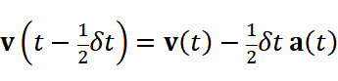
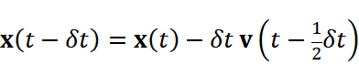
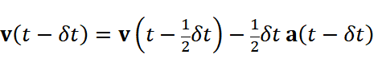
- Check the time reversal property of the velocity Verlet method: compare the and obtained in question (2) and our initial condition and .

4. （20 points）Monte Carlo method:
Compute the following integral 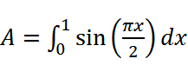, using the hit and miss method: Conduct 10,000 shots, where the procedure within each shot is described in the following.
In each shot, generate a pair of random numbers 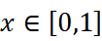 and 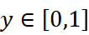. If 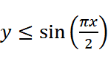, then record one hit. Then get A as the total number of hits divided by the total number of shots.

5. （20 points）2D Random walks:
We have a particle with initial location and 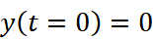. At each step, the particle moves +1 or -1 in x with equal probability, and then independently moves +1 or -1 in y with equal probability. Compute 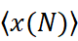, 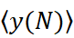, and 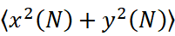 for 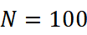 steps, where the average is taken over the number of simulations conducted.
装 订 线

