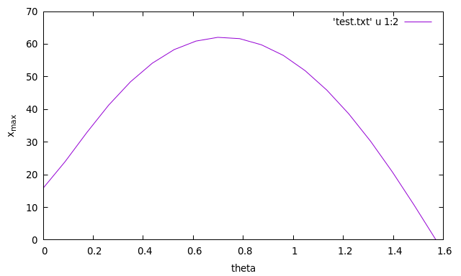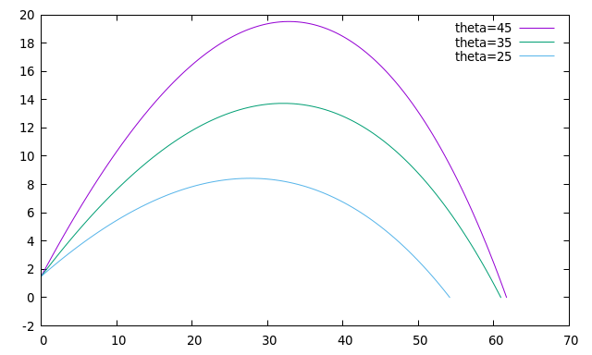Problem1

抛最远角度是40度，弧度0.7。

Problem2

syms x;

b(10)=0;

a(10)=0;

f=abs(sin(x));

a0=int(f,0,pi)/pi;

for k=1:10

f=abs(sin(x))*sin(k*x/2);

b(k)=int(f,-pi,pi)/pi;

f=abs(sin(x))*cos(k*x/2);

a(k)=int(f,-pi,pi)/pi;

end

% bk=0 ; ak=[0.848,0,-0.509,-0.424,-0.121,0,-0.056,-0.084,-0.033,0] ;

% a0=1/pi

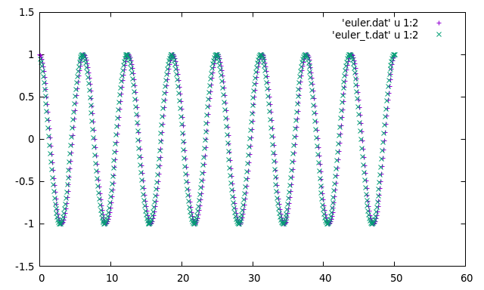Pproblem3

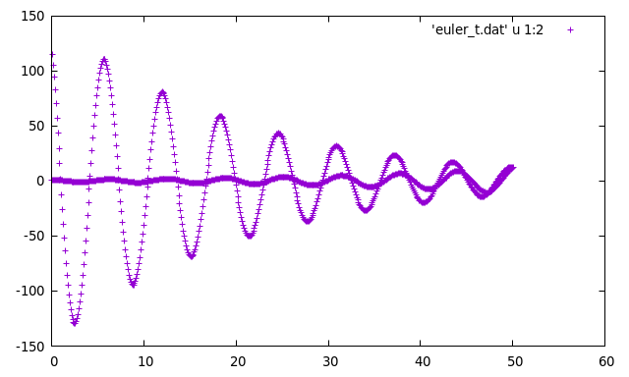velocity verlet 方法的时间反演

欧拉法的时间反演是发散的。

Problem4

steps=1000000;

p=length(find(unifrnd(0,1,steps,1)<=cos(pi*unifrnd(0,1,steps,1)/2)))/steps;

计算结果0.636

Problem5

steps=100;bins=1000;

x(bins)=0;

y(bins)=0;

for i=1:1:bins

x(i)=length(find(unifrnd(0,1,steps,1)<=0.5));

y(i)=length(find(unifrnd(0,1,steps,1)<=0.5));

end

ave_x=sum(x)/bins;ave_y=sum(y)/bins;

asxy=sum(x.^2+y.^2)/bins;

% <x>=50.2026 ; <y>=50.1740 ; <x^2+y^2>=5090.6