**《C#程序设计》课程实验报告**

|  |  |  |  |  |
| --- | --- | --- | --- | --- |
| **学号：** | **12021051064** |  | **姓名：** | **华心童** |

**实验十六、窗体**

**一、实验目的**

1、了解文件流的操作。

2、将实验报告云盘，文件名是**学号姓名实验16**命名。

**二、实验内容**

实验准备：在F盘创建学号文件夹，用于存放实验结果文件。

运行VS2013，创建解决方案是“**Ex学号-16**”。

**基本实验**

**任务1、用户控件【项目名P1601】**

**要求：**完成用户登录页面Login，不能最大化窗口，密码是“*”，

点击“登录”进行判断，包括空判断、是否匹配判断、记录输入错误次数、显示不同的对话信息提示框；

点击“取消”清空用户名和密码的内容，光标定位在用户名密码框内。

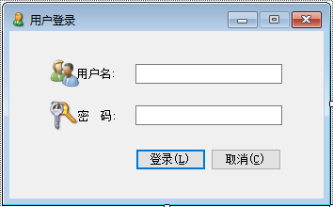

**程序源程序代码：**粘贴program.cs中代码

public partial class Form1 : Form

{

int count = 0;

public Form1()

{

InitializeComponent();

textBox2.PasswordChar = '*';//密码以星号显示

}

private void button1_Click(object sender, EventArgs e)

{

String st1 = textBox1.Text.Trim();//获取文本框内容

String st2 = textBox2.Text.Trim();

if (st1 == "" || st2 == "")

{

MessageBox.Show("用户名和密码不能输入为空", "提示", MessageBoxButtons.OKCancel, MessageBoxIcon.Exclamation);

MessageBox.Show("输入错误，已经尝试" + ++count + "次");

}

else if (st1 == "18351154069" && st2 == "123456")//是否匹配判断

{

MessageBox.Show(st1 + "用户登陆成功！", "你好！", MessageBoxButtons.OK, MessageBoxIcon.Asterisk);

}

else if (st1 != "18351154069" && st2 == "123456")

{

MessageBox.Show("用户名不正确！", "提示", MessageBoxButtons.RetryCancel, MessageBoxIcon.Error);

MessageBox.Show("输入错误，已经尝试" + ++count + "次");

}

else if (st1 == "18351154069" && st2 != "123456")

{

MessageBox.Show("密码不正确！", "提示", MessageBoxButtons.RetryCancel, MessageBoxIcon.Error);

MessageBox.Show("输入错误，已经尝试" + ++count + "次");

}

else if (st1 != "18351154069" && st2 != "123456")

{

MessageBox.Show("用户名，密码不正确！", "提示", MessageBoxButtons.RetryCancel, MessageBoxIcon.Error);

MessageBox.Show("输入错误，已经尝试" + ++count + "次");

}

}

private void label1_Click(object sender, EventArgs e)

{

}

private void button2_Click(object sender, EventArgs e)

{

textBox1.Text = "";//清空文本框内容，下同

textBox2.Text = "";

textBox1.Focus();

}

private void textBox3_TextChanged(object sender, EventArgs e)

{

}

private void textBox4_TextChanged(object sender, EventArgs e)

{

}

private void Form1_Load(object sender, EventArgs e)

{

pictureBox1.Image = Image.FromFile("C:\\Users\\18351154069\\Desktop\\截图\\Username.png");

pictureBox2.Image = Image.FromFile("C:\\Users\\18351154069\\Desktop\\截图\\Password.png");

}

private void pictureBox1_Click(object sender, EventArgs e)

{

}

private void pictureBox2_Click(object sender, EventArgs e)

{

}

private void textBox1_TextChanged(object sender, EventArgs e)

{

}

}

//粘贴运行结果界面截图

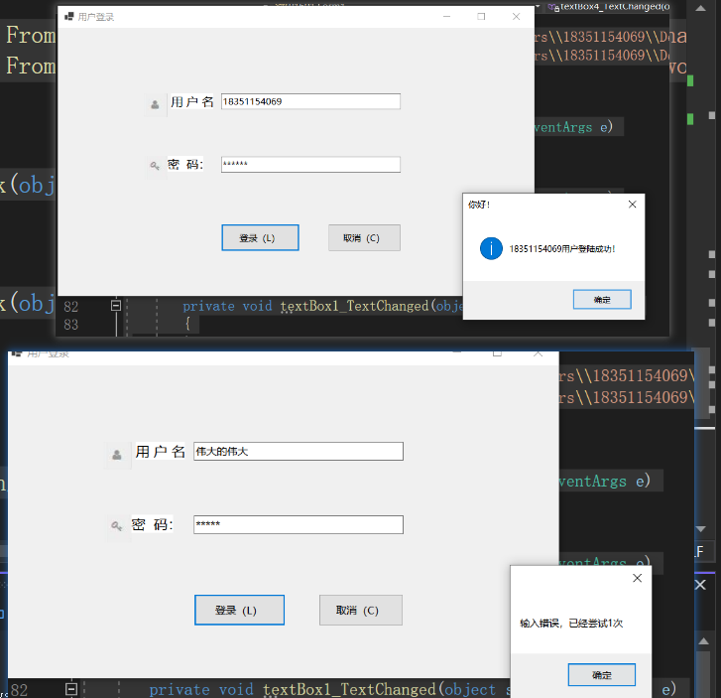

**任务2、控件。【项目名P1602】**

**要求**：完成一个简易计算器，并实现功能。

创建一个类Operator，并派生出ADD，SUB，MUL，DIV，完成模拟运算功能。

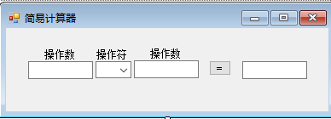

**程序源程序代码：**粘贴program.cs中代码

public partial class Form1 : Form

{

public Form1()

{

InitializeComponent();

}

private void button1_Click(object sender, EventArgs e)

{

float x1 = 0.0F, x2 = 0.0F, x = 0.0F;

char op = '+';

x1=Convert.ToSingle(textBox3.Text);

op=Convert.ToChar(comboBox1.Text);

x2=Convert.ToSingle(textBox4.Text);

Operator obj = null;

switch(op)

{

case '+':

obj = new ADD();

break;

case '-':

obj = new SUB();

break;

case '*':

obj = new MUL();

break;

case '/':

obj = new DIV();

break;

default:

break;

}

if(obj!=null)

{

obj.A = x1;

obj.B= x2;

x = obj.Compute();

}

textBox6.Text = x.ToString();

}

private void Form1_Load(object sender, EventArgs e)

{

comboBox1.DropDownStyle = ComboBoxStyle.DropDownList;

comboBox1.Items.Add("+");

comboBox1.Items.Add("-");

comboBox1.Items.Add("*");

comboBox1.Items.Add("/");

}

private void textBox2_TextChanged(object sender, EventArgs e)

{

}

private void textBox3_TextChanged(object sender, EventArgs e)

{

}

private void textBox1_TextChanged(object sender, EventArgs e)

{

}

private void comboBox1_SelectedIndexChanged(object sender, EventArgs e)

{

}

private void textBox4_TextChanged(object sender, EventArgs e)

{

}

private void textBox5_TextChanged(object sender, EventArgs e)

{

}

private void textBox6_TextChanged(object sender, EventArgs e)

{

}

}

**//operator类**

class Operator

{

private float x1 = 0.0F,x2=0.0F;

public float A

{

get { return x1; }

set { x1 = value; }

}

public float B

{

get { return x2; }

set { x2 = value; }

}

public virtual float Compute()

{

float result = 0.0F;

return result ;

}

}

class ADD : Operator

{

public override float Compute()

{

float result = A + B;

return result;

}

}

class SUB : Operator

{

public override float Compute()

{

float result = A - B;

return result;

}

}

class MUL:Operator

{

public override float Compute()

{

float result = A * B;

return result;

}

}

class DIV:Operator

{

public override float Compute()

{

float result = 0.0F;

if(B!=0)

result= A / B;

return result;

}

}

//粘贴运行结果界面截图

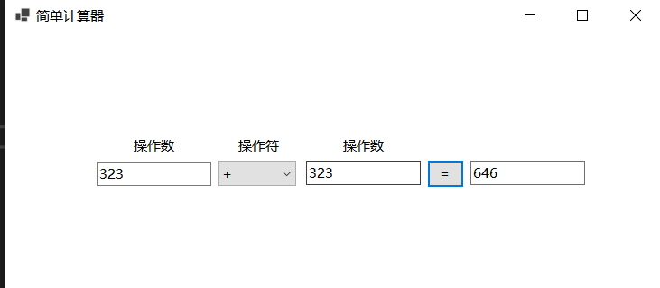

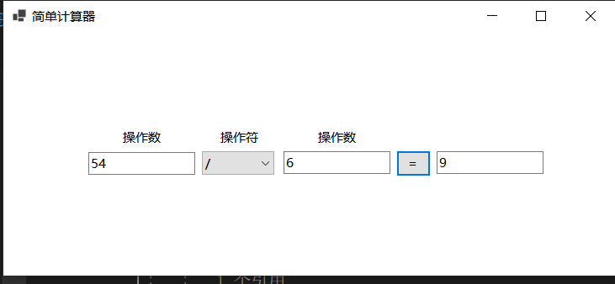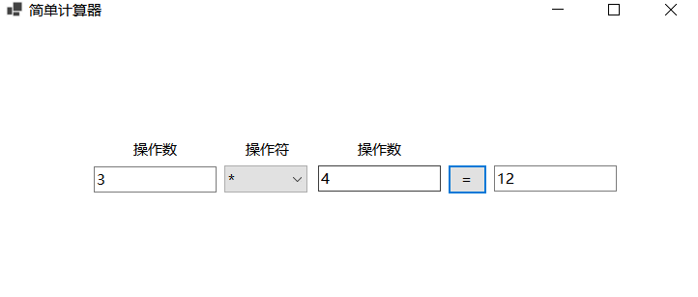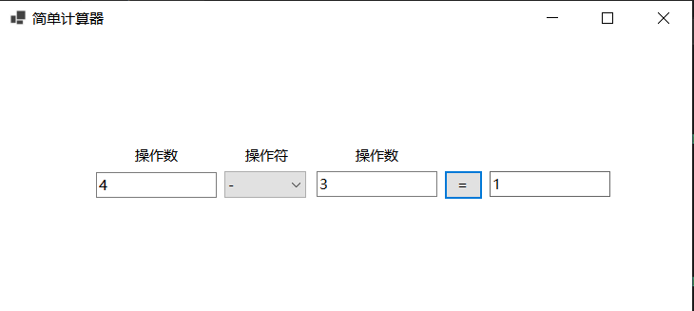

**任务3、组合框、列表框等【P1503】**

**要求：**完成图示的界面设计，设计一个类，点击“保存”将当前部分信息保存至文本文件。

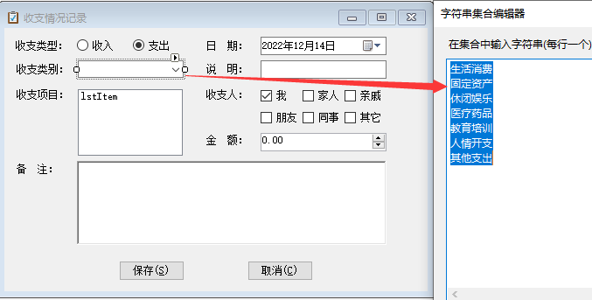

**程序源程序代码：**粘贴program.cs中代码

public partial class Form1 : Form

{

public Form1()

{

InitializeComponent();

}

private void Form1_Load(object sender, EventArgs e)

{

comboBox1.Items.Add("生活消费");

comboBox1.Items.Add("固定资产");

comboBox1.Items.Add("休闲娱乐");

comboBox1.Items.Add("医疗药品");

comboBox1.Items.Add("教育培训");

comboBox1.Items.Add("人情开支");

comboBox1.Items.Add("其他支出");

numericUpDown1.Maximum = 100000;

numericUpDown1.Minimum = 1;

}

private void label1_Click(object sender, EventArgs e)

{

}

private void label4_Click(object sender, EventArgs e)

{

}

private void radioButton2_CheckedChanged(object sender, EventArgs e)

{

}

private void label5_Click(object sender, EventArgs e)

{

}

private void label6_Click(object sender, EventArgs e)

{

}

private void label7_Click(object sender, EventArgs e)

{

}

private void label8_Click(object sender, EventArgs e)

{

}

private void checkBox1_CheckedChanged(object sender, EventArgs e)

{

}

private void button1_Click(object sender, EventArgs e)

{

Save s = new Save();

if (radioButton1.Checked)

{

s.Type = radioButton1.Text;

}

else if (radioButton2.Checked)

{

s.Type= radioButton2.Text;

}

s.Category = comboBox1.Text;

s.Event = richTextBox1.Text;

s.Date = dateTimePicker1.Text;

s.ShuoMin = textBox1.Text;

s.Money = numericUpDown1.Text.ToString();

s.BeiZhu = richTextBox2.Text.ToString();

string filename = @"D:\C#\save.txt";

FileStream fs = new FileStream(filename, FileMode.OpenOrCreate);

StreamWriter sw = new StreamWriter(fs);

sw.WriteLine("收支情况："+s.Type);

sw.WriteLine("收支类别："+s.Category);// s.LeiBie, s.XiangMu, s.RiQi, s.ShuoMin, s.ShouZhipeople, s.Money, s.BeiZhu

sw.WriteLine("收支项目："+s.Event);

sw.WriteLine("日期："+s.Date);

sw.WriteLine("说明："+s.ShuoMin);

sw.Write("收支人：");

foreach (Control c in Controls)

{

if (c is CheckBox && ((CheckBox)c).Checked)

{

sw.Write((c.Text.ToString())+" ");

}

}

//List<string> list = new List<string>();

//if (checkBox1.Checked)

// list.Add(checkBox1.Text);

//if (checkBox2.Checked)

// list.Add(checkBox2.Text);

//if (checkBox3.Checked)

// list.Add(checkBox3.Text);

//if (checkBox4.Checked)

// list.Add(checkBox4.Text);

//if (checkBox5.Checked)

// list.Add(checkBox5.Text);

//if (checkBox6.Checked)

// list.Add(checkBox6.Text);

//string res=string.Join(" ", list.ToArray());

//s.ShouZhipeople=string.Format("收支人："+res);

sw.WriteLine(s.ShouZhipeople);

sw.WriteLine("金额："+s.Money);

sw.WriteLine("备注："+s.BeiZhu);

sw.Flush();

sw.Close();

fs.Close();

MessageBox.Show("保存成功！","提示",MessageBoxButtons.OK,MessageBoxIcon.Information);

}

private void linkLabel1_LinkClicked_1(object sender, LinkLabelLinkClickedEventArgs e)

{

}

private void button2_Click(object sender, EventArgs e)

{

}

private void dateTimePicker1_ValueChanged(object sender, EventArgs e)

{

}

private void richTextBox1_TextChanged(object sender, EventArgs e)

{

}

private void comboBox1_SelectedIndexChanged(object sender, EventArgs e)

{

}

private void numericUpDown1_ValueChanged(object sender, EventArgs e)

{

}

private void checkBox2_CheckedChanged(object sender, EventArgs e)

{

}

private void checkBox3_CheckedChanged(object sender, EventArgs e)

{

}

private void checkBox4_CheckedChanged(object sender, EventArgs e)

{

}

private void checkBox5_CheckedChanged(object sender, EventArgs e)

{

}

private void checkBox6_CheckedChanged(object sender, EventArgs e)

{

}

}

//粘贴运行结果界面截图

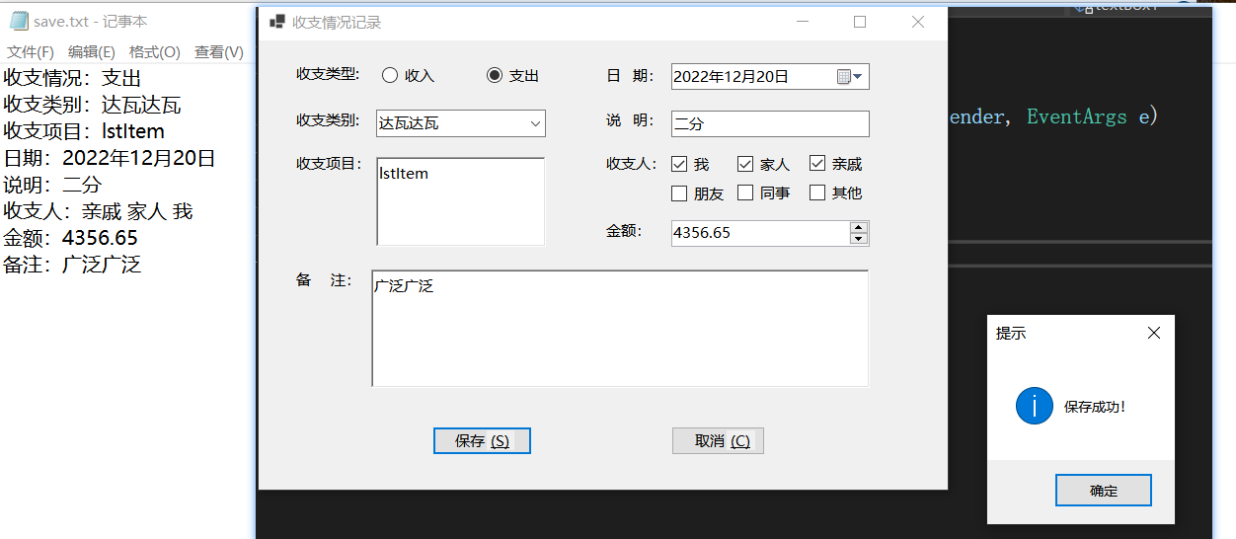

**任务4、时间控件【P1504】**

**要求**：利用时间控件完成图片的透明度变化。

**程序源程序代码：**粘贴program.cs中代码

bool isDisplay = true;

public Form1()

{

InitializeComponent();

}

private void timer1_Tick(object sender, EventArgs e)

{

if(isDisplay)

{

if (this.Opacity + 0.02 < 1)

this.Opacity = this.Opacity + 0.02;

else

{

timer1.Enabled= false;

System.Threading.Thread.Sleep(1000);

isDisplay= false;

timer1.Enabled= true;

}

}

else

{

if(this.Opacity-0.02>0)

this.Opacity -=0.02;

else

{

timer1.Enabled= false;

Form fm=new Form();

fm.Show();

this.Hide();

}

}

}

private void Form1_Load(object sender, EventArgs e)

{

pictureBox1.ImageLocation = @"C:\Users\18351154069\Pictures\Saved Pictures\OIP-C.jfif";

this.Opacity = 0;

timer1.Interval = 500;

timer1.Tick += timer1_Tick;

timer1.Enabled = true;

}

private void pictureBox1_Click(object sender, EventArgs e)

{

}

//粘贴运行结果界面截图

