**《C#程序设计》课程实验报告**

|  |  |  |  |  |
| --- | --- | --- | --- | --- |
| **学号：** | **12021051064** |  | **姓名：** | **华心童** |

**实验九、类的继承与派生**

**一、实验目的**

1、运用虚方法实现重载

3、将实验报告云盘，文件名是**学号姓名实验10**命名。

**二、实验内容**

实验准备：在F盘创建学号文件夹，用于存放实验结果文件。

运行VS2013，创建解决方案是“**Ex学号-10**”。

1. **基本实验**

**任务1、虚方法，【项目名P1001】**

**要求：根据以下类，完成类的设计**。

|  |
| --- |
| Student |
| # sNo：int //学号  # sName：string //姓名  # tName：string //班主任或导师 |
| +Setdata(int sNo,string sName,string sName) void //方法，获取信息  +Display(); //虚方法，显示信息，默认是班主任 |

+ Graduate // Student派生类，重写Display()显示导师姓名

**程序源程序代码：**粘贴program.cs中代码

class Student

{

protected int sNo;

protected string sName;

protected string tName;

public void Setdata(int sNo, string sName, string tName)

{

this.sNo = sNo;

this.sName = sName;

this.tName = tName;

}

public virtual void Display()

{

Console.WriteLine("本科生 学号：{0}，姓名：{1}，班主任：{2}", sNo, sName, tName);

}

}

class Graduate : Student

{

public override void Display()

{

Console.WriteLine("研究生 学号：{0}，姓名：{1}，导师：{2}", sNo, sName, tName);

}

}

class Program

{

static void Main(string[] args)

{

Student S1 = new Student();

Student S2 = new Graduate();

S1.Setdata(064, "华心童", "张三");

S1.Display();

S2.Setdata(064, "华心童", "李四");

S2.Display();

Console.ReadKey();

}

}

//粘贴运行结果界面截图

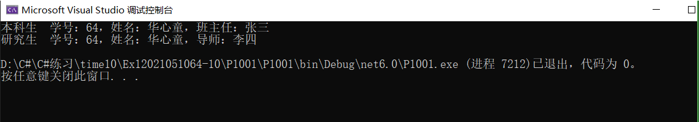

**任务2、虚方法，实现重载【项目名P1002】**

要求：采用虚方法求长方形、圆、圆球体和圆柱体的面积或表面积。【本题注意使用基类的构造方法】

|  |
| --- |
| Rectangle |
| + PI：double //常量，圆周率  # x：double //参数x，长方形的长或圆半径  # y：double //参数y，长方形的宽或圆柱体的高 |
| + Rectangle () //构造函数，无参数  + Rectangle (double x,double y) //构造函数，两个参数  +Area (); //虚方法，默认计算长方形面积 |

**主函数部分**

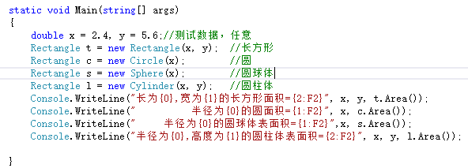

**程序源程序代码：**粘贴program.cs中代码

class Rectangle

{

public const double PI = Math.PI;

protected double x;

protected double y;

public Rectangle() { }

public Rectangle(double x, double y)

{

this.x = x;

this.y = y;

}

public virtual double Area()

{

double area = x * y;

return area;

}

}

class circle : Rectangle

{

public circle(double r) : base(r, 0)

{

this.x= r;

}

public override double Area()

{

double area = x * x * PI;

return area;

}

}

class Sphere : Rectangle

{

public Sphere(double r) : base(r, 0)

{

this.x= r;

}

public override double Area()

{

double area = 4 * PI * x * x;

return area;

}

}

class Cylindar : Rectangle

{

public Cylindar(double a, double b) : base(a, b)

{

this.x = a;

this.y = b;

}

public override double Area()

{

double area = 2 * PI * x * x + 2 * PI * x * y;

return area;

}

}

class Program

{

static void Main(string[] args)

{

double x = 3.6, y = 8.0;

Rectangle t = new Rectangle(x, y);

Rectangle c = new circle(x);

Rectangle s = new Sphere(x);

Rectangle l = new Cylindar(x, y);

Console.WriteLine("长为{0}，宽为{1}的长方形面积={2:F2}", x, y, t.Area());

Console.WriteLine("半径为{0}的圆面积={1:F2}", x, c.Area());

Console.WriteLine("半径为{0}的圆球体表面积={1:F2}", x, s.Area());

Console.WriteLine("半径为{0},高度为{1}的圆柱体表面积={2:F2}", x, y, l.Area());

Console.ReadKey();

}

}

//粘贴运行结果界面截图

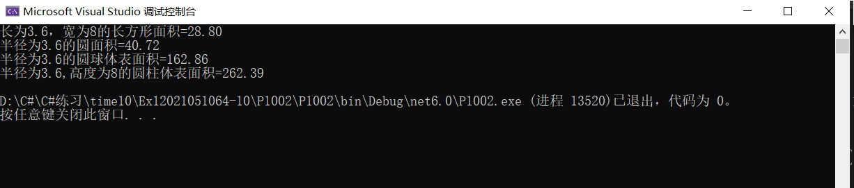

**任务3、虚方法，主函数【项目名P903】**

**要求：**设计一个学生类，包括学号、姓名、性别属性。设计一个大学生类，继承于学生

|  |
| --- |
| Vehicle |
| - name：string //名字  + Name：string //读写属性 |
| + Move() //虚方法，移动  +Speak() //虚方法，鸣笛 |

Train // Vehicle派生类，重写Move ()，Speak()

Car // Vehicle派生类，重写Move ()，Speak()

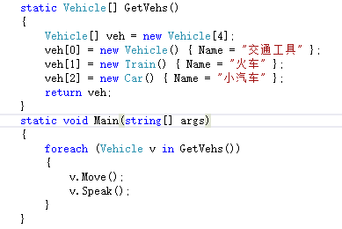

**源程序代码：**粘贴program.cs中代码

class Vehicle

{

private string name;

public string Name

{

get { return name; }

set { name = value; }

}

public Vehicle()

{

}

public Vehicle(string name)

{

this.name = name;

}

public virtual void Move()

{

Console.WriteLine(name+"移动");

}

public virtual void Speak()

{

Console.WriteLine(name+"鸣笛");

}

}

class Train : Vehicle

{

public Train() { }

public override void Move()

{

Console.WriteLine(Name+"快速移动");

}

public override void Speak()

{

Console.WriteLine(Name+"轰隆轰隆");

}

}

class Car : Vehicle

{

public Car() { }

public override void Move()

{

Console.WriteLine(Name+"慢慢移动");

}

public override void Speak()

{

Console.WriteLine(Name+"嘀嘀嘀");

}

}

class Program

{

static Vehicle[] GetVehs()

{

Vehicle[] veh = new Vehicle[3];

veh[0] = new Vehicle() { Name = "交通工具" };

veh[1] = new Train() { Name = "火车" };

veh[2] = new Car() { Name = "小汽车" };

return veh;

}

static void Main(string[] args)

{

foreach (Vehicle v in GetVehs())

{

v.Move();

v.Speak();

}

Console.ReadKey();

}

}

//粘贴运行结果界面截图

