**NAME – SWEETY MITRA**

**REGISTRATION NUMBER – 2021BCSE07AED114**

**COURSE – Btech in CSE**

**BATCH – 2021-25**

**ROLE – WEB DEVELOPMENT**

1. **Design Choices and Alignment with UX/UI Principles**

**User Interface and User Experience (UI/UX)**

• **UI Design**: Focused on a clean, modern, and intuitive design language.

**• UX Research**: Based on user personas, the design prioritizes ease of use across all devices

**Visual Hierarchy:**

The design uses clear visual hierarchy to guide the user’s attention. The logo and university name at the top of the page are prominent, followed by a high-quality hero image that communicates the institution's identity. Key sections, such as admission processes and program options, are placed in logical sequences. Buttons and calls to action (CTA) are in blue, ensuring visibility and encouraging user interaction.

**Color Scheme:**

The blue-and-white color scheme is both professional and welcoming. Blue is often associated with trust, which is fitting for an educational institution. Contrast between the white background and blue buttons/text ensures readability and accessibility.

**Typography:**

The text uses clean, cormorant fonts which improve readability. Headings are bolded and larger, ensuring that they grab attention, while body text is smaller but still clear.

**User Flow:**

The user flow is structured to guide visitors toward key actions such as exploring programs, admissions, and placement information. The “Discover Our Programs” section and “Admission Process” are located prominently, making it easy for prospective students to navigate.

1. **Front-End Development Process and Technologies Used**

The development of the front end of this website likely incorporates various standard and modern web technologies, each playing a pivotal role in building a responsive, interactive, and visually appealing user experience. Below is an expanded breakdown of the core components and technologies involved:

1. **HTML (HyperText Markup Language):**

HTML forms the structural backbone of the website, ensuring that content is organized in a meaningful and semantically appropriate way.

* **Header Section:** The header contains the institution's logo, name, and navigation menu, providing users with immediate access to essential areas of the site.
* **Main Section:** Hero images and prominent CTAs (Calls to Action) guide users toward important actions like registration or learning more about specific programs.
* **Footer Section:** The footer includes college information .

In addition to content structuring, HTML also handles form elements, such as the registration form in the screenshot. These forms would employ various input types (e.g., text, email, buttons) to ensure proper user interaction.

1. **CSS (Cascading Style Sheets):**

CSS is the technology that governs the aesthetic and layout of the website. Through CSS, colors, typography, and spacing are defined to create a cohesive visual identity. This design likely adheres to a combination of custom CSS and CSS frameworks to streamline the design process.

* **CSS Grid and Flexbox:** Both CSS Grid and Flexbox are employed for creating responsive, flexible layouts. For example, the uniform alignment and distribution of elements such as images, buttons, and text boxes across various sections imply the use of a grid system. Flexbox, in particular, is useful for aligning items within the navigation bar, while CSS Grid is likely responsible for the precise positioning of the multi-column layout seen in sections such as “Campus Life” and “Placements.”
* **CSS Media Queries:** A critical component of responsive design, media queries are employed to adjust the layout and styling based on the user’s screen size and device capabilities. This ensures that the website provides an optimal experience whether accessed from a mobile device, tablet, or desktop computer. For instance:
  + On mobile devices, larger elements like images and buttons are resized, and content stacks vertically for better readability.
  + On larger screens, the layout switch to a multi-column design, improving the use of space and enhancing the visual appeal.
* **CSS Variables (Custom Properties):** Modern CSS likely incorporates CSS variables, enabling reusable and consistent color schemes, spacing, and font sizes across the entire website. This also simplifies maintenance, as changes to a single variable automatically cascade throughout the site.

1. **JavaScript (JS):**

JavaScript is critical for providing dynamic behavior and interactivity across the website. From form validation to interactive menus and real-time data updates, JS enhances the overall user experience in various ways.

* **Form Validation:** JavaScript is likely used for validating the input fields of forms like the registration form. Before form data is submitted to the server, JS checks for basic validation rules (e.g., ensuring the email field contains a valid email format), improving the overall user experience by reducing errors.
* **Event Listeners and User Interaction:** JavaScript handles various events, such as clicks on buttons or scrolling actions. This is essential for features like dropdown menus, carousels, and pop-ups. In the screenshot, buttons such as “Register Now” and other calls to action trigger JavaScript functions to either submit forms or load additional content.

1. **Technology:**

• Frontend: HTML5, CSS3, JavaScript (with jQuery)

• Backend: PHP

• Database: MySQL

• Version Control: Git

• Tools: Code editor (e.g., VS Code), browser dev tools

1. **Code Structure**

• HTML: Structured to follow semantic HTML5 tags for SEO and accessibility.

• CSS: Organized using a mobile-first approach, leveraging media queries.

• PHP: Used to handle server-side processing and MySQL queries.

• MySQL Database: Table structure for storing contact form submissions.

1. **Screen Layout:**

* Home
* About
* Contact Us

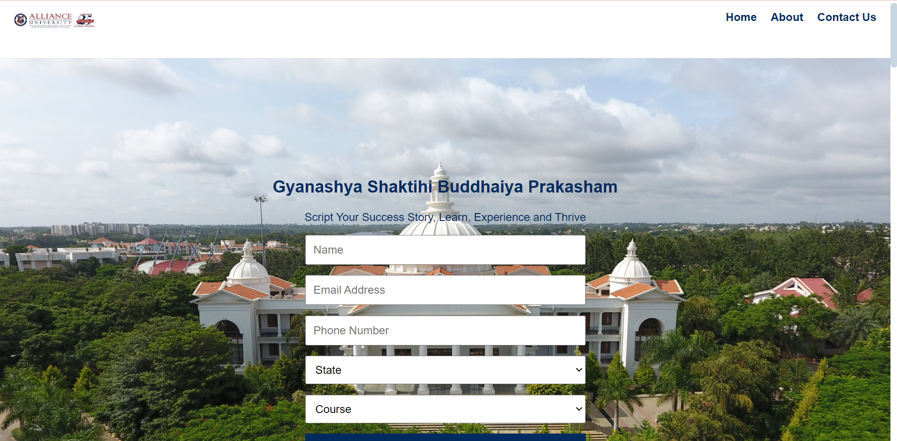

**Conclusion:**

The website design and development are based on modern UX/UI principles and technologies that ensure it is user-friendly, responsive, and accessible. Cross-browser compatibility and security features have been implemented, and the CMS integration allows for easy content management. By following SEO best practices, the site is well-positioned to rank highly in search engines.

Figma Link : https://www.figma.com/design/ayzkuJiWLaqBAYUuwxoc2h/Clg_design?node-id=0-1&t=pu2qiaafKvhfTPve-1