1. **Student table created.**

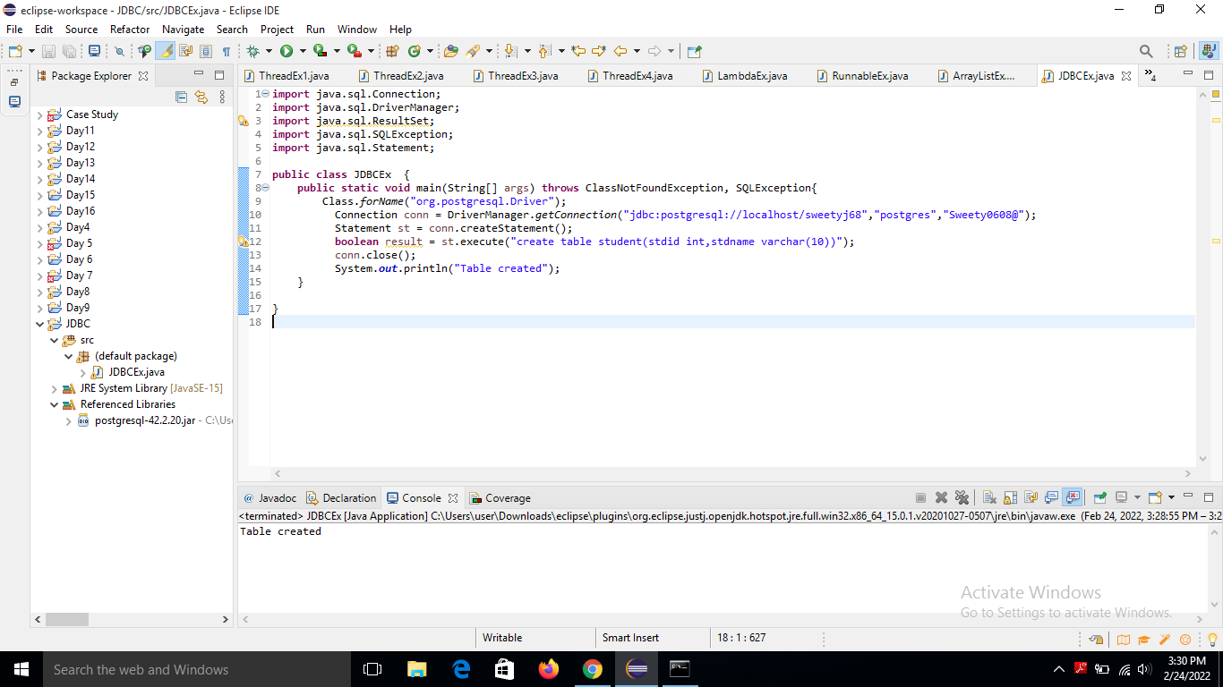

1. **Inserted data into student table.**

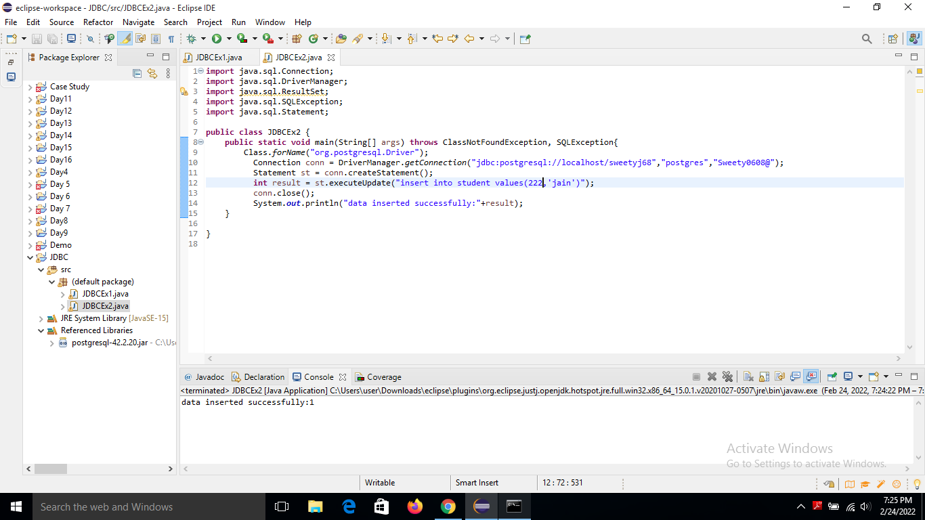

1. **Data Updated into student table.**

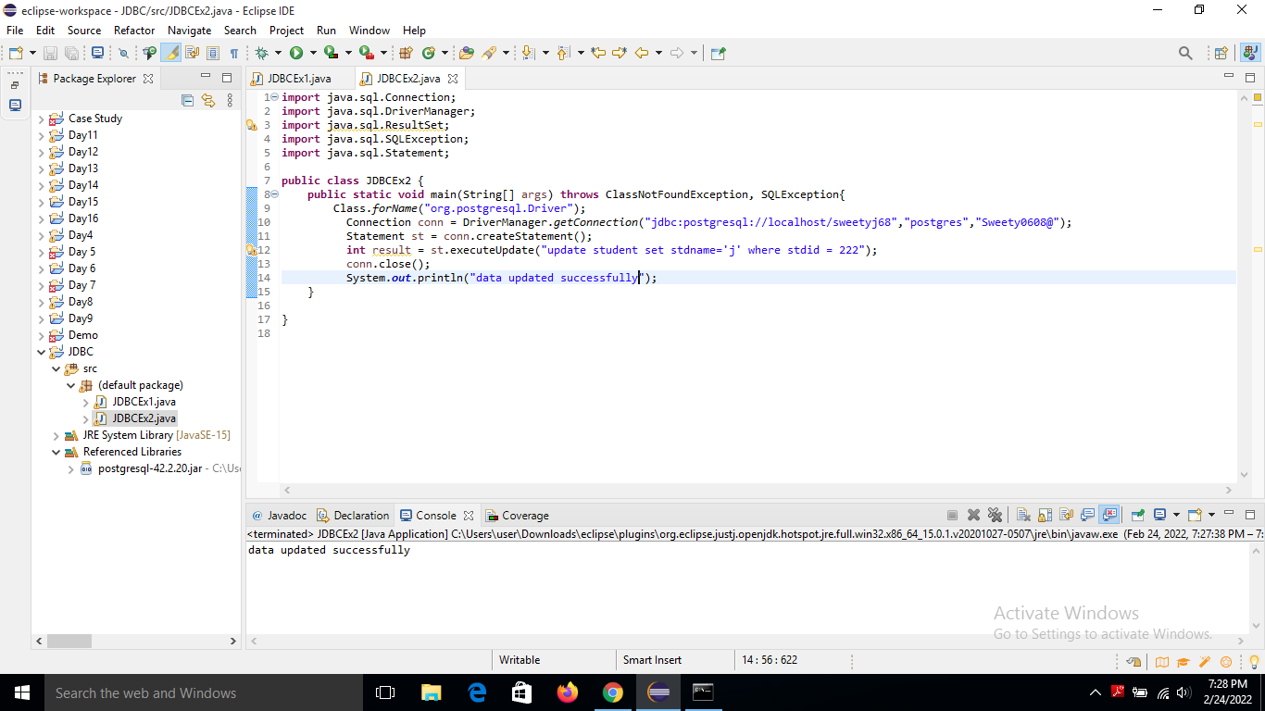

1. **Fetch data from student table.**

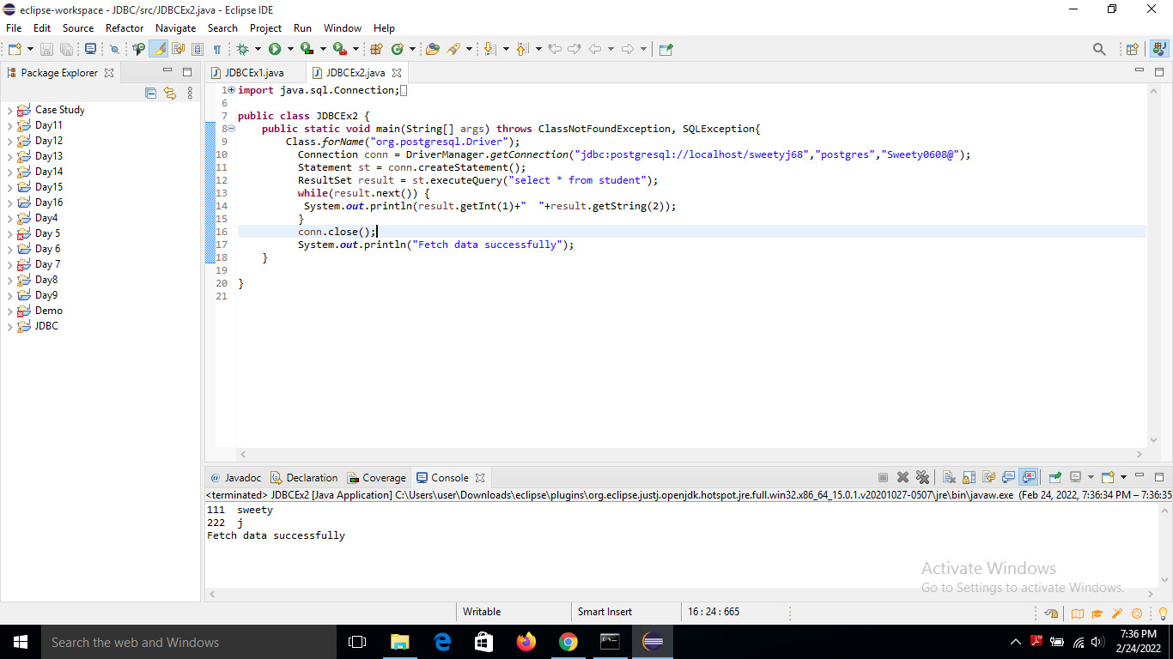

**Session 2**

Implementation of Prepared statement :

1. create a class with end-user implementation scanner class, username and password matching or not otherwise it will give an error.

Contact