COURSE NAME: Theory of Computation COURSE CODE: CSA13

COURSE OUTCOME COVERED

CO1: Apply mathematical foundations such as formal proofs, induction, and basic concepts of automata theory to solve computational problems.(BL:3)

Assessment Tool Weightage: 40%

QUESTIONS: 5 Total Marks:50
Duration : 1 Hour

Analytical Problem

Code of Conduct:

I __v.dharanireddy(192311219)__________________ (Name / Reg No) certify that this submission is my original work and that I have adhered to the guidelines specified for this assessment.
I understand that any violation of academic integrity rules will result in disciplinary action.

Signature of the student: v.dharanireddy

1.Consider the NFA given below which accepts some language L over the alphabet 𝚺={a,b}. Construct a DFA that represents the same language L
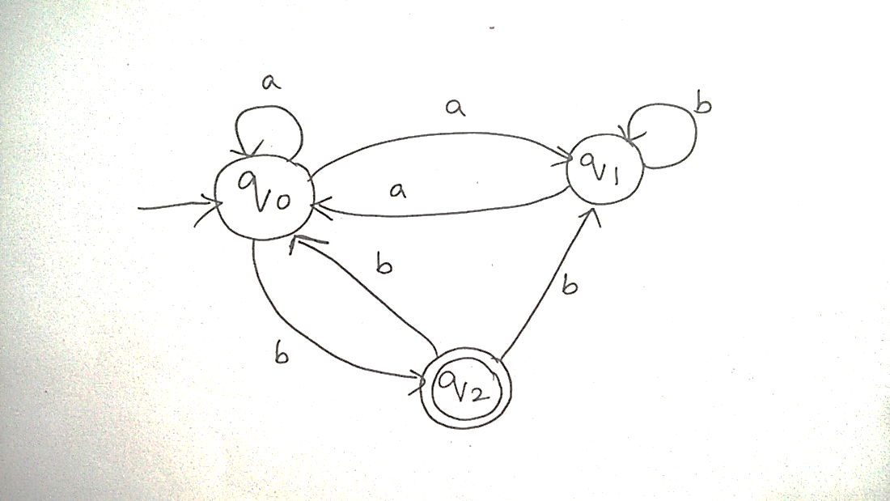
2.Let L be the language of words of length atleast 2 whose last two letters are difference from each other. For example abaab is in L but not bb, Construct an NFA for L, Then draw the equivalent DFA

3. Design a Nondeterministic Finite Automata (NFA) that takes a binary string as input and accepts the string only if the last two digits are the same (either 00 or 11). Write the formal definition of the NFA. Also show that the string 01011 is accepted by the NFA

4. Consider the NFA given below which accepts the language representing the set of all strings having 001 as a substring over the alphabet 𝚺={0,1}. Construct a DFA that represents the same language.

5. A NFA with ε-transitions is given below. Find ε-closure for each state and Design an equivalent DFA which accepts the same language. Draw its transition table and mark the initial and final states
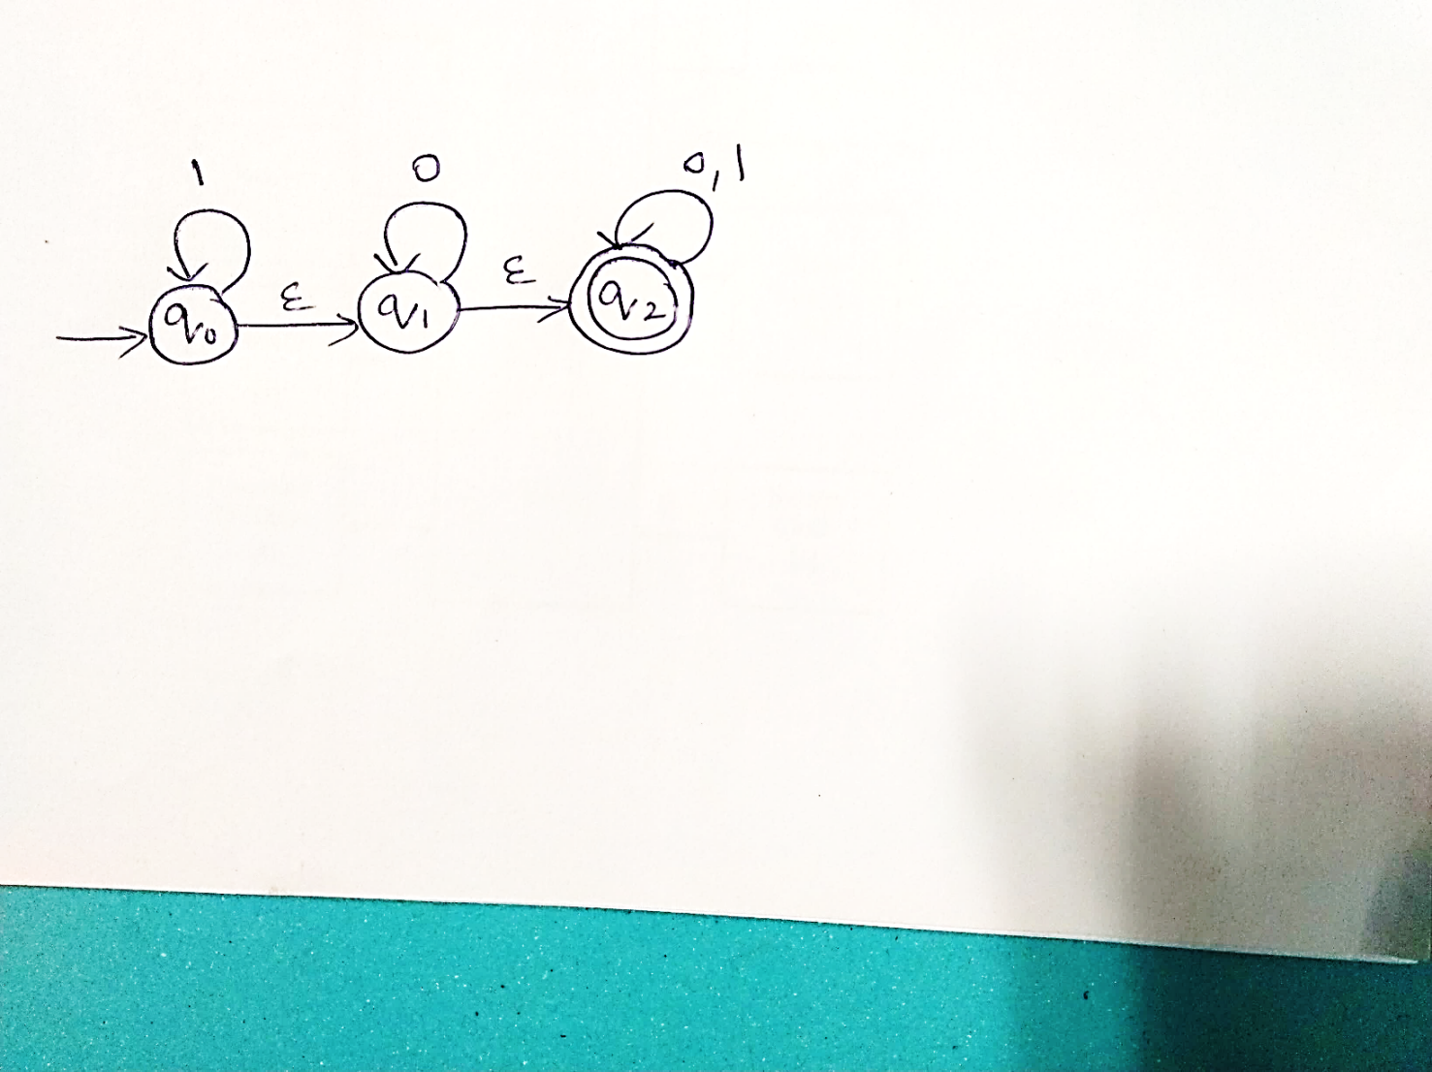

RUBRICS FOR CALCULATION

Criteria | Weightage | Q1 (10) | Q2 (10) | Q3 (10) | Q4 (10) | Q5 (10) | Total Marks (50)
Conceptual Understanding | 30 | 3 | 3 | 3 | 3 | 3 | 15
Accuracy of Answer | 25 | 2.5 | 2.5 | 2.5 | 2.5 | 2.5 | 12.5
Application of Knowledge | 20 | 2 | 2 | 2 | 2 | 2 | 10
Completeness of Response | 15 | 1.5 | 1.5 | 1.5 | 1.5 | 1.5 | 7.5
Clarity & Presentation | 10 | 1 | 1 | 1 | 1 | 1 | 5
Total per Question | 10 Marks | /10 | /10 | /10 | /10 | /10 | / 50

100

