SIMATS ENGINEERING
ASSESSMENT TOOL 1

COURSE NAME: CSA16 COURSE CODE: Data Warehousing and Data Mining

COURSE OUTCOME COVERED

CO2: Apply suitable Data Pre processing techniques like Data cleaning, Data
intergration,Data transformation and data Reduction , for effective data preparation (BL3,BL4) Assessment Tool Weightage: 50%

QUESTIONS: 5 Total Marks:50

Annexure B
Analytical Problem Solving

Criteria | Problem  Understanding  (2) | Method  Selection  (2) | Solution  Process  (2.5) | Accuracy of  Calculation  (2) | Interpretation of Results (1.5) | Total(10)
Weightage | 20% | 20% | 25% | 20% | 15% | 100%
Q1
Q2
Q3
Q4
Q5

Code of Conduct:

I _V.Dharanireddy(192311219)___________________ (Name / Reg No) certify that this submission is my original work and that I have adhered to the guidelines specified for this assessment.
I understand that any violation of academic integrity rules will result in disciplinary action.

Signature of the student: v.dharanireddy

RUBRICS FOR CALCULATION:

 |  | Numerical Problems
Criteria | Weightage | Level 4 (Exemplary) | Level 3 (Proficient) | Level 2 (Developing) | Level 1 (Beginning)
Problem Understanding | 20% | Clearly interprets problem,  identifies all  parameters and  requirements accurately | Understands problem with minor gaps | Partial understanding; misses key elements | Misinterpret s or unable to  understand problem
Method  Selection | 20% | Selects most appropriate  method/formula with strong justification | Selects correct method with minor errors | Inappropriate or partially correct method | Unable to select  method
Solution Process | 25% | Logical, systematic steps with correct approach throughout | Mostly correct steps with minor mistakes | Disorganized steps; multiple errors | No clear process
Accuracy of Calculation | 20% | All calculations accurate; correct final answer | Minor calculation errors | Frequent errors; incorrect final answer | No valid calculations
Interpretation of Results | 15% | Clearly interprets results with units  and engineering relevance | Basic interpretation with minor omissions | Limited or unclear interpretation | No  interpretatio n

Annexure B
Analytical Problem Solving

Covariance Analysis in Health Insurance (10 Marks)
The table below shows the annual premium increase rate (xi) and the number of claims per 100 policyholders (yi) in a health insurance company.
Using the covariance formula, determine whether premium increase and claim frequency have a positive or inverse relationship.
Before computing covariance, calculate the mean of x and y.
Premium Increase % (xi) Claims per 100 Policyholders (yi)
3.2 15 4.0 18 5.5 25
4.8 20

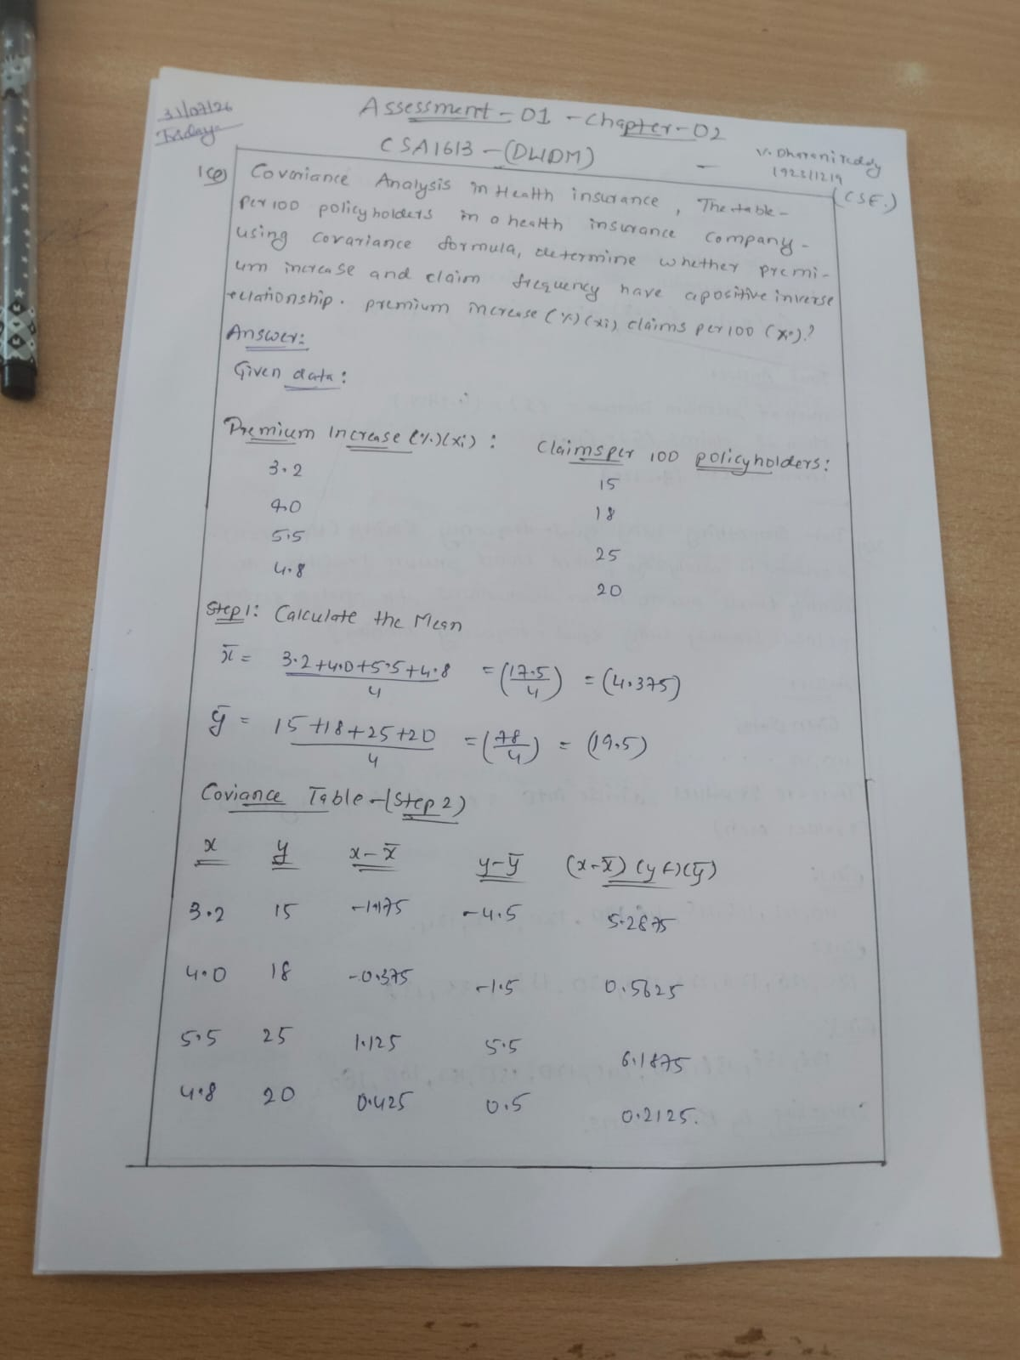
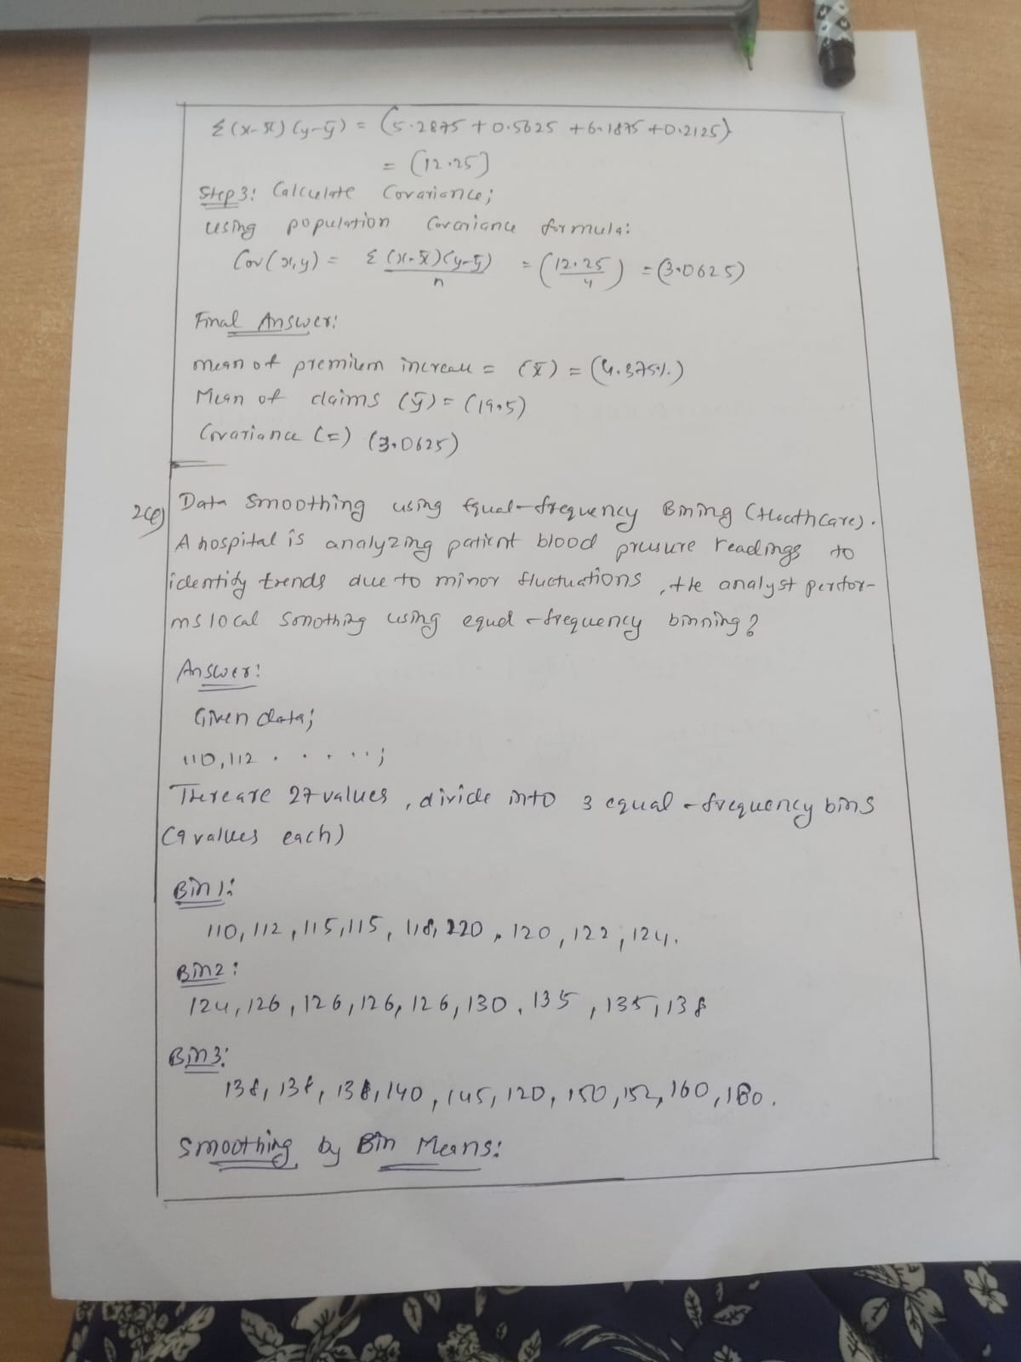

Data Smoothing using Equal-Frequency Binning (Healthcare) (5 Marks)
A hospital is analyzing patient blood pressure readings (systolic) to identify trends. Due to minor fluctuations, the analyst performs local smoothing using equal-frequency (equi-depth) binning.
Sample Data Set (Systolic BP readings):
110, 112, 115, 115, 118, 120, 120, 122, 124, 124, 126, 126, 126, 126, 130, 135, 135, 138, 138, 138, 138, 140, 145, 150, 152, 160, 180

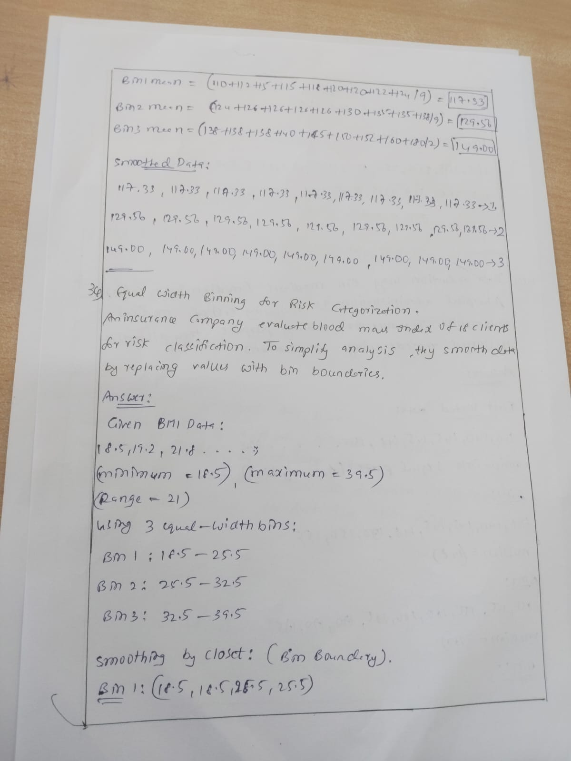

Equal-Width Binning for Risk Categorization (5 Marks)
An insurance company evaluates Body Mass Index (BMI) of 18 clients for risk classification.
To simplify analysis, they smooth the data by replacing values with closest bin boundaries using equal-width partitioning. Sample Data Set (Sorted BMI):
18.5, 19.2, 21.8, 24.9, 25.5, 26.2, 26.4, 27.8, 29.2, 30.2, 30.4, 31.9, 32.4, 33.1, 33.6, 34.7, 38.2, 39.5
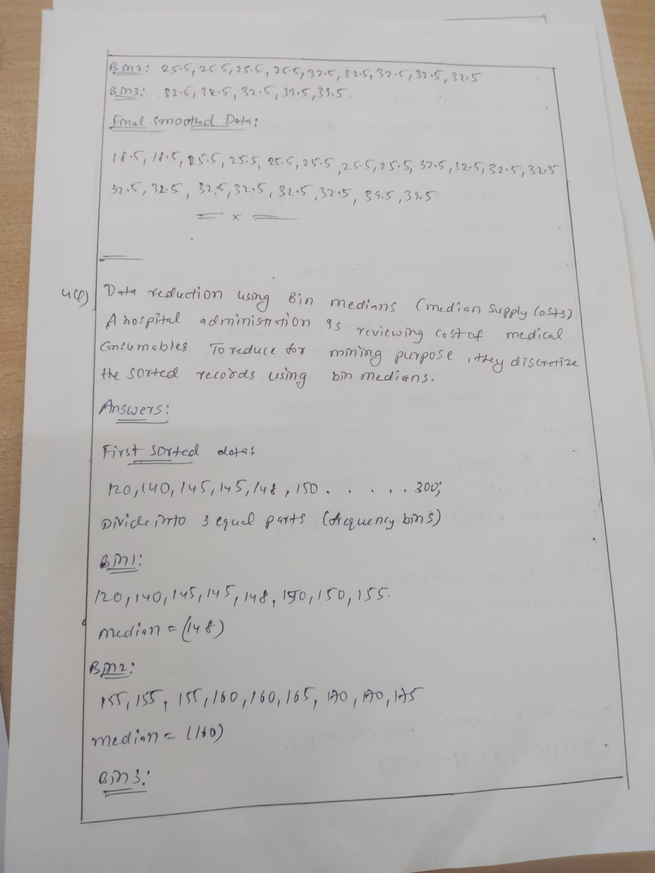

Data Reduction using Bin Medians (Medical Supply Costs) (5 Marks)
A hospital administration is reviewing the cost of medical consumables (in ₹). To reduce data for mining purposes, they discretize the sorted price records using bin medians.
Sample Data Set (Costs in ₹):
120, 150, 160, 160, 140, 145, 145, 148, 150, 150, 155, 155, 155, 155, 165, 170, 170, 175, 175, 175, 175, 180, 190, 200, 210, 230, 300
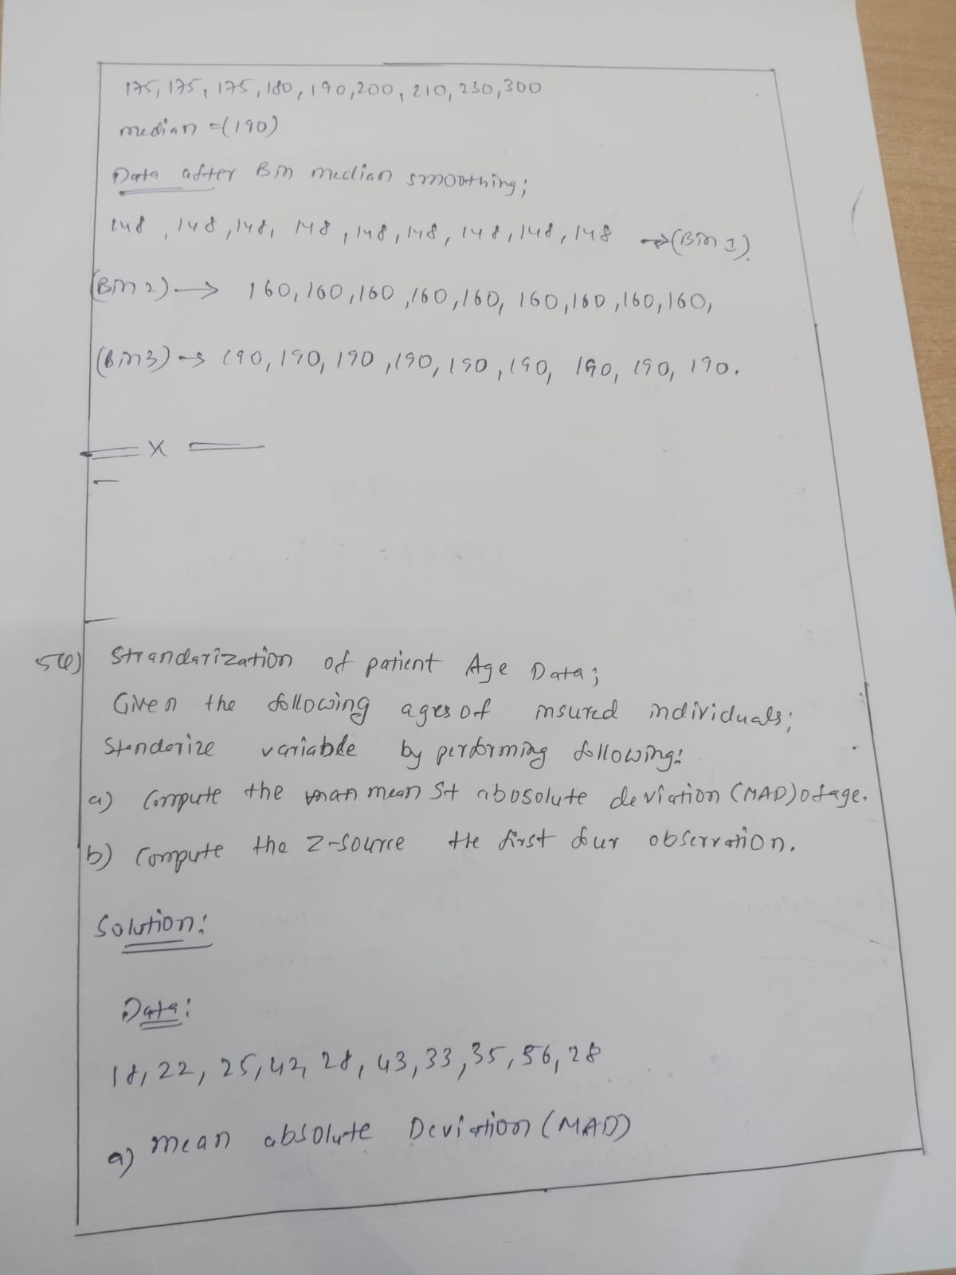

Standardization of Patient Age Data (5 Marks)
Given the following ages of insured individuals:
18, 22, 25, 42, 28, 43, 33, 35, 56, 28
Standardize the variable by performing the following:
- Compute the mean absolute deviation (MAD) of age.
- Compute the z-score for the first four observations.


