SIMATS ENGINEERING
ASSESSMENT TOOL 3

COURSE NAME: INTERNET PROGRAMMING
COURSE CODE: CSA4305

Name: V. Dharani reddy
Reg. No: 192311219
Departement : CSE

AT03-C01-ASSESSMENT : CHAPTER 1

COURSE OUTCOME COVERED
CO-1: Develop well-structured, standards-compliant web pages using HTML/XHTML and
XML, and apply Internet protocols and HTTP communication mechanisms for web content
delivery. (L2)
Assessment Tool: Code along exercise: Make your first HTML page together with CSS
Weightage: 10%

Code of Conduct:
I _V Dharani reddy(192311219)___________________ (Name / Reg No) certify that this submission is my original
work and that I have adhered to the guidelines specified for this assessment.
I understand that any violation of academic integrity rules will result in disciplinary
action.
Signature of the student: V Dharani reddy

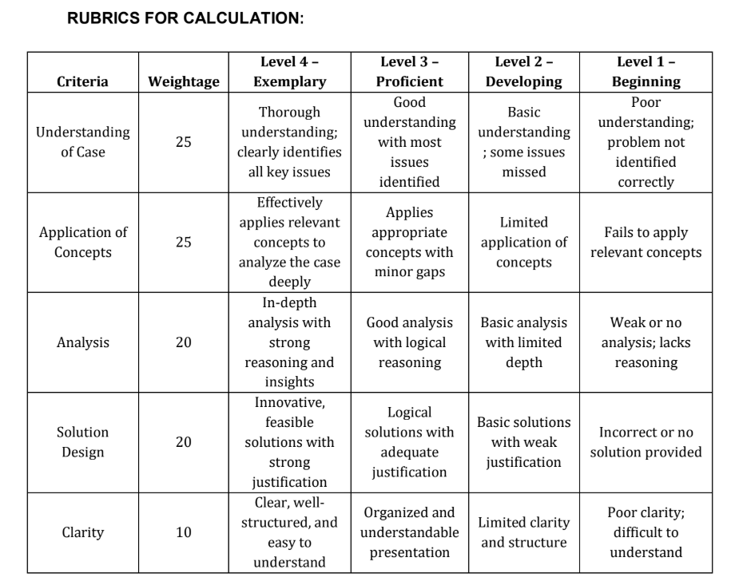

QUESTION AND ANSWER:
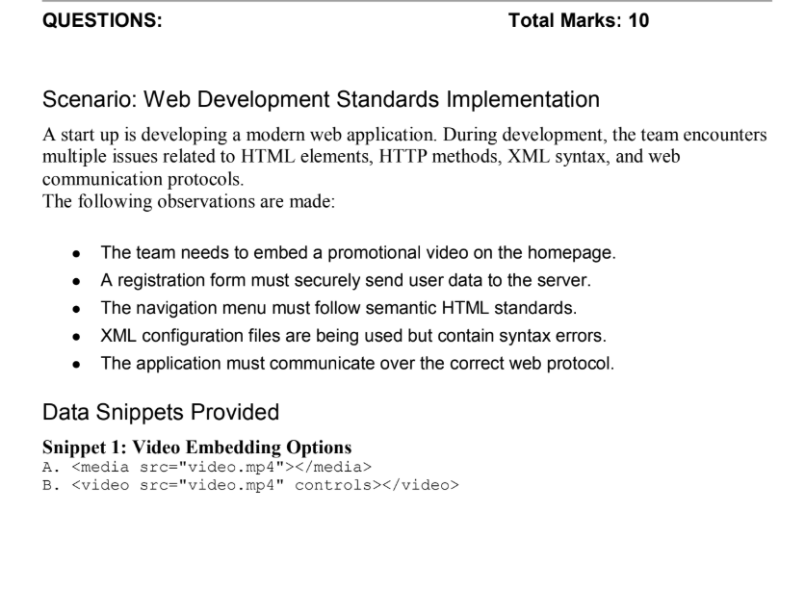
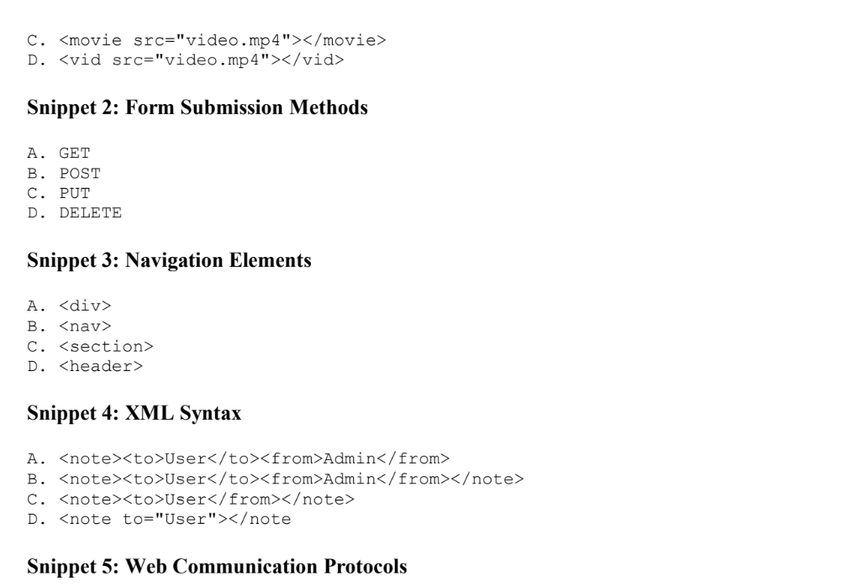

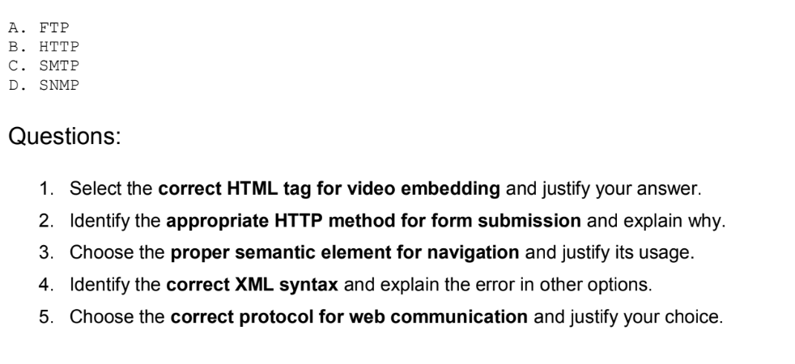
ANSWER:

Scenario: Web Development Standards Implementation

1. Select the correct HTML tag for video embedding and justify your answer.
Correct Answer: B.
<video src="video.mp4" controls></video>
Justification:
- The <video> tag is the standard HTML5 element used to embed videos.
- The controls attribute provides play, pause, volume, and fullscreen controls.
- It is supported by all modern web browsers.
Why other options are incorrect:
- A. <media> is not a valid HTML tag.
- C. <movie> is not a valid HTML tag.
- D. <vid> is not a valid HTML tag.

2. Identify the appropriate HTTP method for form submission and explain why.
Correct Answer: B. POST
Justification:
- POST sends form data in the request body, making it more secure.
- It is suitable for login forms, registration forms, and sensitive information.
- It does not expose user data in the URL.
Why other options are incorrect:
- A. GET – Data is visible in the URL and is not secure for sensitive data.
- C. PUT – Used to update existing resources.
- D. DELETE – Used to delete resources.

3. Choose the proper semantic element for navigation and justify its usage.
Correct Answer: B.
<nav>
Justification:
- <nav> is the HTML5 semantic element specifically designed for navigation links.
- It improves accessibility and search engine optimization (SEO).
Why other options are incorrect:
- A. <div> – Generic container; not semantic.
- C. <section> – Represents a section of content, not navigation.
- D. <header> – Represents introductory content; not specifically for navigation.

4. Identify the correct XML syntax and explain the error in other options.

Correct Answer: B.
<note>
<to>User</to>
<from>Admin</from></note>
Justification:
- All opening tags have matching closing tags.
- XML elements are properly nested.
- The document follows correct XML syntax.

Why other options are incorrect:
A.
<note><to>User</to><from>Admin</from>
- ❌ Missing closing </note> tag.
C.
<note><to>User</from></note>
- ❌ Tags are mismatched (<to> is closed with </from>).
D.
<note to="User"></note>
- ❌ Uses an attribute instead of the required <to> child element, so it does not match the intended XML structure.

5. Choose the correct protocol for web communication and justify your choice.
Correct Answer: HTTP
Justification:
- HTTP (HyperText Transfer Protocol) is the standard protocol used for communication between web browsers and web servers.
- For secure communication, HTTPS (HTTP Secure) is preferred because it encrypts data using SSL/TLS.
Why other options are incorrect:
- FTP – Used for file transfer.
- SMTP – Used for sending emails.
- SNMP – Used for network monitoring and management.

Final Answers (One Mark Format)
Question | Correct Answer
1 | B. <video src="video.mp4" controls></video>
2 | B. POST
3 | B. <nav>
4 | B. <note><to>User</to><from>Admin</from></note>
5 | HTTP (HTTPS for secure web communication)

Conclusion
- Use <video> to embed videos.
- Use POST for secure form submission.
- Use <nav> for website navigation.
- Ensure XML has proper nesting and matching opening/closing tags.
- Use HTTP/HTTPS for browser-server communication, with HTTPS preferred for security.

