SIMATS ENGINEERING
ASSESSMENT TOOL 2

COURSE NAME: INTERNET PROGRAMMING
COURSE CODE: CSA4305

Name: V. Dharani reddy
Reg. No: 192311219
Departement : CSE

AT02-C01-ASSESSMENT : CHAPTER 1

COURSE OUTCOME COVERED
CO-1: Develop well-structured, standards-compliant web pages using HTML/XHTML and
XML, and apply Internet protocols and HTTP communication mechanisms for web content
delivery. (L2)
Assessment Tool: Application-Based Questions
Weightage: 40%
Code of Conduct:
I _V Dharani reddy(192311219)___________________ (Name / Reg No) certify that this submission is my original
work and that I have adhered to the guidelines specified for this assessment.
I understand that any violation of academic integrity rules will result in disciplinary
action.
Signature of the student: V Dharani reddy

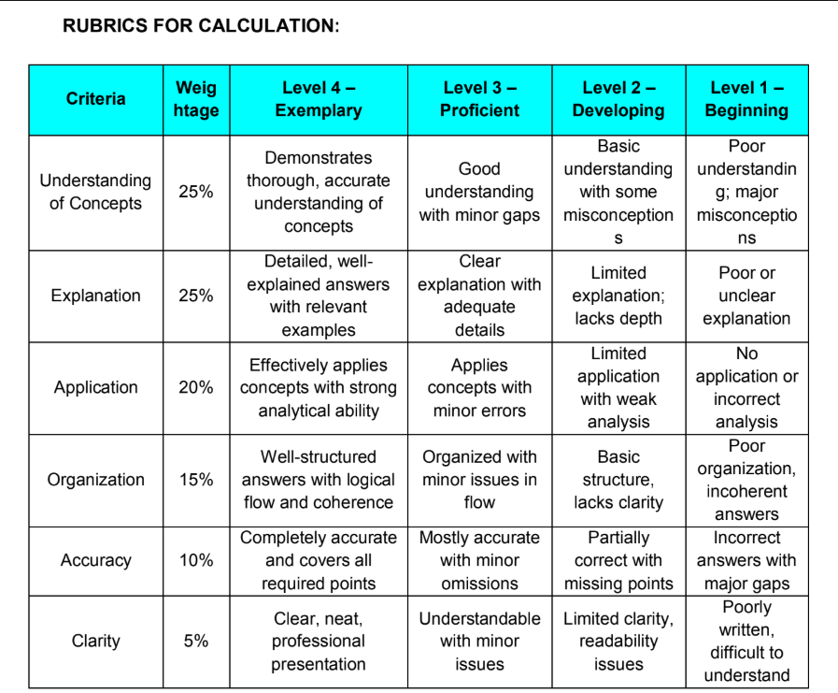

QUESTION AND ANSWERS

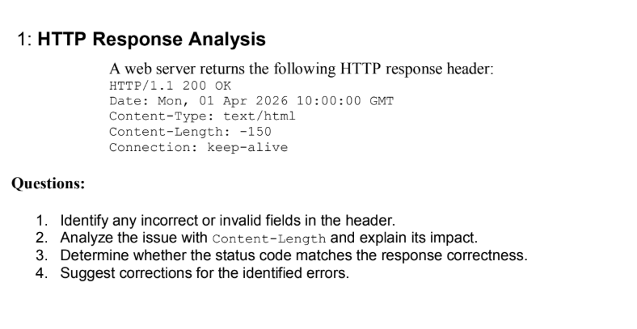

ANSWER:

1. Identify any incorrect or invalid fields in the header.
- Content-Length: -150 is invalid because Content-Length cannot be a negative value.
- The other fields (HTTP/1.1 200 OK, Date, Content-Type, and Connection: keep-alive) are valid.

2. Analyze the issue with Content-Length and explain its impact.
- Content-Length specifies the size of the response body in bytes.
- A value of -150 is invalid because the length cannot be negative.
- Impact:
  - Clients may fail to read the response correctly.
  - Browsers may ignore the response or show an error.
  - It can cause communication issues between the client and server.

3. Determine whether the status code matches the response correctness.
- The status code 200 OK means the request was successful.
- However, the invalid Content-Length makes the response incorrect.
- Therefore, the status code does not fully match the response because the header contains an error.
Explanation:
- POST → Sends form data to the server.
- /register → URL where data is sent.
- Host → Server address.
- Content-Type → Format of submitted data.
- Body → Contains the user's name and email.

4. Suggest corrections for the identified errors.
- Replace the invalid Content-Length: -150 with the correct positive size of the response body.
- Example:
HTTP/1.1 200 OK
Date: Mon, 01 Apr 2026 10:00:00 GMT
Content-Type: text/html
Content-Length: 150
Connection: keep-alive
- Ensure that the Content-Length value matches the actual size of the HTML content.

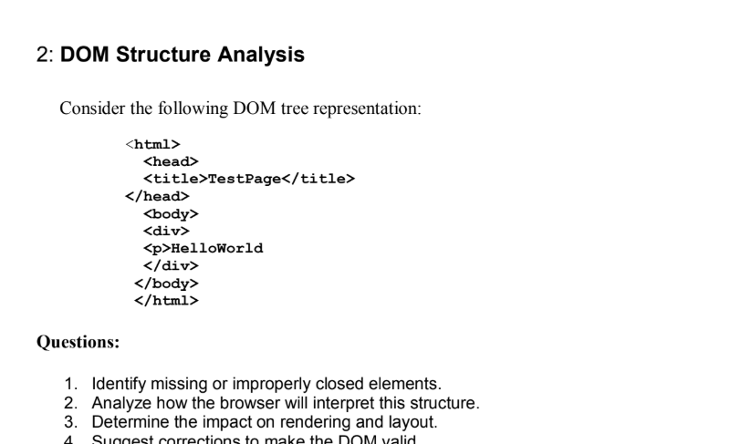

ANSWER:

1. DOM Structure Analysis

1. Identify missing or improperly closed elements.
- The <p> tag is not closed (</p> is missing).
- The <div> tag is closed before the <p> tag, which is an improper nesting.
- The correct closing order should be </p> followed by </div>.

2. Analyze how the browser will interpret this structure.
- Browsers automatically fix HTML errors.
- The browser will automatically close the <p> tag before the </div> tag.
- The page will still display "HelloWorld", but the DOM structure will be corrected internally by the browser.

3. Determine the impact on rendering and layout.
- The text "HelloWorld" will still be displayed.
- Browsers may create a different DOM structure than intended.
- CSS styling and JavaScript DOM operations may behave unexpectedly due to the corrected structure.

4. Suggest corrections to make the DOM valid.
Use the corrected HTML below:
<html><head>
<title>TestPage</title></head><body>
<div>
<p>HelloWorld</p>
</div></body></html>
</div>
</body>
</html>

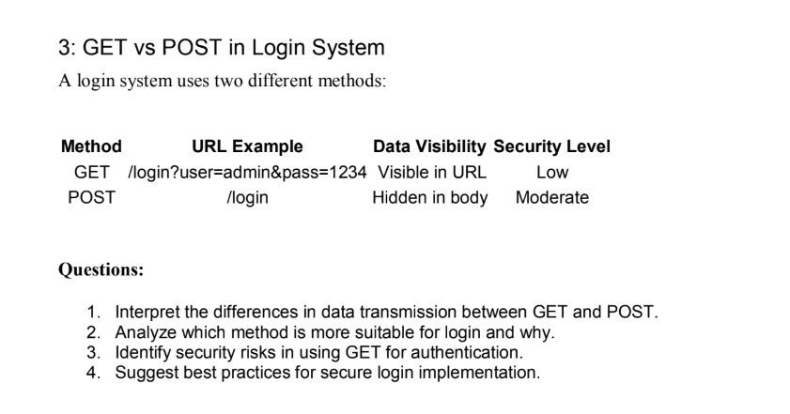
ANSWER:

1. GET vs POST in Login System

1. Interpret the differences in data transmission between GET and POST.
GET | POST
Data is sent in the URL as query parameters. | Data is sent in the request body.
Data is visible in the browser URL. | Data is hidden from the URL.
Less secure for sensitive data. | More secure for sensitive data.

- A normal button only performs actions through JavaScript.
- Without JavaScript or a submit button, the form is never submitted to the server.

2. Analyze which method is more suitable for login and why.
- POST is more suitable for login.
- It hides the username and password in the request body.
- It provides better security and prevents credentials from appearing in the URL, browser history, or bookmarks.

3. Identify security risks in using GET for authentication.
- Username and password are visible in the URL.
- Credentials may be stored in browser history and server logs.
- URLs can be shared accidentally, exposing login details.
- Higher risk of credential theft.

4. Suggest best practices for secure login implementation.
- Use POST instead of GET for login requests.
- Always use HTTPS to encrypt data during transmission.
- Store passwords securely using hashing.
- Use strong authentication methods such as OTP or Multi-Factor Authentication (MFA).
Conclusion:
POST is the preferred method for login because it hides sensitive information in the request body and provides better security than GET.
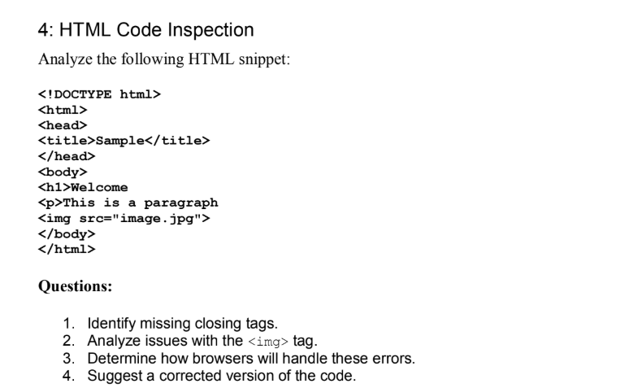

HTML Code Inspection

1. Identify missing closing tags.
- The <h1> tag is missing the closing tag </h1>.
- The <p> tag is missing the closing tag </p>.
- The <img> tag is a void element and does not require a closing tag.

2. Analyze issues with the <img> tag.
- The <img> tag is syntactically correct.
- However, it is missing the alt attribute, which is recommended for accessibility.
- If image.jpg does not exist, the image will not be displayed.

3. Determine how browsers will handle these errors.
- Browsers automatically correct missing closing tags.
- The page will still display the heading, paragraph, and image.
- However, the DOM structure may differ from the intended HTML, which can affect CSS and JavaScript.

4. Suggest a corrected version of the code.
<!DOCTYPE html><html><head>
<title>Sample</title></head><body>
<h1>Welcome</h1>
<p>This is a paragraph</p>
<img src="image.jpg" alt="Sample Image"></body></html>
Conclusion:
The HTML has missing </h1> and </p> closing tags. Adding these tags and including an alt attribute for the <img> tag makes the code valid and improves accessibility.

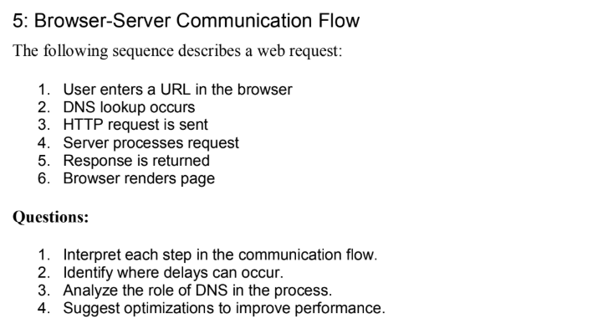

Browser-Server Communication Flow

1. Interpret each step in the communication flow.
- User enters a URL – The user types a website address in the browser.
- DNS lookup occurs – DNS converts the domain name into the server's IP address.
- HTTP request is sent – The browser sends a request to the web server.
- Server processes request – The server handles the request and prepares the response.
- Response is returned – The server sends HTML, CSS, JavaScript, and other resources back to the browser.
- Browser renders page – The browser displays the webpage to the user.

2. Identify where delays can occur.
- Slow DNS lookup.
- Network latency while sending the HTTP request.
- Slow server processing due to high traffic or heavy computation.
- Large response size or slow internet connection.
- Browser rendering delays caused by large CSS, JavaScript, or images.

3. Analyze the role of DNS in the process.
- DNS translates the website name (e.g., www.example.com) into an IP address.
- It enables the browser to locate and connect to the correct server.
- Without DNS, users would have to remember IP addresses instead of domain names.

4. Suggest optimizations to improve performance.
- Use DNS caching to reduce lookup time.
- Enable browser caching for static resources.
- Compress files using Gzip/Brotli.
- Use a Content Delivery Network (CDN).
- Optimize images and reduce unnecessary JavaScript/CSS files.
Conclusion:
The browser-server communication flow involves DNS lookup, HTTP request/response, and page rendering. Performance can be improved through caching, compression, CDNs, and optimized resources.
窗体顶端
窗体底端

