SIMATS ENGINEERING
ASSESSMENT TOOL 1

COURSE NAME: INTERNET PROGRAMMING
COURSE CODE: CSA4305

Name: V. Dharani reddy
Reg. No: 192311219
Departement : CSE

AT01-C01-ASSESSMENT : CHAPTER 1

COURSE OUTCOME COVERED
CO-1: Develop well-structured, standards-compliant web pages using HTML/XHTML and
XML, and apply Internet protocols and HTTP communication mechanisms for web content
delivery. (L2)
Assessment Tool: Application-Based Questions
Weightage: 40%
Code of Conduct:
I _V Dharani reddy(192311219)___________________ (Name / Reg No) certify that this submission is my original
work and that I have adhered to the guidelines specified for this assessment.
I understand that any violation of academic integrity rules will result in disciplinary
action.
Signature of the student: V Dharani reddy

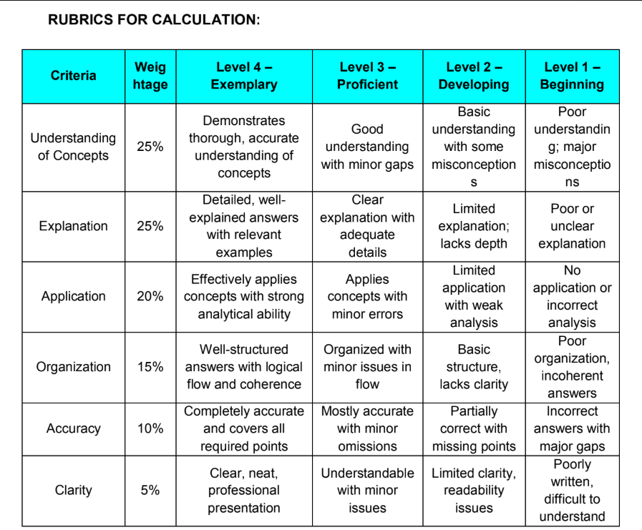

QUESTION AND ANSWERS

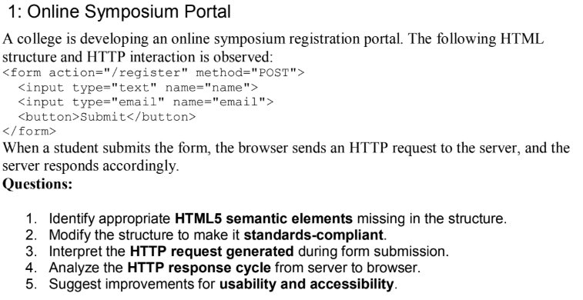

ANSWER:
- Identify appropriate HTML5 semantic elements missing in the structure:
- <header> – Displays the page heading.
- <main> – Contains the main content.
- <section> – Groups the registration form.
- <article> – Holds independent content (optional).
- <footer> – Displays copyright or contact information.
- <label> – Provides labels for input fields.
2. Modify the structure to make it standards-compliant:
<form action="/register" method="POST">
Name: <input type="text" name="name"><br><br>
Email: <input type="email" name="email"><br><br>
<button>Submit</button>
</form>
3. Interpret the HTTP request generated during form submission
When the user clicks Submit, the browser sends an HTTP POST request to the server.
Example:
POST /register HTTP/1.1
Host: example.com
Content-Type: application/x-www-form-urlencoded
name=Rahul&email=rahul@gmail.com
Explanation:
- POST → Sends form data to the server.
- /register → URL where data is sent.
- Host → Server address.
- Content-Type → Format of submitted data.
- Body → Contains the user's name and email.
4. Analyze the HTTP response cycle from server to browser
- User fills the registration form.
- Browser sends an HTTP POST request.
- Server receives and validates the data.
- Server stores the registration details in the database.
- Server sends an HTTP response.
Example Response:
HTTP/1.1 200 OK
Content-Type: text/html
Registration Successful
5. Suggest improvements for usability and accessibility
- Add labels for all input fields.
- Use the required attribute for mandatory fields.
- Provide clear error messages.
- Use semantic HTML5 elements (header, main, section, footer).
- Ensure keyboard accessibility.
- Add placeholder text (optional).
- Use proper color contrast for readability.
- Validate email format using type="email".

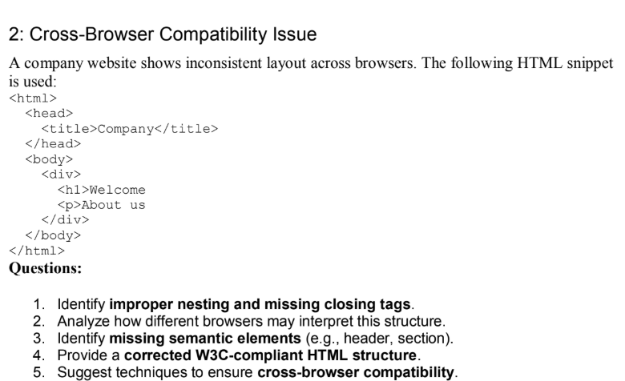

ANSWER:
1. Identify improper nesting and missing closing tags
Errors:
- <h1> is not closed.
- <p> is not closed.
- Missing <!DOCTYPE html> declaration.
2. Analyze how different browsers interpret it
- Browsers automatically close missing tags.
- Different browsers may display the page differently.
- Layout may become inconsistent.
3. Identify missing semantic elements
Missing elements:
- <header>
- <main>
- <section>
4. Corrected W3C-Compliant HTML
<!DOCTYPE html>
<html>
<body>
<header><h1>Welcome</h1></header>
<p>About us</p>
</body>
</html>
5. Techniques to ensure cross-browser compatibility
- Use <!DOCTYPE html>.
- Close all HTML tags.
- Use semantic HTML5 elements.
- Validate HTML using the W3C Validator.
- Test the website in multiple browsers.

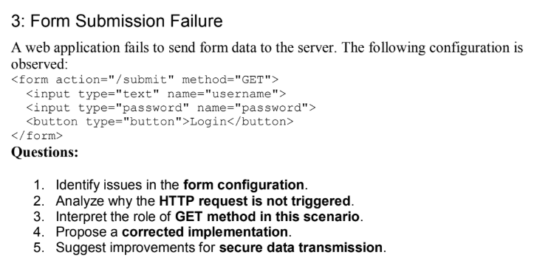
ANSWER:
1. Identify issues in the form configuration
- The form uses the GET method, which is not suitable for sending passwords because the data appears in the URL.
- The button type is set to button, so it does not submit the form.
- For login forms, POST and a submit button should be used.
2. Analyze why the HTTP request is not triggered
- The HTTP request is not sent because the button type is button instead of submit.
- A normal button only performs actions through JavaScript.
- Without JavaScript or a submit button, the form is never submitted to the server.
3. Interpret the role of GET method in this scenario
- The GET method sends form data through the URL as query parameters.
- It is mainly used to retrieve information from the server.
- Since passwords become visible in the URL, GET is not recommended for login forms.
4. Corrected Implementation
<form action="/submit" method="POST">
<input type="text" name="username">
<input type="password" name="password">
<button type="submit">Login</button>
</form>
5. Suggest improvements for secure data transmission
- Use the POST method instead of GET to hide form data from the URL.
- Enable HTTPS to encrypt data during transmission.
- Validate user input and store passwords securely using encryption . This improves both security and user privacy.

