Der TitelFunctional Specification Document

*New Development*

*Election Information System*

|  |  |  |
| --- | --- | --- |
| Proposition to |  | *Andreas Kipf, TUM* |
| Auftraggeber |  | *Federal Republic of Germany* |
| Author of the Document |  | *001Jens Wöhrle & Martin Wurzer* |
| Version of the Document |  | *1.0* |
| Place, Date |  | *München, xx. Monat 200x01.11.2015* |

Inhalt

1. Definition of Goals 3

1.1. Must-Have-Criteria 3

1.2. Should-Have-Criteria 3

1.3. Can-Contain-Criteria 4

2. Product Usage 4

3. Technical realisation 4

4. Using Interface 5

5. Glossary 7

# 

# **Definition of Goals**

Goal of this document is to specify the functional requirement the system implemented by ourselves – Jens Wöhrle & Martin Wurzer IT Systems.

Goal of the project is to implement a complete „election information system“ which makes the people possible to see in real time the current estimated result of the election in a web-interface. Parallel the system has to operate in the polling site, that the people can do their election

## **Must-Have-Criteria**

The implemented system has to contain the following features:

* Voting-System: Every citizen can vote with this system anonymously in the polling site
* Election Analysis with well-structured output of the final result of the election and real-time estimations of the result in the progress of the election.

Therefore it has to provide the following information:

* + Distribution of seats in the “Bundestag”
  + Direct mandates
  + Excess mandates
  + Compensation mandates
* Well-structured and easily understandable visualisation of the data to make the people be more interested in the election and its system
* Privacy: The peoples vote has to be anonymous.
* Security: The system has to be consistent, that means that every person can just vote once. The system must be safe from outside for this purpose.
* Performance: The user must be able to vote quickly – less than 5 seconds. To see the current estimation of the result, the result should be available in less than 3 seconds.

## **Should-Have-Criteria**

The following features the system should contain as well, but are rated as less important than the “must-have-features”:

* Explicit naming of the new members of the “Bundestag”
* Scalability: The system should be unlimitedly scalable if the required hardware is available. That means performance management is required.
* Robustness: Protection against failure

## **Can-Contain-Criteria**

The following described features are “nice-to-have” and will be implemented if resources for their implementation are available. These features make the system more user-friendly

* Analysis of possible coalitions
* Interactive visualisation of the data
* Easteregs

# **Product Usage**

The product will be designed for the usage of every mature citizen. This means it has to be easily understandable and usable. The product needs to be robust during the election to avoid any errors and problems with the system in the highly sensitive election.

# **Technical realisation**

As this is a stand-alone system no specific interaction with already operating systems will be required. The implementation requires a Backend-System and a Front-End-Application for the User.

Backend:

* For the database-system we will be using Postgress or MongoDB

Frontend:

* Here we will be most-likely using several JavaScript-tools. Especially Anjular.Js, a nice framework for the construction of Frontend applications which is very light but powerful and highly scalable. This system works very well with the MongoDB-System together.

# **Using Interface**

The Using interface will accessed via any supported Browser – especially Google Chrome. This Website contains two different views.

* One view will just be used for informational purposed and is available for the public.
* The other one will be used in order to vote and requires and authentication. For this purposed you can ask for an authentication key and with this key you can access the website and vote. As these keys will be distributed anonymously, it is not possible to trace vote. This key has to be received in the polling site or sent to you in advance.

In the following you will be seeing a GUI-Mockup of the System:

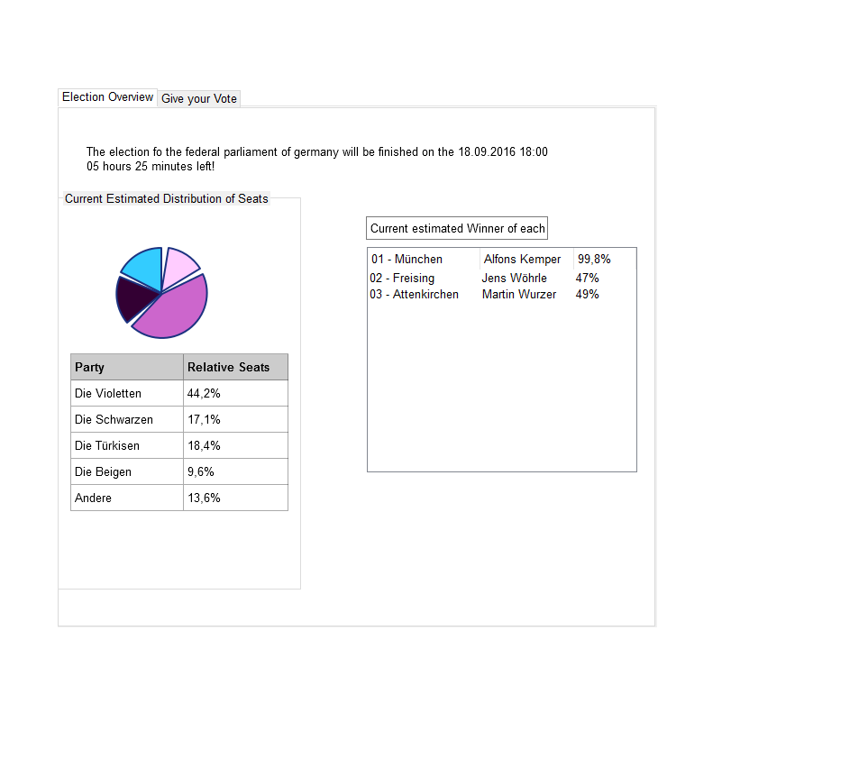

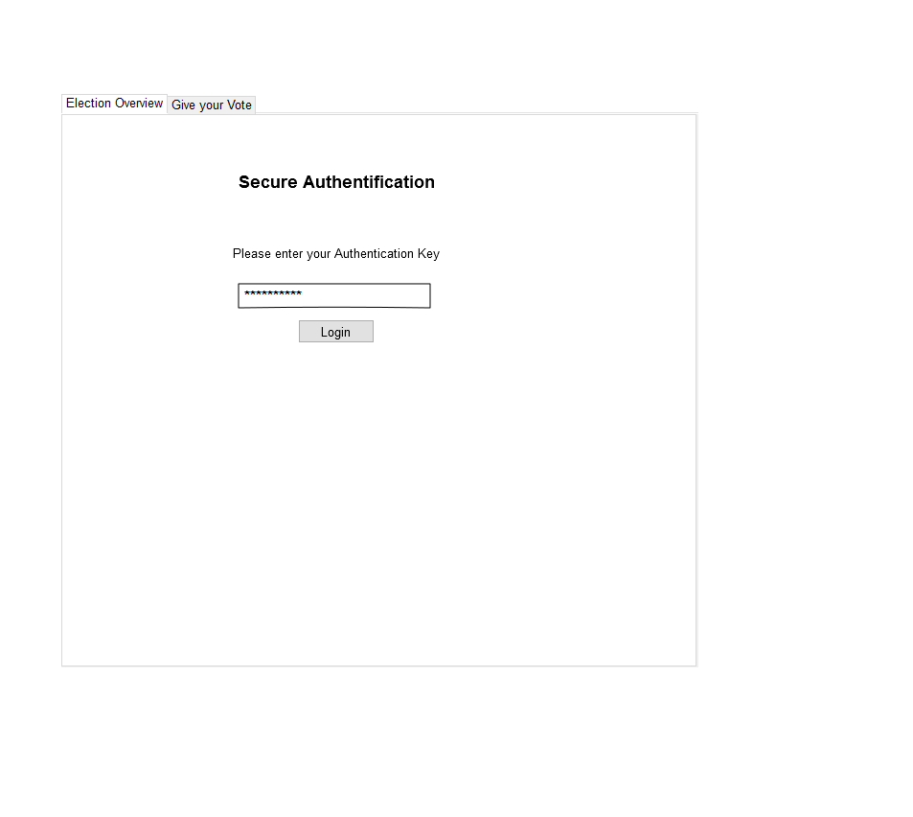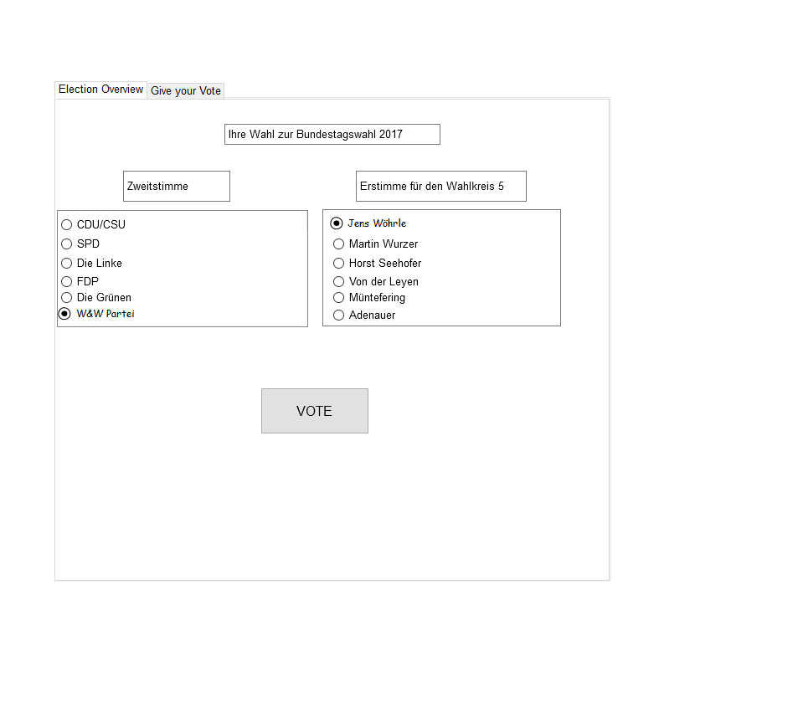

# **Glossary**

|  |  |
| --- | --- |
| German Election System | This means the general and official election system with the procedure of Sainte-Laguë/Schepers |
| Angular.JS | Framework developed by Google based on JavaScript for Single-Page-WebApplications |
| MongoDB | OpenSource Database Managemenrt System which works very well with Angular.JS togehter |