Exercise3-1.R

B-C-Herbert

2019-09-16

###Assignment 1  
  
remove(list = ls())  
  
###Exercise 3  
  
### a)  
x = 0  
y = 0  
x1 = c(2,1)  
y1 = c(3,0)  
  
lx1 = sqrt(sum(x1^2))  
ly1 = sqrt(sum(y1^2))  
projxy = (((t(y1)%*%x1)/ly1)%*%(1/ly1))%*%y1  
projxy

## [,1] [,2]  
## [1,] 2 0

plot(x,y,xlim=c(0,4),ylim=c(-0.2,1.2),type="n",axes=FALSE,frame.plot=FALSE,ann=FALSE,asp=1)  
arrows(0,0,2,1,col = 4)  
arrows(0,0,3,0,col = 2)  
arrows(0,-0.1,2,-0.1)  
arrows(2,1,projxy[1,1],projxy[1,2], lty = 2, code = 0)  
arrows(2,1,2,0, lty = 2, code = 0)  
text(2.2,1.1,"x")  
text(3.2,0,"y")

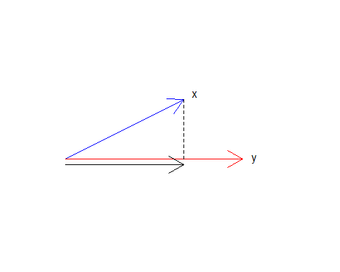

### b)  
x = 0  
y = 0  
x1 = c(2,1)  
y1 = c(3,1)  
  
lx1 = sqrt(sum(x1^2))  
ly1 = sqrt(sum(y1^2))  
projxy = (((t(y1)%*%x1)/ly1)%*%(1/ly1))%*%y1  
projxy

## [,1] [,2]  
## [1,] 2.1 0.7

plot(x,y,xlim=c(0,4),ylim=c(-0.2,1.2),type="n",axes=FALSE,frame.plot=FALSE,ann=FALSE,asp=1)  
arrows(0,0,2,1,col = 4)  
arrows(0,0,3,1,col = 2)  
arrows(0,-0.1,projxy[1,1],projxy[1,2] -0.1)  
arrows(2,1,projxy[1,1],projxy[1,2], lty = 2, code = 0)  
text(2.2,1.1,"x")  
text(3.2,1,"y")

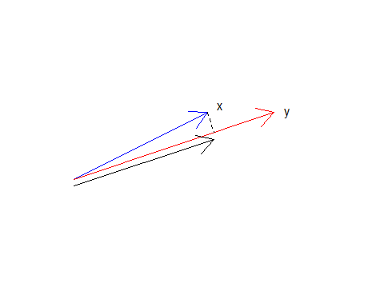

### c)   
?plot

## starting httpd help server ... done

#Mit asp wird das Längenverhätnis zischen den Einheiten der y-Achse und der x-Achse (y/x) bestimmt.  
#asp = 1 sgarantiert, dass das Verhältnis, zwischen den Längeneinheiten 1 beträgt.