###Exercise 3  
  
remove(list = ls())  
  
x1 = seq(-1,1,le=40)  
x2=x1  
  
### i)  
  
A1=matrix(c(1,0,0,1),2,2)  
f= function(v1,v2)  
{  
 A1[1,1]*v1^2+A1[2,2]*v2^2+2*A1[1,2]*v1*v2  
}  
resouter=outer(x1,x2,f)  
persp(x1,x2,asp = 1,resouter,ticktype="detailed", zlab = "z")

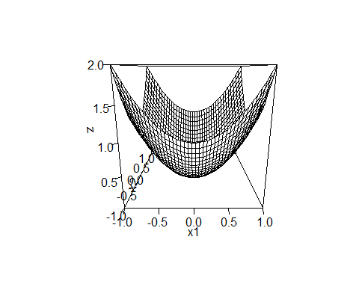

contour(x1,x2,resouter,asp = 1)

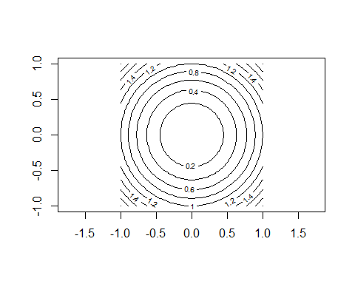

*### ii)*  
  
A2=matrix(c(1,0,0,2),2,2)  
f= function(v1,v2)  
{  
 A2[1,1]*v1^2+A2[2,2]*v2^2+2*A2[1,2]*v1*v2  
}  
resouter=outer(x1,x2,f)  
persp(x1,x2,asp = 1,resouter,ticktype="detailed", zlab = "z")

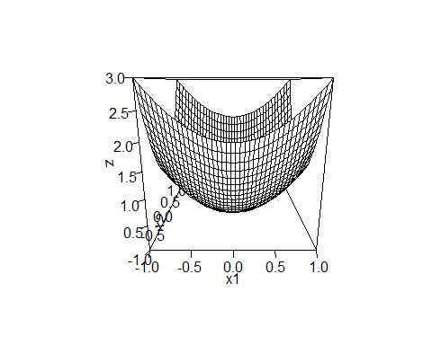

contour(x1,x2,resouter,asp=1)

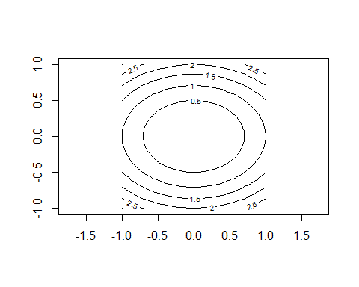

### iii)  
  
A3=matrix(c(1,0,0,0.5),2,2)  
f= function(v1,v2)  
{  
 A3[1,1]*v1^2+A3[2,2]*v2^2+2*A3[1,2]*v1*v2  
}  
resouter=outer(x1,x2,f)  
persp(x1,x2,asp = 1,resouter,ticktype="detailed", zlab = "z")

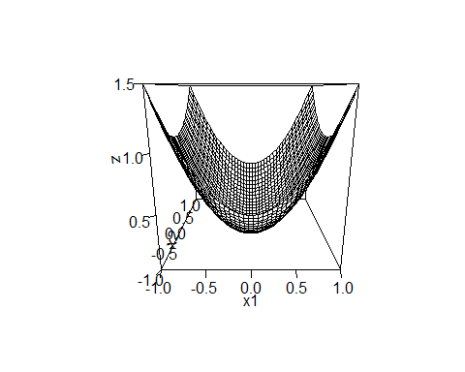

contour(x1,x2,resouter,asp=1)

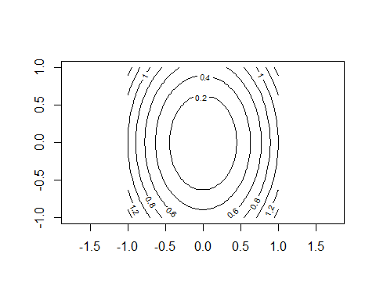

### iv)  
  
A4=matrix(c(1,0.5,0.5,1),2,2)  
f= function(v1,v2)  
{  
 A4[1,1]*v1^2+A4[2,2]*v2^2+2*A4[1,2]*v1*v2  
}  
resouter=outer(x1,x2,f)  
persp(x1,x2,asp = 1,resouter,ticktype="detailed", zlab = "z")

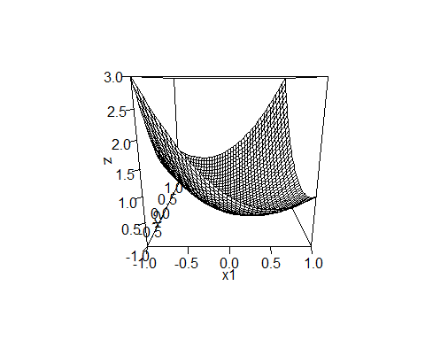

contour(x1,x2,resouter,asp=1)

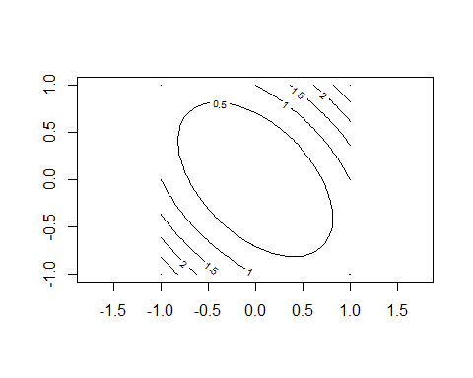

### v)  
  
A5=matrix(c(1,0.8,0.8,1),2,2)  
f= function(v1,v2)  
{  
 A5[1,1]*v1^2+A5[2,2]*v2^2+2*A5[1,2]*v1*v2  
}  
resouter=outer(x1,x2,f)  
persp(x1,x2,asp = 1,resouter,ticktype="detailed", zlab = "z")

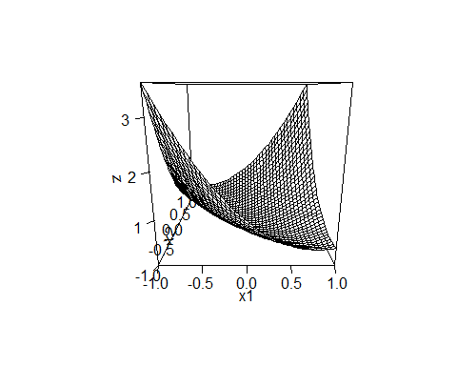

contour(x1,x2,resouter,asp=1)

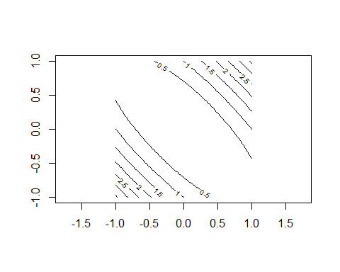

### vi)  
  
A6=matrix(c(1,-0.5,-0.5,1),2,2)  
f= function(v1,v2)  
{  
 A6[1,1]*v1^2+A6[2,2]*v2^2+2*A6[1,2]*v1*v2  
}  
resouter=outer(x1,x2,f)  
persp(x1,x2,asp = 1,resouter,ticktype="detailed", zlab = "z")

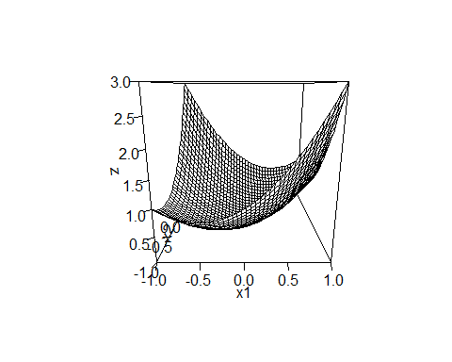

contour(x1,x2,resouter,asp=1)

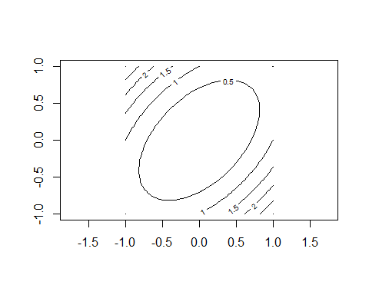

### vii)  
  
A7 = solve(A5)  
f= function(v1,v2)  
{  
 A7[1,1]*v1^2+A7[2,2]*v2^2+2*A7[1,2]*v1*v2  
}  
resouter=outer(x1,x2,f)  
persp(x1,x2,asp = 1,resouter,ticktype="detailed", zlab = "z")

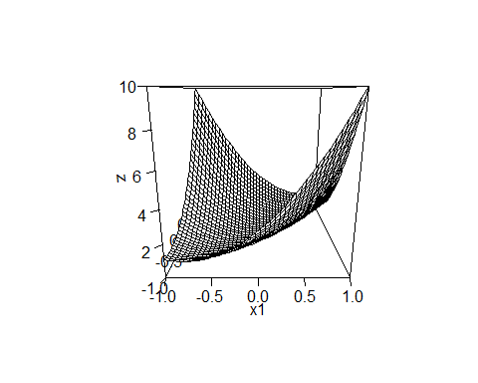

contour(x1,x2,resouter,asp=1)

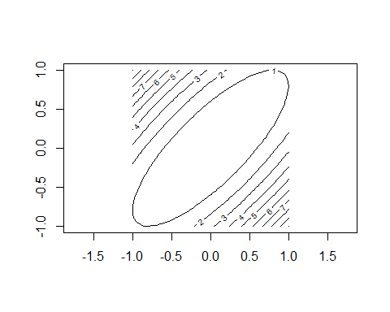

### viii)  
  
A8 = solve(A6)  
f= function(v1,v2)  
{  
 A8[1,1]*v1^2+A8[2,2]*v2^2+2*A8[1,2]*v1*v2  
}  
resouter=outer(x1,x2,f)  
persp(x1,x2,asp = 1,resouter,ticktype="detailed", zlab = "z")

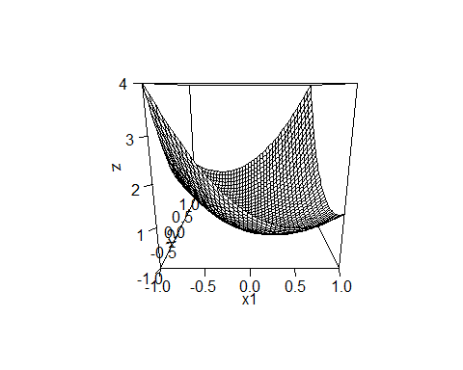

contour(x1,x2,resouter,asp=1)

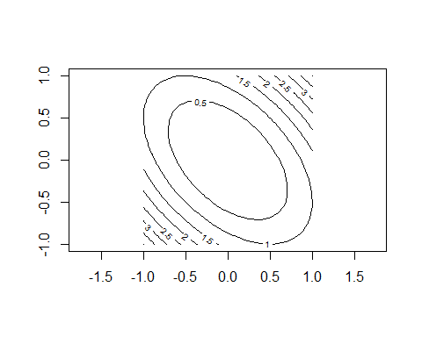

### Exercise 5  
  
remove(list = ls())  
  
x1 = seq(-2,2,le=100)  
x2 = x1  
A = matrix(c(5,4,4,5),2,2)  
  
f= function(v1,v2)  
{  
 A[1,1]*v1^2+A[2,2]*v2^2+2*A[1,2]*v1*v2  
}  
  
resouter=outer(x1,x2,f)  
contour(x1 ,x2 ,resouter,levels = 2, asp = 1, drawlabels = FALSE, xlim=c(-2,2), ylim = c(-2,2))  
  
E=eigen(A)  
E

## eigen() decomposition  
## $values  
## [1] 9 1  
##   
## $vectors  
## [,1] [,2]  
## [1,] 0.7071068 -0.7071068  
## [2,] 0.7071068 0.7071068

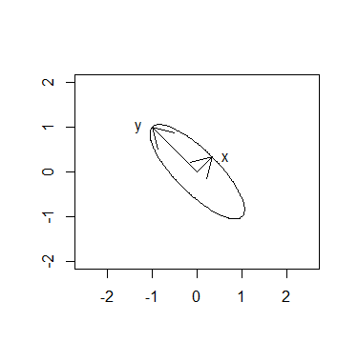###Diese Werte stimmen mit jenen überein, welche mit Hand berechnet wurden.  
  
e10 = E$vectors[,1]  
e11 = (sqrt(2)/sqrt(9))*e10  
arrows(0,0,e11[1],e11[2],col = "black")  
text(e11[1]+0.3,e11[2],"x")  
  
e20 = E$vectors[,2]  
e21 = (sqrt(2)/sqrt(1))*e20  
arrows(0,0,e21[1],e21[2],col = "black")  
text(e21[1]-0.3,e21[2],"y")

le11 = sqrt(sum(e11^2))  
paste("Die Länge des Eigenvektors x beträgt:", round(le11, digits = 6))

## [1] "Die Länge des Eigenvektors x beträgt: 0.471405"

le21 = sqrt(sum(e21^2))  
paste("Die Länge des Eigenvektors y beträgt:", round(le21, digits = 6))

## [1] "Die Länge des Eigenvektors y beträgt: 1.414214"

###Exercise 6  
  
remove(list = ls())  
  
### a)  
A = matrix(c(13,-4,2,-4,13,-2,2,-2,10),3,3)  
EA = eigen(A)  
lamEA = EA$values  
  
###Eigenvalue matrix  
m_lamEA = matrix(c(18,0,0,0,9,0,0,0,9),3,3)  
m_lamEA

## [,1] [,2] [,3]  
## [1,] 18 0 0  
## [2,] 0 9 0  
## [3,] 0 0 9

###Eigenvector matrix  
eiVA = EA$vectors  
eiVA

## [,1] [,2] [,3]  
## [1,] 0.6666667 -0.7453560 0.0000000  
## [2,] -0.6666667 -0.5962848 0.4472136  
## [3,] 0.3333333 0.2981424 0.8944272

###sectral decompostion  
eiVA%*%m_lamEA%*%t(eiVA)

## [,1] [,2] [,3]  
## [1,] 13 -4 2  
## [2,] -4 13 -2  
## [3,] 2 -2 10

###Wie zu erwarten entspreicht das Ergebnis der sectral decomposition der Matrix.

### b)  
  
eiEA1 = EA$vectors[,1]  
eiEA2 = EA$vectors[,2]  
eiEA3 = EA$vectors[,3]  
  
### i)  
lamEA[1]*eiEA1%*%t(eiEA1)

## [,1] [,2] [,3]  
## [1,] 8 -8 4  
## [2,] -8 8 -4  
## [3,] 4 -4 2

### ii)  
lamEA[1]*eiEA1%*%t(eiEA1)+lamEA[2]*eiEA2%*%t(eiEA2)

## [,1] [,2] [,3]  
## [1,] 13 -4.0 2.0  
## [2,] -4 11.2 -5.6  
## [3,] 2 -5.6 2.8

### iii)  
lamEA[1]*eiEA1%*%t(eiEA1)+lamEA[2]*eiEA2%*%t(eiEA2)+lamEA[3]*eiEA3%*%t(eiEA3)

## [,1] [,2] [,3]  
## [1,] 13 -4 2  
## [2,] -4 13 -2  
## [3,] 2 -2 10

### c)  
sqm_lamEA = sqrt(matrix(c(18,0,0,0,9,0,0,0,9),3,3))  
sqm_A = eiVA%*%sqm_lamEA%*%t(eiVA)  
sqm_A

## [,1] [,2] [,3]  
## [1,] 3.5522847 -0.5522847 0.2761424  
## [2,] -0.5522847 3.5522847 -0.2761424  
## [3,] 0.2761424 -0.2761424 3.1380712