Exercise-3.R

B-C-Herbert

2019-09-24

###Exercise 3  
  
remove(list = ls())  
  
x1 = seq(-1,1,le=40)  
x2=x1  
  
# i)  
  
A1=matrix(c(1,0,0,1),2,2)  
f= function(v1,v2)  
{  
 A1[1,1]*v1^2+A1[2,2]*v2^2+2*A1[1,2]*v1*v2  
}  
resouter=outer(x1,x2,f)  
persp(x1,x2,asp = 1,resouter,ticktype="detailed", zlab = "z")

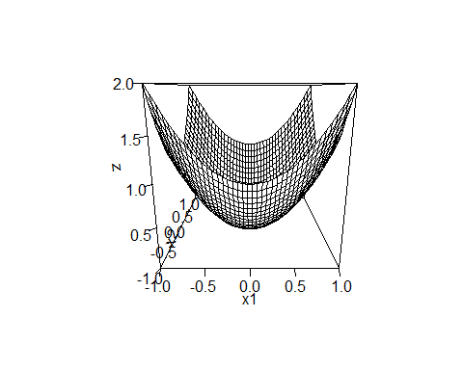

contour(x1,x2,resouter,asp = 1)

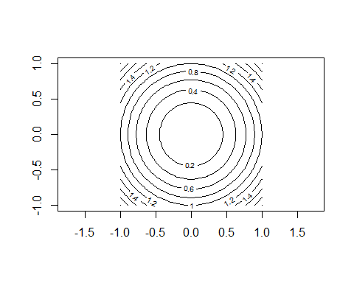

# ii)  
  
A2=matrix(c(1,0,0,2),2,2)  
f= function(v1,v2)  
{  
 A2[1,1]*v1^2+A2[2,2]*v2^2+2*A2[1,2]*v1*v2  
}  
resouter=outer(x1,x2,f)  
persp(x1,x2,asp = 1,resouter,ticktype="detailed", zlab = "z")

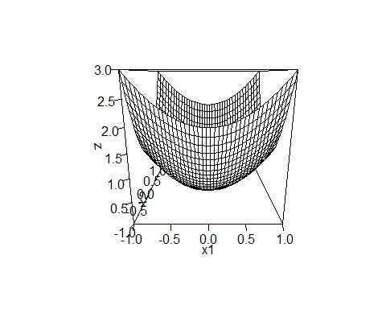

contour(x1,x2,resouter,asp=1)

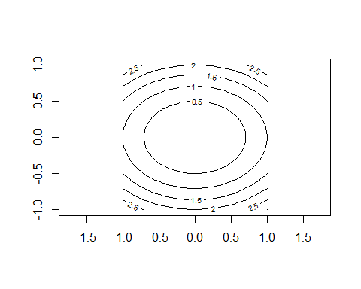

### iii)  
  
A3=matrix(c(1,0,0,0.5),2,2)  
f= function(v1,v2)  
{  
 A3[1,1]*v1^2+A3[2,2]*v2^2+2*A3[1,2]*v1*v2  
}  
resouter=outer(x1,x2,f)  
persp(x1,x2,asp = 1,resouter,ticktype="detailed", zlab = "z")

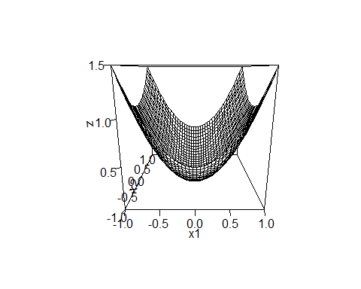

contour(x1,x2,resouter,asp=1)

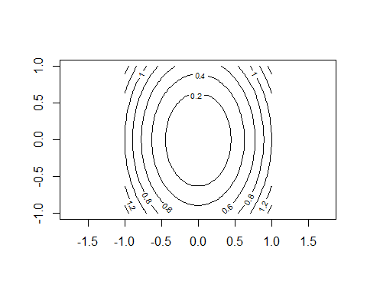

### iv)  
  
A4=matrix(c(1,0.5,0.5,1),2,2)  
f= function(v1,v2)  
{  
 A4[1,1]*v1^2+A4[2,2]*v2^2+2*A4[1,2]*v1*v2  
}  
resouter=outer(x1,x2,f)  
persp(x1,x2,asp = 1,resouter,ticktype="detailed", zlab = "z")

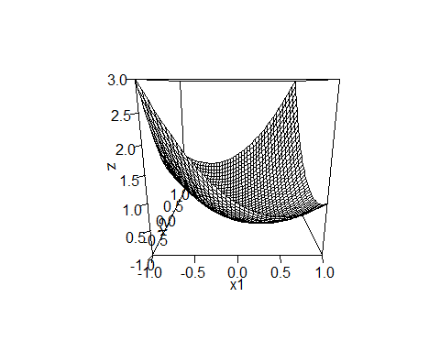

contour(x1,x2,resouter,asp=1)

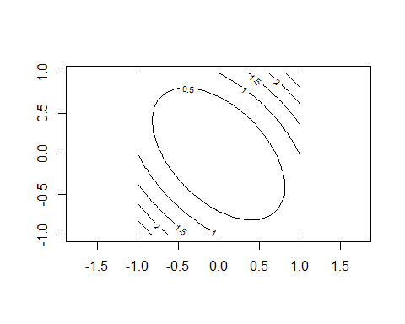

### v)  
  
A5=matrix(c(1,0.8,0.8,1),2,2)  
f= function(v1,v2)  
{  
 A5[1,1]*v1^2+A5[2,2]*v2^2+2*A5[1,2]*v1*v2  
}  
resouter=outer(x1,x2,f)  
persp(x1,x2,asp = 1,resouter,ticktype="detailed", zlab = "z")

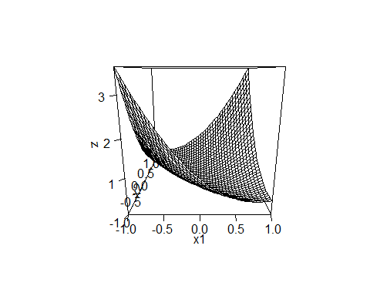

contour(x1,x2,resouter,asp=1)

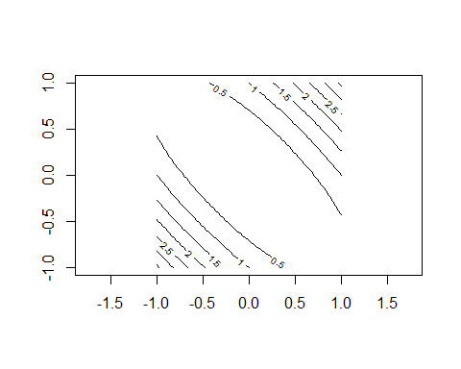

### vi)  
  
A6=matrix(c(1,-0.5,-0.5,1),2,2)  
f= function(v1,v2)  
{  
 A6[1,1]*v1^2+A6[2,2]*v2^2+2*A6[1,2]*v1*v2  
}  
resouter=outer(x1,x2,f)  
persp(x1,x2,asp = 1,resouter,ticktype="detailed", zlab = "z")

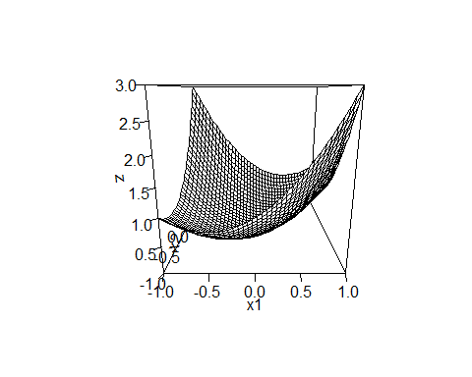

contour(x1,x2,resouter,asp=1)

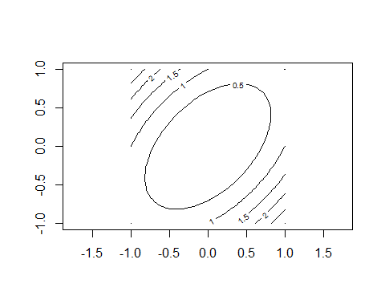

### vii)  
  
A7 = solve(A5)  
f= function(v1,v2)  
{  
 A7[1,1]*v1^2+A7[2,2]*v2^2+2*A7[1,2]*v1*v2  
}  
resouter=outer(x1,x2,f)  
persp(x1,x2,asp = 1,resouter,ticktype="detailed", zlab = "z")

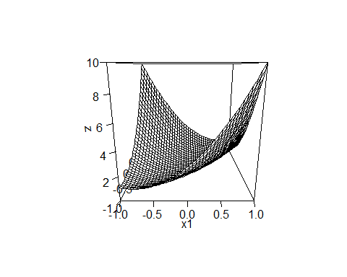

contour(x1,x2,resouter,asp=1)

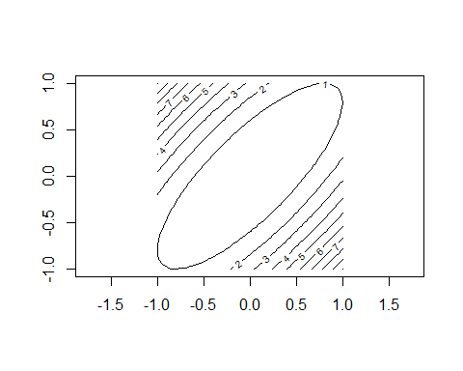

### viii)  
  
A8 = solve(A6)  
f= function(v1,v2)  
{  
 A8[1,1]*v1^2+A8[2,2]*v2^2+2*A8[1,2]*v1*v2  
}  
resouter=outer(x1,x2,f)  
persp(x1,x2,asp = 1,resouter,ticktype="detailed", zlab = "z")

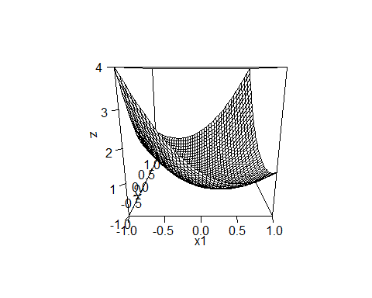

contour(x1,x2,resouter,asp=1)

