### Exercise 1  
  
remove(list = ls())  
  
A = matrix(c(13,-4,2,-4,13,-2,2,-2,10),3,3)  
  
# a) Correlation matrix C  
  
C = cov2cor(A)  
C

## [,1] [,2] [,3]  
## [1,] 1.0000000 -0.3076923 0.1754116  
## [2,] -0.3076923 1.0000000 -0.1754116  
## [3,] 0.1754116 -0.1754116 1.0000000

# b)  
  
CE = eigen(C)  
CE

## eigen() decomposition  
## $values  
## [1] 1.4457487 0.8619436 0.6923077  
##   
## $vectors  
## [,1] [,2] [,3]  
## [1,] 0.6178686 -0.3438582 7.071068e-01  
## [2,] -0.6178686 0.3438582 7.071068e-01  
## [3,] 0.4862889 0.8737981 -1.110223e-16

### Die Eigenwerte und die Eigenvektoren der Korrelationsmatrix sind nicht die gleichen, wie die der Kovarianzmatrix A

## Exercise 2  
  
remove(list = ls())  
  
x1 = seq(-3,3, le = 100)  
x2 = seq(-3,3, le = 100)  
  
# i)  
  
m = c(0,0)  
m1 = 0  
m2 = 0  
  
S11 = 1  
S22 = 1  
  
COR12 = 0  
  
f= function(v1,v2)  
{  
 (1/(2*pi))*exp((-1/2)*(((v1-m1)^2)+((v2-m2)^2)))  
}  
  
z = outer(x1,x2,f)  
persp(x1,x2,z,main="",cex.lab=1.5,theta=30,phi=20,r=50,d=0.1,expand=0.5,  
 ltheta=90,lphi=180,shade=0.75,ticktype="detailed",nticks=5,  
 xlim=**c**(-3,3),ylim=**c**(-3,3),zlim=**c**(0,0.2))

**contour**(x1,x2,z,asp = 1)

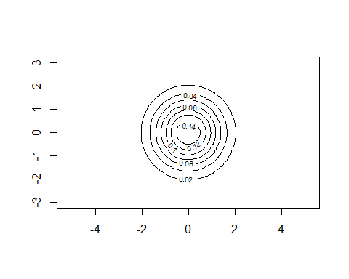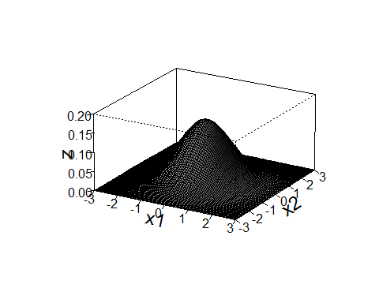

# ii)  
  
m = c(0,0)  
m1 = 0  
m2 = 0  
  
S11 = 1.5^2  
S22 = 1  
  
COR12 = 0  
  
f= function(v1,v2)  
{  
 (1/((2*pi)*sqrt(S11*S22)*sqrt(1-COR12^2)))*exp((-1/(2*(1-COR12^2)))*(((v1-m1)^2/S11)  
 -2*COR12*((v1-m1)/sqrt(S11))*((v2-m2)/sqrt(S22))+((v2-m2)^2)/S22))  
}  
  
z = outer(x1,x2,f)  
persp(x1,x2,z,main="",cex.lab=1.5,theta=30,phi=20,r=50,d=0.1,expand=0.5,  
 ltheta=90,lphi=180,shade=0.75,ticktype="detailed",nticks=5,  
 xlim=c(-3,3),ylim=c(-3,3),zlim=c(0,0.2))

contour(x1,x2,z,asp = 1)

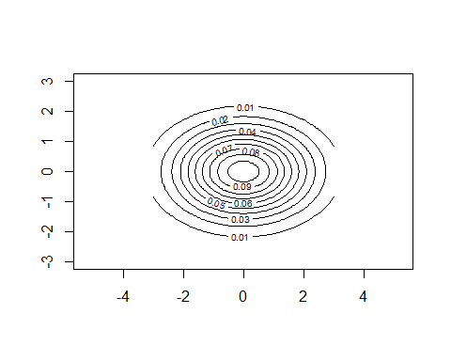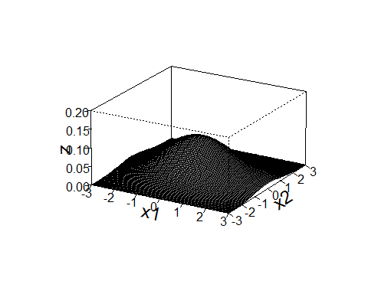

# iii)  
  
m = c(0,0)  
m1 = 0  
m2 = 0  
  
S11 = 1  
S22 = 1  
  
COR12 = -0.8  
  
f= function(v1,v2)  
{  
 (1/((2*pi)*sqrt(S11*S22)*sqrt(1-COR12^2)))*exp((-1/(2*(1-COR12^2)))*(((v1-m1)^2/S11)  
 -2*COR12*((v1-m1)/sqrt(S11))*((v2-m2)/sqrt(S22))+((v2-m2)^2)/S22))  
}  
z = outer(x1,x2,f)  
  
persp(x1,x2,z,main="",cex.lab=1.5,theta=30,phi=20,r=50,d=0.1,expand=0.5,  
 ltheta=90,lphi=180,shade=0.75,ticktype="detailed",nticks=5,  
 xlim=c(-3,3),ylim=c(-3,3),zlim=c(0,0.2))

contour(x1,x2,z,asp = 1)

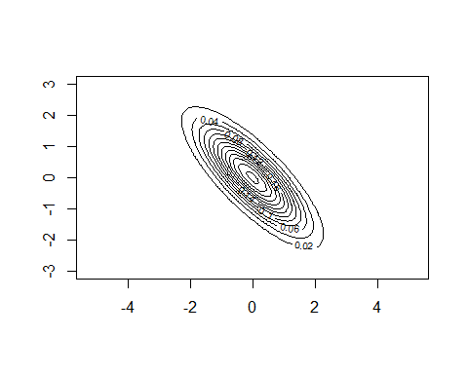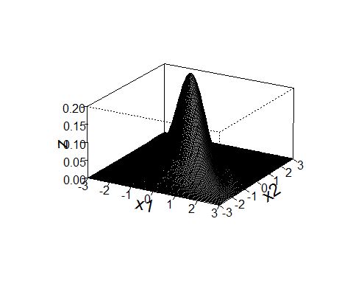

# iv)  
  
m = c(0,0)  
m1 = 0  
m2 = 0  
  
S11 = 1  
S22 = 1  
  
COR12 = 0.8  
  
f= function(v1,v2)  
{  
 (1/((2*pi)*sqrt(S11*S22)*sqrt(1-COR12^2)))*exp((-1/(2*(1-COR12^2)))*(((v1-m1)^2/S11)  
 -2*COR12*((v1-m1)/sqrt(S11))*((v2-m2)/sqrt(S22))+((v2-m2)^2)/S22))  
}  
z = outer(x1,x2,f)  
  
persp(x1,x2,z,main="",cex.lab=1.5,theta=30,phi=20,r=50,d=0.1,expand=0.5,  
 ltheta=90,lphi=180,shade=0.75,ticktype="detailed",nticks=5,  
 xlim=c(-3,3),ylim=c(-3,3),zlim=c(0,0.2))

contour(x1,x2,z,asp = 1)

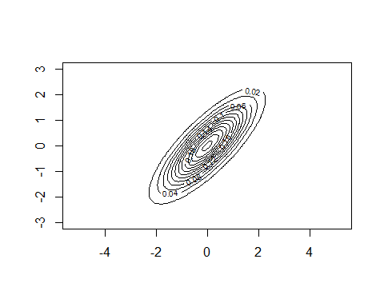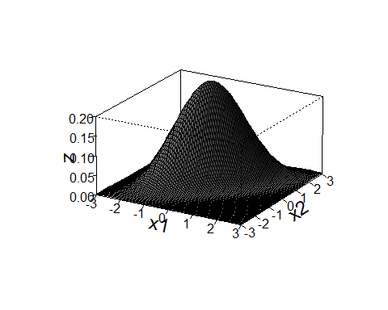

### Exercise 3  
  
remove(list = ls())  
  
m = c(1,0,-1,2)  
m

## [1] 1 0 -1 2

s = c(1,0.2,0.4,-0.5,0.2,2,0.8,0,0.4,0.8,2,0,-0.5,0,0,1)  
S = matrix(s,4,4)  
S

## [,1] [,2] [,3] [,4]  
## [1,] 1.0 0.2 0.4 -0.5  
## [2,] 0.2 2.0 0.8 0.0  
## [3,] 0.4 0.8 2.0 0.0  
## [4,] -0.5 0.0 0.0 1.0

COR = cov2cor(S)  
round(COR, digits = 4)

## [,1] [,2] [,3] [,4]  
## [1,] 1.0000 0.1414 0.2828 -0.5  
## [2,] 0.1414 1.0000 0.4000 0.0  
## [3,] 0.2828 0.4000 1.0000 0.0  
## [4,] -0.5000 0.0000 0.0000 1.0

### X3 und X4 sind unkorreliert, Die beiden paare X1 X2, X2 X3 sind korreliert.   
  
# b)  
  
# i)  
  
m1 = m[3]  
S1 = S[3,3]  
  
paste("X3 ~ N(",m1,",",S1,")")

## [1] "X3 ~ N( -1 , 2 )"

### Exercise 4  
  
remove(list = ls())  
  
e = c(1,0,-1,2)  
e

## [1] 1 0 -1 2

s = c(1,0.2,0.4,-0.5,0.2,2,0.8,0,0.4,0.8,2,0,-0.5,0,0,1)  
S = matrix(s,4,4)  
S

## [,1] [,2] [,3] [,4]  
## [1,] 1.0 0.2 0.4 -0.5  
## [2,] 0.2 2.0 0.8 0.0  
## [3,] 0.4 0.8 2.0 0.0  
## [4,] -0.5 0.0 0.0 1.0

x1 = c(0,0,0,0)  
x2 = c(1,1,1,1)  
x3 = c(1,0,1,0)  
  
# a)  
# i)  
  
denx1 = (1/(((2*pi)^(4/2))*sqrt(det(S))))*exp((-0.5)*(t(x1-e)%*%solve(S)%*%(x1-e)))  
denx1

## [,1]  
## [1,] 4.705344e-05

# ii)  
  
denx2 = (1/(((2*pi)^(4/2))*sqrt(det(S))))*exp((-0.5)*(t(x2-e)%*%solve(S)%*%(x2-e)))  
denx2

## [,1]  
## [1,] 0.00202044

# iii)  
  
denx3 = (1/(((2*pi)^(4/2))*sqrt(det(S))))*exp((-0.5)*(t(x3-e)%*%solve(S)%*%(x3-e)))  
denx3

## [,1]  
## [1,] 0.0001671811

# b)   
  
# i)  
  
(1/(((2*pi)^(4/2))*sqrt(det(S))))*exp((-0.5)*(qchisq(0.95,4)))

## [1] 0.0001470645

# ii)  
  
(1/(((2*pi)^(4/2))*sqrt(det(S))))*exp((-0.5)*(qchisq(0.9,4)))

## [1] 0.000345508

# iii)  
  
(1/(((2*pi)^(4/2))*sqrt(det(S))))*exp((-0.5)*(qchisq(0.8,4)))

## [1] 0.0008459224

### Exercise 5   
  
remove(list = ls())  
  
m = c(1,0.5)  
m1 = 1  
m2 = 0.5  
s = matrix(c(1,0.8,0.8,1),2,2)  
S = solve(s)  
  
# a)   
  
x1 = seq(-3,4,le=100)  
x2 = x1  
  
f= function(v1,v2)  
{  
 S[1,1]*(v1-m1)^2+S[2,2]*(v2-m2)^2+2*S[2,1]*(v1-m1)*(v2-m2)  
}  
  
c = qchisq(0.95,2)  
z = outer(x1,x2,f)  
contour(x1,x2, z, levels = c, asp = 1, drawlabels = FALSE)

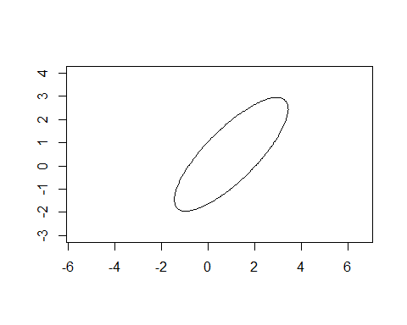

paste("Ervery point on this contour exhibit is lying on on the density value", dens1)

## [1] "Ervery point on this contour exhibit is lying on on the density value 0.00803"

# c)   
  
L1 = sqrt(sum(eigen(s)$values[1]^2))  
L1

## [1] 1.8

L2 = sqrt(sum(eigen(s)$values[2]^2))  
L2

## [1] 0.2

### Exercise 7  
  
remove(list = ls())  
  
getwd()

## [1] "C:/Users/B-C-Herbert/Documents/Studium/Mannheim/VWL/2019 - 2020 WS/Applied Multivariate Statistics/Assignments/Assignment3/Assignment3"

students = read.table(file = "students2008.txt", header = T, dec =",")  
attach(students)

## The following object is masked from package:datasets:  
##   
## sleep

hw = data.frame(height,weight)  
heigthweight = na.omit(hw)  
detach(students)  
attach(heigthweight)  
  
# a)  
  
X = cbind(height,weight)  
  
m1 = mean(height)  
m2 = mean(weight)  
m = c(m1,m2)  
s = cov(X)  
S = solve(s)  
  
x1 = seq(140,220, le = 1000)  
x2 = seq(40,110, le = 1000)  
  
f = function(v1,v2)  
{  
 S[1,1]*(v1-m1)^2+S[2,2]*(v2-m2)^2+2*S[2,1]*(v1-m1)*(v2-m2)  
}  
  
resouter = outer(x1,x2,f)  
contour(x1,x2, resouter, levels = qchisq(0.95,2), asp = 1, drawlabels = FALSE, main = "Students 2018", xlab = "height", ylab = "weight")  
  
# b)  
  
points(height,weight, pch = 16)  
points(m1,m2,pch=16,col = "red")  
  
c = sqrt(qchisq(0.95,2))  
arrows(m1,m2,m1+eigen(S)$vectors[1,1]*c/sqrt(eigen(S)$values[1]),  
 m2+eigen(S)$vectors[2,1]*c/sqrt(eigen(S)$values[1]))  
arrows(m1,m2,m1-eigen(S)$vectors[1,2]*c/sqrt(eigen(S)$values[2]),  
 m2-eigen(S)$vectors[2,2]*c/sqrt(eigen(S)$values[2]))

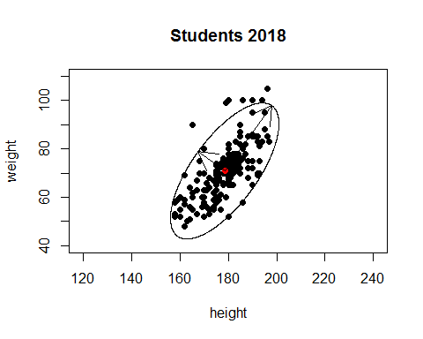

e11 = eigen(S)$vectors[1,1]*c/sqrt(eigen(S)$values[1])  
e12 = eigen(S)$vectors[2,1]*c/sqrt(eigen(S)$values[1])  
e21 = eigen(S)$vectors[1,2]*c/sqrt(eigen(S)$values[2])  
e22 = eigen(S)$vectors[2,2]*c/sqrt(eigen(S)$values[2])  
  
L1 = sqrt(e11^2+e12^2)  
L1

## [1] 13.60434

L2 = sqrt(e21^2+e22^2)  
L2

## [1] 33.26774

# c)  
  
?mahalanobis

## starting httpd help server ...

## done

dis = mahalanobis(heigthweight,m,solve(S))  
dm = dim(heigthweight)[1]  
c = sqrt(qchisq(0.95,2))  
sum((sqrt(dis))<c)/dm

## [1] 0.9433962

94,34% der Punkte liegen in der Kontur.