Exercise-2.R

B-C-Herbert

2019-10-01

### Exercise 2  
  
remove(list = ls())  
  
x1 = seq(-3,3, le = 100)  
x2 = seq(-3,3, le = 100)  
  
# i)  
  
m = c(0,0)  
m1 = 0  
m2 = 0  
  
S11 = 1  
S22 = 1  
  
COR12 = 0  
  
f= function(v1,v2)  
{  
 (1/(2*pi))*exp((-1/2)*(((v1-m1)^2)+((v2-m2)^2)))  
}  
  
z = outer(x1,x2,f)  
persp(x1,x2,z,main="",cex.lab=1.5,theta=30,phi=20,r=50,d=0.1,expand=0.5,  
 ltheta=90,lphi=180,shade=0.75,ticktype="detailed",nticks=5,  
 xlim=c(-3,3),ylim=c(-3,3),zlim=c(0,0.2))

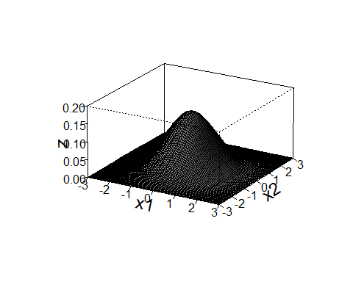

contour(x1,x2,z,asp = 1)

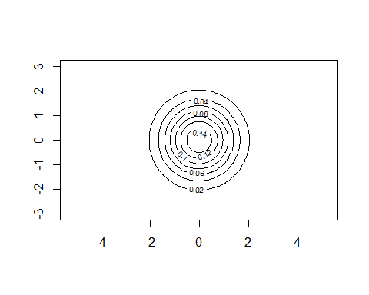

# ii)  
  
m = c(0,0)  
m1 = 0  
m2 = 0  
  
S11 = 1.5^2  
S22 = 1  
  
COR12 = 0  
  
f= function(v1,v2)  
{  
 (1/((2*pi)*sqrt(S11*S22)*sqrt(1-COR12^2)))*exp((-1/(2*(1-COR12^2)))*(((v1-m1)^2/S11)  
 -2*COR12*((v1-m1)/sqrt(S11))*((v2-m2)/sqrt(S22))+((v2-m2)^2)/S22))  
}  
  
z = outer(x1,x2,f)  
persp(x1,x2,z,main="",cex.lab=1.5,theta=30,phi=20,r=50,d=0.1,expand=0.5,  
 ltheta=90,lphi=180,shade=0.75,ticktype="detailed",nticks=5,  
 xlim=c(-3,3),ylim=c(-3,3),zlim=c(0,0.2))

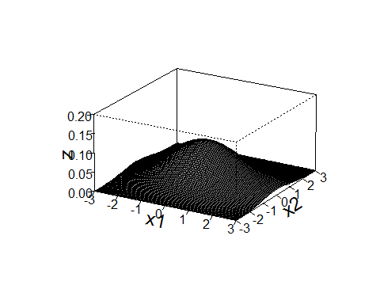

contour(x1,x2,z,asp = 1)

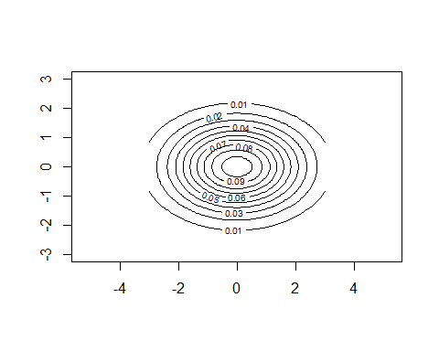

# iii)  
  
m = c(0,0)  
m1 = 0  
m2 = 0  
  
S11 = 1  
S22 = 1  
  
COR12 = -0.8  
  
f= function(v1,v2)  
{  
 (1/((2*pi)*sqrt(S11*S22)*sqrt(1-COR12^2)))*exp((-1/(2*(1-COR12^2)))*(((v1-m1)^2/S11)  
 -2*COR12*((v1-m1)/sqrt(S11))*((v2-m2)/sqrt(S22))+((v2-m2)^2)/S22))  
}  
z = outer(x1,x2,f)  
  
persp(x1,x2,z,main="",cex.lab=1.5,theta=30,phi=20,r=50,d=0.1,expand=0.5,  
 ltheta=90,lphi=180,shade=0.75,ticktype="detailed",nticks=5,  
 xlim=c(-3,3),ylim=c(-3,3),zlim=c(0,0.2))

## Warning in persp.default(x1, x2, z, main = "", cex.lab = 1.5, theta = 30, :  
## surface extends beyond the box

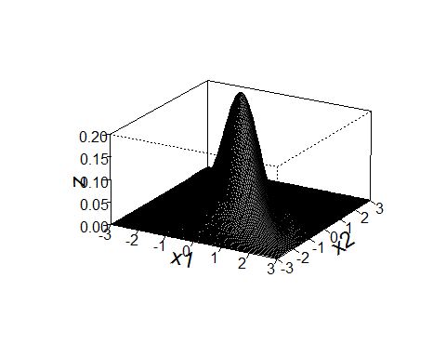

contour(x1,x2,z,asp = 1)

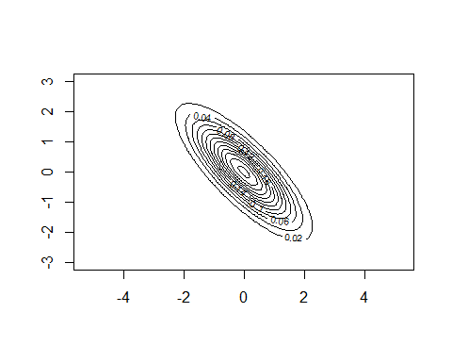

# iv)  
  
m = c(0,0)  
m1 = 0  
m2 = 0  
  
S11 = 1  
S22 = 1  
  
COR12 = 0.8  
  
f= function(v1,v2)  
{  
 (1/((2*pi)*sqrt(S11*S22)*sqrt(1-COR12^2)))*exp((-1/(2*(1-COR12^2)))*(((v1-m1)^2/S11)  
 -2*COR12*((v1-m1)/sqrt(S11))*((v2-m2)/sqrt(S22))+((v2-m2)^2)/S22))  
}  
z = outer(x1,x2,f)  
  
persp(x1,x2,z,main="",cex.lab=1.5,theta=30,phi=20,r=50,d=0.1,expand=0.5,  
 ltheta=90,lphi=180,shade=0.75,ticktype="detailed",nticks=5,  
 xlim=c(-3,3),ylim=c(-3,3),zlim=c(0,0.2))

## Warning in persp.default(x1, x2, z, main = "", cex.lab = 1.5, theta = 30, :  
## surface extends beyond the box

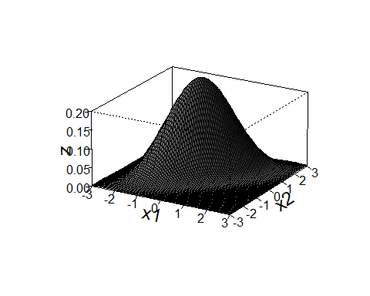

contour(x1,x2,z,asp = 1)

