Exercise-5.R

B-C-Herbert

2019-10-02

### Exercise 5   
  
remove(list = ls())  
  
m = c(1,0.5)  
m1 = 1  
m2 = 0.5  
s = matrix(c(1,0.8,0.8,1),2,2)  
S = solve(s)  
  
# a)   
  
x1 = seq(-3,4,le=100)  
x2 = x1  
  
f= function(v1,v2)  
{  
 S[1,1]*(v1-m1)^2+S[2,2]*(v2-m2)^2+2*S[2,1]*(v1-m1)*(v2-m2)  
}  
  
c = qchisq(0.95,2)  
z = outer(x1,x2,f)  
contour(x1,x2, z, levels = c, asp = 1, drawlabels = FALSE)

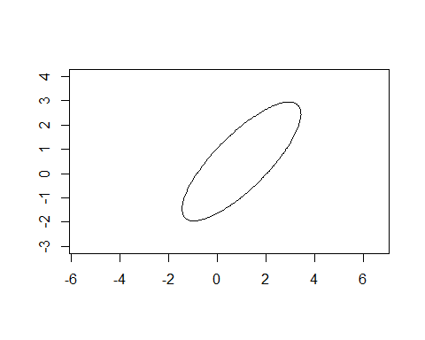

# b)   
  
COR = cov2cor(s)  
COR12 = COR[1,2]  
dens = sqrt((1/((2*pi)*sqrt(1-COR12^2)))*exp((-1/(2*(1-COR12^2)))*qchisq(0.95,2)))  
dens1 = round(dens, digits = 5)  
paste("Ervery point on this contour exhibit is lying on on the density value", dens1)

## [1] "Ervery point on this contour exhibit is lying on on the density value 0.00803"

# c)   
  
L1 = sqrt(sum(eigen(s)$values[1]^2))  
L1

## [1] 1.8

L2 = sqrt(sum(eigen(s)$values[2]^2))  
L2

## [1] 0.2