Exercise-7.R

B-C-Herbert

2019-10-02

### Exercise 7  
  
remove(list = ls())  
  
getwd()

## [1] "C:/Users/B-C-Herbert/Documents/Studium/Mannheim/VWL/2019 - 2020 WS/Applied Multivariate Statistics/Assignments/Assignment3/Assignment3"

students = read.table(file = "students2008.txt", header = T, dec =",")  
attach(students)

## The following object is masked from package:datasets:  
##   
## sleep

hw = data.frame(height,weight)  
heigthweight = na.omit(hw)  
detach(students)  
attach(heigthweight)  
  
# a)  
  
X = cbind(height,weight)  
  
m1 = mean(height)  
m2 = mean(weight)  
m = c(m1,m2)  
s = cov(X)  
S = solve(s)  
  
x1 = seq(140,220, le = 1000)  
x2 = seq(40,110, le = 1000)  
  
f = function(v1,v2)  
{  
 S[1,1]*(v1-m1)^2+S[2,2]*(v2-m2)^2+2*S[2,1]*(v1-m1)*(v2-m2)  
}  
  
resouter = outer(x1,x2,f)  
contour(x1,x2, resouter, levels = qchisq(0.95,2), asp = 1, drawlabels = FALSE, main = "Students 2018", xlab = "height", ylab = "weight")  
  
# b)  
  
points(height,weight, pch = 16)  
points(m1,m2,pch=16,col = "red")  
  
c = sqrt(qchisq(0.95,2))  
arrows(m1,m2,m1+eigen(S)$vectors[1,1]*c/sqrt(eigen(S)$values[1]),  
 m2+eigen(S)$vectors[2,1]*c/sqrt(eigen(S)$values[1]))  
arrows(m1,m2,m1-eigen(S)$vectors[1,2]*c/sqrt(eigen(S)$values[2]),  
 m2-eigen(S)$vectors[2,2]*c/sqrt(eigen(S)$values[2]))

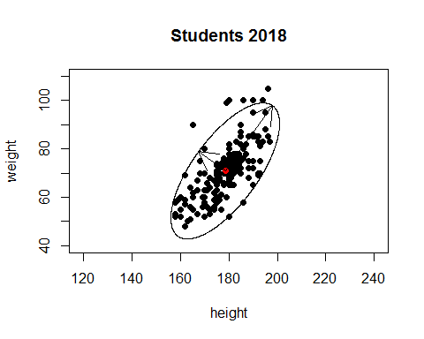

e11 = eigen(S)$vectors[1,1]*c/sqrt(eigen(S)$values[1])  
e12 = eigen(S)$vectors[2,1]*c/sqrt(eigen(S)$values[1])  
e21 = eigen(S)$vectors[1,2]*c/sqrt(eigen(S)$values[2])  
e22 = eigen(S)$vectors[2,2]*c/sqrt(eigen(S)$values[2])  
  
L1 = sqrt(e11^2+e12^2)  
L1

## [1] 13.60434

L2 = sqrt(e21^2+e22^2)  
L2

## [1] 33.26774

# c)  
  
?mahalanobis

## starting httpd help server ...

## done

dis = mahalanobis(heigthweight,m,solve(S))  
dm = dim(heigthweight)[1]  
c = sqrt(qchisq(0.95,2))  
sum((sqrt(dis))<c)/dm

## [1] 0.9433962