### Exercise 5  
  
remove(list = ls())  
  
outlier3dim <-  
 structure(list(x1 = c(6.03715164059163, 0.658893396127709,   
 -0.209427598650197, 1.49037743943188, 5.10139004612713, 2.52660473655032,   
 4.08270263854686, 1.6396297328328, 2.00195903263504, 2.77458657610558,   
 1.28741521441567, 2.16712480728223, 3.94020137996952, 3.66671226097114,   
 5.54307038464309, 2.99996304016723),   
 x2 = c(4.66175971455103,   
 2.49020943909436, 0.686000191260295, 4.747219548586, 2.92391034468324,   
 2.30272543343906, 3.35099338246828, -0.676869585898721, 5.43329622565632,   
 3.87047176119487, 3.16424600806285, 0.828611417313106, 6.34731657802144,   
 0.683996758387633, 4.61239921442428, 2.59789091562676),   
 x3 = c(13.0501573302298, 3.00057699240579, 1.70373289701793, 8.9782687954901, 9.26777654464302,   
 5.08300843101136, 11.0413483929881, 2.08137596466126, 10.9661939544758,   
 4.31909969951773, 5.88679514311043, 4.07501107116231, 14.6272252027742,   
 7.1921458497291, 14.5033586402903, 7.85822188801989)),   
 class = "data.frame", row.names = c(NA,-16L))  
A = outlier3dim  
x1 = outlier3dim$x1  
x2 = outlier3dim$x2  
x3 = outlier3dim$x3  
boxplot(x1)

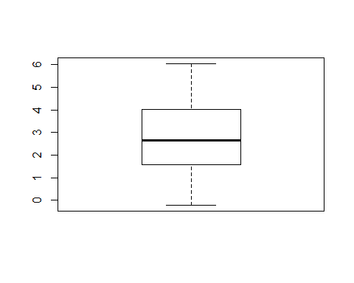

boxplot(x2)

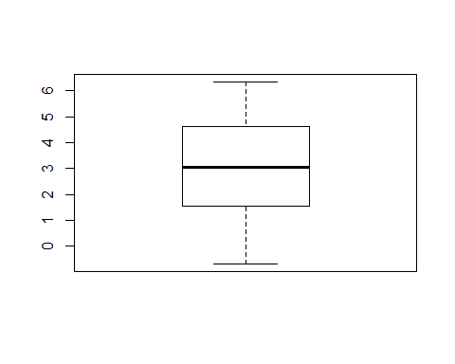

boxplot(x3)

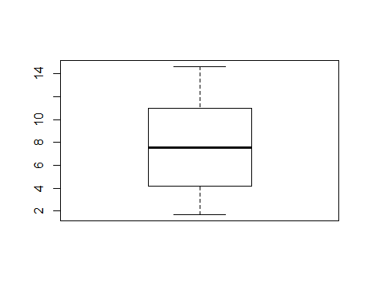

S = cov(outlier3dim)  
Sinv = solve(S)  
R = cov2cor(S)  
  
lam1 = eigen(S)$values[1]  
lam2 = eigen(S)$values[2]  
lam3 = eigen(S)$values[3]  
  
X = scale(A, TRUE, FALSE)  
  
y1 = X%*%eigen(S)$vectors[,1]  
y2 = X%*%eigen(S)$vectors[,2]  
y3 = X%*%eigen(S)$vectors[,3]  
boxplot(c(y1),c(y2),c(y3))  
points(3,max(y3),pch = 16 )

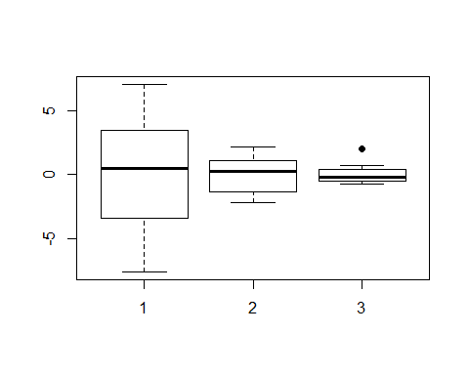

fab = c(rep("black",9),"red",rep("black"))  
siz = c(rep(1, 9), 2, rep(1))  
pairs(~y1+y2+y3, pch = 16, asp = 1, col = fab, cex = siz)

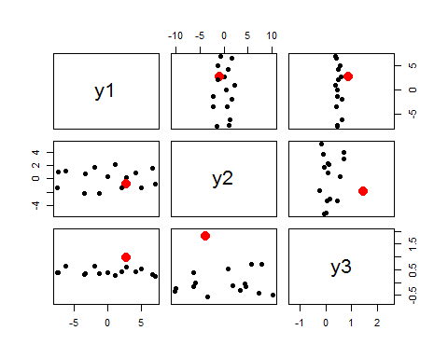

### Exercise 6  
  
remove(list = ls())  
  
students = read.table(file = "students2008.txt", header = T, dec =",")  
attach(students)

## The following object is masked from package:datasets:  
##   
## sleep

heightweight=data.frame(height,weight)  
heightweight=na.omit(heightweight)  
attach(heightweight)

## The following objects are masked from students:  
##   
## height, weight

m1=mean(height)  
m2=mean(weight)  
c2=qchisq(0.95,2)  
S=cov(heightweight)  
Sinv=solve(S)  
a11=Sinv[1,1]  
a12=Sinv[1,2]  
a22=Sinv[2,2]  
x1=seq(150,210,le=1000)  
x2=seq(40,110,le=1000)  
f=function(x1,x2)  
{  
 a11*(x1-m1)^2+a22*(x2-m2)^2+2*a12*(x1-m1)*(x2-m2)  
}  
z=outer(x1,x2,f)  
  
# a)  
  
contour(x1,x2,z,asp=1,levels=c2,drawlabels=FALSE,lwd=2,  
 cex.axis=1.5,cex.lab=1.5,cex.main=1.5,  
 xlab="height",ylab="weight",main="Students 2008")  
reseigen=eigen(S)  
lambda=reseigen$values  
E=reseigen$vectors  
lambda1=lambda[1]  
lambda2=lambda[2]  
e1=E[,1]  
e2=E[,2]  
arrows(m1,m2,sqrt(c2*lambda1)*e1[1]+m1,sqrt(c2*lambda1)*e1[2]+m2,lwd=2, col = "red")  
arrows(m1,m2,sqrt(c2*lambda2)*e2[1]+m1,sqrt(c2*lambda2)*e2[2]+m2,lwd=2, col = "red")  
arrows(m1,m2,-sqrt(c2*lambda1)*e1[1]+m1,-sqrt(c2*lambda1)*e1[2]+m2,lwd=2, col = "red")  
arrows(m1,m2,-sqrt(c2*lambda2)*e2[1]+m1,-sqrt(c2*lambda2)*e2[2]+m2,lwd=2, col = "red")  
  
points(height,weight,pch=16)

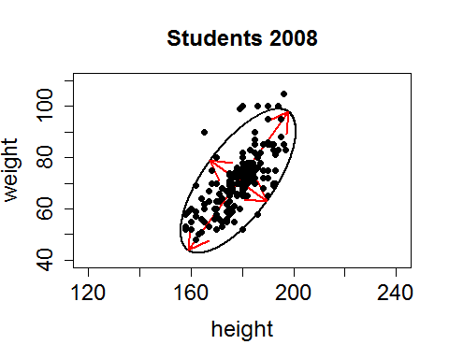

# ii)  
X = scale(heightweight, TRUE, FALSE)  
S = cov(heightweight)  
Ee = eigen(S)  
S = matrix(c(Ee$values[1],0,0,Ee$values[2]),2,2)  
Sinv = solve(S)  
lam1 = eigen(S)$values[1]  
lam2 = eigen(S)$values[2]  
  
c2=qchisq(0.95,2)  
  
x1 = seq(-40,40, le = 1000)  
x2 = seq(-30,30, le = 1000)  
  
f=function(x1,x2)  
{  
 1/(lam1)*(x1)^2+1/lam2*(x2)^2  
}  
z=outer(x1,x2,f)  
  
contour(x1,x2,z,asp=1,levels=c2,drawlabels=FALSE,lwd=2,  
 cex.axis=1.5,cex.lab=1.5,cex.main=1.5,  
 xlab="height",ylab="weight",main="Students 2008")  
  
reseigen=eigen(S)  
  
lambda=reseigen$values  
E=reseigen$vectors  
lambda1=lambda[1]  
lambda2=lambda[2]  
e1=E[,1]  
e2=E[,2]  
m1 = 0  
m2 = 0  
arrows(m1,m2,sqrt(c2*lambda1)*e1[1]+m1,sqrt(c2*lambda1)*e1[2]+m2,lwd=2, col = "red")  
arrows(m1,m2,sqrt(c2*lambda2)*e2[1]+m1,sqrt(c2*lambda2)*e2[2]+m2,lwd=2, col = "red")  
arrows(m1,m2,-sqrt(c2*lambda1)*e1[1]+m1,sqrt(c2*lambda1)*e1[2]+m2,lwd=2, col = "red")  
arrows(m1,m2,sqrt(c2*lambda2)*e2[1]+m1,-sqrt(c2*lambda2)*e2[2]+m2,lwd=2, col = "red")  
  
y1 = X%*%Ee$vectors[,1]  
y2 = X%*%Ee$vectors[,2]  
  
Y = cbind(y1,y2)  
points(Y, pch = 16)

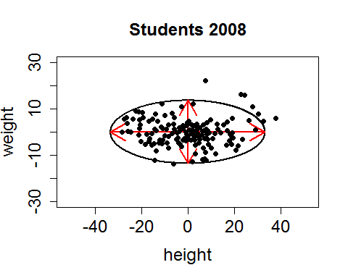

boxplot(c(y1),c(y2))

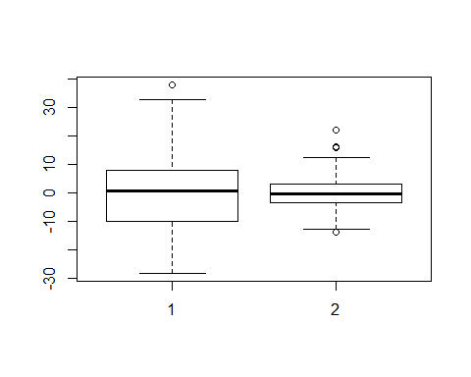

plot(y1,height, pch = 16, asp = 1)

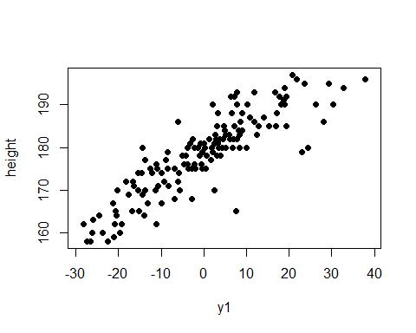

plot(y2,height, pch = 16, asp = 1)

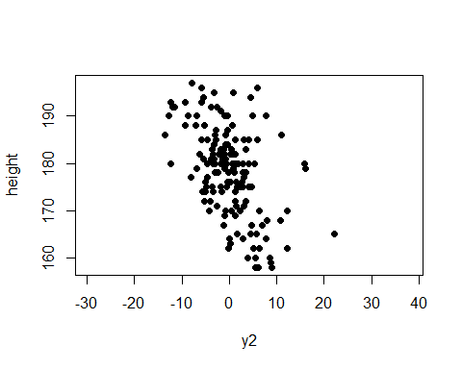

plot(y1, weight, pch = 16, asp = 1)

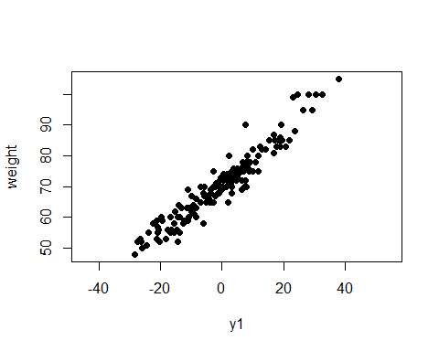

plot(y2, weight, pch = 16, asp = 1)

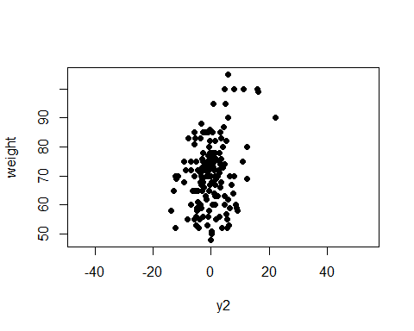

# b)   
round(Ee$vectors, digits = 4)

## [,1] [,2]  
## [1,] 0.5875 -0.8092  
## [2,] 0.8092 0.5875

round(Ee$values, digits = 4)

## [1] 184.7198 30.8903

round(cor(y1,height), digits = 4)

## [,1]  
## [1,] 0.8713

round(cor(y1,weight), digits = 4)

## [,1]  
## [1,] 0.9586

round(cor(y2,height), digits = 4)

## [,1]  
## [1,] -0.4908

round(cor(y2,weight), digits = 4)

## [,1]  
## [1,] 0.2846

round(Ee$values[1]/sum(Ee$values), digits = 4)

## [1] 0.8567

round(sum(Ee$values)/sum(Ee$values), digits = 4)

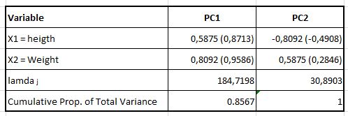## [1] 1