Exercise-5.R

B-C-Herbert

2019-10-05

### Exercise 5  
  
remove(list = ls())  
  
outlier3dim <-  
 structure(list(x1 = c(6.03715164059163, 0.658893396127709,   
 -0.209427598650197, 1.49037743943188, 5.10139004612713, 2.52660473655032,   
 4.08270263854686, 1.6396297328328, 2.00195903263504, 2.77458657610558,   
 1.28741521441567, 2.16712480728223, 3.94020137996952, 3.66671226097114,   
 5.54307038464309, 2.99996304016723),   
 x2 = c(4.66175971455103,   
 2.49020943909436, 0.686000191260295, 4.747219548586, 2.92391034468324,   
 2.30272543343906, 3.35099338246828, -0.676869585898721, 5.43329622565632,   
 3.87047176119487, 3.16424600806285, 0.828611417313106, 6.34731657802144,   
 0.683996758387633, 4.61239921442428, 2.59789091562676),   
 x3 = c(13.0501573302298, 3.00057699240579, 1.70373289701793, 8.9782687954901, 9.26777654464302,   
 5.08300843101136, 11.0413483929881, 2.08137596466126, 10.9661939544758,   
 4.31909969951773, 5.88679514311043, 4.07501107116231, 14.6272252027742,   
 7.1921458497291, 14.5033586402903, 7.85822188801989)),   
 class = "data.frame", row.names = c(NA,-16L))  
A = outlier3dim  
x1 = outlier3dim$x1  
x2 = outlier3dim$x2  
x3 = outlier3dim$x3  
boxplot(x1)

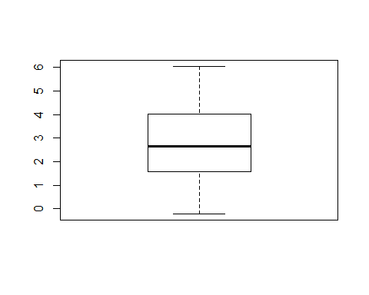

boxplot(x2)

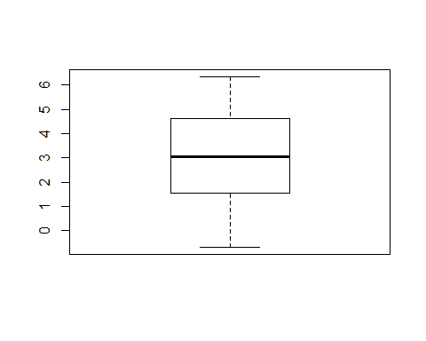

boxplot(x3)

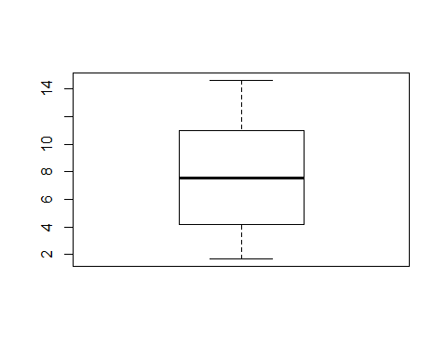

S = cov(outlier3dim)  
Sinv = solve(S)  
R = cov2cor(S)  
  
lam1 = eigen(S)$values[1]  
lam2 = eigen(S)$values[2]  
lam3 = eigen(S)$values[3]  
  
X = scale(A, TRUE, FALSE)  
  
y1 = X%*%eigen(S)$vectors[,1]  
y2 = X%*%eigen(S)$vectors[,2]  
y3 = X%*%eigen(S)$vectors[,3]  
boxplot(c(y1),c(y2),c(y3))  
points(3,max(y3),pch = 16 )

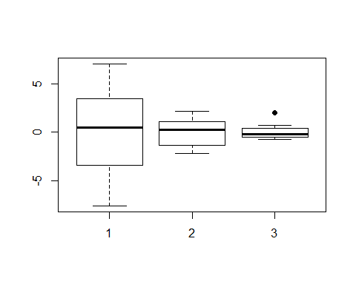

fab = c(rep("black",9),"red",rep("black"))  
siz = c(rep(1, 9), 2, rep(1))  
pairs(~y1+y2+y3, pch = 16, asp = 1, col = fab, cex = siz)

