Exercise4.R

B-C-Herbert

2019-10-24

### Exercise 4  
  
remove(list = ls())  
  
appro = read.table(file = "Approx2dim.txt", header = T, dec =".")  
attach(appro)  
x1 = ï..x1  
Approx2 = data.frame(x1,x2)  
Approx2 = na.omit(Approx2)  
  
plot(x1,x2, asp = 1, xlim = c(-4,3), ylim = c(-2, 4), main = "Least Squares Regression and Eigenvector Projection")  
abline(h = 0, v = 0)  
  
reslm = lm(x2 ~ x1 - 1)  
x2hatlm = reslm$fitted.values  
  
abline(reslm, col= "blue")  
points(x1,x2hatlm, pch = 16, col = "blue")  
  
S = cov(Approx2)  
E = eigen(S)$vectors  
X = scale(Approx2, center = F, scale = T)  
  
Ahat = X%*%E[,1]%*%t(E[,1])  
reslm2 = lm(Ahat[,2] ~ Ahat[,1] -1)  
x2hatlm2 = reslm2$fitted.values  
  
abline(reslm2, col = "red", lwd = 2)  
points(Ahat[,1], x2hatlm2, pch = 16, col ="red")

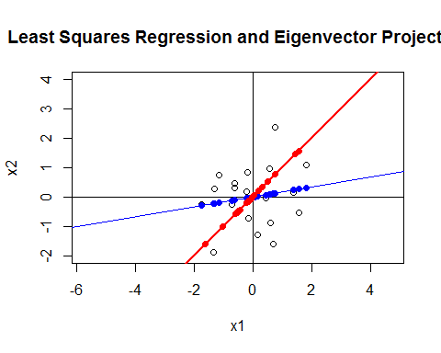

#Approximation Error for OLS = sum of residuals  
sum((reslm$residuals)^2)

## [1] 18.46061

# Approximation Error  
AE = (dim(X)[1]-1)*sum(eigen(S)$values[2])  
AE

## [1] 15.79869