### Exercise3  
  
remove(list = ls())  
  
euro = read.table(file = "Europe.txt", header = T, dec =".")  
attach(euro)  
europe = data.frame(euro)  
europe = na.omit(europe)  
Country = ï..Country  
numbers = cbind(CPI, UNE, INP, BOP, PRC, UN)  
S = cov(numbers)  
  
# a)  
R = cor(numbers)  
  
Ehat = eigen(R)$vectors  
Lamhat = eigen(R)$values  
Lam = diag(x = c(Lamhat),nrow = 6, ncol = 6)  
round(Lam, digits = 4)

## [,1] [,2] [,3] [,4] [,5] [,6]  
## [1,] 2.2648 0.0000 0.0000 0.0000 0.0000 0.000  
## [2,] 0.0000 1.5357 0.0000 0.0000 0.0000 0.000  
## [3,] 0.0000 0.0000 0.9192 0.0000 0.0000 0.000  
## [4,] 0.0000 0.0000 0.0000 0.7077 0.0000 0.000  
## [5,] 0.0000 0.0000 0.0000 0.0000 0.4418 0.000  
## [6,] 0.0000 0.0000 0.0000 0.0000 0.0000 0.131

Lamhatsqu = sqrt(Lam)  
round(Lamhatsqu, digits = 4)

## [,1] [,2] [,3] [,4] [,5] [,6]  
## [1,] 1.5049 0.0000 0.0000 0.0000 0.0000 0.0000  
## [2,] 0.0000 1.2392 0.0000 0.0000 0.0000 0.0000  
## [3,] 0.0000 0.0000 0.9587 0.0000 0.0000 0.0000  
## [4,] 0.0000 0.0000 0.0000 0.8412 0.0000 0.0000  
## [5,] 0.0000 0.0000 0.0000 0.0000 0.6647 0.0000  
## [6,] 0.0000 0.0000 0.0000 0.0000 0.0000 0.3619

ltil = Ehat%*%Lamhatsqu  
Ltil = round(ltil, digits = 4)  
Ltil

## [,1] [,2] [,3] [,4] [,5] [,6]  
## [1,] -0.7676 -0.2105 -0.1603 0.5420 -0.1303 -0.1733  
## [2,] -0.5602 0.4162 -0.5732 -0.1790 0.3900 -0.0146  
## [3,] -0.4364 -0.6618 0.4140 -0.3408 0.2594 -0.1293  
## [4,] 0.5469 -0.6109 -0.1610 0.4062 0.3561 0.1001  
## [5,] 0.9334 0.1490 -0.1682 -0.0483 0.0489 -0.2711  
## [6,] -0.0318 0.6962 0.5825 0.3136 0.2761 -0.0208

pcfa1 = data.frame(Variable = names(europe)[2:7], Ltil[,1:2], Communalities = ((Ltil[,1])^2+(Ltil[,2])^2), SpeVar = 1-((Ltil[,1])^2+(Ltil[,2])^2))  
PCFA1 = format(pcfa1, digits = 4)  
PCFA1

## Variable X1 X2 Communalities SpeVar  
## 1 CPI -0.7676 -0.2105 0.6335 0.3665  
## 2 UNE -0.5602 0.4162 0.4870 0.5130  
## 3 INP -0.4364 -0.6618 0.6284 0.3716  
## 4 BOP 0.5469 -0.6109 0.6723 0.3277  
## 5 PRC 0.9334 0.1490 0.8934 0.1066  
## 6 UN -0.0318 0.6962 0.4857 0.5143

Prop = c(((sum(Ltil[,1]^2))/6),((sum(Ltil[,1]^2))/6)+(sum(Ltil[,2]^2))/6)  
round(Prop, digits = 4)

## [1] 0.3775 0.6334

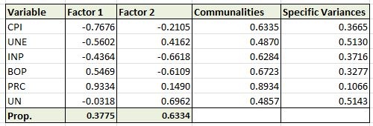

# b)  
Lstar = round(varimax(Ltil[,1:2])$loadings[1:6,1:2], digits = 4)  
Rotma = varimax(Ltil[,1:2])$rotmat  
pcfa2 = data.frame(Variable = names(europe)[2:7], Lstar[,1:2], Communalities = ((Lstar[,1])^2+(Lstar[,2])^2), SpeVar = 1-((Lstar[,1])^2+(Lstar[,2])^2))  
PCFA2 = format(pcfa2, digits = 4)  
PCFA2

## Variable X1 X2 Communalities SpeVar  
## 1 CPI -0.7762 0.1762 0.6335 0.3665  
## 2 UNE -0.2978 0.6311 0.4870 0.5130  
## 3 INP -0.6969 -0.3779 0.6285 0.3715  
## 4 BOP 0.1943 -0.7966 0.6723 0.3277  
## 5 PRC 0.8934 -0.3086 0.8934 0.1066  
## 6 UN 0.3002 0.6290 0.4858 0.5142

Prop2 = c(((sum(Lstar[,1]^2))/6),((sum(Lstar[,1]^2))/6)+(sum(Lstar[,2]^2))/6)  
round(Prop2, digits = 4)

## [1] 0.3505 0.6334

### Name Factor 1: Demand Surplus  
### Name Factor 2: Business Cycle  
  
plot(PCFA2$X1,PCFA2$X2, type = "n", asp = 1, ylim = c(-1.5,1.5), xlim = c(-1.5,1.5), xlab = "l1", ylab = "l2")  
text(Lstar[,1],Lstar[,2], PCFA2$Variable)  
arrows(0,0,Rotma[1,1],Rotma[1,2])  
arrows(0,0,Rotma[2,1],Rotma[2,2])  
arrows(0,0,Rotma[1,2],-Rotma[1,1])  
arrows(0,0,-Rotma[1.1],Rotma[2,1])

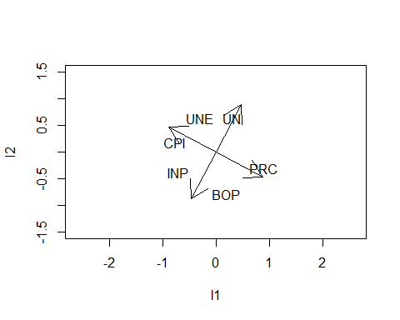

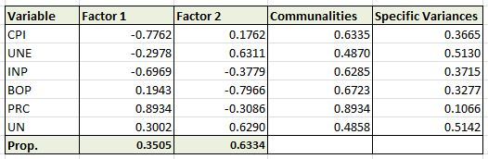

# c)  
round(varimax(Ltil)$rotmat, digits = 4)

## [,1] [,2] [,3] [,4] [,5] [,6]  
## [1,] 0.3037 -0.0298 0.3920 -0.6677 0.4121 -0.3710  
## [2,] 0.0482 0.5668 -0.3355 -0.1943 -0.4798 -0.5439  
## [3,] -0.1194 0.6119 0.5903 -0.1083 -0.1856 0.4655  
## [4,] 0.0130 0.3683 0.2139 0.6431 0.4885 -0.4077  
## [5,] 0.0429 0.4081 -0.5826 -0.2148 0.5479 0.3819  
## [6,] -0.9430 -0.0345 0.0108 -0.2122 0.1634 -0.1944

round(eigen(S)$vectors, digits = 4)

## [,1] [,2] [,3] [,4] [,5] [,6]  
## [1,] -0.0030 0.0039 0.2080 0.9754 0.0680 0.0275  
## [2,] -0.0004 -0.0015 0.0505 0.0385 -0.8902 0.4510  
## [3,] -0.0039 0.0092 -0.9763 0.2077 -0.0172 0.0576  
## [4,] 0.1209 0.9926 0.0078 -0.0053 -0.0008 0.0014  
## [5,] 0.9927 -0.1208 -0.0041 0.0044 -0.0001 0.0004  
## [6,] 0.0000 -0.0015 0.0312 -0.0631 0.4501 0.8902

# They are not the same!

# d)  
euro = read.table(file = "Europe.txt", header = T, dec =".")  
attach(euro)  
europe = data.frame(euro)  
europe = na.omit(europe)  
Country = ï..Country  
numbers = cbind(CPI, UNE, INP, BOP, PRC, UN)  
S = cov(numbers)  
  
R = cor(numbers)  
  
Ehat = eigen(R)$vectors  
Lamhat = eigen(R)$values  
Lam = diag(x = c(Lamhat),nrow = 6, ncol = 6)  
round(Lam, digits = 4)

## [,1] [,2] [,3] [,4] [,5] [,6]  
## [1,] 2.2648 0.0000 0.0000 0.0000 0.0000 0.000  
## [2,] 0.0000 1.5357 0.0000 0.0000 0.0000 0.000  
## [3,] 0.0000 0.0000 0.9192 0.0000 0.0000 0.000  
## [4,] 0.0000 0.0000 0.0000 0.7077 0.0000 0.000  
## [5,] 0.0000 0.0000 0.0000 0.0000 0.4418 0.000  
## [6,] 0.0000 0.0000 0.0000 0.0000 0.0000 0.131

Lamhatsqu = sqrt(Lam)  
round(Lamhatsqu, digits = 4)

## [,1] [,2] [,3] [,4] [,5] [,6]  
## [1,] 1.5049 0.0000 0.0000 0.0000 0.0000 0.0000  
## [2,] 0.0000 1.2392 0.0000 0.0000 0.0000 0.0000  
## [3,] 0.0000 0.0000 0.9587 0.0000 0.0000 0.0000  
## [4,] 0.0000 0.0000 0.0000 0.8412 0.0000 0.0000  
## [5,] 0.0000 0.0000 0.0000 0.0000 0.6647 0.0000  
## [6,] 0.0000 0.0000 0.0000 0.0000 0.0000 0.3619

ltil = Ehat%*%Lamhatsqu  
Ltil = round(ltil, digits = 4)  
  
c = diag(1-((Ltil[,1])^2+(Ltil[,2])^2),6,6)  
round(R-Ltil[,1:2]%*%t(Ltil[,1:2])-c, digits = 4)

## CPI UNE INP BOP PRC UN  
## CPI 0.0000 -0.0534 -0.2626 0.1823 0.0414 0.0442  
## UNE -0.0534 0.0000 -0.0733 0.1570 0.1280 -0.2820  
## INP -0.2626 -0.0733 0.0000 -0.1256 -0.0054 0.2085  
## BOP 0.1823 0.1570 -0.1256 0.0000 -0.0023 0.1298  
## PRC 0.0414 0.1280 -0.0054 -0.0023 0.0000 -0.0940  
## UN 0.0442 -0.2820 0.2085 0.1298 -0.0940 0.0000