### Exercise 2  
  
remove(list = ls())  
  
library(tools)  
library(HSAUR)

## Warning: package 'HSAUR' was built under R version 3.4.4

data("voting")  
  
# a)  
DelDis = voting  
  
I = diag(1, nrow = 15, ncol = 15)  
J = matrix(c(rep(1, 15*15)), nrow = 15, ncol = 15)  
n = 1/15  
H = I-n*J  
DelDis2 = DelDis^2  
B = -0.5*H%*%DelDis2%*%H  
round(eigen(B)$values, digits = 4)

## [1] 497.7608 146.1762 102.9131 76.8776 55.1154 24.7437 8.0050  
## [8] 6.1717 2.3582 0.0000 -2.0261 -15.2141 -18.6943 -20.4015  
## [15] -33.9858

### B has negativ eigenvalues, so it is not nonnegativ definite. Therfor it is not Euclidean.  
  
# b)  
Q = -0.5*H%*%DelDis2%*%H  
Qe = eigen(Q)$vectors[,1:2]  
Qlam = eigen(Q)$values[1:2]  
QLam = diag(sqrt(Qlam), nrow = 2, ncol = 2)  
Yhat = Qe%*%QLam  
CM = c("Hunt(R)", "Sandman(R)", "Howard(D)", "Thompson(D)",  
 "Freylinghuysen(R)", "Forsythe(R)", "Widnall(R)",   
 "Roe(D)", "Heltoski(D)", "Rodino(D)", "Minish(D)",   
 "Rinaldo(R)", "Maraziti(R)", "Daniels(D)", "Patten(D)")  
plot(Yhat, type = "n", asp = 1, xlab = "Coordinate 1", ylab = "Coordinate 2", xlim = c(-13,7), ylim = c(-6,8))  
text(Yhat[,1],Yhat[,2], CM)

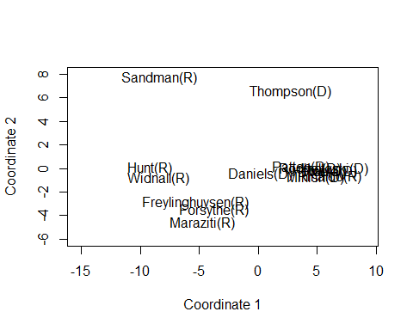

# c)   
data.frame("C1" = cmdscale(voting, k = 2)[,1],"Yhat1" = Yhat[,1],"C2" = cmdscale(voting, k = 2)[,2],"Yhat2" = Yhat[,2])

## C1 Yhat1 C2 Yhat2  
## Hunt(R) -9.1640883 -9.1640883 0.02161894 0.02161894  
## Sandman(R) -8.3699537 -8.3699537 7.68023459 7.68023459  
## Howard(D) 5.6277025 5.6277025 -0.26582292 -0.26582292  
## Thompson(D) 2.7528216 2.7528216 6.55124865 6.55124865  
## Freylinghuysen(R) -5.3440596 -5.3440596 -2.89073549 -2.89073549  
## Forsythe(R) -3.7133046 -3.7133046 -3.49671135 -3.49671135  
## Widnall(R) -8.4431079 -8.4431079 -0.83225871 -0.83225871  
## Roe(D) 5.6935834 5.6935834 -0.22380571 -0.22380571  
## Heltoski(D) 6.5311040 6.5311040 -0.05545261 -0.05545261  
## Rodino(D) 4.4214984 4.4214984 -0.02052953 -0.02052953  
## Minish(D) 4.8940977 4.8940977 -0.78542948 -0.78542948  
## Rinaldo(R) 6.0315595 6.0315595 -0.71851563 -0.71851563  
## Maraziti(R) -4.7595652 -4.7595652 -4.64131141 -4.64131141  
## Daniels(D) 0.2098827 0.2098827 -0.42931460 -0.42931460  
## Patten(D) 3.6318295 3.6318295 0.10678526 0.10678526

### These are the same results.

### Exercise 3  
  
remove(list = ls())  
I = diag(1, nrow = 23, ncol = 23)  
J = matrix(c(rep(1, 23*23)), nrow = 23, ncol = 23)  
n = 1/230  
H = I-n*J  
  
# a)  
# i)  
pref = read.table(file = "Preferences.txt", header = T)  
Pref = cbind(Name = pref[,1],pref[,2:21])  
Preferences = as.matrix(Pref[,2:21])  
X = scale(Preferences, center = T, scale = F)  
Q = X%*%t(X)  
Qlam = eigen(Q)$values[1:2]  
QLam = diag(sqrt(Qlam), nrow = 2, ncol = 2)  
Qe = eigen(Q)$vectors[,1:2]  
Yhat = Qe%*%QLam  
head(Yhat,4)

## [,1] [,2]  
## [1,] -0.6713242 -0.06986646  
## [2,] -0.4397291 -1.67075200  
## [3,] 1.5584607 -1.47549195  
## [4,] 0.4263072 2.37895190

# ii)  
S = cov(Preferences)  
E = eigen(S)$vectors  
Yhat = X%*%E  
head(Yhat[,1:2],4)

## [,1] [,2]  
## [1,] 0.6713242 0.06986646  
## [2,] 0.4397291 1.67075200  
## [3,] -1.5584607 1.47549195  
## [4,] -0.4263072 -2.37895190

# b)  
X = scale(Preferences, center = T, scale = F)  
S = cov(X)  
Lam = eigen(S)$values[1:2]  
E = eigen(S)$vectors[,1:2]  
Yhat = X%*%E  
plot(Yhat, type = "n", asp = 1, xlab = "PC1", ylab = "PC2")  
text(Yhat[,1],Yhat[,2], pref[,1])  
  
# c)  
E_1 = E[,1]  
E_2 = E[,2]  
lqa = sqrt(E_1^2+E_2^2)  
ra = order(lqa, decreasing = T)  
arrows(0,0,2.5*E_1[ra[1:4]],2.5*E_2[ra[1:4]], col="red")  
text(3*E_1[ra[1:4]],3*E_2[ra[1:4]], labels = c("Q4","Q19","Q1","Q18"), col = "red")   
  
# d)   
colMeans(Preferences)

## Q1 Q2 Q3 Q4 Q5 Q6   
## 0.30434783 0.04347826 -0.91304348 -0.04347826 -0.21739130 0.39130435   
## Q7 Q8 Q9 Q10 Q11 Q12   
## -0.47826087 0.13043478 -0.39130435 -0.13043478 0.39130435 -0.56521739   
## Q13 Q14 Q15 Q16 Q17 Q18   
## 0.13043478 0.13043478 0.30434783 -0.21739130 -0.65217391 0.04347826   
## Q19 Q20   
## 0.13043478 -0.47826087

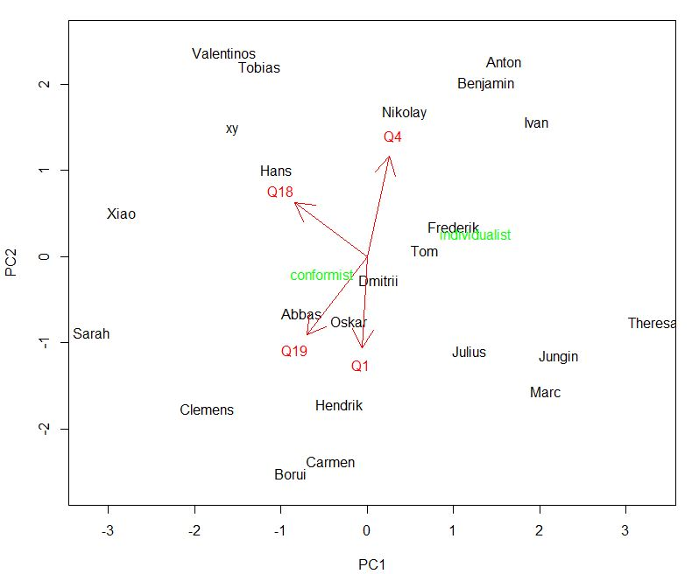Conformist = c(1,1,-1,-1,-1,1,-1,1,-1,-1,1,-1,1,1,1,-1,-1,1,1,-1)  
Individualist = (-1)*Conformist  
means = colMeans(Preferences, na.rm = F, dims = 1)  
XC = Conformist-means  
XI = Individualist-means  
YhatC = XC%*%E  
YhatI = XI%*%E  
  
text(YhatC[1,1],YhatC[1,2], "conformist", col = "green")  
text(YhatI[1,1],YhatI[1,2], "individualist", col = "green")