Exercise2.R

B-C-Herbert

2019-11-06

### Exercise 2  
  
remove(list = ls())  
  
library(tools)  
library(HSAUR)

## Warning: package 'HSAUR' was built under R version 3.4.4

data("voting")  
  
# a)  
DelDis = voting  
  
I = diag(1, nrow = 15, ncol = 15)  
J = matrix(c(rep(1, 15*15)), nrow = 15, ncol = 15)  
n = 1/15  
H = I-n*J  
DelDis2 = DelDis^2  
B = -0.5*H%*%DelDis2%*%H  
round(eigen(B)$values, digits = 4)

## [1] 497.7608 146.1762 102.9131 76.8776 55.1154 24.7437 8.0050  
## [8] 6.1717 2.3582 0.0000 -2.0261 -15.2141 -18.6943 -20.4015  
## [15] -33.9858

### B has negativ eigenvalues, so it is not nonnegativ definite. Therfor it is not Euclidean.  
  
# b)  
Q = -0.5*H%*%DelDis2%*%H  
Qe = eigen(Q)$vectors[,1:2]  
Qlam = eigen(Q)$values[1:2]  
QLam = diag(sqrt(Qlam), nrow = 2, ncol = 2)  
Yhat = Qe%*%QLam  
CM = c("Hunt(R)", "Sandman(R)", "Howard(D)", "Thompson(D)",  
 "Freylinghuysen(R)", "Forsythe(R)", "Widnall(R)",   
 "Roe(D)", "Heltoski(D)", "Rodino(D)", "Minish(D)",   
 "Rinaldo(R)", "Maraziti(R)", "Daniels(D)", "Patten(D)")  
plot(Yhat, type = "n", asp = 1, xlab = "Coordinate 1", ylab = "Coordinate 2", xlim = c(-13,7), ylim = c(-6,8))  
text(Yhat[,1],Yhat[,2], CM)

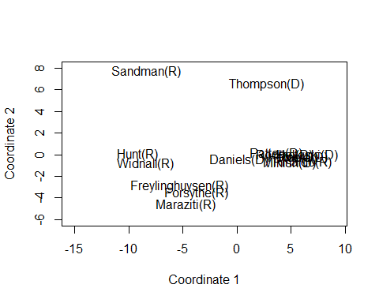

# c)  
data.frame("C1" = cmdscale(voting, k = 2)[,1],"Yhat1" = Yhat[,1],"C2" = cmdscale(voting, k = 2)[,2],"Yhat2" = Yhat[,2])

## C1 Yhat1 C2 Yhat2  
## Hunt(R) -9.1640883 -9.1640883 0.02161894 0.02161894  
## Sandman(R) -8.3699537 -8.3699537 7.68023459 7.68023459  
## Howard(D) 5.6277025 5.6277025 -0.26582292 -0.26582292  
## Thompson(D) 2.7528216 2.7528216 6.55124865 6.55124865  
## Freylinghuysen(R) -5.3440596 -5.3440596 -2.89073549 -2.89073549  
## Forsythe(R) -3.7133046 -3.7133046 -3.49671135 -3.49671135  
## Widnall(R) -8.4431079 -8.4431079 -0.83225871 -0.83225871  
## Roe(D) 5.6935834 5.6935834 -0.22380571 -0.22380571  
## Heltoski(D) 6.5311040 6.5311040 -0.05545261 -0.05545261  
## Rodino(D) 4.4214984 4.4214984 -0.02052953 -0.02052953  
## Minish(D) 4.8940977 4.8940977 -0.78542948 -0.78542948  
## Rinaldo(R) 6.0315595 6.0315595 -0.71851563 -0.71851563  
## Maraziti(R) -4.7595652 -4.7595652 -4.64131141 -4.64131141  
## Daniels(D) 0.2098827 0.2098827 -0.42931460 -0.42931460  
## Patten(D) 3.6318295 3.6318295 0.10678526 0.10678526

### These are the same results.