### Exercise 1  
  
remove(list = ls())  
  
euro = read.table(file = "Europe.txt", header = T, dec =".")  
attach(euro)  
europe = data.frame(euro)  
europe = na.omit(europe)  
Country = ï..Country  
numbers = cbind(CPI, UNE, INP, BOP, PRC, UN)  
  
# a)   
Euro = scale(numbers, center = TRUE, scale = TRUE)  
EuroEuc = dist(Euro, method = "euclidean", diag = TRUE, upper = TRUE)  
reshclust = hclust(EuroEuc, method = "complete")  
plot(reshclust, hang = -1, labels = Country, ylab = "Euclidean Distance")  
rect.hclust(reshclust, k = 5, border = c(1,2,3,4,5))

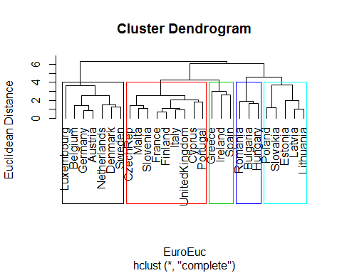

# b)   
S1 = cov(Euro)  
lam1 = eigen(S1)$values[1:2]  
e1 = eigen(S1)$vectors[,1:2]  
Yhat = Euro%*%e1  
plot(-Yhat[,1],Yhat[,2], type = "n", asp = 1, ylab = "PC2", xlab = "PC1")  
text(-Yhat[,1],Yhat[,2], Country, col = cutree(reshclust, k = 5))  
  
arrows(0,0,-2*e1[1,1],2*e1[1,2], col = "blue", lwd = 2)  
text(-2.5*e1[1,1],2.5*e1[1,2], labels = variable.names(europe[2]), col = "blue")  
arrows(0,0,-2*e1[2,1],2*e1[2,2], col = "blue", lwd = 2)  
text(-2.5*e1[2,1],2.5*e1[2,2], labels = variable.names(europe[3]), col = "blue")  
arrows(0,0,-2*e1[3,1],2*e1[3,2], col = "blue", lwd = 2)  
text(-2.5*e1[3,1],2.5*e1[3,2], labels = variable.names(europe[4]), col = "blue")  
arrows(0,0,-2*e1[4,1],2*e1[4,2], col = "blue", lwd = 2)  
text(-2.5*e1[4,1],2.5*e1[4,2], labels = variable.names(europe[5]), col = "blue")  
arrows(0,0,-2*e1[5,1],2*e1[5,2], col = "blue", lwd = 2)  
text(-2.5*e1[5,1],2.5*e1[5,2], labels = variable.names(europe[6]), col = "blue")  
arrows(0,0,-2*e1[6,1],2*e1[6,2], col = "blue", lwd = 2)  
text(-2.5*e1[6,1],2.5*e1[6,2], labels = variable.names(europe[7]), col = "blue")

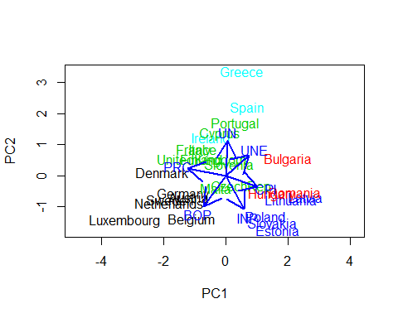

# c)  
  
# d)  
R1 = cor(Euro)  
round(R1, digits = 2)

## CPI UNE INP BOP PRC UN  
## CPI 1.00 0.29 0.21 -0.11 -0.71 -0.08  
## UNE 0.29 1.00 -0.10 -0.40 -0.33 0.03  
## INP 0.21 -0.10 1.00 0.04 -0.51 -0.24  
## BOP -0.11 -0.40 0.04 1.00 0.42 -0.31  
## PRC -0.71 -0.33 -0.51 0.42 1.00 -0.02  
## UN -0.08 0.03 -0.24 -0.31 -0.02 1.00

EuroDist = as.dist(1-R1)  
EuroClus = hclust(EuroDist, method = "complete")  
plot(EuroClus, hang = -1, labels = variable.names(europe[2:7]), ylab = "1-R Distances")

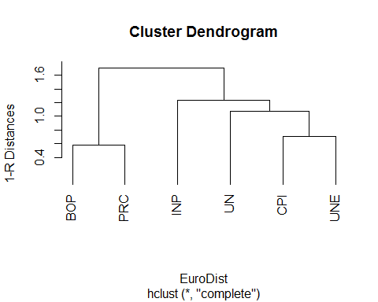

### Exercis 2  
  
remove(list = ls())  
  
pers = read.table(file = "Personality2019.txt", header = T, dec =".")  
Pers = as.matrix(pers[,2:33])  
pers$Name

## [1] Toni Lion Borui Sarah Abbas Marc Dmitrii   
## [8] Ivan Benjamin Julius Samuel Theresa Rickmer Florentia  
## [15] Anton Frederik Carmen Louis Felipe Stepan Nikolai   
## [22] Tom Tobias Xiao Hendrik Jungin   
## 26 Levels: Abbas Anton Benjamin Borui Carmen Dmitrii Felipe ... Xiao

# a)  
  
X = scale(Pers, center = TRUE, scale = FALSE)  
S = cov(X)  
lam = eigen(S)$values[1:2]  
e = eigen(S)$vectors[,1:2]  
Yhat = X%*%e  
plot(Yhat[,1],Yhat[,2], type = "n", asp = 1)  
text(Yhat[,1],Yhat[,2], pers$Name)  
Expl = cumsum(eigen(S)$values)/sum(eigen(S)$values)  
Expl[2]

## [1] 0.3017799

# The first two principal components explain 30.18% of the total variance.  
  
# b)   
lengthOfAxes = sqrt(e[,1]^2+e[,2]^2)  
o = order(lengthOfAxes, decreasing = TRUE)  
arrows(0,0,3*e[o[1],1],3*e[o[1],2], col = "blue")  
text(3.5*e[o[1],1],3.5*e[o[1],2], labels = variable.names(pers[o[1]+1]), col = "blue")  
arrows(0,0,3*e[o[2],1],3*e[o[2],2], col = "blue")  
text(3.5*e[o[2],1],3.5*e[o[2],2], labels = variable.names(pers[o[2]+1]), col = "blue")  
arrows(0,0,3*e[o[3],1],3*e[o[3],2], col = "blue")  
text(3.5*e[o[3],1],3.5*e[o[3],2], labels = variable.names(pers[o[3]+1]), col = "blue")  
arrows(0,0,3*e[o[4],1],3*e[o[4],2], col = "blue")  
text(3.5*e[o[4],1],3.5*e[o[4],2], labels = variable.names(pers[o[4]+1]), col = "blue")  
  
# c)  
Chol = c(0,1,0,0,0,1,0,0,0,1,0,0,0,1,0,0,0,1,0,0,0,1,0,0,0,1,0,0,0,1,0,0)  
San = c(0,0,1,0,0,0,1,0,0,0,1,0,0,0,1,0,0,0,1,0,0,0,1,0,0,0,1,0,0,0,1,0)  
Mel = c(1,0,0,0,1,0,0,0,1,0,0,0,1,0,0,0,1,0,0,0,1,0,0,0,1,0,0,0,1,0,0,0)  
phle = c(rep(1,32))  
Phle = phle-(Chol+San+Mel)  
Choleric = Chol-colMeans(Pers)  
C = Choleric%*%e  
text(C[1,1],C[1,2], labels = "Cholerica", col = "green")  
Melancholic = Mel-colMeans(Pers)  
M = Melancholic%*%e  
text(M[1,1],M[1,2], labels = "Melancholic", col = "green")  
Sanguine = San-colMeans(Pers)  
Sa = Sanguine%*%e  
text(Sa[1,1],Sa[1,2], labels = "Sanguine", col = "green")  
Phlegmatic = Phle-colMeans(Pers)  
P = Phlegmatic%*%e  
text(P[1,1],P[1,2], labels = "Phlegmatic", col = "green")  
  
# d)  
Intro = Phle+Mel  
Unst = Mel+Chol  
Extro = Chol+San  
Stabel = San+Phle  
Introvert = Intro-colMeans(Pers)  
Int = Introvert%*%e  
text(Int[1,1],Int[1,2], labels = "Introvert", col = "red")  
Unstable = Unst-colMeans(Pers)  
Uns = Unstable%*%e  
text(Uns[1,1],Uns[1,2], labels = "Unstable", col = "red")  
Extrovert = Extro-colMeans(Pers)  
Ex = Extrovert%*%e  
text(Ex[1,1],Ex[1,2], labels = "Extrovert", col = "red")  
Stabele = Stabel-colMeans(Pers)  
St = Stabele%*%e  
text(St[1,1],St[1,2], labels = "Stable", col = "red")

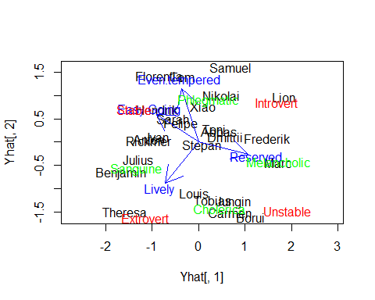

# e)  
Delta = as.matrix(dist(Pers, method = "manhattan", upper = TRUE, diag = TRUE))  
Deltastar = Delta^2  
I = diag(1, nrow = 26, ncol = 26)  
J = matrix(c(rep(1, 26*26)), nrow = 26, ncol = 26)  
n = 1/26  
H = I-n*J  
B = -0.5*H%*%Deltastar%*%H  
reseigen = eigen(B)  
lambda = round(reseigen$values, digits = 4)  
lambda

## [1] 580.1522 507.7782 333.5213 296.7573 194.7462 123.1985 103.0154  
## [8] 85.5694 76.6256 52.2152 45.5587 34.9044 26.5002 8.5767  
## [15] 5.2770 0.0000 -7.3348 -11.6107 -14.1745 -20.3273 -32.1523  
## [22] -35.9884 -50.6483 -54.9865 -74.0686 -86.2971

# Since there are negative eigenvalues, B is not n.n.d.  
  
# f)  
QE = reseigen$vectors  
Qlam = reseigen$values  
QLam = diag(Qlam[1:2])  
QYhat = QE[,1:2]%*%sqrt(QLam)  
plot(-QYhat[,1],QYhat[,2], asp = 1, type = "n", ylab = "Y2hat", xlab = "X2hat")  
text(-QYhat[,1],QYhat[,2], pers$Name)

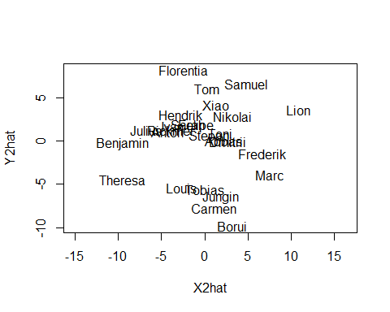

# The biplot differs from the MDS-plot.  
  
# g)   
Personality = dist(X, method = "euclidean", upper = TRUE, diag = TRUE)  
PersALM = hclust(Personality, method = "average")  
plot(PersALM, hang = -1, labels = pers$Name, ylab = "Personality Distance")  
rect.hclust(PersALM, k = 4, border = c(1,2,3,4))

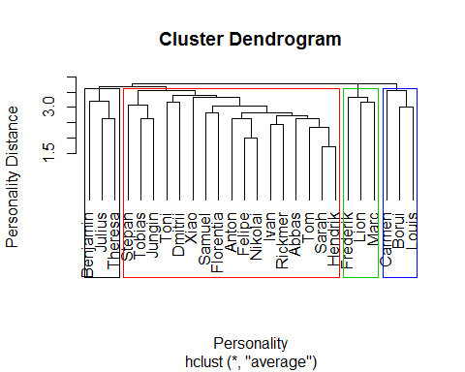

plot(Yhat[,1],Yhat[,2], type = "n", asp = 1)  
text(Yhat[,1],Yhat[,2], pers$Name, col = cutree(PersALM, k = 4))

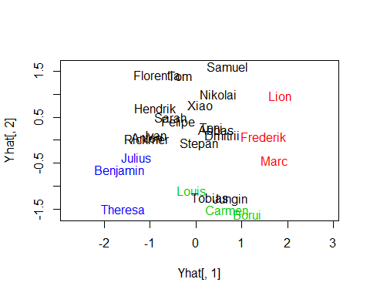

# The cluster does correspond more or less to the biplot except the observations Tobias and Jungin.

### Exercise 3  
  
remove(list = ls())  
  
pers3 = read.table(file = "Personality.txt", header = T, dec =".")  
  
# a)  
Pers3 = scale(pers3, scale = FALSE, center = TRUE)  
R = cor(pers3)  
PersDelt = as.dist(1-R)  
Persreshc = hclust(PersDelt, method = "average")  
plot(Persreshc, hang = -1, labels = pers3$Name, ylab = "1 -R Distance")  
rect.hclust(Persreshc, k = 4, border = c(1,2,3,4) )

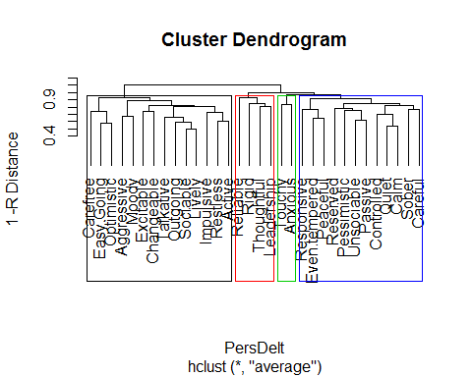

Group = sort(cutree(Persreshc, k = 4))  
Group[1:12]

## Quiet Calm Unsociable Even.tempered Reserved   
## 1 1 1 1 1   
## Pessimistic Responsive Controlled Sober Peaceful   
## 1 1 1 1 1   
## Careful Passive   
## 1 1

# Cluster 1  
Group[13:14]

## Touchy Anxious   
## 2 2

# Cluster 2  
Group[15:28]

## Sociable Restless Outgoing Aggressive Talkative Excitable   
## 3 3 3 3 3 3   
## Changeable Easy.Going Impulsive Lively Optimistic Carefree   
## 3 3 3 3 3 3   
## Moody Active   
## 3 3

# Cluster 3  
Group[29:32]

## Reliable Rigid Thoughtful Leadership   
## 4 4 4 4

# Cluster 4  
  
# b)  
X3 = R  
Q = X3%*%t(X3)  
QE = eigen(Q)$vectors  
Qlam = eigen(Q)$values  
QLam = diag(Qlam[1:2])  
QYhat = QE[,1:2]%*%sqrt(QLam)  
plot(QYhat[,1],QYhat[,2], asp = 1, type = "n")  
text(QYhat[,1],QYhat[,2], variable.names(pers3), col = cutree(Persreshc, k = 4))

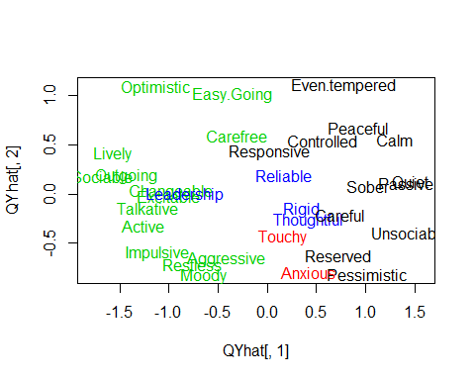

# c)  
Chol = c(0,1,0,0,0,1,0,0,0,1,0,0,0,1,0,0,0,1,0,0,0,1,0,0,0,1,0,0,0,1,0,0)  
San = c(0,0,1,0,0,0,1,0,0,0,1,0,0,0,1,0,0,0,1,0,0,0,1,0,0,0,1,0,0,0,1,0)  
CSan = 2*San  
Mel = c(1,0,0,0,1,0,0,0,1,0,0,0,1,0,0,0,1,0,0,0,1,0,0,0,1,0,0,0,1,0,0,0)  
CMel = 3*Mel  
phle = c(rep(1,32))  
Phle = phle-(Chol+San+Mel)  
CPhle = 4*Phle  
Color = CPhle+Chol+CSan+CMel  
plot(QYhat[,1],QYhat[,2], asp = 1, type = "n")  
text(QYhat[,1],QYhat[,2], variable.names(pers3), col = Color)

