Exercise1.R

B-C-Herbert

2019-11-11

### Exercise 1  
  
remove(list = ls())  
  
euro = read.table(file = "Europe.txt", header = T, dec =".")  
attach(euro)  
europe = data.frame(euro)  
europe = na.omit(europe)  
Country = ï..Country  
numbers = cbind(CPI, UNE, INP, BOP, PRC, UN)  
  
# a)   
Euro = scale(numbers, center = TRUE, scale = TRUE)  
EuroEuc = dist(Euro, method = "euclidean", diag = TRUE, upper = TRUE)  
reshclust = hclust(EuroEuc, method = "complete")  
plot(reshclust, hang = -1, labels = Country, ylab = "Euclidean Distance")  
rect.hclust(reshclust, k = 5, border = c(1,2,3,4,5))

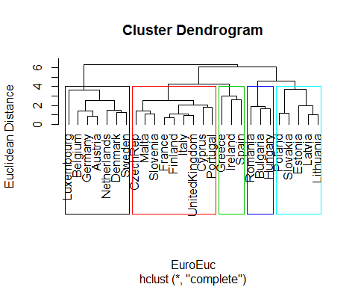

# b)   
S1 = cov(Euro)  
lam1 = eigen(S1)$values[1:2]  
e1 = eigen(S1)$vectors[,1:2]  
Yhat = Euro%*%e1  
plot(-Yhat[,1],Yhat[,2], type = "n", asp = 1, ylab = "PC2", xlab = "PC1")  
text(-Yhat[,1],Yhat[,2], Country, col = cutree(reshclust, k = 5))  
  
arrows(0,0,-2*e1[1,1],2*e1[1,2], col = "blue", lwd = 2)  
text(-2.5*e1[1,1],2.5*e1[1,2], labels = variable.names(europe[2]), col = "blue")  
arrows(0,0,-2*e1[2,1],2*e1[2,2], col = "blue", lwd = 2)  
text(-2.5*e1[2,1],2.5*e1[2,2], labels = variable.names(europe[3]), col = "blue")  
arrows(0,0,-2*e1[3,1],2*e1[3,2], col = "blue", lwd = 2)  
text(-2.5*e1[3,1],2.5*e1[3,2], labels = variable.names(europe[4]), col = "blue")  
arrows(0,0,-2*e1[4,1],2*e1[4,2], col = "blue", lwd = 2)  
text(-2.5*e1[4,1],2.5*e1[4,2], labels = variable.names(europe[5]), col = "blue")  
arrows(0,0,-2*e1[5,1],2*e1[5,2], col = "blue", lwd = 2)  
text(-2.5*e1[5,1],2.5*e1[5,2], labels = variable.names(europe[6]), col = "blue")  
arrows(0,0,-2*e1[6,1],2*e1[6,2], col = "blue", lwd = 2)  
text(-2.5*e1[6,1],2.5*e1[6,2], labels = variable.names(europe[7]), col = "blue")

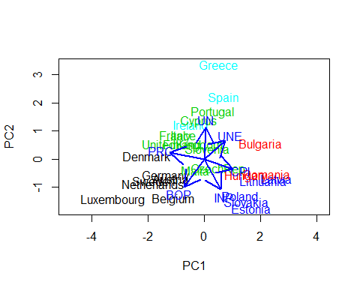

# c)  
  
# d)  
R1 = cor(Euro)  
round(R1, digits = 2)

## CPI UNE INP BOP PRC UN  
## CPI 1.00 0.29 0.21 -0.11 -0.71 -0.08  
## UNE 0.29 1.00 -0.10 -0.40 -0.33 0.03  
## INP 0.21 -0.10 1.00 0.04 -0.51 -0.24  
## BOP -0.11 -0.40 0.04 1.00 0.42 -0.31  
## PRC -0.71 -0.33 -0.51 0.42 1.00 -0.02  
## UN -0.08 0.03 -0.24 -0.31 -0.02 1.00

EuroDist = as.dist(1-R1)  
EuroClus = hclust(EuroDist, method = "complete")  
plot(EuroClus, hang = -1, labels = variable.names(europe[2:7]), ylab = "1-R Distances")

