Exercise2.R

B-C-Herbert

2019-11-11

### Exercis 2  
  
remove(list = ls())  
  
pers = read.table(file = "Personality2019.txt", header = T, dec =".")  
Pers = as.matrix(pers[,2:33])  
pers$Name

## [1] Toni Lion Borui Sarah Abbas Marc Dmitrii   
## [8] Ivan Benjamin Julius Samuel Theresa Rickmer Florentia  
## [15] Anton Frederik Carmen Louis Felipe Stepan Nikolai   
## [22] Tom Tobias Xiao Hendrik Jungin   
## 26 Levels: Abbas Anton Benjamin Borui Carmen Dmitrii Felipe ... Xiao

# a)  
  
X = scale(Pers, center = TRUE, scale = FALSE)  
S = cov(X)  
lam = eigen(S)$values[1:2]  
e = eigen(S)$vectors[,1:2]  
Yhat = X%*%e  
plot(Yhat[,1],Yhat[,2], type = "n", asp = 1)  
text(Yhat[,1],Yhat[,2], pers$Name)  
Expl = cumsum(eigen(S)$values)/sum(eigen(S)$values)  
Expl[2]

## [1] 0.3017799

# The first two principal components explain 30.18% of the total variance.  
  
# b)   
lengthOfAxes = sqrt(e[,1]^2+e[,2]^2)  
o = order(lengthOfAxes, decreasing = TRUE)  
arrows(0,0,3*e[o[1],1],3*e[o[1],2], col = "blue")  
text(3.5*e[o[1],1],3.5*e[o[1],2], labels = variable.names(pers[o[1]+1]), col = "blue")  
arrows(0,0,3*e[o[2],1],3*e[o[2],2], col = "blue")  
text(3.5*e[o[2],1],3.5*e[o[2],2], labels = variable.names(pers[o[2]+1]), col = "blue")  
arrows(0,0,3*e[o[3],1],3*e[o[3],2], col = "blue")  
text(3.5*e[o[3],1],3.5*e[o[3],2], labels = variable.names(pers[o[3]+1]), col = "blue")  
arrows(0,0,3*e[o[4],1],3*e[o[4],2], col = "blue")  
text(3.5*e[o[4],1],3.5*e[o[4],2], labels = variable.names(pers[o[4]+1]), col = "blue")  
  
# c)  
Chol = c(0,1,0,0,0,1,0,0,0,1,0,0,0,1,0,0,0,1,0,0,0,1,0,0,0,1,0,0,0,1,0,0)  
San = c(0,0,1,0,0,0,1,0,0,0,1,0,0,0,1,0,0,0,1,0,0,0,1,0,0,0,1,0,0,0,1,0)  
Mel = c(1,0,0,0,1,0,0,0,1,0,0,0,1,0,0,0,1,0,0,0,1,0,0,0,1,0,0,0,1,0,0,0)  
phle = c(rep(1,32))  
Phle = phle-(Chol+San+Mel)  
Choleric = Chol-colMeans(Pers)  
C = Choleric%*%e  
text(C[1,1],C[1,2], labels = "Cholerica", col = "green")  
Melancholic = Mel-colMeans(Pers)  
M = Melancholic%*%e  
text(M[1,1],M[1,2], labels = "Melancholic", col = "green")  
Sanguine = San-colMeans(Pers)  
Sa = Sanguine%*%e  
text(Sa[1,1],Sa[1,2], labels = "Sanguine", col = "green")  
Phlegmatic = Phle-colMeans(Pers)  
P = Phlegmatic%*%e  
text(P[1,1],P[1,2], labels = "Phlegmatic", col = "green")  
  
# d)  
Intro = Phle+Mel  
Unst = Mel+Chol  
Extro = Chol+San  
Stabel = San+Phle  
Introvert = Intro-colMeans(Pers)  
Int = Introvert%*%e  
text(Int[1,1],Int[1,2], labels = "Introvert", col = "red")  
Unstable = Unst-colMeans(Pers)  
Uns = Unstable%*%e  
text(Uns[1,1],Uns[1,2], labels = "Unstable", col = "red")  
Extrovert = Extro-colMeans(Pers)  
Ex = Extrovert%*%e  
text(Ex[1,1],Ex[1,2], labels = "Extrovert", col = "red")  
Stabele = Stabel-colMeans(Pers)  
St = Stabele%*%e  
text(St[1,1],St[1,2], labels = "Stable", col = "red")

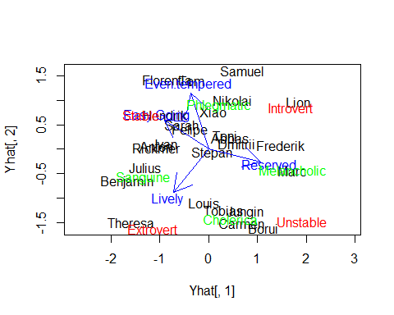

# e)  
Delta = as.matrix(dist(Pers, method = "manhattan", upper = TRUE, diag = TRUE))  
Deltastar = Delta^2  
I = diag(1, nrow = 26, ncol = 26)  
J = matrix(c(rep(1, 26*26)), nrow = 26, ncol = 26)  
n = 1/26  
H = I-n*J  
B = -0.5*H%*%Deltastar%*%H  
reseigen = eigen(B)  
lambda = round(reseigen$values, digits = 4)  
lambda

## [1] 580.1522 507.7782 333.5213 296.7573 194.7462 123.1985 103.0154  
## [8] 85.5694 76.6256 52.2152 45.5587 34.9044 26.5002 8.5767  
## [15] 5.2770 0.0000 -7.3348 -11.6107 -14.1745 -20.3273 -32.1523  
## [22] -35.9884 -50.6483 -54.9865 -74.0686 -86.2971

# Since there are negative eigenvalues, B is not n.n.d.  
  
# f)  
QE = reseigen$vectors  
Qlam = reseigen$values  
QLam = diag(Qlam[1:2])  
QYhat = QE[,1:2]%*%sqrt(QLam)  
plot(-QYhat[,1],QYhat[,2], asp = 1, type = "n", ylab = "Y2hat", xlab = "X2hat")  
text(-QYhat[,1],QYhat[,2], pers$Name)

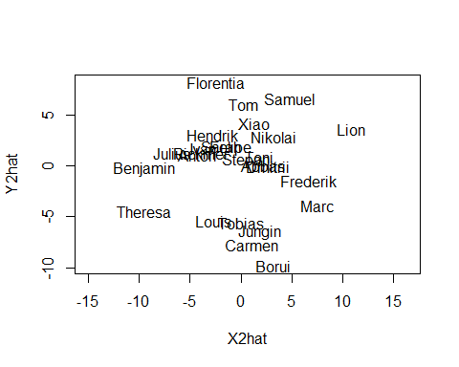

# The biplot differs from the MDS-plot.  
  
# g)   
Personality = dist(X, method = "euclidean", upper = TRUE, diag = TRUE)  
PersALM = hclust(Personality, method = "average")  
plot(PersALM, hang = -1, labels = pers$Name, ylab = "Personality Distance")  
rect.hclust(PersALM, k = 4, border = c(1,2,3,4))

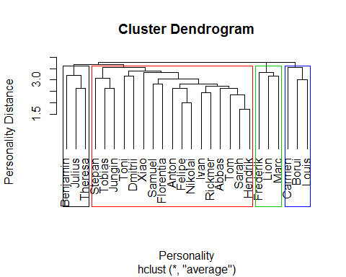

plot(Yhat[,1],Yhat[,2], type = "n", asp = 1)  
text(Yhat[,1],Yhat[,2], pers$Name, col = cutree(PersALM, k = 4))

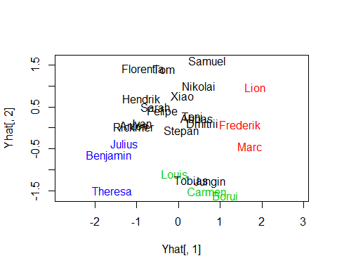

# The cluster does correspond more or less to the biplot except the observations Tobias and Jungin.