Exercise3.R

B-C-Herbert

2019-11-11

### Exercise 3  
  
remove(list = ls())  
  
pers3 = read.table(file = "Personality.txt", header = T, dec =".")  
  
# a)  
Pers3 = scale(pers3, scale = FALSE, center = TRUE)  
R = cor(pers3)  
PersDelt = as.dist(1-R)  
Persreshc = hclust(PersDelt, method = "average")  
plot(Persreshc, hang = -1, labels = pers3$Name, ylab = "1 -R Distance")  
rect.hclust(Persreshc, k = 4, border = c(1,2,3,4) )

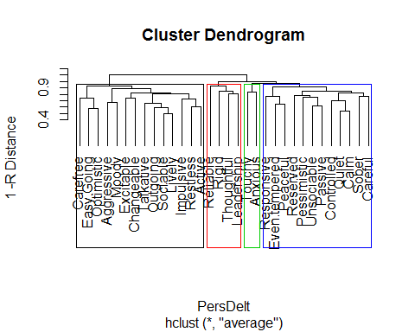

Group = sort(cutree(Persreshc, k = 4))  
Group[1:12]

## Quiet Calm Unsociable Even.tempered Reserved   
## 1 1 1 1 1   
## Pessimistic Responsive Controlled Sober Peaceful   
## 1 1 1 1 1   
## Careful Passive   
## 1 1

# Cluster 1  
Group[13:14]

## Touchy Anxious   
## 2 2

# Cluster 2  
Group[15:28]

## Sociable Restless Outgoing Aggressive Talkative Excitable   
## 3 3 3 3 3 3   
## Changeable Easy.Going Impulsive Lively Optimistic Carefree   
## 3 3 3 3 3 3   
## Moody Active   
## 3 3

# Cluster 3  
Group[29:32]

## Reliable Rigid Thoughtful Leadership   
## 4 4 4 4

# Cluster 4  
  
# b)  
X3 = R  
Q = X3%*%t(X3)  
QE = eigen(Q)$vectors  
Qlam = eigen(Q)$values  
QLam = diag(Qlam[1:2])  
QYhat = QE[,1:2]%*%sqrt(QLam)  
plot(QYhat[,1],QYhat[,2], asp = 1, type = "n")  
text(QYhat[,1],QYhat[,2], variable.names(pers3), col = cutree(Persreshc, k = 4))

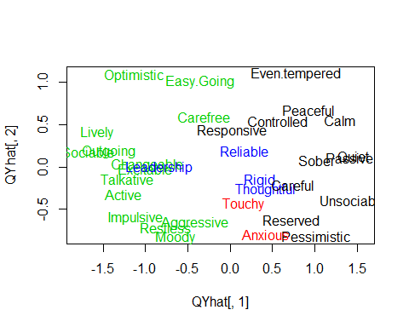

# c)  
Chol = c(0,1,0,0,0,1,0,0,0,1,0,0,0,1,0,0,0,1,0,0,0,1,0,0,0,1,0,0,0,1,0,0)  
San = c(0,0,1,0,0,0,1,0,0,0,1,0,0,0,1,0,0,0,1,0,0,0,1,0,0,0,1,0,0,0,1,0)  
CSan = 2*San  
Mel = c(1,0,0,0,1,0,0,0,1,0,0,0,1,0,0,0,1,0,0,0,1,0,0,0,1,0,0,0,1,0,0,0)  
CMel = 3*Mel  
phle = c(rep(1,32))  
Phle = phle-(Chol+San+Mel)  
CPhle = 4*Phle  
Color = CPhle+Chol+CSan+CMel  
plot(QYhat[,1],QYhat[,2], asp = 1, type = "n")  
text(QYhat[,1],QYhat[,2], variable.names(pers3), col = Color)

